SUPPLEMENT

The effectiveness of COVID-19 vaccines to prevent post COVID cardiac and thromboembolic complications.

**Table of contents**

**Figure S1: Follow-up in vaccinated and unvaccinated cohorts.** 6

(A) Main analysis, (B) Follow-up ends at first vaccine dose after index date, (C) Post COVID sequelae refers just to the first outcome after infection. 6

**Figure S2: Study Inclusion Flowchart CPRD AURUM** 7

**Figure S3: Study Inclusion Flowchart CPRD GOLD.** 8

**Figure S4: Study Inclusion Flowchart SIDIAP.** 9

**Figure S5: Study Inclusion Flowchart CORIVA.** 10

**Table S1: Characteristics of unweighted populations in CPRD AURUM,** database, stratified by staggered cohort and exposure status. Exposure is any COVID-19 vaccine. 11

**Table S2: Characteristics of weighted populations in CPRD AURUM,** database, stratified by staggered cohort and exposure status. Exposure is ChAdOx1 vaccine. 13

**Table S3: Characteristics of unweighted populations in CPRD AURUM,** database, stratified by staggered cohort and exposure status. Exposure is ChAdOx1 vaccine. 15

**Table S4: Characteristics of weighted populations in CPRD AURUM,** database, stratified by staggered cohort and exposure status. Exposure is BNT162b2 vaccine. 17

**Table S5: Characteristics of unweighted populations in CPRD AURUM,** database, stratified by staggered cohort and exposure status. Exposure is BNT162b2 vaccine. 19

**Table S6: Characteristics of weighted populations in CPRD GOLD,** database, stratified by staggered cohort and exposure status. Exposure is any COVID-19 vaccine. 21

**Table S7: Characteristics of unweighted populations in CPRD GOLD,** database, stratified by staggered cohort and exposure status. Exposure is any COVID-19 vaccine. 23

**Table S8: Characteristics of weighted populations in CPRD GOLD,** database, stratified by staggered cohort and exposure status. Exposure is ChAdOx1 vaccine. 25

**Table S9: Characteristics of unweighted populations in CPRD GOLD,** database, stratified by staggered cohort and exposure status. Exposure is ChAdOx1 vaccine. 27

**Table S10: Characteristics of weighted populations in CPRD GOLD,** database, stratified by staggered cohort and exposure status. Exposure is BNT162b2 vaccine. 29

**Table S11: Characteristics of unweighted populations in CPRD GOLD,** database, stratified by staggered cohort and exposure status. Exposure is BNT162b2 vaccine. 31

**Table S12: Characteristics of weighted populations in SIDIAP,** database, stratified by staggered cohort and exposure status. Exposure is any COVID-19 vaccine. 33

**Table S13: Characteristics of unweighted populations in SIDIAP,** database, stratified by staggered cohort and exposure status. Exposure is any COVID-19 vaccine. 35

**Table S14: Characteristics of weighted populations in SIDIAP,** database, stratified by staggered cohort and exposure status. Exposure is BNT162b2 vaccine. 37

**Table S15: Characteristics of unweighted populations in SIDIAP,** database, stratified by staggered cohort and exposure status. Exposure is BNT162b2 vaccine. 39

**Table S16: Characteristics of weighted populations in SIDIAP,** database, stratified by staggered cohort and exposure status. Exposure is ChAdOx1 vaccine. 41

**Table S17: Characteristics of unweighted populations in SIDIAP,** database, stratified by staggered cohort and exposure status. Exposure is ChAdOx1 vaccine. 43

**Table S18: Characteristics of weighted populations in CORIVA,** database, stratified by staggered cohort and exposure status. Exposure is any COVID-19 vaccine. 45

**Table S19: Characteristics of unweighted populations in CORIVA,** database, stratified by staggered cohort and exposure status. Exposure is any COVID-19 vaccine. 47

**Table S20: Characteristics of weighted populations in CORIVA,** database, stratified by staggered cohort and exposure status. Exposure is BNT162b2 vaccine. 49

**Table S21: Characteristics of unweighted populations in CORIVA,** database, stratified by staggered cohort and exposure status. Exposure is BNT162b2 vaccine. 51

**Table S22: Characteristics of weighted populations in CPRD AURUM** database, stratified by staggered cohort and vaccine. 53

**Table S23: Characteristics of unweighted populations in CPRD AURUM** database, stratified by staggered cohort and vaccine. 55

**Table S24: Characteristics of weighted populations in CPRD GOLD** database, stratified by staggered cohort and vaccine. 57

**Table S25: Characteristics of unweighted populations in CPRD GOLD** database, stratified by staggered cohort and vaccine. 59

**Table S26: Number of records (and risk per 10,000 individuals) for post COVID-19 cardiac and thromboembolic complications,** across cohorts and databases, stratified by exposure status (any COVID-19 vaccine). Follow-up ends at first vaccine dose after index date. 61

**Table S27: Number of records (and risk per 10,000 individuals) for post COVID-19 cardiac and thromboembolic complications,** across cohorts and databases, stratified by exposure status (any COVID-19 vaccine). Only first outcome after COVID-19 captured. 66

**Table S28: Number of records (and risk per 10,000 individuals) for post COVID-19 cardiac and thromboembolic complications,** across cohorts and databases, stratified by exposure status (ChAdOx1 vaccine). 71

**Table S29: Number of records (and risk per 10,000 individuals) for post COVID-19 cardiac and thromboembolic complications,** across cohorts and databases, stratified by exposure status (ChAdOx1 vaccine). Follow-up ends at first vaccine dose after index date. 76

**Table S30: Number of records (and risk per 10,000 individuals) for post COVID-19 cardiac and thromboembolic complications,** across cohorts and databases, stratified by exposure status (ChAdOx1 vaccine). Only first outcome after COVID-19 captured. 81

**Table S31: Number of records (and risk per 10,000 individuals) for post COVID-19 cardiac and thromboembolic complications,** across cohorts and databases, stratified by exposure status (BNT162b2 vaccine). 86

**Table S32: Number of records (and risk per 10,000 individuals) for post COVID-19 cardiac and thromboembolic complications,** across cohorts and databases, stratified by exposure status (BNT162b2 vaccine). Follow-up ends at first vaccine dose after index date. 91

**Table S33: Number of records (and risk per 10,000 individuals) for post COVID-19 cardiac and thromboembolic complications,** across cohorts and databases, stratified by exposure status (BNT162b2 vaccine). Only first outcome after COVID-19 captured. 96

**Table S34: Number of records (and risk per 10,000 individuals) for post COVID-19 cardiac and thromboembolic complications,** across cohorts and databases, stratified by vaccine (BNT162b2 - ChAdOx1). 101

**Table S35: Number of records (and risk per 10,000 individuals) for post COVID-19 cardiac and thromboembolic complications,** across cohorts and databases, stratified by vaccine (BNT162b2 - ChAdOx1). Follow-up ends at first vaccine dose after index date. 106

**Table S36: Number of records (and risk per 10,000 individuals) for post COVID-19 cardiac and thromboembolic complications,** across cohorts and databases, stratified by vaccine (BNT162b2 - ChAdOx1). Only first outcome after COVID-19 captured. 111

**Figure S6: Forest plots for vaccine effect (any COVID-19 vaccine),** meta-analysis across cohorts and databases. Follow-up ends at first vaccine dose after index date. Dashed line represents a level of hetereogeneity I2 > 0.4. 116

**Figure S7: Forest plots for vaccine effect (any COVID-19 vaccine),** meta-analysis across cohorts and databases. Only first outcome after COVID-19 captured. Dashed line represents a level of hetereogeneity I2 > 0.4. 117

**Figure S8: Forest plots for vaccine effect (ChAdOx1 vaccine),** meta-analysis across cohorts and databases. Dashed line represents a level of hetereogeneity I2 > 0.4. 118

**Figure S9: Forest plots for vaccine effect (ChAdOx1 vaccine),** meta-analysis across cohorts and databases. Follow-up ends at first vaccine dose after index date. Dashed line represents a level of hetereogeneity I2 > 0.4. 119

**Figure S10: Forest plots for vaccine effect (ChAdOx1 vaccine),** meta-analysis across cohorts and databases. Only first outcome after COVID-19 captured. Dashed line represents a level of hetereogeneity I2 > 0.4. 120

**Figure S11: Forest plots for vaccine effect (BNT162b2 vaccine),** meta-analysis across cohorts and databases. Dashed line represents a level of hetereogeneity I2 > 0.4. 121

**Figure S12: Forest plots for vaccine effect (BNT162b2 vaccine),** meta-analysis across cohorts and databases. Follow-up ends at first vaccine dose after index date. Dashed line represents a level of hetereogeneity I2 > 0.4. 122

**Figure S13: Forest plots for vaccine effect (BNT162b2 vaccine),** meta-analysis across cohorts and databases. Only first outcome after COVID-19 captured. Dashed line represents a level of hetereogeneity I2 > 0.4. 123

**Figure S14: Forest plots for vaccine effect (any COVID-19 vaccine) on preventing venous thromboembolism complications,** for each cohort and database (meta-analysis estimates across cohorts in the last panel). Dashed line represents a level of hetereogeneity I2 > 0.4. 124

**Figure S15: Forest plots for vaccine effect (any COVID-19 vaccine) on preventing venous thromboembolism complications,** for each cohort and database (meta-analysis estimates across cohorts in the last panel).Follow-up ends at first vaccine dose after index date. Dashed line represents a level of hetereogeneity I2 > 0.4. 125

**Figure S16: Forest plots for vaccine effect (any COVID-19 vaccine) on preventing venous thromboembolism complications,** for each cohort and database (meta-analysis estimates across cohorts in the last panel).Only first outcome after COVID-19 captured. Dashed line represents a level of hetereogeneity I2 > 0.4. 126

**Figure S17: Forest plots for vaccine effect (ChAdOx1 vaccine) on preventing venous thromboembolism complications,** for each cohort and database (meta-analysis estimates across cohorts in the last panel). Dashed line represents a level of hetereogeneity I2 > 0.4. 127

**Figure S18: Forest plots for vaccine effect (ChAdOx1 vaccine) on preventing venous thromboembolism complications,** for each cohort and database (meta-analysis estimates across cohorts in the last panel).Follow-up ends at first vaccine dose after index date. Dashed line represents a level of hetereogeneity I2 > 0.4. 128

**Figure S19: Forest plots for vaccine effect (ChAdOx1 vaccine) on preventing venous thromboembolism complications,** for each cohort and database (meta-analysis estimates across cohorts in the last panel).Only first outcome after COVID-19 captured. Dashed line represents a level of hetereogeneity I2 > 0.4. 129

**Figure S20: Forest plots for vaccine effect (BNT162b2 vaccine) on preventing venous thromboembolism complications,** for each cohort and database (meta-analysis estimates across cohorts in the last panel). Dashed line represents a level of hetereogeneity I2 > 0.4. 130

**Figure S21: Forest plots for vaccine effect (BNT162b2 vaccine) on preventing venous thromboembolism complications,** for each cohort and database (meta-analysis estimates across cohorts in the last panel).Follow-up ends at first vaccine dose after index date. Dashed line represents a level of hetereogeneity I2 > 0.4. 131

**Figure S22: Forest plots for vaccine effect (BNT162b2 vaccine) on preventing venous thromboembolism complications,** for each cohort and database (meta-analysis estimates across cohorts in the last panel).Only first outcome after COVID-19 captured. Dashed line represents a level of hetereogeneity I2 > 0.4. 132

**Figure S23: Forest plots for vaccine effect (any COVID-19 vaccine) on preventing arterial thrombosis/thromboembolism complications,** for each cohort and database (meta-analysis estimates across cohorts in the last panel). Dashed line represents a level of hetereogeneity I2 > 0.4. 133

**Figure S24: Forest plots for vaccine effect (any COVID-19 vaccine) on preventing arterial thrombosis/thromboembolism complications,** for each cohort and database (meta-analysis estimates across cohorts in the last panel).Follow-up ends at first vaccine dose after index date. Dashed line represents a level of hetereogeneity I2 > 0.4. 134

**Figure S25: Forest plots for vaccine effect (any COVID-19 vaccine) on preventing arterial thrombosis/thromboembolism complications,** for each cohort and database (meta-analysis estimates across cohorts in the last panel).Only first outcome after COVID-19 captured. Dashed line represents a level of hetereogeneity I2 > 0.4. 135

**Figure S26: Forest plots for vaccine effect (ChAdOx1 vaccine) on preventing arterial thrombosis/thromboembolism complications,** for each cohort and database (meta-analysis estimates across cohorts in the last panel). Dashed line represents a level of hetereogeneity I2 > 0.4. 136

**Figure S27: Forest plots for vaccine effect (ChAdOx1 vaccine) on preventing arterial thrombosis/thromboembolism complications,** for each cohort and database (meta-analysis estimates across cohorts in the last panel).Follow-up ends at first vaccine dose after index date. Dashed line represents a level of hetereogeneity I2 > 0.4. 137

**Figure S28: Forest plots for vaccine effect (ChAdOx1 vaccine) on preventing arterial thrombosis/thromboembolism complications,** for each cohort and database (meta-analysis estimates across cohorts in the last panel).Only first outcome after COVID-19 captured. Dashed line represents a level of hetereogeneity I2 > 0.4. 138

**Figure S29: Forest plots for vaccine effect (BNT162b2 vaccine) on preventing arterial thrombosis/thromboembolism complications,** for each cohort and database (meta-analysis estimates across cohorts in the last panel). Dashed line represents a level of hetereogeneity I2 > 0.4. 139

**Figure S30: Forest plots for vaccine effect (BNT162b2 vaccine) on preventing arterial thrombosis/thromboembolism complications,** for each cohort and database (meta-analysis estimates across cohorts in the last panel).Follow-up ends at first vaccine dose after index date. Dashed line represents a level of hetereogeneity I2 > 0.4. 140

**Figure S31: Forest plots for vaccine effect (BNT162b2 vaccine) on preventing arterial thrombosis/thromboembolism complications,** for each cohort and database (meta-analysis estimates across cohorts in the last panel).Only first outcome after COVID-19 captured. Dashed line represents a level of hetereogeneity I2 > 0.4. 141

**Figure S32: Forest plots for vaccine effect (any COVID-19 vaccine) on preventing cardiac diseases and hemorrhagic stroke,** for each cohort and database (meta-analysis estimates across cohorts in the last panel). Dashed line represents a level of hetereogeneity I2 > 0.4. 142

**Figure S33: Forest plots for vaccine effect (any COVID-19 vaccine) on preventing cardiac diseases and hemorrhagic stroke,** for each cohort and database (meta-analysis estimates across cohorts in the last panel).Follow-up ends at first vaccine dose after index date. Dashed line represents a level of hetereogeneity I2 > 0.4. 143

**Figure S34: Forest plots for vaccine effect (any COVID-19 vaccine) on preventing cardiac diseases and hemorrhagic stroke,** for each cohort and database (meta-analysis estimates across cohorts in the last panel).Only first outcome after COVID-19 captured. Dashed line represents a level of hetereogeneity I2 > 0.4. 144

**Figure S35: Forest plots for vaccine effect (ChAdOx1 vaccine) on preventing cardiac diseases and hemorrhagic stroke,** for each cohort and database (meta-analysis estimates across cohorts in the last panel). Dashed line represents a level of hetereogeneity I2 > 0.4. 145

**Figure S36: Forest plots for vaccine effect (ChAdOx1 vaccine) on preventing cardiac diseases and hemorrhagic stroke,** for each cohort and database (meta-analysis estimates across cohorts in the last panel).Follow-up ends at first vaccine dose after index date. Dashed line represents a level of hetereogeneity I2 > 0.4. 146

**Figure S37: Forest plots for vaccine effect (ChAdOx1 vaccine) on preventing cardiac diseases and hemorrhagic stroke,** for each cohort and database (meta-analysis estimates across cohorts in the last panel).Only first outcome after COVID-19 captured. Dashed line represents a level of hetereogeneity I2 > 0.4. 147

**Figure S38: Forest plots for vaccine effect (BNT162b2 vaccine) on preventing cardiac diseases and hemorrhagic stroke,** for each cohort and database (meta-analysis estimates across cohorts in the last panel). Dashed line represents a level of hetereogeneity I2 > 0.4. 148

**Figure S39: Forest plots for vaccine effect (BNT162b2 vaccine) on preventing cardiac diseases and hemorrhagic stroke,** for each cohort and database (meta-analysis estimates across cohorts in the last panel).Follow-up ends at first vaccine dose after index date. Dashed line represents a level of hetereogeneity I2 > 0.4. 149

**Figure S40: Forest plots for vaccine effect (BNT162b2 vaccine) on preventing cardiac diseases and hemorrhagic stroke,** for each cohort and database (meta-analysis estimates across cohorts in the last panel).Only first outcome after COVID-19 captured. Dashed line represents a level of hetereogeneity I2 > 0.4. 150

**Figure S41: Forest plots for comparative effect,** meta-analysis across cohorts and databases. Follow-up ends at first vaccine dose after index date. Dashed line represents a level of hetereogeneity I2 > 0.4. 151

**Figure S42: Forest plots for comparative effect,** meta-analysis across cohorts and databases. Only first outcome after COVID-19 captured. Dashed line represents a level of hetereogeneity I2 > 0.4. 152

**Figure S43: Forest plots for comparative effect on preventing venous thromboembolism complications,** for each cohort and database (meta-analysis estimates across cohorts in the last panel). Dashed line represents a level of hetereogeneity I2 > 0.4. 153

**Figure S44: Forest plots for comparative effect on preventing venous thromboembolism complications,** for each cohort and database (meta-analysis estimates across cohorts in the last panel).Follow-up ends at first vaccine dose after index date. Dashed line represents a level of hetereogeneity I2 > 0.4. 154

**Figure S45: Forest plots for comparative effect on preventing venous thromboembolism complications,** for each cohort and database (meta-analysis estimates across cohorts in the last panel).Only first outcome after COVID-19 captured. Dashed line represents a level of hetereogeneity I2 > 0.4. 155

**Figure S46: Forest plots for comparative effect on preventing arterial thrombosis/thromboembolism complications,** for each cohort and database (meta-analysis estimates across cohorts in the last panel). Dashed line represents a level of hetereogeneity I2 > 0.4. 156

**Figure S47: Forest plots for comparative effect on preventing arterial thrombosis/thromboembolism complications,** for each cohort and database (meta-analysis estimates across cohorts in the last panel).Follow-up ends at first vaccine dose after index date. Dashed line represents a level of hetereogeneity I2 > 0.4. 157

**Figure S48: Forest plots for comparative effect on preventing arterial thrombosis/thromboembolism complications,** for each cohort and database (meta-analysis estimates across cohorts in the last panel).Only first outcome after COVID-19 captured. Dashed line represents a level of hetereogeneity I2 > 0.4. 158

**Figure S49: Forest plots for comparative effect on preventing cardiac diseases and hemorrhagic stroke,** for each cohort and database (meta-analysis estimates across cohorts in the last panel). Dashed line represents a level of hetereogeneity I2 > 0.4. 159

**Figure S50: Forest plots for comparative effect on preventing cardiac diseases and hemorrhagic stroke,** for each cohort and database (meta-analysis estimates across cohorts in the last panel).Follow-up ends at first vaccine dose after index date. Dashed line represents a level of hetereogeneity I2 > 0.4. 160

**Figure S51: Forest plots for comparative effect on preventing cardiac diseases and hemorrhagic stroke,** for each cohort and database (meta-analysis estimates across cohorts in the last panel).Only first outcome after COVID-19 captured. Dashed line represents a level of hetereogeneity I2 > 0.4. 161

## **Figure S1: Follow-up in vaccinated and unvaccinated cohorts.**

## (A) Main analysis, (B) Follow-up ends at first vaccine dose after index date, (C) Post COVID sequelae refers just to the first outcome after infection.

|  |
| --- |
|  |

## **Figure S2: Study Inclusion Flowchart CPRD AURUM**

|  |
| --- |
|  |

## **Figure S3: Study Inclusion Flowchart CPRD GOLD.**

|  |
| --- |
|  |

## **Figure S4: Study Inclusion Flowchart SIDIAP.**

|  |
| --- |
|  |

## **Figure S5: Study Inclusion Flowchart CORIVA.**

|  |
| --- |
|  |

## 

## **Table S1: Characteristics of unweighted populations in CPRD AURUM,** database, stratified by staggered cohort and exposure status. Exposure is any COVID-19 vaccine.

|  | **Cohort 1** | | | **Cohort 2** | | | **Cohort 3** | | | **Cohort 4** | | |
| --- | --- | --- | --- | --- | --- | --- | --- | --- | --- | --- | --- | --- |
| **Unvaccinated** | **Vaccinated** | **ASMD** | **Unvaccinated** | **Vaccinated** | **ASMD** | **Unvaccinated** | **Vaccinated** | **ASMD** | **Unvaccinated** | **Vaccinated** | **ASMD** |
| **N (individuals)** | 346,674 | 552,602 |  | 1,975,726 | 1,563,569 |  | 1,510,401 | 1,528,031 |  | 2,027,763 | 2,085,598 |  |
| **Age, median [Q25-Q75]** | 78 [76-82] | 81 [78-86] | 0.319 | 42 [32-55] | 68 [60-73] | 0.995 | 41 [31-53] | 55 [51-60] | 0.610 | 35 [27-45] | 35 [27-43] | 0.134 |
| **Sex: Female, N(%)** | 192,771 (56%) | 314,141 (57%) | 0.025 | 1,244,636 (63%) | 852,976 (55%) | 0.172 | 880,404 (58%) | 771,929 (51%) | 0.157 | 862,676 (43%) | 958,124 (46%) | 0.068 |
| **Years of prior history*, median [Q25-Q75]** | 24 [10-35] | 25 [11-37] | 0.056 | 15 [7-25] | 21 [9-32] | 0.278 | 13 [6-22] | 17 [8-27] | 0.207 | 8 [4-16] | 8 [3-18] | 0.032 |
| **Number of GP visits, median [Q25-Q75]** | 10 [5-17] | 11 [6-19] | 0.105 | 6 [2-11] | 10 [6-17] | 0.367 | 4 [1-10] | 7 [3-12] | 0.180 | 2 [0-5] | 3 [1-7] | 0.108 |
| **Number of PCR tests, median [Q25-Q75]** | 0[0-0] | 0[0-0] | 0.103 | 0[0-0] | 0[0-0] | 0.065 | 0[0-0] | 0[0-0] | 0.007 | 0[0-0] | 0[0-0] | 0.078 |
| **Comorbidities**, N(%)** |  |  |  |  |  |  |  |  |  |  |  |  |
| Anxiety | 51,067 (15%) | 82,765 (15%) | 0.007 | 435,770 (22%) | 309,567 (20%) | 0.056 | 289,563 (19%) | 292,336 (19%) | 0.001 | 265,627 (13%) | 338,058 (16%) | 0.088 |
| Asthma | 36,474 (11%) | 61,899 (11%) | 0.022 | 501,209 (25%) | 275,768 (18%) | 0.189 | 294,123 (19%) | 209,708 (14%) | 0.155 | 138,317 (7%) | 173,056 (8%) | 0.056 |
| Chronic kidney disease | 71,083 (21%) | 137,953 (25%) | 0.107 | 55,104 (3%) | 154,263 (10%) | 0.294 | 24,340 (2%) | 30,896 (2%) | 0.031 | 18,625 (1%) | 5,796 (0%) | 0.083 |
| COPD | 28,665 (8%) | 47,422 (9%) | 0.011 | 29,729 (2%) | 107,297 (7%) | 0.270 | 13,433 (1%) | 15,685 (1%) | 0.014 | 10,543 (1%) | 2,535 (0%) | 0.071 |
| Dementia | 16,610 (5%) | 32,934 (6%) | 0.052 | 6,692 (0%) | 15,828 (1%) | 0.082 | 3,425 (0%) | 3,219 (0%) | 0.003 | 2,691 (0%) | 575 (0%) | 0.037 |
| Depressive disorder | 42,145 (12%) | 64,840 (12%) | 0.013 | 367,463 (19%) | 283,390 (18%) | 0.012 | 236,584 (16%) | 265,876 (17%) | 0.047 | 210,644 (10%) | 253,317 (12%) | 0.056 |
| Diabetes | 63,154 (18%) | 101,682 (18%) | 0.005 | 107,425 (5%) | 253,026 (16%) | 0.351 | 60,932 (4%) | 84,224 (6%) | 0.069 | 49,154 (2%) | 22,968 (1%) | 0.101 |
| GERD | 18,336 (5%) | 32,360 (6%) | 0.025 | 68,070 (3%) | 84,985 (5%) | 0.097 | 39,594 (3%) | 58,961 (4%) | 0.070 | 31,119 (2%) | 38,612 (2%) | 0.025 |
| Heart failure | 17,882 (5%) | 33,578 (6%) | 0.040 | 12,275 (1%) | 37,396 (2%) | 0.146 | 5,641 (0%) | 7,204 (0%) | 0.015 | 4,611 (0%) | 1,163 (0%) | 0.046 |
| Hypertension | 172,799 (50%) | 301,294 (55%) | 0.094 | 206,105 (10%) | 545,782 (35%) | 0.611 | 110,912 (7%) | 240,120 (16%) | 0.264 | 86,435 (4%) | 54,357 (3%) | 0.091 |
| Hypothyroidism | 31,444 (9%) | 56,367 (10%) | 0.038 | 78,934 (4%) | 118,453 (8%) | 0.154 | 43,892 (3%) | 67,686 (4%) | 0.081 | 30,993 (2%) | 35,364 (2%) | 0.013 |
| Malignant neoplastic disease | 68,984 (20%) | 131,635 (24%) | 0.095 | 60,318 (3%) | 207,240 (13%) | 0.379 | 29,689 (2%) | 61,923 (4%) | 0.122 | 22,701 (1%) | 13,590 (1%) | 0.050 |
| Myocardial infarction | 16,027 (5%) | 29,525 (5%) | 0.033 | 20,259 (1%) | 56,161 (4%) | 0.172 | 7,396 (0%) | 12,703 (1%) | 0.042 | 5,764 (0%) | 1,621 (0%) | 0.049 |
| Osteoporosis | 29,909 (9%) | 59,521 (11%) | 0.072 | 18,263 (1%) | 64,108 (4%) | 0.204 | 8,846 (1%) | 15,089 (1%) | 0.045 | 6,922 (0%) | 2,535 (0%) | 0.046 |
| Pneumonia | 16,992 (5%) | 28,398 (5%) | 0.011 | 31,746 (2%) | 50,739 (3%) | 0.107 | 17,785 (1%) | 22,064 (1%) | 0.023 | 13,305 (1%) | 13,282 (1%) | 0.002 |
| Rheumatoid arthritis | 6,596 (2%) | 11,237 (2%) | 0.009 | 14,811 (1%) | 33,173 (2%) | 0.116 | 5,548 (0%) | 9,130 (1%) | 0.033 | 3,710 (0%) | 1,816 (0%) | 0.026 |
| Stroke | 15,249 (4%) | 26,478 (5%) | 0.019 | 16,942 (1%) | 39,907 (3%) | 0.131 | 7,422 (0%) | 10,828 (1%) | 0.028 | 6,030 (0%) | 2,291 (0%) | 0.042 |
| Venous thromboembolism | 19,607 (6%) | 35,332 (6%) | 0.031 | 28,876 (1%) | 63,048 (4%) | 0.158 | 13,608 (1%) | 26,299 (2%) | 0.072 | 12,945 (1%) | 4,787 (0%) | 0.062 |

The 4 cohorts represent vaccine rollout periods. *Calculated as the days of previous observation in the database before index date. **Assessed anytime before index date. ASMD = Absolute standardized mean difference, GP = General practice, PCR = Polymerase chain reaction, COPD = Chronic obstructive pulmonary disease, GERD = Gastro-Esophageal reflux disease

## **Table S2: Characteristics of weighted populations in CPRD AURUM,** database, stratified by staggered cohort and exposure status. Exposure is ChAdOx1 vaccine.

|  | **Cohort 1** | | | **Cohort 2** | | | **Cohort 3** | | | **Cohort 4** | | |
| --- | --- | --- | --- | --- | --- | --- | --- | --- | --- | --- | --- | --- |
| **Unvaccinated** | **Vaccinated** | **ASMD** | **Unvaccinated** | **Vaccinated** | **ASMD** | **Unvaccinated** | **Vaccinated** | **ASMD** | **Unvaccinated** | **Vaccinated** | **ASMD** |
| **N (individuals)** | 100,517 | 99,985 |  | 308,608 | 304,995 |  | 448,766 | 445,397 |  | 242,955 | 243,847 |  |
| **Age, median [Q25-Q75]** | 78 [76-84] | 78 [76-84] | 0.001 | 62 [47-69] | 62 [47-69] | 0.007 | 50 [41-57] | 52 [41-57] | 0.001 | 44 [41-48] | 44 [41-48] | 0.003 |
| **Sex: Female, N(%)** | 57,756 (57%) | 57,174 (57%) | 0.006 | 179,574 (58%) | 176,871 (58%) | 0.004 | 236,260 (53%) | 234,320 (53%) | 0.001 | 101,805 (42%) | 100,846 (41%) | 0.011 |
| **Years of prior history*, median [Q25-Q75]** | 24 [10-36] | 24 [10-36] | 0.004 | 18 [8-29] | 18 [8-29] | 0.002 | 14 [6-24] | 14 [6-24] | 0.002 | 10 [5-18] | 9 [5-18] | 0.004 |
| **Number of GP visits, median [Q25-Q75]** | 10 [5-18] | 10 [6-18] | 0.003 | 8 [3-15] | 8 [5-15] | 0.003 | 4 [1-11] | 6 [2-10] | 0.007 | 2 [0-7] | 2 [1-7] | 0.016 |
| **Number of PCR tests, median [Q25-Q75]** | 0[0-0] | 0[0-0] | 0.011 | 0[0-0] | 0[0-0] | 0.003 | 0[0-0] | 0[0-0] | 0.003 | 0[0-0] | 0[0-0] | 0.005 |
| **Comorbidities**, N(%)** |  |  |  |  |  |  |  |  |  |  |  |  |
| Anxiety | 15,457 (15%) | 15,069 (15%) | 0.009 | 67,125 (22%) | 64,408 (21%) | 0.015 | 90,806 (20%) | 87,243 (20%) | 0.016 | 37,475 (15%) | 38,040 (16%) | 0.005 |
| Asthma | 10,993 (11%) | 10,863 (11%) | 0.002 | 65,274 (21%) | 62,424 (20%) | 0.017 | 76,417 (17%) | 75,841 (17%) | 0.000 | 17,944 (7%) | 17,468 (7%) | 0.009 |
| Chronic kidney disease | 23,223 (23%) | 22,872 (23%) | 0.005 | 23,022 (7%) | 24,288 (8%) | 0.019 | 8,460 (2%) | 8,356 (2%) | 0.001 | 2,419 (1%) | 2,043 (1%) | 0.017 |
| COPD | 8,669 (9%) | 8,770 (9%) | 0.005 | 14,411 (5%) | 15,226 (5%) | 0.015 | 5,747 (1%) | 4,794 (1%) | 0.019 | 1,263 (1%) | 1,250 (1%) | 0.001 |
| Dementia | 6,529 (6%) | 6,431 (6%) | 0.003 | 3,880 (1%) | 3,541 (1%) | 0.009 | 898 (0%) | 1,004 (0%) | 0.006 | 203 (0%) | 399 (0%) | 0.023 |
| Depressive disorder | 12,559 (12%) | 12,267 (12%) | 0.007 | 60,745 (20%) | 57,903 (19%) | 0.018 | 80,264 (18%) | 77,017 (17%) | 0.016 | 32,304 (13%) | 33,302 (14%) | 0.011 |
| Diabetes | 18,750 (19%) | 18,602 (19%) | 0.001 | 39,262 (13%) | 38,979 (13%) | 0.002 | 25,334 (6%) | 26,121 (6%) | 0.009 | 6,679 (3%) | 6,315 (3%) | 0.010 |
| GERD | 5,590 (6%) | 5,471 (5%) | 0.004 | 14,645 (5%) | 14,339 (5%) | 0.002 | 14,758 (3%) | 14,823 (3%) | 0.002 | 5,727 (2%) | 6,021 (2%) | 0.007 |
| Heart failure | 6,181 (6%) | 5,763 (6%) | 0.016 | 6,098 (2%) | 5,685 (2%) | 0.008 | 2,241 (0%) | 1,983 (0%) | 0.008 | 610 (0%) | 545 (0%) | 0.006 |
| Hypertension | 52,737 (52%) | 51,796 (52%) | 0.013 | 78,623 (25%) | 79,827 (26%) | 0.016 | 51,054 (11%) | 51,059 (11%) | 0.003 | 15,350 (6%) | 15,670 (6%) | 0.004 |
| Hypothyroidism | 9,956 (10%) | 9,690 (10%) | 0.007 | 19,720 (6%) | 19,562 (6%) | 0.001 | 16,480 (4%) | 16,361 (4%) | 0.000 | 5,735 (2%) | 5,984 (2%) | 0.006 |
| Malignant neoplastic disease | 21,691 (22%) | 21,468 (21%) | 0.003 | 25,191 (8%) | 27,892 (9%) | 0.035 | 13,140 (3%) | 12,870 (3%) | 0.002 | 4,003 (2%) | 3,621 (1%) | 0.013 |
| Myocardial infarction | 5,182 (5%) | 4,988 (5%) | 0.008 | 7,777 (3%) | 8,594 (3%) | 0.018 | 3,415 (1%) | 3,228 (1%) | 0.004 | 933 (0%) | 636 (0%) | 0.022 |
| Osteoporosis | 9,975 (10%) | 10,018 (10%) | 0.003 | 9,052 (3%) | 9,423 (3%) | 0.009 | 3,285 (1%) | 3,499 (1%) | 0.006 | 840 (0%) | 934 (0%) | 0.006 |
| Pneumonia | 5,770 (6%) | 5,268 (5%) | 0.021 | 9,096 (3%) | 8,541 (3%) | 0.009 | 6,196 (1%) | 6,077 (1%) | 0.001 | 1,923 (1%) | 2,040 (1%) | 0.005 |
| Rheumatoid arthritis | 2,002 (2%) | 2,063 (2%) | 0.005 | 4,856 (2%) | 4,971 (2%) | 0.004 | 2,266 (1%) | 2,795 (1%) | 0.016 | 665 (0%) | 478 (0%) | 0.016 |
| Stroke | 5,085 (5%) | 4,791 (5%) | 0.012 | 6,650 (2%) | 6,616 (2%) | 0.001 | 3,150 (1%) | 2,942 (1%) | 0.005 | 908 (0%) | 773 (0%) | 0.010 |
| Venous thromboembolism | 6,342 (6%) | 6,069 (6%) | 0.010 | 9,208 (3%) | 9,850 (3%) | 0.014 | 6,193 (1%) | 7,393 (2%) | 0.023 | 2,532 (1%) | 1,239 (1%) | 0.061 |

The 4 cohorts represent vaccine rollout periods. *Calculated as the days of previous observation in the database before index date. **Assessed anytime before index date. ASMD = Absolute standardized mean difference, GP = General practice, PCR = Polymerase chain reaction, COPD = Chronic obstructive pulmonary disease, GERD = Gastro-Esophageal reflux disease

## **Table S3: Characteristics of unweighted populations in CPRD AURUM,** database, stratified by staggered cohort and exposure status. Exposure is ChAdOx1 vaccine.

|  | **Cohort 1** | | | **Cohort 2** | | | **Cohort 3** | | | **Cohort 4** | | |
| --- | --- | --- | --- | --- | --- | --- | --- | --- | --- | --- | --- | --- |
| **Unvaccinated** | **Vaccinated** | **ASMD** | **Unvaccinated** | **Vaccinated** | **ASMD** | **Unvaccinated** | **Vaccinated** | **ASMD** | **Unvaccinated** | **Vaccinated** | **ASMD** |
| **N (individuals)** | 344,687 | 219,804 |  | 1,975,770 | 969,262 |  | 1,510,493 | 1,473,602 |  | 2,066,318 | 542,670 |  |
| **Age, median [Q25-Q75]** | 78 [76-82] | 80 [77-85] | 0.240 | 42 [32-55] | 69 [63-73] | 1.059 | 41 [31-53] | 55 [51-60] | 0.605 | 34 [27-45] | 45 [42-48] | 0.507 |
| **Sex: Female, N(%)** | 191,649 (56%) | 127,656 (58%) | 0.050 | 1,244,532 (63%) | 528,692 (55%) | 0.172 | 880,468 (58%) | 739,444 (50%) | 0.163 | 880,225 (43%) | 242,758 (45%) | 0.043 |
| **Years of prior history*, median [Q25-Q75]** | 24 [10-35] | 24 [9-36] | 0.018 | 15 [7-25] | 21 [9-33] | 0.288 | 13 [6-22] | 17 [8-27] | 0.203 | 7 [4-16] | 10 [5-18] | 0.143 |
| **Number of GP visits, median [Q25-Q75]** | 10 [5-17] | 12 [6-19] | 0.121 | 6 [2-11] | 10 [6-17] | 0.359 | 4 [1-10] | 7 [3-12] | 0.169 | 2 [0-5] | 3 [1-8] | 0.146 |
| **Number of PCR tests, median [Q25-Q75]** | 0[0-0] | 0[0-0] | 0.194 | 0[0-0] | 0[0-0] | 0.070 | 0[0-0] | 0[0-0] | 0.005 | 0[0-0] | 0[0-0] | 0.066 |
| **Comorbidities**, N(%)** |  |  |  |  |  |  |  |  |  |  |  |  |
| Anxiety | 50,786 (15%) | 33,355 (15%) | 0.012 | 435,737 (22%) | 187,469 (19%) | 0.067 | 289,618 (19%) | 281,846 (19%) | 0.001 | 268,451 (13%) | 86,805 (16%) | 0.085 |
| Asthma | 36,259 (11%) | 24,009 (11%) | 0.013 | 501,234 (25%) | 159,162 (16%) | 0.221 | 294,156 (19%) | 200,995 (14%) | 0.157 | 140,178 (7%) | 41,393 (8%) | 0.033 |
| Chronic kidney disease | 70,604 (20%) | 51,053 (23%) | 0.066 | 55,103 (3%) | 97,339 (10%) | 0.299 | 24,361 (2%) | 24,198 (2%) | 0.002 | 18,798 (1%) | 2,879 (1%) | 0.045 |
| COPD | 28,448 (8%) | 19,105 (9%) | 0.016 | 29,730 (2%) | 67,700 (7%) | 0.274 | 13,436 (1%) | 13,621 (1%) | 0.004 | 10,647 (1%) | 1,510 (0%) | 0.038 |
| Dementia | 16,327 (5%) | 16,795 (8%) | 0.121 | 6,689 (0%) | 12,106 (1%) | 0.103 | 3,424 (0%) | 1,896 (0%) | 0.023 | 2,729 (0%) | 447 (0%) | 0.015 |
| Depressive disorder | 41,905 (12%) | 27,009 (12%) | 0.004 | 367,500 (19%) | 170,626 (18%) | 0.026 | 236,628 (16%) | 256,789 (17%) | 0.047 | 212,626 (10%) | 74,210 (14%) | 0.104 |
| Diabetes | 62,733 (18%) | 39,751 (18%) | 0.003 | 107,449 (5%) | 154,348 (16%) | 0.344 | 60,968 (4%) | 78,394 (5%) | 0.061 | 49,223 (2%) | 9,729 (2%) | 0.041 |
| GERD | 18,253 (5%) | 12,156 (6%) | 0.010 | 68,089 (3%) | 52,694 (5%) | 0.097 | 39,619 (3%) | 56,444 (4%) | 0.068 | 31,367 (2%) | 13,807 (3%) | 0.073 |
| Heart failure | 17,716 (5%) | 13,147 (6%) | 0.037 | 12,277 (1%) | 24,276 (3%) | 0.152 | 5,638 (0%) | 5,673 (0%) | 0.002 | 4,625 (0%) | 681 (0%) | 0.024 |
| Hypertension | 171,846 (50%) | 114,922 (52%) | 0.049 | 206,105 (10%) | 345,014 (36%) | 0.626 | 110,975 (7%) | 224,543 (15%) | 0.251 | 87,010 (4%) | 31,330 (6%) | 0.072 |
| Hypothyroidism | 31,256 (9%) | 21,855 (10%) | 0.030 | 78,921 (4%) | 73,992 (8%) | 0.156 | 43,887 (3%) | 64,026 (4%) | 0.077 | 31,315 (2%) | 13,920 (3%) | 0.074 |
| Malignant neoplastic disease | 68,598 (20%) | 49,023 (22%) | 0.059 | 60,355 (3%) | 131,135 (14%) | 0.387 | 29,693 (2%) | 55,601 (4%) | 0.108 | 22,873 (1%) | 7,505 (1%) | 0.025 |
| Myocardial infarction | 15,938 (5%) | 11,236 (5%) | 0.023 | 20,262 (1%) | 33,142 (3%) | 0.163 | 7,401 (0%) | 11,237 (1%) | 0.035 | 5,781 (0%) | 861 (0%) | 0.026 |
| Osteoporosis | 29,704 (9%) | 22,986 (10%) | 0.063 | 18,255 (1%) | 42,319 (4%) | 0.216 | 8,856 (1%) | 12,455 (1%) | 0.031 | 6,980 (0%) | 1,380 (0%) | 0.015 |
| Pneumonia | 16,837 (5%) | 12,101 (6%) | 0.028 | 31,706 (2%) | 33,170 (3%) | 0.116 | 17,787 (1%) | 20,399 (1%) | 0.018 | 13,425 (1%) | 4,297 (1%) | 0.017 |
| Rheumatoid arthritis | 6,549 (2%) | 4,544 (2%) | 0.012 | 14,813 (1%) | 20,294 (2%) | 0.114 | 5,536 (0%) | 8,463 (1%) | 0.030 | 3,723 (0%) | 821 (0%) | 0.007 |
| Stroke | 15,118 (4%) | 10,876 (5%) | 0.027 | 16,944 (1%) | 24,851 (3%) | 0.132 | 7,424 (0%) | 9,547 (1%) | 0.021 | 6,059 (0%) | 1,153 (0%) | 0.016 |
| Venous thromboembolism | 19,455 (6%) | 13,782 (6%) | 0.026 | 28,887 (1%) | 39,415 (4%) | 0.159 | 13,609 (1%) | 24,312 (2%) | 0.067 | 13,021 (1%) | 1,936 (0%) | 0.039 |

The 4 cohorts represent vaccine rollout periods. *Calculated as the days of previous observation in the database before index date. **Assessed anytime before index date. ASMD = Absolute standardized mean difference, GP = General practice, PCR = Polymerase chain reaction, COPD = Chronic obstructive pulmonary disease, GERD = Gastro-Esophageal reflux disease

## **Table S4: Characteristics of weighted populations in CPRD AURUM,** database, stratified by staggered cohort and exposure status. Exposure is BNT162b2 vaccine.

|  | **Cohort 1** | | | **Cohort 2** | | | **Cohort 3** | | | **Cohort 4** | | |
| --- | --- | --- | --- | --- | --- | --- | --- | --- | --- | --- | --- | --- |
| **Unvaccinated** | **Vaccinated** | **ASMD** | **Unvaccinated** | **Vaccinated** | **ASMD** | **Unvaccinated** | **Vaccinated** | **ASMD** | **Unvaccinated** | **Vaccinated** | **ASMD** |
| **N (individuals)** | 105,853 | 106,684 |  | 255,400 | 253,164 |  | 37,236 | 37,227 |  | 630,449 | 633,628 |  |
| **Age, median [Q25-Q75]** | 80 [77-85] | 80 [77-85] | 0.003 | 58 [46-67] | 58 [46-68] | 0.006 | 54 [45-64] | 54 [45-64] | 0.016 | 32 [25-37] | 32 [25-37] | 0.001 |
| **Sex: Female, N(%)** | 60,612 (57%) | 60,891 (57%) | 0.004 | 147,020 (58%) | 146,572 (58%) | 0.007 | 22,049 (59%) | 22,144 (59%) | 0.005 | 278,649 (44%) | 282,744 (45%) | 0.009 |
| **Years of prior history*, median [Q25-Q75]** | 24 [11-36] | 24 [11-35] | 0.005 | 18 [8-29] | 18 [8-29] | 0.007 | 16 [7-27] | 17 [7-27] | 0.007 | 7 [4-16] | 7 [3-18] | 0.006 |
| **Number of GP visits, median [Q25-Q75]** | 10 [5-18] | 10 [6-17] | 0.002 | 8 [3-15] | 10 [5-15] | 0.013 | 6 [2-15] | 8 [4-14] | 0.003 | 2 [0-6] | 2 [0-6] | 0.011 |
| **Number of PCR tests, median [Q25-Q75]** | 0[0-0] | 0[0-0] | 0.001 | 0[0-0] | 0[0-0] | 0.003 | 0[0-0] | 0[0-0] | 0.000 | 0[0-0] | 0[0-0] | 0.010 |
| **Comorbidities**, N(%)** |  |  |  |  |  |  |  |  |  |  |  |  |
| Anxiety | 15,706 (15%) | 15,578 (15%) | 0.007 | 57,951 (23%) | 55,594 (22%) | 0.018 | 7,672 (21%) | 7,363 (20%) | 0.021 | 96,918 (15%) | 96,528 (15%) | 0.004 |
| Asthma | 11,563 (11%) | 11,733 (11%) | 0.002 | 60,265 (24%) | 58,010 (23%) | 0.016 | 6,397 (17%) | 6,215 (17%) | 0.013 | 50,849 (8%) | 48,590 (8%) | 0.015 |
| Chronic kidney disease | 25,741 (24%) | 26,243 (25%) | 0.007 | 17,219 (7%) | 18,864 (7%) | 0.028 | 2,790 (7%) | 2,621 (7%) | 0.017 | 2,035 (0%) | 1,846 (0%) | 0.006 |
| COPD | 9,240 (9%) | 8,999 (8%) | 0.011 | 11,625 (5%) | 12,410 (5%) | 0.017 | 1,224 (3%) | 886 (2%) | 0.055 | 859 (0%) | 807 (0%) | 0.002 |
| Dementia | 6,683 (6%) | 5,727 (5%) | 0.040 | 2,225 (1%) | 1,309 (1%) | 0.043 | 618 (2%) | 529 (1%) | 0.019 | 112 (0%) | 107 (0%) | 0.001 |
| Depressive disorder | 12,529 (12%) | 12,450 (12%) | 0.005 | 52,883 (21%) | 50,765 (20%) | 0.016 | 6,588 (18%) | 6,431 (17%) | 0.011 | 71,832 (11%) | 71,139 (11%) | 0.005 |
| Diabetes | 20,227 (19%) | 20,182 (19%) | 0.005 | 32,557 (13%) | 32,989 (13%) | 0.008 | 3,153 (8%) | 3,212 (9%) | 0.006 | 8,183 (1%) | 7,675 (1%) | 0.008 |
| GERD | 6,148 (6%) | 5,937 (6%) | 0.011 | 12,436 (5%) | 12,160 (5%) | 0.003 | 1,552 (4%) | 1,509 (4%) | 0.006 | 9,586 (2%) | 10,173 (2%) | 0.007 |
| Heart failure | 6,643 (6%) | 6,329 (6%) | 0.014 | 4,618 (2%) | 3,987 (2%) | 0.018 | 767 (2%) | 552 (1%) | 0.044 | 474 (0%) | 344 (0%) | 0.008 |
| Hypertension | 56,732 (54%) | 57,023 (53%) | 0.003 | 62,628 (25%) | 63,500 (25%) | 0.013 | 7,802 (21%) | 7,697 (21%) | 0.007 | 11,603 (2%) | 12,098 (2%) | 0.005 |
| Hypothyroidism | 10,528 (10%) | 10,633 (10%) | 0.001 | 16,084 (6%) | 16,368 (6%) | 0.007 | 2,046 (5%) | 2,032 (5%) | 0.002 | 8,722 (1%) | 8,355 (1%) | 0.006 |
| Malignant neoplastic disease | 23,367 (22%) | 23,618 (22%) | 0.002 | 19,432 (8%) | 22,945 (9%) | 0.053 | 2,799 (8%) | 2,742 (7%) | 0.006 | 3,432 (1%) | 2,913 (0%) | 0.012 |
| Myocardial infarction | 5,451 (5%) | 5,473 (5%) | 0.001 | 6,811 (3%) | 7,856 (3%) | 0.026 | 704 (2%) | 637 (2%) | 0.013 | 607 (0%) | 569 (0%) | 0.002 |
| Osteoporosis | 10,923 (10%) | 10,997 (10%) | 0.000 | 6,664 (3%) | 6,208 (2%) | 0.010 | 1,166 (3%) | 1,014 (3%) | 0.024 | 653 (0%) | 702 (0%) | 0.002 |
| Pneumonia | 5,814 (5%) | 5,303 (5%) | 0.023 | 7,059 (3%) | 6,337 (3%) | 0.016 | 991 (3%) | 831 (2%) | 0.028 | 3,698 (1%) | 3,579 (1%) | 0.003 |
| Rheumatoid arthritis | 2,115 (2%) | 2,076 (2%) | 0.004 | 4,061 (2%) | 4,486 (2%) | 0.014 | 330 (1%) | 382 (1%) | 0.014 | 723 (0%) | 523 (0%) | 0.010 |
| Stroke | 5,304 (5%) | 4,911 (5%) | 0.019 | 5,139 (2%) | 5,592 (2%) | 0.014 | 657 (2%) | 560 (2%) | 0.021 | 828 (0%) | 669 (0%) | 0.007 |
| Venous thromboembolism | 6,564 (6%) | 6,603 (6%) | 0.000 | 7,760 (3%) | 7,984 (3%) | 0.007 | 980 (3%) | 965 (3%) | 0.003 | 2,860 (0%) | 1,602 (0%) | 0.034 |

The 4 cohorts represent vaccine rollout periods. *Calculated as the days of previous observation in the database before index date. **Assessed anytime before index date. ASMD = Absolute standardized mean difference, GP = General practice, PCR = Polymerase chain reaction, COPD = Chronic obstructive pulmonary disease, GERD = Gastro-Esophageal reflux disease

## **Table S5: Characteristics of unweighted populations in CPRD AURUM,** database, stratified by staggered cohort and exposure status. Exposure is BNT162b2 vaccine.

|  | **Cohort 1** | | | **Cohort 2** | | | **Cohort 3** | | | **Cohort 4** | | |
| --- | --- | --- | --- | --- | --- | --- | --- | --- | --- | --- | --- | --- |
| **Unvaccinated** | **Vaccinated** | **ASMD** | **Unvaccinated** | **Vaccinated** | **ASMD** | **Unvaccinated** | **Vaccinated** | **ASMD** | **Unvaccinated** | **Vaccinated** | **ASMD** |
| **N (individuals)** | 348,052 | 332,790 |  | 1,976,163 | 594,262 |  | 1,510,323 | 54,102 |  | 2,014,161 | 1,335,671 |  |
| **Age, median [Q25-Q75]** | 78 [76-82] | 82 [79-86] | 0.375 | 42 [32-55] | 67 [56-73] | 0.899 | 41 [31-53] | 58 [50-82] | 0.777 | 35 [27-45] | 31 [25-37] | 0.377 |
| **Sex: Female, N(%)** | 193,520 (56%) | 186,481 (56%) | 0.009 | 1,244,798 (63%) | 324,259 (55%) | 0.172 | 880,418 (58%) | 32,310 (60%) | 0.029 | 856,596 (43%) | 625,195 (47%) | 0.086 |
| **Years of prior history*, median [Q25-Q75]** | 23 [10-35] | 26 [13-38] | 0.081 | 15 [7-25] | 21 [9-32] | 0.261 | 13 [6-22] | 19 [8-30] | 0.308 | 8 [4-16] | 7 [3-19] | 0.012 |
| **Number of GP visits, median [Q25-Q75]** | 10 [5-17] | 11 [6-18] | 0.094 | 6 [2-11] | 11 [6-17] | 0.381 | 4 [1-10] | 10 [5-17] | 0.436 | 2 [0-5] | 3 [1-7] | 0.103 |
| **Number of PCR tests, median [Q25-Q75]** | 0[0-0] | 0[0-0] | 0.013 | 0[0-0] | 0[0-0] | 0.056 | 0[0-0] | 0[0-0] | 0.165 | 0[0-0] | 0[0-0] | 0.082 |
| **Comorbidities**, N(%)** |  |  |  |  |  |  |  |  |  |  |  |  |
| Anxiety | 51,245 (15%) | 49,410 (15%) | 0.003 | 435,705 (22%) | 122,087 (21%) | 0.037 | 289,623 (19%) | 10,441 (19%) | 0.003 | 264,577 (13%) | 218,144 (16%) | 0.090 |
| Asthma | 36,625 (11%) | 37,889 (11%) | 0.028 | 501,289 (25%) | 116,596 (20%) | 0.138 | 294,101 (19%) | 8,668 (16%) | 0.090 | 137,548 (7%) | 114,378 (9%) | 0.065 |
| Chronic kidney disease | 71,413 (21%) | 86,899 (26%) | 0.133 | 55,136 (3%) | 56,923 (10%) | 0.285 | 24,372 (2%) | 6,692 (12%) | 0.431 | 18,579 (1%) | 2,664 (0%) | 0.097 |
| COPD | 28,829 (8%) | 28,317 (9%) | 0.008 | 29,793 (2%) | 39,595 (7%) | 0.263 | 13,430 (1%) | 2,063 (4%) | 0.194 | 10,501 (1%) | 942 (0%) | 0.083 |
| Dementia | 16,828 (5%) | 16,138 (5%) | 0.001 | 6,731 (0%) | 3,720 (1%) | 0.041 | 3,424 (0%) | 1,323 (2%) | 0.194 | 2,673 (0%) | 119 (0%) | 0.047 |
| Depressive disorder | 42,297 (12%) | 37,831 (11%) | 0.024 | 367,534 (19%) | 112,753 (19%) | 0.010 | 236,577 (16%) | 9,046 (17%) | 0.029 | 209,905 (10%) | 155,037 (12%) | 0.038 |
| Diabetes | 63,483 (18%) | 61,929 (19%) | 0.010 | 107,471 (5%) | 98,676 (17%) | 0.362 | 60,945 (4%) | 5,817 (11%) | 0.259 | 49,143 (2%) | 12,040 (1%) | 0.120 |
| GERD | 18,404 (5%) | 20,204 (6%) | 0.034 | 68,110 (3%) | 32,288 (5%) | 0.097 | 39,607 (3%) | 2,506 (5%) | 0.108 | 31,062 (2%) | 21,599 (2%) | 0.006 |
| Heart failure | 17,980 (5%) | 20,430 (6%) | 0.042 | 12,311 (1%) | 13,120 (2%) | 0.134 | 5,627 (0%) | 1,529 (3%) | 0.197 | 4,614 (0%) | 448 (0%) | 0.054 |
| Hypertension | 173,422 (50%) | 186,367 (56%) | 0.124 | 206,136 (10%) | 200,762 (34%) | 0.586 | 110,969 (7%) | 15,536 (29%) | 0.579 | 86,231 (4%) | 19,649 (1%) | 0.169 |
| Hypothyroidism | 31,595 (9%) | 34,512 (10%) | 0.044 | 78,935 (4%) | 44,456 (7%) | 0.150 | 43,876 (3%) | 3,642 (7%) | 0.179 | 30,913 (2%) | 18,516 (1%) | 0.012 |
| Malignant neoplastic disease | 69,247 (20%) | 82,610 (25%) | 0.118 | 60,370 (3%) | 76,103 (13%) | 0.367 | 29,693 (2%) | 6,311 (12%) | 0.392 | 22,630 (1%) | 5,104 (0%) | 0.086 |
| Myocardial infarction | 16,111 (5%) | 18,289 (5%) | 0.040 | 20,304 (1%) | 23,019 (4%) | 0.185 | 7,409 (0%) | 1,464 (3%) | 0.177 | 5,738 (0%) | 715 (0%) | 0.056 |
| Osteoporosis | 30,053 (9%) | 36,535 (11%) | 0.079 | 18,282 (1%) | 21,789 (4%) | 0.184 | 8,852 (1%) | 2,632 (5%) | 0.265 | 6,904 (0%) | 1,028 (0%) | 0.058 |
| Pneumonia | 17,134 (5%) | 16,297 (5%) | 0.001 | 31,724 (2%) | 17,567 (3%) | 0.091 | 17,791 (1%) | 1,658 (3%) | 0.131 | 13,263 (1%) | 7,793 (1%) | 0.010 |
| Rheumatoid arthritis | 6,613 (2%) | 6,693 (2%) | 0.008 | 14,823 (1%) | 12,878 (2%) | 0.118 | 5,533 (0%) | 667 (1%) | 0.097 | 3,692 (0%) | 891 (0%) | 0.033 |
| Stroke | 15,325 (4%) | 15,601 (5%) | 0.014 | 16,962 (1%) | 15,056 (3%) | 0.130 | 7,431 (0%) | 1,281 (2%) | 0.158 | 6,019 (0%) | 1,022 (0%) | 0.051 |
| Venous thromboembolism | 19,679 (6%) | 21,549 (6%) | 0.034 | 28,882 (1%) | 23,632 (4%) | 0.155 | 13,639 (1%) | 1,980 (4%) | 0.185 | 12,941 (1%) | 2,541 (0%) | 0.070 |

The 4 cohorts represent vaccine rollout periods. *Calculated as the days of previous observation in the database before index date. **Assessed anytime before index date. ASMD = Absolute standardized mean difference, GP = General practice, PCR = Polymerase chain reaction, COPD = Chronic obstructive pulmonary disease, GERD = Gastro-Esophageal reflux disease

## **Table S6: Characteristics of weighted populations in CPRD GOLD,** database, stratified by staggered cohort and exposure status. Exposure is any COVID-19 vaccine.

|  | **Cohort 1** | | | **Cohort 2** | | | **Cohort 3** | | | **Cohort 4** | | |
| --- | --- | --- | --- | --- | --- | --- | --- | --- | --- | --- | --- | --- |
| **Unvaccinated** | **Vaccinated** | **ASMD** | **Unvaccinated** | **Vaccinated** | **ASMD** | **Unvaccinated** | **Vaccinated** | **ASMD** | **Unvaccinated** | **Vaccinated** | **ASMD** |
| **N (individuals)** | 40,084 | 40,014 |  | 111,674 | 111,393 |  | 124,883 | 124,955 |  | 196,235 | 195,302 |  |
| **Age, median [Q25-Q75]** | 82 [78-86] | 82 [78-86] | 0.004 | 62 [50-69] | 62 [50-69] | 0.005 | 50 [41-58] | 52 [41-58] | 0.000 | 34 [26-42] | 34 [26-43] | 0.004 |
| **Sex: Female, N(%)** | 23,206 (58%) | 23,175 (58%) | 0.000 | 63,290 (57%) | 63,079 (57%) | 0.001 | 63,572 (51%) | 63,955 (51%) | 0.006 | 84,762 (43%) | 85,083 (44%) | 0.007 |
| **Years of prior history*, median [Q25-Q75]** | 17 [13-20] | 18 [13-20] | 0.001 | 17 [11-19] | 17 [11-19] | 0.005 | 17 [9-19] | 17 [9-19] | 0.000 | 13 [6-18] | 14 [5-18] | 0.006 |
| **Number of GP visits, median [Q25-Q75]** | 12 [7-20] | 12 [8-20] | 0.000 | 8 [3-15] | 10 [5-15] | 0.000 | 4 [0-10] | 4 [1-10] | 0.009 | 0 [0-5] | 2 [0-5] | 0.004 |
| **Number of PCR tests, median [Q25-Q75]** | 0[0-0] | 0[0-0] | 0.002 | 0[0-0] | 0[0-0] | 0.009 | 0[0-0] | 0[0-0] | 0.003 | 0[0-0] | 0[0-0] | 0.000 |
| **Comorbidities**, N(%)** |  |  |  |  |  |  |  |  |  |  |  |  |
| Anxiety | 4,933 (12%) | 4,920 (12%) | 0.000 | 22,884 (20%) | 22,299 (20%) | 0.012 | 24,993 (20%) | 24,695 (20%) | 0.006 | 31,360 (16%) | 30,689 (16%) | 0.007 |
| Asthma | 3,911 (10%) | 3,931 (10%) | 0.002 | 18,514 (17%) | 18,209 (16%) | 0.006 | 17,431 (14%) | 17,388 (14%) | 0.001 | 14,817 (8%) | 14,596 (7%) | 0.003 |
| Chronic kidney disease | 8,998 (22%) | 8,953 (22%) | 0.002 | 6,848 (6%) | 7,431 (7%) | 0.022 | 2,120 (2%) | 2,287 (2%) | 0.010 | 922 (0%) | 807 (0%) | 0.009 |
| COPD | 3,439 (9%) | 3,341 (8%) | 0.008 | 5,972 (5%) | 6,496 (6%) | 0.021 | 2,089 (2%) | 1,938 (2%) | 0.010 | 734 (0%) | 688 (0%) | 0.004 |
| Dementia | 2,634 (7%) | 2,332 (6%) | 0.031 | 1,383 (1%) | 865 (1%) | 0.046 | 283 (0%) | 313 (0%) | 0.005 | 78 (0%) | 134 (0%) | 0.013 |
| Depressive disorder | 3,783 (9%) | 3,705 (9%) | 0.006 | 20,874 (19%) | 20,246 (18%) | 0.013 | 22,015 (18%) | 21,682 (17%) | 0.007 | 23,010 (12%) | 22,630 (12%) | 0.004 |
| Diabetes | 5,928 (15%) | 5,802 (14%) | 0.008 | 11,000 (10%) | 11,657 (10%) | 0.020 | 5,345 (4%) | 5,651 (5%) | 0.012 | 2,586 (1%) | 2,366 (1%) | 0.009 |
| GERD | 1,930 (5%) | 1,970 (5%) | 0.005 | 4,521 (4%) | 4,479 (4%) | 0.001 | 3,343 (3%) | 3,346 (3%) | 0.000 | 2,657 (1%) | 2,614 (1%) | 0.001 |
| Heart failure | 2,417 (6%) | 2,205 (6%) | 0.022 | 2,002 (2%) | 2,029 (2%) | 0.002 | 639 (1%) | 614 (0%) | 0.003 | 250 (0%) | 207 (0%) | 0.006 |
| Hypertension | 14,288 (36%) | 14,282 (36%) | 0.001 | 22,488 (20%) | 22,695 (20%) | 0.006 | 11,108 (9%) | 11,313 (9%) | 0.006 | 4,318 (2%) | 4,619 (2%) | 0.011 |
| Hypothyroidism | 3,151 (8%) | 3,155 (8%) | 0.001 | 6,321 (6%) | 6,361 (6%) | 0.002 | 4,134 (3%) | 4,055 (3%) | 0.004 | 2,475 (1%) | 2,621 (1%) | 0.007 |
| Malignant neoplastic disease | 8,302 (21%) | 8,283 (21%) | 0.000 | 8,661 (8%) | 10,177 (9%) | 0.050 | 3,813 (3%) | 3,777 (3%) | 0.002 | 1,614 (1%) | 1,676 (1%) | 0.004 |
| Myocardial infarction | 2,119 (5%) | 1,984 (5%) | 0.015 | 3,308 (3%) | 3,740 (3%) | 0.023 | 1,193 (1%) | 1,267 (1%) | 0.006 | 430 (0%) | 343 (0%) | 0.010 |
| Osteoporosis | 3,702 (9%) | 3,670 (9%) | 0.002 | 3,154 (3%) | 3,179 (3%) | 0.002 | 1,038 (1%) | 1,030 (1%) | 0.001 | 363 (0%) | 375 (0%) | 0.002 |
| Pneumonia | 1,654 (4%) | 1,452 (4%) | 0.026 | 2,424 (2%) | 2,211 (2%) | 0.013 | 1,401 (1%) | 1,314 (1%) | 0.007 | 1,035 (1%) | 1,055 (1%) | 0.002 |
| Rheumatoid arthritis | 637 (2%) | 624 (2%) | 0.002 | 1,618 (1%) | 1,818 (2%) | 0.015 | 551 (0%) | 760 (1%) | 0.023 | 280 (0%) | 157 (0%) | 0.019 |
| Stroke | 2,103 (5%) | 1,866 (5%) | 0.027 | 2,468 (2%) | 2,512 (2%) | 0.003 | 916 (1%) | 981 (1%) | 0.006 | 385 (0%) | 356 (0%) | 0.003 |
| Venous thromboembolism | 1,732 (4%) | 1,648 (4%) | 0.010 | 2,639 (2%) | 2,596 (2%) | 0.002 | 1,466 (1%) | 1,638 (1%) | 0.012 | 959 (0%) | 518 (0%) | 0.036 |

The 4 cohorts represent vaccine rollout periods. *Calculated as the days of previous observation in the database before index date. **Assessed anytime before index date. ASMD = Absolute standardized mean difference, GP = General practice, PCR = Polymerase chain reaction, COPD = Chronic obstructive pulmonary disease, GERD = Gastro-Esophageal reflux disease

## **Table S7: Characteristics of unweighted populations in CPRD GOLD,** database, stratified by staggered cohort and exposure status. Exposure is any COVID-19 vaccine.

|  | **Cohort 1** | | | **Cohort 2** | | | **Cohort 3** | | | **Cohort 4** | | |
| --- | --- | --- | --- | --- | --- | --- | --- | --- | --- | --- | --- | --- |
| **Unvaccinated** | **Vaccinated** | **ASMD** | **Unvaccinated** | **Vaccinated** | **ASMD** | **Unvaccinated** | **Vaccinated** | **ASMD** | **Unvaccinated** | **Vaccinated** | **ASMD** |
| **N (individuals)** | 169,100 | 118,507 |  | 583,399 | 486,619 |  | 417,996 | 462,832 |  | 469,876 | 550,437 |  |
| **Age, median [Q25-Q75]** | 78 [76-82] | 84 [81-87] | 0.550 | 45 [33-58] | 71 [66-75] | 1.117 | 42 [31-55] | 56 [52-61] | 0.546 | 37 [28-49] | 35 [27-43] | 0.250 |
| **Sex: Female, N(%)** | 93,719 (55%) | 68,258 (58%) | 0.044 | 344,747 (59%) | 262,113 (54%) | 0.106 | 230,567 (55%) | 230,957 (50%) | 0.105 | 208,184 (44%) | 249,603 (45%) | 0.021 |
| **Years of prior history*, median [Q25-Q75]** | 17 [13-20] | 18 [14-20] | 0.023 | 17 [10-19] | 17 [13-20] | 0.085 | 17 [9-19] | 17 [10-19] | 0.055 | 13 [6-18] | 14 [6-18] | 0.020 |
| **Number of GP visits, median [Q25-Q75]** | 11 [6-18] | 14 [9-21] | 0.180 | 5 [1-11] | 11 [6-17] | 0.414 | 3 [0-8] | 6 [2-12] | 0.239 | 0 [0-4] | 2 [0-6] | 0.115 |
| **Number of PCR tests, median [Q25-Q75]** | 0[0-0] | 0[0-0] | 0.052 | 0[0-0] | 0[0-0] | 0.069 | 0[0-0] | 0[0-0] | 0.016 | 0[0-0] | 0[0-0] | 0.044 |
| **Comorbidities**, N(%)** |  |  |  |  |  |  |  |  |  |  |  |  |
| Anxiety | 20,097 (12%) | 14,878 (13%) | 0.020 | 132,282 (23%) | 78,442 (16%) | 0.166 | 83,022 (20%) | 83,629 (18%) | 0.046 | 65,306 (14%) | 88,512 (16%) | 0.061 |
| Asthma | 15,573 (9%) | 12,090 (10%) | 0.034 | 119,520 (20%) | 61,821 (13%) | 0.210 | 68,746 (16%) | 52,312 (11%) | 0.149 | 30,811 (7%) | 46,774 (8%) | 0.074 |
| Chronic kidney disease | 29,343 (17%) | 29,934 (25%) | 0.194 | 15,484 (3%) | 49,550 (10%) | 0.311 | 6,676 (2%) | 8,145 (2%) | 0.013 | 4,746 (1%) | 1,376 (0%) | 0.096 |
| COPD | 14,248 (8%) | 9,602 (8%) | 0.012 | 12,247 (2%) | 39,371 (8%) | 0.275 | 5,114 (1%) | 6,699 (1%) | 0.020 | 3,716 (1%) | 953 (0%) | 0.089 |
| Dementia | 6,678 (4%) | 6,860 (6%) | 0.086 | 1,986 (0%) | 6,557 (1%) | 0.110 | 1,188 (0%) | 636 (0%) | 0.032 | 774 (0%) | 159 (0%) | 0.044 |
| Depressive disorder | 16,339 (10%) | 10,720 (9%) | 0.021 | 111,568 (19%) | 72,063 (15%) | 0.115 | 66,705 (16%) | 77,560 (17%) | 0.022 | 50,341 (11%) | 64,215 (12%) | 0.030 |
| Diabetes | 23,579 (14%) | 17,895 (15%) | 0.033 | 29,125 (5%) | 66,688 (14%) | 0.303 | 12,407 (3%) | 25,465 (6%) | 0.126 | 9,225 (2%) | 5,012 (1%) | 0.089 |
| GERD | 7,610 (5%) | 6,174 (5%) | 0.033 | 18,053 (3%) | 22,884 (5%) | 0.083 | 8,864 (2%) | 15,586 (3%) | 0.076 | 5,920 (1%) | 8,482 (2%) | 0.024 |
| Heart failure | 7,475 (4%) | 7,118 (6%) | 0.071 | 4,013 (1%) | 12,939 (3%) | 0.154 | 1,732 (0%) | 2,410 (1%) | 0.016 | 1,274 (0%) | 293 (0%) | 0.054 |
| Hypertension | 56,298 (33%) | 44,709 (38%) | 0.093 | 58,662 (10%) | 139,644 (29%) | 0.485 | 24,457 (6%) | 64,451 (14%) | 0.273 | 16,440 (3%) | 11,991 (2%) | 0.080 |
| Hypothyroidism | 12,126 (7%) | 9,825 (8%) | 0.042 | 22,026 (4%) | 31,923 (7%) | 0.126 | 10,616 (3%) | 19,001 (4%) | 0.087 | 6,676 (1%) | 7,790 (1%) | 0.000 |
| Malignant neoplastic disease | 30,687 (18%) | 26,725 (23%) | 0.110 | 19,781 (3%) | 65,779 (14%) | 0.370 | 8,870 (2%) | 19,474 (4%) | 0.119 | 5,916 (1%) | 4,164 (1%) | 0.050 |
| Myocardial infarction | 7,707 (5%) | 6,298 (5%) | 0.035 | 8,409 (1%) | 20,200 (4%) | 0.165 | 2,665 (1%) | 5,556 (1%) | 0.059 | 2,003 (0%) | 501 (0%) | 0.066 |
| Osteoporosis | 12,736 (8%) | 11,677 (10%) | 0.082 | 5,836 (1%) | 23,843 (5%) | 0.232 | 2,580 (1%) | 4,797 (1%) | 0.046 | 1,855 (0%) | 637 (0%) | 0.055 |
| Pneumonia | 5,401 (3%) | 4,381 (4%) | 0.028 | 7,250 (1%) | 12,120 (2%) | 0.092 | 3,822 (1%) | 4,889 (1%) | 0.014 | 2,522 (1%) | 2,797 (1%) | 0.004 |
| Rheumatoid arthritis | 2,565 (2%) | 1,833 (2%) | 0.002 | 4,013 (1%) | 9,000 (2%) | 0.104 | 1,294 (0%) | 2,566 (1%) | 0.037 | 877 (0%) | 316 (0%) | 0.037 |
| Stroke | 7,214 (4%) | 5,843 (5%) | 0.032 | 5,886 (1%) | 14,921 (3%) | 0.146 | 2,170 (1%) | 3,998 (1%) | 0.042 | 1,591 (0%) | 620 (0%) | 0.048 |
| Venous thromboembolism | 6,188 (4%) | 5,096 (4%) | 0.033 | 7,342 (1%) | 14,077 (3%) | 0.115 | 3,067 (1%) | 6,732 (1%) | 0.069 | 2,611 (1%) | 1,018 (0%) | 0.061 |

The 4 cohorts represent vaccine rollout periods. *Calculated as the days of previous observation in the database before index date. **Assessed anytime before index date. ASMD = Absolute standardized mean difference, GP = General practice, PCR = Polymerase chain reaction, COPD = Chronic obstructive pulmonary disease, GERD = Gastro-Esophageal reflux disease

## **Table S8: Characteristics of weighted populations in CPRD GOLD,** database, stratified by staggered cohort and exposure status. Exposure is ChAdOx1 vaccine.

|  | **Cohort 1** | | | **Cohort 2** | | | **Cohort 3** | | | **Cohort 4** | | |
| --- | --- | --- | --- | --- | --- | --- | --- | --- | --- | --- | --- | --- |
| **Unvaccinated** | **Vaccinated** | **ASMD** | **Unvaccinated** | **Vaccinated** | **ASMD** | **Unvaccinated** | **Vaccinated** | **ASMD** | **Unvaccinated** | **Vaccinated** | **ASMD** |
| **N (individuals)** | 29,163 | 29,082 |  | 82,091 | 82,226 |  | 116,090 | 115,912 |  | 70,312 | 70,823 |  |
| **Age, median [Q25-Q75]** | 82 [79-87] | 82 [80-87] | 0.002 | 64 [53-71] | 64 [53-70] | 0.001 | 52 [42-58] | 52 [42-58] | 0.003 | 42 [39-48] | 42 [38-48] | 0.000 |
| **Sex: Female, N(%)** | 17,126 (59%) | 17,076 (59%) | 0.000 | 45,269 (55%) | 45,487 (55%) | 0.003 | 58,599 (50%) | 58,799 (51%) | 0.005 | 29,480 (42%) | 29,458 (42%) | 0.007 |
| **Years of prior history*, median [Q25-Q75]** | 17 [13-20] | 17 [14-20] | 0.001 | 17 [11-19] | 17 [11-19] | 0.002 | 17 [9-19] | 17 [8-19] | 0.001 | 14 [7-18] | 14 [6-18] | 0.001 |
| **Number of GP visits, median [Q25-Q75]** | 12 [7-21] | 12 [8-20] | 0.005 | 8 [3-16] | 10 [5-16] | 0.002 | 4 [0-10] | 4 [1-10] | 0.014 | 0 [0-6] | 2 [0-6] | 0.003 |
| **Number of PCR tests, median [Q25-Q75]** | 0[0-0] | 0[0-0] | 0.005 | 0[0-0] | 0[0-0] | 0.005 | 0[0-0] | 0[0-0] | 0.004 | 0[0-0] | 0[0-0] | 0.000 |
| **Comorbidities**, N(%)** |  |  |  |  |  |  |  |  |  |  |  |  |
| Anxiety | 3,481 (12%) | 3,496 (12%) | 0.003 | 16,202 (20%) | 15,970 (19%) | 0.008 | 23,083 (20%) | 22,695 (20%) | 0.008 | 12,154 (17%) | 11,947 (17%) | 0.011 |
| Asthma | 2,863 (10%) | 2,870 (10%) | 0.002 | 13,358 (16%) | 13,192 (16%) | 0.006 | 16,057 (14%) | 16,029 (14%) | 0.000 | 4,767 (7%) | 4,744 (7%) | 0.003 |
| Chronic kidney disease | 6,959 (24%) | 6,928 (24%) | 0.001 | 5,850 (7%) | 6,384 (8%) | 0.024 | 2,031 (2%) | 2,104 (2%) | 0.005 | 616 (1%) | 517 (1%) | 0.016 |
| COPD | 2,556 (9%) | 2,485 (9%) | 0.008 | 5,069 (6%) | 5,523 (7%) | 0.022 | 1,969 (2%) | 1,874 (2%) | 0.006 | 539 (1%) | 478 (1%) | 0.011 |
| Dementia | 2,042 (7%) | 1,794 (6%) | 0.034 | 1,319 (2%) | 826 (1%) | 0.053 | 263 (0%) | 265 (0%) | 0.000 | 59 (0%) | 111 (0%) | 0.021 |
| Depressive disorder | 2,641 (9%) | 2,608 (9%) | 0.003 | 14,875 (18%) | 14,558 (18%) | 0.011 | 20,497 (18%) | 20,298 (18%) | 0.004 | 10,492 (15%) | 10,218 (14%) | 0.014 |
| Diabetes | 4,346 (15%) | 4,273 (15%) | 0.006 | 8,933 (11%) | 9,524 (12%) | 0.022 | 5,139 (4%) | 5,350 (5%) | 0.009 | 1,459 (2%) | 1,421 (2%) | 0.005 |
| GERD | 1,366 (5%) | 1,380 (5%) | 0.003 | 3,514 (4%) | 3,414 (4%) | 0.006 | 3,153 (3%) | 3,136 (3%) | 0.001 | 1,258 (2%) | 1,297 (2%) | 0.003 |
| Heart failure | 1,844 (6%) | 1,699 (6%) | 0.020 | 1,793 (2%) | 1,720 (2%) | 0.006 | 613 (1%) | 601 (1%) | 0.001 | 177 (0%) | 151 (0%) | 0.008 |
| Hypertension | 10,466 (36%) | 10,581 (36%) | 0.010 | 17,843 (22%) | 18,115 (22%) | 0.007 | 10,489 (9%) | 10,714 (9%) | 0.007 | 3,119 (4%) | 3,233 (5%) | 0.006 |
| Hypothyroidism | 2,338 (8%) | 2,360 (8%) | 0.004 | 4,857 (6%) | 4,837 (6%) | 0.001 | 3,897 (3%) | 3,742 (3%) | 0.007 | 1,432 (2%) | 1,412 (2%) | 0.003 |
| Malignant neoplastic disease | 6,210 (21%) | 6,164 (21%) | 0.002 | 7,090 (9%) | 8,270 (10%) | 0.049 | 3,588 (3%) | 3,590 (3%) | 0.000 | 1,059 (2%) | 1,117 (2%) | 0.006 |
| Myocardial infarction | 1,569 (5%) | 1,500 (5%) | 0.010 | 2,720 (3%) | 3,083 (4%) | 0.024 | 1,155 (1%) | 1,202 (1%) | 0.004 | 319 (0%) | 242 (0%) | 0.018 |
| Osteoporosis | 2,838 (10%) | 2,846 (10%) | 0.002 | 2,715 (3%) | 2,668 (3%) | 0.004 | 944 (1%) | 986 (1%) | 0.004 | 252 (0%) | 281 (0%) | 0.006 |
| Pneumonia | 1,287 (4%) | 1,147 (4%) | 0.024 | 1,997 (2%) | 1,883 (2%) | 0.009 | 1,307 (1%) | 1,245 (1%) | 0.005 | 487 (1%) | 473 (1%) | 0.003 |
| Rheumatoid arthritis | 464 (2%) | 445 (2%) | 0.005 | 1,280 (2%) | 1,491 (2%) | 0.020 | 514 (0%) | 743 (1%) | 0.027 | 184 (0%) | 120 (0%) | 0.020 |
| Stroke | 1,600 (5%) | 1,421 (5%) | 0.027 | 2,073 (3%) | 2,122 (3%) | 0.003 | 873 (1%) | 963 (1%) | 0.009 | 263 (0%) | 257 (0%) | 0.002 |
| Venous thromboembolism | 1,339 (5%) | 1,191 (4%) | 0.024 | 2,112 (3%) | 2,219 (3%) | 0.008 | 1,407 (1%) | 1,572 (1%) | 0.013 | 590 (1%) | 297 (0%) | 0.053 |

The 4 cohorts represent vaccine rollout periods. *Calculated as the days of previous observation in the database before index date. **Assessed anytime before index date. ASMD = Absolute standardized mean difference, GP = General practice, PCR = Polymerase chain reaction, COPD = Chronic obstructive pulmonary disease, GERD = Gastro-Esophageal reflux disease

## **Table S9: Characteristics of unweighted populations in CPRD GOLD,** database, stratified by staggered cohort and exposure status. Exposure is ChAdOx1 vaccine.

|  | **Cohort 1** | | | **Cohort 2** | | | **Cohort 3** | | | **Cohort 4** | | |
| --- | --- | --- | --- | --- | --- | --- | --- | --- | --- | --- | --- | --- |
| **Unvaccinated** | **Vaccinated** | **ASMD** | **Unvaccinated** | **Vaccinated** | **ASMD** | **Unvaccinated** | **Vaccinated** | **ASMD** | **Unvaccinated** | **Vaccinated** | **ASMD** |
| **N (individuals)** | 168,972 | 82,406 |  | 582,791 | 302,999 |  | 418,184 | 423,876 |  | 485,154 | 147,744 |  |
| **Age, median [Q25-Q75]** | 78 [76-82] | 84 [82-88] | 0.657 | 45 [33-58] | 71 [66-76] | 1.153 | 42 [31-55] | 56 [52-61] | 0.560 | 37 [28-49] | 44 [41-48] | 0.262 |
| **Sex: Female, N(%)** | 93,648 (55%) | 47,915 (58%) | 0.055 | 344,408 (59%) | 162,753 (54%) | 0.109 | 230,680 (55%) | 210,283 (50%) | 0.111 | 215,080 (44%) | 64,999 (44%) | 0.007 |
| **Years of prior history*, median [Q25-Q75]** | 17 [13-20] | 17 [14-20] | 0.016 | 17 [10-19] | 17 [13-19] | 0.090 | 17 [9-19] | 17 [10-19] | 0.047 | 13 [6-18] | 14 [7-18] | 0.054 |
| **Number of GP visits, median [Q25-Q75]** | 11 [6-18] | 14 [9-21] | 0.177 | 5 [1-11] | 11 [7-18] | 0.451 | 3 [0-8] | 6 [2-12] | 0.245 | 0 [0-4] | 3 [0-7] | 0.174 |
| **Number of PCR tests, median [Q25-Q75]** | 0[0-0] | 0[0-0] | 0.053 | 0[0-0] | 0[0-0] | 0.074 | 0[0-0] | 0[0-0] | 0.018 | 0[0-0] | 0[0-0] | 0.029 |
| **Comorbidities**, N(%)** |  |  |  |  |  |  |  |  |  |  |  |  |
| Anxiety | 20,087 (12%) | 9,923 (12%) | 0.005 | 132,145 (23%) | 49,010 (16%) | 0.165 | 83,054 (20%) | 75,258 (18%) | 0.054 | 66,918 (14%) | 24,601 (17%) | 0.080 |
| Asthma | 15,567 (9%) | 8,491 (10%) | 0.037 | 119,442 (20%) | 39,988 (13%) | 0.196 | 68,792 (16%) | 48,034 (11%) | 0.148 | 31,538 (7%) | 10,517 (7%) | 0.025 |
| Chronic kidney disease | 29,280 (17%) | 21,564 (26%) | 0.216 | 15,435 (3%) | 34,168 (11%) | 0.344 | 6,675 (2%) | 7,553 (2%) | 0.014 | 4,947 (1%) | 739 (1%) | 0.060 |
| COPD | 14,234 (8%) | 6,837 (8%) | 0.005 | 12,242 (2%) | 27,472 (9%) | 0.307 | 5,122 (1%) | 6,334 (1%) | 0.023 | 3,834 (1%) | 640 (0%) | 0.046 |
| Dementia | 6,664 (4%) | 4,773 (6%) | 0.086 | 1,998 (0%) | 5,124 (2%) | 0.135 | 1,201 (0%) | 548 (0%) | 0.035 | 831 (0%) | 126 (0%) | 0.024 |
| Depressive disorder | 16,333 (10%) | 6,998 (8%) | 0.041 | 111,526 (19%) | 45,154 (15%) | 0.113 | 66,763 (16%) | 70,703 (17%) | 0.019 | 51,687 (11%) | 21,711 (15%) | 0.122 |
| Diabetes | 23,547 (14%) | 12,387 (15%) | 0.031 | 29,089 (5%) | 43,647 (14%) | 0.322 | 12,392 (3%) | 24,219 (6%) | 0.135 | 9,455 (2%) | 2,254 (2%) | 0.032 |
| GERD | 7,613 (5%) | 4,054 (5%) | 0.020 | 18,044 (3%) | 14,294 (5%) | 0.084 | 8,869 (2%) | 14,447 (3%) | 0.079 | 6,051 (1%) | 2,883 (2%) | 0.056 |
| Heart failure | 7,468 (4%) | 5,058 (6%) | 0.077 | 4,016 (1%) | 9,180 (3%) | 0.174 | 1,738 (0%) | 2,308 (1%) | 0.019 | 1,316 (0%) | 191 (0%) | 0.032 |
| Hypertension | 56,262 (33%) | 31,217 (38%) | 0.096 | 58,578 (10%) | 88,833 (29%) | 0.499 | 24,450 (6%) | 59,554 (14%) | 0.277 | 16,971 (3%) | 6,761 (5%) | 0.055 |
| Hypothyroidism | 12,132 (7%) | 7,042 (9%) | 0.051 | 21,999 (4%) | 20,521 (7%) | 0.134 | 10,622 (3%) | 17,382 (4%) | 0.087 | 6,848 (1%) | 3,245 (2%) | 0.059 |
| Malignant neoplastic disease | 30,670 (18%) | 18,950 (23%) | 0.120 | 19,707 (3%) | 42,687 (14%) | 0.386 | 8,893 (2%) | 17,903 (4%) | 0.120 | 6,143 (1%) | 2,192 (1%) | 0.019 |
| Myocardial infarction | 7,704 (5%) | 4,500 (5%) | 0.041 | 8,413 (1%) | 13,456 (4%) | 0.178 | 2,660 (1%) | 5,280 (1%) | 0.063 | 2,057 (0%) | 330 (0%) | 0.035 |
| Osteoporosis | 12,732 (8%) | 8,564 (10%) | 0.100 | 5,847 (1%) | 16,117 (5%) | 0.249 | 2,576 (1%) | 4,330 (1%) | 0.045 | 1,923 (0%) | 408 (0%) | 0.021 |
| Pneumonia | 5,401 (3%) | 3,231 (4%) | 0.039 | 7,241 (1%) | 8,604 (3%) | 0.113 | 3,814 (1%) | 4,527 (1%) | 0.016 | 2,615 (1%) | 921 (1%) | 0.011 |
| Rheumatoid arthritis | 2,559 (2%) | 1,257 (2%) | 0.001 | 4,017 (1%) | 5,999 (2%) | 0.113 | 1,286 (0%) | 2,405 (1%) | 0.039 | 918 (0%) | 191 (0%) | 0.015 |
| Stroke | 7,200 (4%) | 4,193 (5%) | 0.039 | 5,885 (1%) | 10,213 (3%) | 0.162 | 2,167 (1%) | 3,789 (1%) | 0.045 | 1,625 (0%) | 369 (0%) | 0.016 |
| Venous thromboembolism | 6,185 (4%) | 3,550 (4%) | 0.033 | 7,335 (1%) | 9,466 (3%) | 0.128 | 3,072 (1%) | 6,339 (1%) | 0.073 | 2,712 (1%) | 460 (0%) | 0.038 |

The 4 cohorts represent vaccine rollout periods. *Calculated as the days of previous observation in the database before index date. **Assessed anytime before index date. ASMD = Absolute standardized mean difference, GP = General practice, PCR = Polymerase chain reaction, COPD = Chronic obstructive pulmonary disease, GERD = Gastro-Esophageal reflux disease

## **Table S10: Characteristics of weighted populations in CPRD GOLD,** database, stratified by staggered cohort and exposure status. Exposure is BNT162b2 vaccine.

|  | **Cohort 1** | | | **Cohort 2** | | | **Cohort 3** | | | **Cohort 4** | | |
| --- | --- | --- | --- | --- | --- | --- | --- | --- | --- | --- | --- | --- |
| **Unvaccinated** | **Vaccinated** | **ASMD** | **Unvaccinated** | **Vaccinated** | **ASMD** | **Unvaccinated** | **Vaccinated** | **ASMD** | **Unvaccinated** | **Vaccinated** | **ASMD** |
| **N (individuals)** | 15,295 | 15,304 |  | 60,813 | 61,113 |  | 24,008 | 24,157 |  | 151,713 | 152,100 |  |
| **Age, median [Q25-Q75]** | 80 [77-85] | 80 [77-85] | 0.000 | 64 [53-70] | 66 [52-70] | 0.008 | 52 [44-58] | 52 [44-58] | 0.004 | 32 [24-38] | 32 [24-38] | 0.003 |
| **Sex: Female, N(%)** | 8,644 (57%) | 8,657 (57%) | 0.001 | 34,612 (57%) | 34,776 (57%) | 0.000 | 12,846 (54%) | 12,993 (54%) | 0.006 | 66,947 (44%) | 67,555 (44%) | 0.006 |
| **Years of prior history*, median [Q25-Q75]** | 17 [12-20] | 18 [12-21] | 0.001 | 17 [12-19] | 17 [11-19] | 0.003 | 17 [11-19] | 17 [11-19] | 0.004 | 13 [6-18] | 14 [5-18] | 0.001 |
| **Number of GP visits, median [Q25-Q75]** | 12 [7-20] | 12 [8-20] | 0.001 | 8 [3-15] | 8 [4-15] | 0.009 | 4 [0-10] | 4 [1-10] | 0.006 | 0 [0-5] | 2 [0-5] | 0.007 |
| **Number of PCR tests, median [Q25-Q75]** | 0[0-0] | 0[0-0] | 0.006 | 0[0-0] | 0[0-0] | 0.004 | 0[0-0] | 0[0-0] | 0.001 | 0[0-0] | 0[0-0] | 0.013 |
| **Comorbidities**, N(%)** |  |  |  |  |  |  |  |  |  |  |  |  |
| Anxiety | 1,969 (13%) | 1,940 (13%) | 0.006 | 11,790 (19%) | 11,914 (19%) | 0.003 | 5,342 (22%) | 5,235 (22%) | 0.014 | 24,455 (16%) | 23,928 (16%) | 0.011 |
| Asthma | 1,498 (10%) | 1,488 (10%) | 0.002 | 9,126 (15%) | 9,093 (15%) | 0.004 | 2,926 (12%) | 2,985 (12%) | 0.005 | 12,195 (8%) | 11,929 (8%) | 0.007 |
| Chronic kidney disease | 3,112 (20%) | 3,057 (20%) | 0.009 | 3,563 (6%) | 3,764 (6%) | 0.013 | 398 (2%) | 407 (2%) | 0.002 | 468 (0%) | 346 (0%) | 0.016 |
| COPD | 1,190 (8%) | 1,151 (8%) | 0.010 | 3,222 (5%) | 3,237 (5%) | 0.000 | 293 (1%) | 274 (1%) | 0.008 | 315 (0%) | 250 (0%) | 0.010 |
| Dementia | 1,087 (7%) | 864 (6%) | 0.060 | 646 (1%) | 355 (1%) | 0.053 | 55 (0%) | 80 (0%) | 0.019 | 21 (0%) | 28 (0%) | 0.004 |
| Depressive disorder | 1,527 (10%) | 1,496 (10%) | 0.007 | 10,709 (18%) | 10,912 (18%) | 0.006 | 4,382 (18%) | 4,343 (18%) | 0.007 | 17,112 (11%) | 16,594 (11%) | 0.012 |
| Diabetes | 2,193 (14%) | 2,173 (14%) | 0.004 | 6,057 (10%) | 6,199 (10%) | 0.006 | 883 (4%) | 858 (4%) | 0.007 | 1,609 (1%) | 1,271 (1%) | 0.023 |
| GERD | 880 (6%) | 872 (6%) | 0.003 | 2,440 (4%) | 2,505 (4%) | 0.004 | 659 (3%) | 706 (3%) | 0.011 | 1,935 (1%) | 1,961 (1%) | 0.001 |
| Heart failure | 857 (6%) | 748 (5%) | 0.032 | 1,097 (2%) | 933 (2%) | 0.022 | 119 (0%) | 77 (0%) | 0.027 | 107 (0%) | 77 (0%) | 0.008 |
| Hypertension | 5,338 (35%) | 5,312 (35%) | 0.004 | 12,828 (21%) | 12,901 (21%) | 0.000 | 2,597 (11%) | 2,645 (11%) | 0.004 | 2,260 (1%) | 2,369 (2%) | 0.006 |
| Hypothyroidism | 1,129 (7%) | 1,067 (7%) | 0.016 | 3,476 (6%) | 3,416 (6%) | 0.005 | 935 (4%) | 954 (4%) | 0.003 | 1,772 (1%) | 1,653 (1%) | 0.008 |
| Malignant neoplastic disease | 3,126 (20%) | 3,097 (20%) | 0.005 | 5,084 (8%) | 5,529 (9%) | 0.024 | 864 (4%) | 922 (4%) | 0.011 | 877 (1%) | 902 (1%) | 0.002 |
| Myocardial infarction | 764 (5%) | 681 (4%) | 0.026 | 1,797 (3%) | 1,853 (3%) | 0.005 | 230 (1%) | 186 (1%) | 0.020 | 189 (0%) | 128 (0%) | 0.013 |
| Osteoporosis | 1,312 (9%) | 1,225 (8%) | 0.021 | 1,775 (3%) | 1,805 (3%) | 0.002 | 251 (1%) | 282 (1%) | 0.012 | 154 (0%) | 135 (0%) | 0.004 |
| Pneumonia | 573 (4%) | 475 (3%) | 0.035 | 1,232 (2%) | 1,107 (2%) | 0.016 | 256 (1%) | 244 (1%) | 0.005 | 744 (0%) | 698 (0%) | 0.005 |
| Rheumatoid arthritis | 248 (2%) | 234 (2%) | 0.008 | 854 (1%) | 945 (2%) | 0.012 | 113 (0%) | 102 (0%) | 0.007 | 165 (0%) | 62 (0%) | 0.025 |
| Stroke | 739 (5%) | 650 (4%) | 0.028 | 1,291 (2%) | 1,297 (2%) | 0.000 | 172 (1%) | 129 (1%) | 0.023 | 204 (0%) | 138 (0%) | 0.013 |
| Venous thromboembolism | 640 (4%) | 622 (4%) | 0.006 | 1,355 (2%) | 1,347 (2%) | 0.002 | 273 (1%) | 256 (1%) | 0.008 | 604 (0%) | 288 (0%) | 0.039 |

The 4 cohorts represent vaccine rollout periods. *Calculated as the days of previous observation in the database before index date. **Assessed anytime before index date. ASMD = Absolute standardized mean difference, GP = General practice, PCR = Polymerase chain reaction, COPD = Chronic obstructive pulmonary disease, GERD = Gastro-Esophageal reflux disease

## **Table S11: Characteristics of unweighted populations in CPRD GOLD,** database, stratified by staggered cohort and exposure status. Exposure is BNT162b2 vaccine.

|  | **Cohort 1** | | | **Cohort 2** | | | **Cohort 3** | | | **Cohort 4** | | |
| --- | --- | --- | --- | --- | --- | --- | --- | --- | --- | --- | --- | --- |
| **Unvaccinated** | **Vaccinated** | **ASMD** | **Unvaccinated** | **Vaccinated** | **ASMD** | **Unvaccinated** | **Vaccinated** | **ASMD** | **Unvaccinated** | **Vaccinated** | **ASMD** |
| **N (individuals)** | 169,459 | 32,755 |  | 584,309 | 180,670 |  | 416,549 | 36,748 |  | 465,326 | 365,096 |  |
| **Age, median [Q25-Q75]** | 78 [76-82] | 81 [79-86] | 0.306 | 45 [33-58] | 70 [66-74] | 1.059 | 42 [31-55] | 54 [50-60] | 0.407 | 37 [28-49] | 31 [24-37] | 0.445 |
| **Sex: Female, N(%)** | 93,939 (55%) | 18,415 (56%) | 0.016 | 345,249 (59%) | 97,747 (54%) | 0.101 | 229,807 (55%) | 19,649 (53%) | 0.034 | 206,080 (44%) | 167,510 (46%) | 0.032 |
| **Years of prior history*, median [Q25-Q75]** | 17 [13-20] | 18 [13-21] | 0.017 | 17 [10-19] | 17 [12-19] | 0.076 | 17 [9-19] | 18 [12-20] | 0.153 | 13 [6-18] | 15 [6-18] | 0.018 |
| **Number of GP visits, median [Q25-Q75]** | 11 [6-18] | 14 [9-21] | 0.172 | 5 [1-11] | 10 [6-16] | 0.348 | 3 [0-8] | 6 [2-11] | 0.183 | 0 [0-4] | 2 [0-6] | 0.092 |
| **Number of PCR tests, median [Q25-Q75]** | 0[0-0] | 0[0-0] | 0.046 | 0[0-0] | 0[0-0] | 0.061 | 0[0-0] | 0[0-0] | 0.005 | 0[0-0] | 0[0-0] | 0.045 |
| **Comorbidities**, N(%)** |  |  |  |  |  |  |  |  |  |  |  |  |
| Anxiety | 20,145 (12%) | 4,336 (13%) | 0.041 | 132,397 (23%) | 28,697 (16%) | 0.172 | 82,752 (20%) | 8,004 (22%) | 0.047 | 64,849 (14%) | 59,094 (16%) | 0.063 |
| Asthma | 15,611 (9%) | 3,250 (10%) | 0.024 | 119,679 (20%) | 21,396 (12%) | 0.236 | 68,556 (16%) | 4,053 (11%) | 0.158 | 30,579 (7%) | 33,240 (9%) | 0.094 |
| Chronic kidney disease | 29,378 (17%) | 7,430 (23%) | 0.134 | 15,504 (3%) | 15,033 (8%) | 0.251 | 6,636 (2%) | 566 (2%) | 0.004 | 4,692 (1%) | 578 (0%) | 0.112 |
| COPD | 14,265 (8%) | 2,417 (7%) | 0.039 | 12,276 (2%) | 11,545 (6%) | 0.214 | 5,085 (1%) | 348 (1%) | 0.026 | 3,657 (1%) | 285 (0%) | 0.108 |
| Dementia | 6,705 (4%) | 1,895 (6%) | 0.085 | 2,008 (0%) | 1,375 (1%) | 0.056 | 1,168 (0%) | 87 (0%) | 0.009 | 746 (0%) | 29 (0%) | 0.053 |
| Depressive disorder | 16,385 (10%) | 3,310 (10%) | 0.015 | 111,708 (19%) | 26,294 (15%) | 0.122 | 66,510 (16%) | 6,569 (18%) | 0.051 | 49,969 (11%) | 39,181 (11%) | 0.000 |
| Diabetes | 23,614 (14%) | 4,882 (15%) | 0.028 | 29,200 (5%) | 22,552 (12%) | 0.267 | 12,338 (3%) | 1,191 (3%) | 0.016 | 9,143 (2%) | 2,507 (1%) | 0.112 |
| GERD | 7,655 (5%) | 2,012 (6%) | 0.072 | 18,069 (3%) | 8,525 (5%) | 0.084 | 8,839 (2%) | 1,093 (3%) | 0.054 | 5,864 (1%) | 5,213 (1%) | 0.015 |
| Heart failure | 7,502 (4%) | 1,782 (5%) | 0.047 | 4,026 (1%) | 3,669 (2%) | 0.116 | 1,715 (0%) | 100 (0%) | 0.024 | 1,236 (0%) | 98 (0%) | 0.063 |
| Hypertension | 56,411 (33%) | 11,995 (37%) | 0.070 | 58,749 (10%) | 49,763 (28%) | 0.459 | 24,301 (6%) | 4,679 (13%) | 0.239 | 16,363 (4%) | 4,776 (1%) | 0.144 |
| Hypothyroidism | 12,163 (7%) | 2,373 (7%) | 0.003 | 22,061 (4%) | 11,106 (6%) | 0.109 | 10,565 (3%) | 1,553 (4%) | 0.094 | 6,617 (1%) | 4,180 (1%) | 0.025 |
| Malignant neoplastic disease | 30,728 (18%) | 6,972 (21%) | 0.079 | 19,832 (3%) | 22,617 (13%) | 0.342 | 8,827 (2%) | 1,522 (4%) | 0.116 | 5,804 (1%) | 1,796 (0%) | 0.081 |
| Myocardial infarction | 7,716 (5%) | 1,603 (5%) | 0.016 | 8,437 (1%) | 6,621 (4%) | 0.141 | 2,644 (1%) | 271 (1%) | 0.012 | 1,985 (0%) | 154 (0%) | 0.080 |
| Osteoporosis | 12,776 (8%) | 2,770 (8%) | 0.034 | 5,867 (1%) | 7,531 (4%) | 0.200 | 2,558 (1%) | 458 (1%) | 0.066 | 1,841 (0%) | 205 (0%) | 0.072 |
| Pneumonia | 5,415 (3%) | 1,032 (3%) | 0.003 | 7,266 (1%) | 3,418 (2%) | 0.052 | 3,790 (1%) | 345 (1%) | 0.003 | 2,512 (1%) | 1,696 (0%) | 0.011 |
| Rheumatoid arthritis | 2,566 (2%) | 512 (2%) | 0.004 | 4,018 (1%) | 2,929 (2%) | 0.087 | 1,276 (0%) | 154 (0%) | 0.019 | 881 (0%) | 111 (0%) | 0.048 |
| Stroke | 7,203 (4%) | 1,490 (5%) | 0.015 | 5,907 (1%) | 4,632 (3%) | 0.117 | 2,152 (1%) | 199 (1%) | 0.003 | 1,578 (0%) | 225 (0%) | 0.062 |
| Venous thromboembolism | 6,198 (4%) | 1,389 (4%) | 0.030 | 7,333 (1%) | 4,490 (2%) | 0.091 | 3,056 (1%) | 370 (1%) | 0.029 | 2,585 (1%) | 496 (0%) | 0.072 |

The 4 cohorts represent vaccine rollout periods. *Calculated as the days of previous observation in the database before index date. **Assessed anytime before index date. ASMD = Absolute standardized mean difference, GP = General practice, PCR = Polymerase chain reaction, COPD = Chronic obstructive pulmonary disease, GERD = Gastro-Esophageal reflux disease

## **Table S12: Characteristics of weighted populations in SIDIAP,** database, stratified by staggered cohort and exposure status. Exposure is any COVID-19 vaccine.

|  | **Cohort 1** | | | **Cohort 2** | | | **Cohort 3** | | | **Cohort 4** | | |
| --- | --- | --- | --- | --- | --- | --- | --- | --- | --- | --- | --- | --- |
| **Unvaccinated** | **Vaccinated** | **ASMD** | **Unvaccinated** | **Vaccinated** | **ASMD** | **Unvaccinated** | **Vaccinated** | **ASMD** | **Unvaccinated** | **Vaccinated** | **ASMD** |
| **N (individuals)** | 58,342 | 58,535 |  | 235,543 | 235,780 |  | 344,520 | 342,678 |  | 413,428 | 412,893 |  |
| **Age, median [Q25-Q75]** | 86 [83-89] | 86 [82-89] | 0.002 | 68 [63-73] | 68 [63-74] | 0.003 | 52 [46-58] | 52 [46-59] | 0.000 | 36 [28-44] | 36 [28-44] | 0.002 |
| **Sex: Female, N(%)** | 36,115 (62%) | 36,214 (62%) | 0.001 | 128,806 (55%) | 129,053 (55%) | 0.001 | 164,316 (48%) | 163,188 (48%) | 0.001 | 188,426 (46%) | 188,471 (46%) | 0.001 |
| **Years of prior history*, median [Q25-Q75]** | 15 [15-15] | 15 [15-15] | 0.001 | 15 [15-15] | 15 [15-15] | 0.000 | 15 [15-15] | 15 [15-15] | 0.003 | 15 [13-16] | 15 [13-16] | 0.004 |
| **Number of GP visits, median [Q25-Q75]** | 8 [3-15] | 8 [4-15] | 0.007 | 4 [0-9] | 4 [1-9] | 0.014 | 0 [0-6] | 2 [0-6] | 0.001 | 0 [0-4] | 0 [0-5] | 0.014 |
| **Number of PCR tests, median [Q25-Q75]** | 0[0-0] | 0[0-0] | 0.006 | 0[0-0] | 0[0-0] | 0.002 | 0[0-0] | 0[0-0] | 0.004 | 0[0-0] | 0[0-0] | 0.009 |
| **Comorbidities**, N(%)** |  |  |  |  |  |  |  |  |  |  |  |  |
| Anxiety | 11,384 (20%) | 11,467 (20%) | 0.002 | 52,314 (22%) | 52,262 (22%) | 0.001 | 81,514 (24%) | 80,775 (24%) | 0.002 | 84,856 (21%) | 83,145 (20%) | 0.010 |
| Asthma | 3,708 (6%) | 3,627 (6%) | 0.007 | 10,973 (5%) | 10,703 (5%) | 0.006 | 14,915 (4%) | 14,492 (4%) | 0.005 | 19,969 (5%) | 19,628 (5%) | 0.004 |
| Chronic kidney disease | 18,755 (32%) | 18,803 (32%) | 0.001 | 21,147 (9%) | 21,249 (9%) | 0.001 | 7,411 (2%) | 7,335 (2%) | 0.001 | 3,293 (1%) | 2,846 (1%) | 0.012 |
| COPD | 7,008 (12%) | 6,983 (12%) | 0.002 | 17,160 (7%) | 16,784 (7%) | 0.006 | 8,852 (3%) | 8,622 (3%) | 0.003 | 3,210 (1%) | 3,215 (1%) | 0.000 |
| Dementia | 5,686 (10%) | 5,812 (10%) | 0.006 | 4,628 (2%) | 4,425 (2%) | 0.006 | 1,247 (0%) | 1,229 (0%) | 0.001 | 673 (0%) | 689 (0%) | 0.001 |
| Depressive disorder | 10,960 (19%) | 11,020 (19%) | 0.001 | 34,232 (15%) | 34,571 (15%) | 0.004 | 34,243 (10%) | 32,427 (9%) | 0.016 | 23,679 (6%) | 23,024 (6%) | 0.007 |
| Diabetes | 14,529 (25%) | 14,269 (24%) | 0.012 | 39,335 (17%) | 39,133 (17%) | 0.003 | 25,964 (8%) | 26,135 (8%) | 0.003 | 14,136 (3%) | 14,091 (3%) | 0.000 |
| GERD | 6,898 (12%) | 6,871 (12%) | 0.003 | 21,088 (9%) | 21,212 (9%) | 0.002 | 16,959 (5%) | 17,024 (5%) | 0.002 | 10,569 (3%) | 10,903 (3%) | 0.005 |
| Heart failure | 9,320 (16%) | 9,141 (16%) | 0.010 | 10,251 (4%) | 10,196 (4%) | 0.001 | 4,001 (1%) | 3,743 (1%) | 0.007 | 1,606 (0%) | 1,565 (0%) | 0.002 |
| Hypertension | 38,140 (65%) | 37,917 (65%) | 0.013 | 96,384 (41%) | 96,118 (41%) | 0.003 | 58,596 (17%) | 57,241 (17%) | 0.008 | 22,160 (5%) | 22,739 (6%) | 0.006 |
| Hypothyroidism | 7,350 (13%) | 7,236 (12%) | 0.007 | 24,054 (10%) | 24,260 (10%) | 0.003 | 21,956 (6%) | 21,573 (6%) | 0.003 | 17,452 (4%) | 17,758 (4%) | 0.004 |
| Malignant neoplastic disease | 15,402 (26%) | 15,230 (26%) | 0.009 | 37,052 (16%) | 38,490 (16%) | 0.016 | 19,765 (6%) | 19,599 (6%) | 0.001 | 9,413 (2%) | 8,865 (2%) | 0.009 |
| Myocardial infarction | 2,258 (4%) | 2,235 (4%) | 0.003 | 5,972 (3%) | 5,812 (2%) | 0.005 | 3,615 (1%) | 3,448 (1%) | 0.004 | 1,362 (0%) | 1,364 (0%) | 0.000 |
| Osteoporosis | 9,270 (16%) | 9,151 (16%) | 0.007 | 18,870 (8%) | 19,036 (8%) | 0.002 | 7,126 (2%) | 7,039 (2%) | 0.001 | 2,254 (1%) | 2,040 (0%) | 0.007 |
| Pneumonia | 6,643 (11%) | 6,563 (11%) | 0.005 | 15,630 (7%) | 15,557 (7%) | 0.002 | 14,821 (4%) | 14,580 (4%) | 0.002 | 14,171 (3%) | 14,083 (3%) | 0.001 |
| Rheumatoid arthritis | 765 (1%) | 727 (1%) | 0.006 | 2,274 (1%) | 2,286 (1%) | 0.000 | 1,544 (0%) | 1,592 (0%) | 0.002 | 754 (0%) | 646 (0%) | 0.006 |
| Stroke | 5,119 (9%) | 5,043 (9%) | 0.006 | 8,750 (4%) | 7,706 (3%) | 0.024 | 4,343 (1%) | 4,147 (1%) | 0.005 | 1,828 (0%) | 1,840 (0%) | 0.001 |
| Venous thromboembolism | 2,469 (4%) | 2,418 (4%) | 0.005 | 4,745 (2%) | 4,419 (2%) | 0.010 | 3,365 (1%) | 2,982 (1%) | 0.011 | 1,931 (0%) | 1,777 (0%) | 0.005 |

The 4 cohorts represent vaccine rollout periods. *Calculated as the days of previous observation in the database before index date. **Assessed anytime before index date. ASMD = Absolute standardized mean difference, GP = General practice, PCR = Polymerase chain reaction, COPD = Chronic obstructive pulmonary disease, GERD = Gastro-Esophageal reflux disease

## **Table S13: Characteristics of unweighted populations in SIDIAP,** database, stratified by staggered cohort and exposure status. Exposure is any COVID-19 vaccine.

|  | **Cohort 1** | | | **Cohort 2** | | | **Cohort 3** | | | **Cohort 4** | | |
| --- | --- | --- | --- | --- | --- | --- | --- | --- | --- | --- | --- | --- |
| **Unvaccinated** | **Vaccinated** | **ASMD** | **Unvaccinated** | **Vaccinated** | **ASMD** | **Unvaccinated** | **Vaccinated** | **ASMD** | **Unvaccinated** | **Vaccinated** | **ASMD** |
| **N (individuals)** | 223,962 | 89,941 |  | 433,151 | 819,590 |  | 869,497 | 954,232 |  | 1,061,634 | 880,950 |  |
| **Age, median [Q25-Q75]** | 85 [82-88] | 87 [83-90] | 0.253 | 67 [62-72] | 72 [65-78] | 0.391 | 48 [43-57] | 54 [49-58] | 0.192 | 38 [28-51] | 37 [29-43] | 0.246 |
| **Sex: Female, N(%)** | 136,888 (61%) | 56,235 (63%) | 0.029 | 237,494 (55%) | 443,019 (54%) | 0.016 | 409,207 (47%) | 462,599 (48%) | 0.028 | 488,499 (46%) | 408,555 (46%) | 0.007 |
| **Years of prior history*, median [Q25-Q75]** | 15 [15-15] | 15 [15-15] | 0.051 | 15 [15-15] | 15 [15-15] | 0.185 | 15 [15-15] | 15 [15-15] | 0.246 | 15 [10-16] | 15 [15-16] | 0.195 |
| **Number of GP visits, median [Q25-Q75]** | 7 [2-13] | 10 [5-18] | 0.251 | 3 [0-8] | 6 [2-11] | 0.168 | 1 [0-5] | 2 [0-7] | 0.105 | 0 [0-4] | 2 [0-6] | 0.060 |
| **Number of PCR tests, median [Q25-Q75]** | 0[0-0] | 0[0-1] | 0.070 | 0[0-0] | 0[0-1] | 0.042 | 0[0-0] | 0[0-1] | 0.073 | 0[0-0] | 0[0-1] | 0.123 |
| **Comorbidities**, N(%)** |  |  |  |  |  |  |  |  |  |  |  |  |
| Anxiety | 41,908 (19%) | 18,117 (20%) | 0.036 | 97,857 (23%) | 181,286 (22%) | 0.011 | 197,922 (23%) | 233,123 (24%) | 0.039 | 203,019 (19%) | 186,562 (21%) | 0.051 |
| Asthma | 13,371 (6%) | 5,841 (6%) | 0.022 | 19,809 (5%) | 41,966 (5%) | 0.025 | 36,811 (4%) | 42,221 (4%) | 0.009 | 45,374 (4%) | 46,776 (5%) | 0.049 |
| Chronic kidney disease | 63,041 (28%) | 31,132 (35%) | 0.140 | 32,450 (7%) | 101,792 (12%) | 0.165 | 22,454 (3%) | 20,303 (2%) | 0.030 | 20,368 (2%) | 5,314 (1%) | 0.118 |
| COPD | 24,459 (11%) | 11,292 (13%) | 0.051 | 28,780 (7%) | 67,795 (8%) | 0.062 | 19,020 (2%) | 27,451 (3%) | 0.044 | 15,415 (1%) | 5,836 (1%) | 0.077 |
| Dementia | 16,743 (7%) | 10,455 (12%) | 0.142 | 7,404 (2%) | 19,153 (2%) | 0.045 | 6,009 (1%) | 2,787 (0%) | 0.057 | 5,866 (1%) | 1,310 (0%) | 0.068 |
| Depressive disorder | 38,148 (17%) | 18,040 (20%) | 0.078 | 61,308 (14%) | 124,929 (15%) | 0.031 | 77,039 (9%) | 98,723 (10%) | 0.050 | 66,864 (6%) | 49,608 (6%) | 0.028 |
| Diabetes | 51,964 (23%) | 22,968 (26%) | 0.054 | 65,572 (15%) | 155,362 (19%) | 0.102 | 60,254 (7%) | 78,356 (8%) | 0.048 | 49,331 (5%) | 29,768 (3%) | 0.065 |
| GERD | 25,376 (11%) | 10,728 (12%) | 0.019 | 34,715 (8%) | 87,626 (11%) | 0.092 | 37,828 (4%) | 53,565 (6%) | 0.058 | 31,600 (3%) | 23,657 (3%) | 0.018 |
| Heart failure | 28,538 (13%) | 16,202 (18%) | 0.147 | 16,697 (4%) | 42,924 (5%) | 0.066 | 11,909 (1%) | 10,469 (1%) | 0.025 | 10,738 (1%) | 2,776 (0%) | 0.086 |
| Hypertension | 138,631 (62%) | 60,128 (67%) | 0.104 | 157,290 (36%) | 390,610 (48%) | 0.231 | 125,239 (14%) | 188,390 (20%) | 0.142 | 97,835 (9%) | 43,351 (5%) | 0.168 |
| Hypothyroidism | 26,875 (12%) | 11,473 (13%) | 0.023 | 42,245 (10%) | 89,496 (11%) | 0.038 | 50,396 (6%) | 64,873 (7%) | 0.041 | 49,279 (5%) | 38,477 (4%) | 0.013 |
| Malignant neoplastic disease | 54,714 (24%) | 24,173 (27%) | 0.056 | 81,394 (19%) | 151,745 (19%) | 0.007 | 48,971 (6%) | 59,566 (6%) | 0.026 | 37,755 (4%) | 18,021 (2%) | 0.092 |
| Myocardial infarction | 7,886 (4%) | 3,642 (4%) | 0.028 | 9,894 (2%) | 22,773 (3%) | 0.031 | 7,570 (1%) | 11,483 (1%) | 0.033 | 6,171 (1%) | 2,459 (0%) | 0.046 |
| Osteoporosis | 32,239 (14%) | 14,846 (17%) | 0.058 | 29,512 (7%) | 81,707 (10%) | 0.114 | 16,393 (2%) | 21,679 (2%) | 0.027 | 14,373 (1%) | 3,343 (0%) | 0.105 |
| Pneumonia | 22,254 (10%) | 10,959 (12%) | 0.072 | 27,837 (6%) | 61,325 (7%) | 0.042 | 34,513 (4%) | 44,236 (5%) | 0.033 | 36,413 (3%) | 32,657 (4%) | 0.015 |
| Rheumatoid arthritis | 2,666 (1%) | 1,204 (1%) | 0.013 | 3,771 (1%) | 8,890 (1%) | 0.022 | 3,239 (0%) | 4,770 (0%) | 0.019 | 2,706 (0%) | 1,281 (0%) | 0.024 |
| Stroke | 16,690 (7%) | 8,542 (9%) | 0.073 | 14,256 (3%) | 32,612 (4%) | 0.037 | 10,877 (1%) | 12,068 (1%) | 0.001 | 9,400 (1%) | 3,384 (0%) | 0.063 |
| Venous thromboembolism | 8,014 (4%) | 4,126 (5%) | 0.051 | 8,172 (2%) | 17,846 (2%) | 0.021 | 7,747 (1%) | 8,920 (1%) | 0.005 | 6,632 (1%) | 3,768 (0%) | 0.027 |

The 4 cohorts represent vaccine rollout periods. *Calculated as the days of previous observation in the database before index date. **Assessed anytime before index date. ASMD = Absolute standardized mean difference, GP = General practice, PCR = Polymerase chain reaction, COPD = Chronic obstructive pulmonary disease, GERD = Gastro-Esophageal reflux disease

## **Table S14: Characteristics of weighted populations in SIDIAP,** database, stratified by staggered cohort and exposure status. Exposure is BNT162b2 vaccine.

|  | **Cohort 1** | | | **Cohort 2** | | | **Cohort 3** | | | **Cohort 4** | | |
| --- | --- | --- | --- | --- | --- | --- | --- | --- | --- | --- | --- | --- |
| **Unvaccinated** | **Vaccinated** | **ASMD** | **Unvaccinated** | **Vaccinated** | **ASMD** | **Unvaccinated** | **Vaccinated** | **ASMD** | **Unvaccinated** | **Vaccinated** | **ASMD** |
| **N (individuals)** | 57,981 | 57,843 |  | 99,838 | 99,488 |  | 276,241 | 273,593 |  | 312,492 | 313,346 |  |
| **Age, median [Q25-Q75]** | 86 [83-89] | 86 [82-89] | 0.000 | 74 [71-81] | 74 [72-81] | 0.006 | 50 [45-56] | 50 [45-56] | 0.003 | 36 [29-43] | 36 [29-43] | 0.004 |
| **Sex: Female, N(%)** | 35,828 (62%) | 35,895 (62%) | 0.005 | 58,343 (58%) | 57,844 (58%) | 0.006 | 130,375 (47%) | 129,701 (47%) | 0.004 | 145,270 (46%) | 144,384 (46%) | 0.008 |
| **Years of prior history*, median [Q25-Q75]** | 15 [15-15] | 15 [15-15] | 0.002 | 15 [15-15] | 15 [15-15] | 0.005 | 15 [15-15] | 15 [15-15] | 0.001 | 15 [13-16] | 15 [14-16] | 0.004 |
| **Number of GP visits, median [Q25-Q75]** | 8 [3-15] | 8 [4-15] | 0.008 | 4 [0-10] | 6 [2-10] | 0.013 | 0 [0-5] | 2 [0-6] | 0.000 | 0 [0-4] | 0 [0-5] | 0.012 |
| **Number of PCR tests, median [Q25-Q75]** | 0[0-0] | 0[0-0] | 0.006 | 0[0-0] | 0[0-0] | 0.009 | 0[0-0] | 0[0-0] | 0.005 | 0[0-0] | 0[0-0] | 0.010 |
| **Comorbidities**, N(%)** |  |  |  |  |  |  |  |  |  |  |  |  |
| Anxiety | 11,327 (20%) | 11,359 (20%) | 0.003 | 20,281 (20%) | 20,181 (20%) | 0.001 | 67,000 (24%) | 63,263 (23%) | 0.027 | 65,060 (21%) | 64,616 (21%) | 0.005 |
| Asthma | 3,734 (6%) | 3,583 (6%) | 0.010 | 5,213 (5%) | 5,179 (5%) | 0.001 | 12,220 (4%) | 11,760 (4%) | 0.006 | 15,491 (5%) | 15,211 (5%) | 0.005 |
| Chronic kidney disease | 18,610 (32%) | 18,576 (32%) | 0.000 | 15,548 (16%) | 15,607 (16%) | 0.003 | 5,583 (2%) | 5,399 (2%) | 0.003 | 1,999 (1%) | 2,008 (1%) | 0.000 |
| COPD | 6,980 (12%) | 6,907 (12%) | 0.003 | 9,163 (9%) | 9,045 (9%) | 0.003 | 6,020 (2%) | 6,047 (2%) | 0.002 | 1,998 (1%) | 2,000 (1%) | 0.000 |
| Dementia | 5,678 (10%) | 5,771 (10%) | 0.006 | 4,152 (4%) | 3,716 (4%) | 0.022 | 1,037 (0%) | 980 (0%) | 0.003 | 502 (0%) | 506 (0%) | 0.000 |
| Depressive disorder | 10,920 (19%) | 10,923 (19%) | 0.001 | 15,653 (16%) | 15,532 (16%) | 0.002 | 26,419 (10%) | 24,357 (9%) | 0.023 | 17,262 (6%) | 17,507 (6%) | 0.003 |
| Diabetes | 14,416 (25%) | 14,096 (24%) | 0.011 | 20,461 (20%) | 20,645 (21%) | 0.006 | 19,302 (7%) | 18,543 (7%) | 0.008 | 10,119 (3%) | 10,440 (3%) | 0.005 |
| GERD | 6,784 (12%) | 6,826 (12%) | 0.003 | 10,187 (10%) | 10,088 (10%) | 0.002 | 12,811 (5%) | 12,805 (5%) | 0.002 | 7,750 (2%) | 8,224 (3%) | 0.009 |
| Heart failure | 9,390 (16%) | 8,983 (16%) | 0.018 | 7,563 (8%) | 7,296 (7%) | 0.009 | 3,044 (1%) | 2,699 (1%) | 0.011 | 1,069 (0%) | 1,049 (0%) | 0.001 |
| Hypertension | 37,879 (65%) | 37,465 (65%) | 0.012 | 51,262 (51%) | 50,608 (51%) | 0.010 | 42,266 (15%) | 41,291 (15%) | 0.006 | 15,063 (5%) | 15,323 (5%) | 0.003 |
| Hypothyroidism | 7,310 (13%) | 7,166 (12%) | 0.007 | 11,611 (12%) | 11,249 (11%) | 0.010 | 16,597 (6%) | 16,509 (6%) | 0.001 | 13,155 (4%) | 13,617 (4%) | 0.007 |
| Malignant neoplastic disease | 15,302 (26%) | 14,971 (26%) | 0.012 | 19,393 (19%) | 18,719 (19%) | 0.015 | 14,311 (5%) | 13,981 (5%) | 0.003 | 6,555 (2%) | 6,398 (2%) | 0.004 |
| Myocardial infarction | 2,286 (4%) | 2,182 (4%) | 0.009 | 3,130 (3%) | 2,924 (3%) | 0.011 | 2,569 (1%) | 2,451 (1%) | 0.004 | 875 (0%) | 880 (0%) | 0.000 |
| Osteoporosis | 9,170 (16%) | 9,085 (16%) | 0.003 | 11,182 (11%) | 11,201 (11%) | 0.002 | 4,764 (2%) | 4,639 (2%) | 0.002 | 1,344 (0%) | 1,306 (0%) | 0.002 |
| Pneumonia | 6,588 (11%) | 6,476 (11%) | 0.005 | 7,945 (8%) | 7,918 (8%) | 0.000 | 11,759 (4%) | 11,273 (4%) | 0.007 | 10,730 (3%) | 10,798 (3%) | 0.001 |
| Rheumatoid arthritis | 755 (1%) | 718 (1%) | 0.006 | 1,064 (1%) | 1,111 (1%) | 0.005 | 1,113 (0%) | 1,026 (0%) | 0.004 | 536 (0%) | 461 (0%) | 0.006 |
| Stroke | 5,070 (9%) | 5,006 (9%) | 0.003 | 5,363 (5%) | 5,086 (5%) | 0.012 | 3,121 (1%) | 3,043 (1%) | 0.002 | 1,199 (0%) | 1,253 (0%) | 0.003 |
| Venous thromboembolism | 2,452 (4%) | 2,378 (4%) | 0.006 | 2,660 (3%) | 2,526 (3%) | 0.008 | 2,527 (1%) | 2,211 (1%) | 0.012 | 1,394 (0%) | 1,327 (0%) | 0.003 |

The 4 cohorts represent vaccine rollout periods. *Calculated as the days of previous observation in the database before index date. **Assessed anytime before index date. ASMD = Absolute standardized mean difference, GP = General practice, PCR = Polymerase chain reaction, COPD = Chronic obstructive pulmonary disease, GERD = Gastro-Esophageal reflux disease

## **Table S15: Characteristics of unweighted populations in SIDIAP,** database, stratified by staggered cohort and exposure status. Exposure is BNT162b2 vaccine.

|  | **Cohort 1** | | | **Cohort 2** | | | **Cohort 3** | | | **Cohort 4** | | |
| --- | --- | --- | --- | --- | --- | --- | --- | --- | --- | --- | --- | --- |
| **Unvaccinated** | **Vaccinated** | **ASMD** | **Unvaccinated** | **Vaccinated** | **ASMD** | **Unvaccinated** | **Vaccinated** | **ASMD** | **Unvaccinated** | **Vaccinated** | **ASMD** |
| **N (individuals)** | 223,960 | 88,896 |  | 433,111 | 445,581 |  | 869,109 | 706,435 |  | 1,068,043 | 580,329 |  |
| **Age, median [Q25-Q75]** | 85 [82-88] | 87 [84-90] | 0.258 | 67 [62-72] | 78 [74-83] | 0.943 | 48 [43-57] | 53 [48-57] | 0.127 | 38 [28-51] | 38 [31-43] | 0.231 |
| **Sex: Female, N(%)** | 136,891 (61%) | 55,704 (63%) | 0.032 | 237,440 (55%) | 254,378 (57%) | 0.046 | 409,076 (47%) | 341,289 (48%) | 0.025 | 491,528 (46%) | 274,150 (47%) | 0.024 |
| **Years of prior history*, median [Q25-Q75]** | 15 [15-15] | 15 [15-15] | 0.051 | 15 [15-15] | 15 [15-15] | 0.206 | 15 [15-15] | 15 [15-15] | 0.244 | 15 [10-16] | 15 [15-16] | 0.211 |
| **Number of GP visits, median [Q25-Q75]** | 7 [2-13] | 10 [5-18] | 0.253 | 3 [0-8] | 7 [3-12] | 0.247 | 1 [0-5] | 2 [0-7] | 0.093 | 0 [0-4] | 2 [0-6] | 0.059 |
| **Number of PCR tests, median [Q25-Q75]** | 0[0-0] | 0[0-1] | 0.067 | 0[0-0] | 0[0-1] | 0.019 | 0[0-0] | 0[0-1] | 0.074 | 0[0-0] | 0[0-1] | 0.121 |
| **Comorbidities**, N(%)** |  |  |  |  |  |  |  |  |  |  |  |  |
| Anxiety | 41,914 (19%) | 17,962 (20%) | 0.038 | 97,901 (23%) | 91,620 (21%) | 0.050 | 197,933 (23%) | 172,434 (24%) | 0.039 | 204,108 (19%) | 125,466 (22%) | 0.062 |
| Asthma | 13,370 (6%) | 5,796 (7%) | 0.023 | 19,824 (5%) | 25,291 (6%) | 0.050 | 36,788 (4%) | 31,586 (4%) | 0.012 | 45,747 (4%) | 30,865 (5%) | 0.048 |
| Chronic kidney disease | 63,046 (28%) | 30,745 (35%) | 0.139 | 32,447 (7%) | 83,968 (19%) | 0.341 | 22,494 (3%) | 13,920 (2%) | 0.041 | 20,416 (2%) | 3,171 (1%) | 0.124 |
| COPD | 24,471 (11%) | 11,169 (13%) | 0.051 | 28,773 (7%) | 44,207 (10%) | 0.119 | 19,028 (2%) | 17,815 (3%) | 0.022 | 15,424 (1%) | 3,218 (1%) | 0.090 |
| Dementia | 16,748 (7%) | 10,393 (12%) | 0.143 | 7,389 (2%) | 17,606 (4%) | 0.136 | 6,003 (1%) | 2,033 (0%) | 0.058 | 5,878 (1%) | 856 (0%) | 0.068 |
| Depressive disorder | 38,161 (17%) | 17,894 (20%) | 0.079 | 61,309 (14%) | 72,447 (16%) | 0.059 | 77,050 (9%) | 69,517 (10%) | 0.033 | 67,070 (6%) | 32,476 (6%) | 0.029 |
| Diabetes | 51,948 (23%) | 22,682 (26%) | 0.054 | 65,583 (15%) | 99,692 (22%) | 0.186 | 60,242 (7%) | 53,330 (8%) | 0.024 | 49,433 (5%) | 19,502 (3%) | 0.065 |
| GERD | 25,370 (11%) | 10,611 (12%) | 0.019 | 34,704 (8%) | 53,110 (12%) | 0.131 | 37,842 (4%) | 37,707 (5%) | 0.046 | 31,662 (3%) | 15,544 (3%) | 0.017 |
| Heart failure | 28,525 (13%) | 16,041 (18%) | 0.147 | 16,686 (4%) | 34,932 (8%) | 0.171 | 11,920 (1%) | 7,057 (1%) | 0.034 | 10,734 (1%) | 1,642 (0%) | 0.090 |
| Hypertension | 138,655 (62%) | 59,414 (67%) | 0.103 | 157,291 (36%) | 252,365 (57%) | 0.416 | 125,235 (14%) | 128,859 (18%) | 0.104 | 97,944 (9%) | 26,383 (5%) | 0.184 |
| Hypothyroidism | 26,868 (12%) | 11,363 (13%) | 0.024 | 42,216 (10%) | 53,488 (12%) | 0.073 | 50,384 (6%) | 46,214 (7%) | 0.031 | 49,424 (5%) | 25,961 (4%) | 0.007 |
| Malignant neoplastic disease | 54,729 (24%) | 23,784 (27%) | 0.053 | 81,399 (19%) | 96,204 (22%) | 0.070 | 48,967 (6%) | 40,510 (6%) | 0.004 | 37,874 (4%) | 11,535 (2%) | 0.095 |
| Myocardial infarction | 7,890 (4%) | 3,590 (4%) | 0.027 | 9,892 (2%) | 14,140 (3%) | 0.055 | 7,573 (1%) | 7,753 (1%) | 0.023 | 6,182 (1%) | 1,405 (0%) | 0.053 |
| Osteoporosis | 32,250 (14%) | 14,701 (17%) | 0.059 | 29,528 (7%) | 56,885 (13%) | 0.201 | 16,385 (2%) | 14,126 (2%) | 0.008 | 14,380 (1%) | 1,876 (0%) | 0.113 |
| Pneumonia | 22,249 (10%) | 10,811 (12%) | 0.071 | 27,831 (6%) | 38,127 (9%) | 0.081 | 34,511 (4%) | 31,972 (5%) | 0.028 | 36,645 (3%) | 21,355 (4%) | 0.013 |
| Rheumatoid arthritis | 2,666 (1%) | 1,189 (1%) | 0.013 | 3,769 (1%) | 5,143 (1%) | 0.028 | 3,242 (0%) | 2,843 (0%) | 0.005 | 2,700 (0%) | 812 (0%) | 0.026 |
| Stroke | 16,693 (7%) | 8,475 (10%) | 0.075 | 14,244 (3%) | 24,307 (5%) | 0.106 | 10,868 (1%) | 8,114 (1%) | 0.009 | 9,394 (1%) | 2,033 (0%) | 0.068 |
| Venous thromboembolism | 8,023 (4%) | 4,072 (5%) | 0.050 | 8,162 (2%) | 12,564 (3%) | 0.062 | 7,738 (1%) | 6,066 (1%) | 0.003 | 6,658 (1%) | 2,434 (0%) | 0.028 |

The 4 cohorts represent vaccine rollout periods. *Calculated as the days of previous observation in the database before index date. **Assessed anytime before index date. ASMD = Absolute standardized mean difference, GP = General practice, PCR = Polymerase chain reaction, COPD = Chronic obstructive pulmonary disease, GERD = Gastro-Esophageal reflux disease

## **Table S16: Characteristics of weighted populations in SIDIAP,** database, stratified by staggered cohort and exposure status. Exposure is ChAdOx1 vaccine.

|  | **Cohort 2** | | | **Cohort 3** | | |
| --- | --- | --- | --- | --- | --- | --- |
| **Unvaccinated** | **Vaccinated** | **ASMD** | **Unvaccinated** | **Vaccinated** | **ASMD** |
| **N (individuals)** | 120,307 | 120,802 |  | 44,033 | 43,901 |  |
| **Age, median [Q25-Q75]** | 64 [61-66] | 64 [61-66] | 0.000 | 64 [61-66] | 64 [61-67] | 0.002 |
| **Sex: Female, N(%)** | 62,434 (52%) | 62,425 (52%) | 0.004 | 23,009 (52%) | 22,980 (52%) | 0.002 |
| **Years of prior history*, median [Q25-Q75]** | 15 [15-15] | 15 [15-15] | 0.003 | 15 [15-15] | 15 [15-15] | 0.005 |
| **Number of GP visits, median [Q25-Q75]** | 2 [0-7] | 4 [1-8] | 0.017 | 2 [0-7] | 2 [0-7] | 0.003 |
| **Number of PCR tests, median [Q25-Q75]** | 0[0-0] | 0[0-0] | 0.013 | 0[0-0] | 0[0-0] | 0.005 |
| **Comorbidities**, N(%)** |  |  |  |  |  |  |
| Anxiety | 28,213 (23%) | 27,989 (23%) | 0.007 | 10,333 (23%) | 9,717 (22%) | 0.032 |
| Asthma | 4,909 (4%) | 4,785 (4%) | 0.006 | 1,664 (4%) | 1,639 (4%) | 0.002 |
| Chronic kidney disease | 4,390 (4%) | 4,526 (4%) | 0.005 | 1,556 (4%) | 1,597 (4%) | 0.006 |
| COPD | 6,702 (6%) | 6,846 (6%) | 0.004 | 2,405 (5%) | 2,350 (5%) | 0.005 |
| Dementia | 470 (0%) | 397 (0%) | 0.010 | 170 (0%) | 171 (0%) | 0.000 |
| Depressive disorder | 16,483 (14%) | 16,258 (13%) | 0.007 | 5,940 (13%) | 5,813 (13%) | 0.007 |
| Diabetes | 16,127 (13%) | 16,418 (14%) | 0.005 | 5,698 (13%) | 5,705 (13%) | 0.002 |
| GERD | 9,580 (8%) | 9,569 (8%) | 0.002 | 3,206 (7%) | 3,216 (7%) | 0.002 |
| Heart failure | 2,268 (2%) | 2,236 (2%) | 0.003 | 844 (2%) | 847 (2%) | 0.001 |
| Hypertension | 39,422 (33%) | 39,551 (33%) | 0.001 | 13,589 (31%) | 13,737 (31%) | 0.009 |
| Hypothyroidism | 10,965 (9%) | 11,173 (9%) | 0.005 | 4,002 (9%) | 3,830 (9%) | 0.013 |
| Malignant neoplastic disease | 12,621 (10%) | 12,418 (10%) | 0.007 | 4,304 (10%) | 3,910 (9%) | 0.030 |
| Myocardial infarction | 2,553 (2%) | 2,500 (2%) | 0.004 | 888 (2%) | 868 (2%) | 0.003 |
| Osteoporosis | 6,687 (6%) | 6,679 (6%) | 0.001 | 2,155 (5%) | 2,200 (5%) | 0.005 |
| Pneumonia | 6,452 (5%) | 6,392 (5%) | 0.003 | 2,243 (5%) | 2,167 (5%) | 0.007 |
| Rheumatoid arthritis | 1,009 (1%) | 931 (1%) | 0.008 | 337 (1%) | 259 (1%) | 0.021 |
| Stroke | 2,693 (2%) | 2,582 (2%) | 0.007 | 965 (2%) | 1,000 (2%) | 0.006 |
| Venous thromboembolism | 1,686 (1%) | 1,469 (1%) | 0.016 | 659 (1%) | 541 (1%) | 0.023 |

The 4 cohorts represent vaccine rollout periods. *Calculated as the days of previous observation in the database before index date. **Assessed anytime before index date. ASMD = Absolute standardized mean difference, GP = General practice, PCR = Polymerase chain reaction, COPD = Chronic obstructive pulmonary disease, GERD = Gastro-Esophageal reflux disease

## **Table S17: Characteristics of unweighted populations in SIDIAP,** database, stratified by staggered cohort and exposure status. Exposure is ChAdOx1 vaccine.

|  | **Cohort 2** | | | **Cohort 3** | | |
| --- | --- | --- | --- | --- | --- | --- |
| **Unvaccinated** | **Vaccinated** | **ASMD** | **Unvaccinated** | **Vaccinated** | **ASMD** |
| **N (individuals)** | 433,636 | 323,204 |  | 873,400 | 84,204 |  |
| **Age, median [Q25-Q75]** | 67 [62-72] | 64 [62-67] | 0.241 | 48 [43-57] | 64 [61-67] | 0.986 |
| **Sex: Female, N(%)** | 237,722 (55%) | 162,269 (50%) | 0.093 | 411,107 (47%) | 44,374 (53%) | 0.113 |
| **Years of prior history*, median [Q25-Q75]** | 15 [15-15] | 15 [15-15] | 0.158 | 15 [15-15] | 15 [15-15] | 0.281 |
| **Number of GP visits, median [Q25-Q75]** | 3 [0-8] | 4 [1-9] | 0.037 | 1 [0-5] | 4 [1-8] | 0.182 |
| **Number of PCR tests, median [Q25-Q75]** | 0[0-0] | 0[0-1] | 0.047 | 0[0-0] | 0[0-0] | 0.029 |
| **Comorbidities**, N(%)** |  |  |  |  |  |  |
| Anxiety | 97,950 (23%) | 77,793 (24%) | 0.035 | 198,282 (23%) | 19,626 (23%) | 0.014 |
| Asthma | 19,861 (5%) | 13,894 (4%) | 0.014 | 36,915 (4%) | 3,283 (4%) | 0.017 |
| Chronic kidney disease | 32,497 (7%) | 12,206 (4%) | 0.162 | 22,570 (3%) | 3,199 (4%) | 0.069 |
| COPD | 28,826 (7%) | 18,658 (6%) | 0.036 | 19,103 (2%) | 4,996 (6%) | 0.191 |
| Dementia | 7,407 (2%) | 1,009 (0%) | 0.140 | 6,041 (1%) | 345 (0%) | 0.038 |
| Depressive disorder | 61,377 (14%) | 44,463 (14%) | 0.011 | 77,249 (9%) | 11,874 (14%) | 0.166 |
| Diabetes | 65,666 (15%) | 45,453 (14%) | 0.031 | 60,383 (7%) | 12,142 (14%) | 0.245 |
| GERD | 34,755 (8%) | 28,610 (9%) | 0.030 | 37,840 (4%) | 6,754 (8%) | 0.154 |
| Heart failure | 16,741 (4%) | 5,636 (2%) | 0.129 | 11,981 (1%) | 1,703 (2%) | 0.050 |
| Hypertension | 157,484 (36%) | 114,179 (35%) | 0.021 | 125,527 (14%) | 28,314 (34%) | 0.463 |
| Hypothyroidism | 42,257 (10%) | 30,350 (9%) | 0.012 | 50,476 (6%) | 7,763 (9%) | 0.131 |
| Malignant neoplastic disease | 81,510 (19%) | 36,352 (11%) | 0.212 | 49,066 (6%) | 7,842 (9%) | 0.141 |
| Myocardial infarction | 9,910 (2%) | 7,242 (2%) | 0.003 | 7,561 (1%) | 1,784 (2%) | 0.103 |
| Osteoporosis | 29,546 (7%) | 19,864 (6%) | 0.027 | 16,434 (2%) | 4,382 (5%) | 0.180 |
| Pneumonia | 27,865 (6%) | 18,329 (6%) | 0.032 | 34,617 (4%) | 4,445 (5%) | 0.063 |
| Rheumatoid arthritis | 3,762 (1%) | 2,557 (1%) | 0.008 | 3,246 (0%) | 535 (1%) | 0.037 |
| Stroke | 14,284 (3%) | 6,369 (2%) | 0.083 | 10,884 (1%) | 1,915 (2%) | 0.078 |
| Venous thromboembolism | 8,163 (2%) | 3,613 (1%) | 0.063 | 7,746 (1%) | 1,110 (1%) | 0.041 |

The 4 cohorts represent vaccine rollout periods. *Calculated as the days of previous observation in the database before index date. **Assessed anytime before index date. ASMD = Absolute standardized mean difference, GP = General practice, PCR = Polymerase chain reaction, COPD = Chronic obstructive pulmonary disease, GERD = Gastro-Esophageal reflux disease

## **Table S18: Characteristics of weighted populations in CORIVA,** database, stratified by staggered cohort and exposure status. Exposure is any COVID-19 vaccine.

|  | **Cohort 1** | | | **Cohort 2** | | | **Cohort 3** | | | **Cohort 4** | | |
| --- | --- | --- | --- | --- | --- | --- | --- | --- | --- | --- | --- | --- |
| **Unvaccinated** | **Vaccinated** | **ASMD** | **Unvaccinated** | **Vaccinated** | **ASMD** | **Unvaccinated** | **Vaccinated** | **ASMD** | **Unvaccinated** | **Vaccinated** | **ASMD** |
| **N (individuals)** | 10,630 | 10,630 |  | 3,863 | 3,863 |  | 17,929 | 17,929 |  | 18,740 | 18,740 |  |
| **Age, median [Q25-Q75]** | 78 [72-83] | 78 [72-83] | 0.000 | 70 [65-75] | 70 [65-75] | 0.000 | 52 [45-59] | 50 [45-59] | 0.000 | 40 [30-51] | 40 [30-51] | 0.000 |
| **Sex: Female, N(%)** | 7,165 (67%) | 7,165 (67%) | 0.000 | 2,439 (63%) | 2,439 (63%) | 0.000 | 9,054 (50%) | 9,054 (50%) | 0.000 | 8,493 (45%) | 8,493 (45%) | 0.000 |
| **Years of prior history*, median [Q25-Q75]** | 4 [4-4] | 4 [4-4] | 0.000 | 4 [4-4] | 4 [4-4] | 0.000 | 4 [4-4] | 4 [4-4] | 0.000 | 5 [4-5] | 5 [4-5] | 0.000 |
| **Number of GP visits, median [Q25-Q75]** | 14 [4-24] | 14 [6-23] | 0.004 | 12 [3-23] | 12 [5-22] | 0.000 | 2 [0-11] | 4 [1-10] | 0.002 | 2 [0-8] | 2 [0-8] | 0.005 |
| **Number of PCR tests, median [Q25-Q75]** | 0[0-0] | 0[0-0] | 0.003 | 0[0-0] | 0[0-0] | 0.002 | 0[0-0] | 0[0-0] | 0.000 | 0[0-0] | 0[0-0] | 0.002 |
| **Comorbidities**, N(%)** |  |  |  |  |  |  |  |  |  |  |  |  |
| Anxiety | 1,060 (10%) | 1,076 (10%) | 0.005 | 405 (10%) | 415 (11%) | 0.008 | 1,545 (9%) | 1,500 (8%) | 0.009 | 1,552 (8%) | 1,495 (8%) | 0.011 |
| Asthma | 996 (9%) | 917 (9%) | 0.026 | 372 (10%) | 365 (9%) | 0.006 | 936 (5%) | 894 (5%) | 0.011 | 845 (5%) | 782 (4%) | 0.016 |
| Chronic kidney disease | 1,015 (10%) | 999 (9%) | 0.005 | 336 (9%) | 309 (8%) | 0.025 | 347 (2%) | 339 (2%) | 0.003 | 212 (1%) | 194 (1%) | 0.009 |
| COPD | 757 (7%) | 723 (7%) | 0.012 | 264 (7%) | 258 (7%) | 0.006 | 442 (2%) | 417 (2%) | 0.009 | 318 (2%) | 249 (1%) | 0.030 |
| Dementia | 438 (4%) | 412 (4%) | 0.013 | 106 (3%) | 90 (2%) | 0.027 | 120 (1%) | 131 (1%) | 0.008 | 71 (0%) | 70 (0%) | 0.001 |
| Depressive disorder | 1,076 (10%) | 1,083 (10%) | 0.002 | 462 (12%) | 433 (11%) | 0.023 | 1,787 (10%) | 1,764 (10%) | 0.004 | 1,679 (9%) | 1,739 (9%) | 0.011 |
| Diabetes | 1,861 (18%) | 1,833 (17%) | 0.007 | 640 (17%) | 588 (15%) | 0.037 | 1,012 (6%) | 963 (5%) | 0.012 | 814 (4%) | 764 (4%) | 0.014 |
| GERD | 1,416 (13%) | 1,458 (14%) | 0.011 | 523 (14%) | 531 (14%) | 0.006 | 1,562 (9%) | 1,600 (9%) | 0.007 | 1,166 (6%) | 1,172 (6%) | 0.001 |
| Heart failure | 3,898 (37%) | 3,839 (36%) | 0.011 | 1,003 (26%) | 970 (25%) | 0.020 | 1,348 (8%) | 1,324 (7%) | 0.005 | 781 (4%) | 737 (4%) | 0.012 |
| Hypertension | 8,016 (75%) | 8,221 (77%) | 0.045 | 2,569 (67%) | 2,641 (68%) | 0.040 | 5,521 (31%) | 5,643 (31%) | 0.015 | 3,359 (18%) | 3,538 (19%) | 0.025 |
| Hypothyroidism | 1,218 (11%) | 1,160 (11%) | 0.017 | 419 (11%) | 428 (11%) | 0.007 | 981 (5%) | 948 (5%) | 0.008 | 654 (3%) | 675 (4%) | 0.006 |
| Malignant neoplastic disease | 1,655 (16%) | 1,732 (16%) | 0.020 | 640 (17%) | 659 (17%) | 0.013 | 771 (4%) | 782 (4%) | 0.003 | 455 (2%) | 453 (2%) | 0.001 |
| Myocardial infarction | 269 (3%) | 264 (2%) | 0.003 | 86 (2%) | 71 (2%) | 0.026 | 127 (1%) | 116 (1%) | 0.008 | 81 (0%) | 75 (0%) | 0.005 |
| Osteoporosis | 675 (6%) | 685 (6%) | 0.004 | 187 (5%) | 176 (5%) | 0.013 | 233 (1%) | 230 (1%) | 0.001 | 131 (1%) | 146 (1%) | 0.009 |
| Pneumonia | 771 (7%) | 768 (7%) | 0.001 | 249 (6%) | 244 (6%) | 0.005 | 657 (4%) | 670 (4%) | 0.004 | 567 (3%) | 562 (3%) | 0.002 |
| Rheumatoid arthritis | 268 (3%) | 273 (3%) | 0.003 | 139 (4%) | 122 (3%) | 0.024 | 209 (1%) | 187 (1%) | 0.012 | 130 (1%) | 116 (1%) | 0.009 |
| Stroke | 460 (4%) | 461 (4%) | 0.001 | 147 (4%) | 144 (4%) | 0.004 | 179 (1%) | 189 (1%) | 0.006 | 112 (1%) | 116 (1%) | 0.003 |
| Venous thromboembolism | 469 (4%) | 472 (4%) | 0.001 | 171 (4%) | 123 (3%) | 0.064 | 306 (2%) | 301 (2%) | 0.002 | 219 (1%) | 201 (1%) | 0.009 |

The 4 cohorts represent vaccine rollout periods. *Calculated as the days of previous observation in the database before index date. **Assessed anytime before index date. ASMD = Absolute standardized mean difference, GP = General practice, PCR = Polymerase chain reaction, COPD = Chronic obstructive pulmonary disease, GERD = Gastro-Esophageal reflux disease

## **Table S19: Characteristics of unweighted populations in CORIVA,** database, stratified by staggered cohort and exposure status. Exposure is any COVID-19 vaccine.

|  | **Cohort 1** | | | **Cohort 2** | | | **Cohort 3** | | | **Cohort 4** | | |
| --- | --- | --- | --- | --- | --- | --- | --- | --- | --- | --- | --- | --- |
| **Unvaccinated** | **Vaccinated** | **ASMD** | **Unvaccinated** | **Vaccinated** | **ASMD** | **Unvaccinated** | **Vaccinated** | **ASMD** | **Unvaccinated** | **Vaccinated** | **ASMD** |
| **N (individuals)** | 23,982 | 26,736 |  | 34,317 | 4,572 |  | 96,423 | 24,050 |  | 147,545 | 22,245 |  |
| **Age, median [Q25-Q75]** | 79 [73-85] | 77 [73-82] | 0.127 | 72 [67-81] | 70 [66-75] | 0.177 | 54 [46-66] | 51 [45-59] | 0.227 | 42 [32-58] | 40 [30-51] | 0.186 |
| **Sex: Female, N(%)** | 16,532 (69%) | 17,342 (65%) | 0.087 | 21,862 (64%) | 2,891 (63%) | 0.010 | 48,984 (51%) | 12,233 (51%) | 0.001 | 72,057 (49%) | 10,026 (45%) | 0.076 |
| **Years of prior history*, median [Q25-Q75]** | 4 [4-4] | 4 [4-4] | 0.019 | 4 [4-4] | 4 [4-4] | 0.002 | 4 [4-4] | 4 [4-4] | 0.002 | 5 [4-5] | 5 [4-5] | 0.003 |
| **Number of GP visits, median [Q25-Q75]** | 11 [1-22] | 16 [8-26] | 0.216 | 9 [1-20] | 13 [6-23] | 0.147 | 2 [0-10] | 5 [1-11] | 0.088 | 1 [0-6] | 3 [1-8] | 0.106 |
| **Number of PCR tests, median [Q25-Q75]** | 0[0-0] | 0[0-0] | 0.029 | 0[0-0] | 0[0-0] | 0.027 | 0[0-0] | 0[0-0] | 0.008 | 0[0-0] | 0[0-0] | 0.035 |
| **Comorbidities**, N(%)** |  |  |  |  |  |  |  |  |  |  |  |  |
| Anxiety | 1,966 (8%) | 3,238 (12%) | 0.130 | 2,817 (8%) | 513 (11%) | 0.102 | 6,406 (7%) | 2,162 (9%) | 0.087 | 9,287 (6%) | 1,847 (8%) | 0.077 |
| Asthma | 1,986 (8%) | 2,668 (10%) | 0.059 | 2,653 (8%) | 447 (10%) | 0.072 | 4,385 (5%) | 1,250 (5%) | 0.030 | 5,405 (4%) | 968 (4%) | 0.035 |
| Chronic kidney disease | 2,270 (9%) | 2,507 (9%) | 0.003 | 2,939 (9%) | 367 (8%) | 0.019 | 2,523 (3%) | 415 (2%) | 0.061 | 2,335 (2%) | 221 (1%) | 0.052 |
| COPD | 1,569 (7%) | 1,976 (7%) | 0.033 | 2,015 (6%) | 312 (7%) | 0.039 | 2,743 (3%) | 529 (2%) | 0.041 | 2,558 (2%) | 294 (1%) | 0.034 |
| Dementia | 1,152 (5%) | 819 (3%) | 0.090 | 1,297 (4%) | 100 (2%) | 0.094 | 1,147 (1%) | 151 (1%) | 0.059 | 1,067 (1%) | 76 (0%) | 0.052 |
| Depressive disorder | 2,066 (9%) | 3,233 (12%) | 0.114 | 3,189 (9%) | 535 (12%) | 0.079 | 7,286 (8%) | 2,561 (11%) | 0.108 | 10,034 (7%) | 2,152 (10%) | 0.105 |
| Diabetes | 3,971 (17%) | 4,734 (18%) | 0.030 | 4,818 (14%) | 712 (16%) | 0.043 | 6,065 (6%) | 1,228 (5%) | 0.051 | 6,594 (4%) | 901 (4%) | 0.021 |
| GERD | 2,533 (11%) | 4,585 (17%) | 0.192 | 3,364 (10%) | 667 (15%) | 0.147 | 6,287 (7%) | 2,322 (10%) | 0.115 | 7,455 (5%) | 1,427 (6%) | 0.059 |
| Heart failure | 8,724 (36%) | 9,642 (36%) | 0.007 | 9,570 (28%) | 1,139 (25%) | 0.068 | 9,982 (10%) | 1,607 (7%) | 0.132 | 9,182 (6%) | 828 (4%) | 0.115 |
| Hypertension | 16,651 (69%) | 21,677 (81%) | 0.272 | 20,654 (60%) | 3,167 (69%) | 0.191 | 29,974 (31%) | 7,555 (31%) | 0.007 | 27,992 (19%) | 4,172 (19%) | 0.006 |
| Hypothyroidism | 2,496 (10%) | 3,094 (12%) | 0.037 | 3,198 (9%) | 515 (11%) | 0.064 | 4,725 (5%) | 1,309 (5%) | 0.025 | 5,180 (4%) | 799 (4%) | 0.004 |
| Malignant neoplastic disease | 3,194 (13%) | 5,044 (19%) | 0.151 | 5,061 (15%) | 782 (17%) | 0.064 | 4,587 (5%) | 1,011 (4%) | 0.027 | 4,134 (3%) | 523 (2%) | 0.028 |
| Myocardial infarction | 548 (2%) | 743 (3%) | 0.031 | 696 (2%) | 86 (2%) | 0.011 | 840 (1%) | 146 (1%) | 0.031 | 777 (1%) | 87 (0%) | 0.020 |
| Osteoporosis | 1,273 (5%) | 2,015 (8%) | 0.091 | 1,446 (4%) | 212 (5%) | 0.021 | 1,545 (2%) | 289 (1%) | 0.034 | 1,408 (1%) | 164 (1%) | 0.024 |
| Pneumonia | 1,611 (7%) | 2,046 (8%) | 0.036 | 2,081 (6%) | 291 (6%) | 0.012 | 3,342 (3%) | 898 (4%) | 0.014 | 3,919 (3%) | 683 (3%) | 0.025 |
| Rheumatoid arthritis | 493 (2%) | 817 (3%) | 0.063 | 891 (3%) | 153 (3%) | 0.044 | 1,022 (1%) | 250 (1%) | 0.002 | 987 (1%) | 137 (1%) | 0.007 |
| Stroke | 1,137 (5%) | 1,011 (4%) | 0.048 | 1,450 (4%) | 169 (4%) | 0.027 | 1,359 (1%) | 232 (1%) | 0.041 | 1,256 (1%) | 133 (1%) | 0.030 |
| Venous thromboembolism | 1,058 (4%) | 1,207 (5%) | 0.005 | 1,349 (4%) | 149 (3%) | 0.036 | 1,808 (2%) | 387 (2%) | 0.020 | 1,788 (1%) | 235 (1%) | 0.015 |

The 4 cohorts represent vaccine rollout periods. *Calculated as the days of previous observation in the database before index date. **Assessed anytime before index date. ASMD = Absolute standardized mean difference, GP = General practice, PCR = Polymerase chain reaction, COPD = Chronic obstructive pulmonary disease, GERD = Gastro-Esophageal reflux disease

## **Table S20: Characteristics of weighted populations in CORIVA,** database, stratified by staggered cohort and exposure status. Exposure is BNT162b2 vaccine.

|  | **Cohort 1** | | | **Cohort 2** | | | **Cohort 3** | | | **Cohort 4** | | |
| --- | --- | --- | --- | --- | --- | --- | --- | --- | --- | --- | --- | --- |
| **Unvaccinated** | **Vaccinated** | **ASMD** | **Unvaccinated** | **Vaccinated** | **ASMD** | **Unvaccinated** | **Vaccinated** | **ASMD** | **Unvaccinated** | **Vaccinated** | **ASMD** |
| **N (individuals)** | 9,118 | 9,118 |  | 3,465 | 3,465 |  | 14,414 | 14,414 |  | 13,759 | 13,759 |  |
| **Age, median [Q25-Q75]** | 78 [73-83] | 78 [73-83] | 0.000 | 70 [65-75] | 70 [65-75] | 0.000 | 50 [45-59] | 50 [45-59] | 0.000 | 38 [30-50] | 38 [30-50] | 0.000 |
| **Sex: Female, N(%)** | 6,206 (68%) | 6,206 (68%) | 0.000 | 2,197 (63%) | 2,197 (63%) | 0.000 | 7,324 (51%) | 7,324 (51%) | 0.000 | 6,552 (48%) | 6,552 (48%) | 0.000 |
| **Years of prior history*, median [Q25-Q75]** | 4 [4-4] | 4 [4-4] | 0.000 | 4 [4-4] | 4 [4-4] | 0.000 | 4 [4-4] | 4 [4-4] | 0.000 | 5 [4-5] | 5 [4-5] | 0.000 |
| **Number of GP visits, median [Q25-Q75]** | 14 [4-25] | 14 [7-24] | 0.004 | 12 [3-23] | 12 [5-22] | 0.000 | 2 [0-10] | 4 [1-10] | 0.002 | 2 [0-8] | 2 [0-8] | 0.004 |
| **Number of PCR tests, median [Q25-Q75]** | 0[0-0] | 0[0-0] | 0.002 | 0[0-0] | 0[0-0] | 0.003 | 0[0-0] | 0[0-0] | 0.000 | 0[0-0] | 0[0-0] | 0.001 |
| **Comorbidities**, N(%)** |  |  |  |  |  |  |  |  |  |  |  |  |
| Anxiety | 935 (10%) | 956 (10%) | 0.007 | 367 (11%) | 373 (11%) | 0.006 | 1,284 (9%) | 1,278 (9%) | 0.001 | 1,206 (9%) | 1,170 (9%) | 0.009 |
| Asthma | 891 (10%) | 822 (9%) | 0.026 | 340 (10%) | 333 (10%) | 0.007 | 747 (5%) | 718 (5%) | 0.009 | 644 (5%) | 615 (4%) | 0.010 |
| Chronic kidney disease | 939 (10%) | 905 (10%) | 0.012 | 302 (9%) | 278 (8%) | 0.025 | 225 (2%) | 220 (2%) | 0.003 | 144 (1%) | 132 (1%) | 0.008 |
| COPD | 666 (7%) | 639 (7%) | 0.011 | 238 (7%) | 227 (7%) | 0.013 | 333 (2%) | 316 (2%) | 0.008 | 223 (2%) | 171 (1%) | 0.032 |
| Dementia | 403 (4%) | 377 (4%) | 0.014 | 91 (3%) | 81 (2%) | 0.018 | 75 (1%) | 72 (0%) | 0.002 | 46 (0%) | 38 (0%) | 0.012 |
| Depressive disorder | 960 (11%) | 966 (11%) | 0.002 | 420 (12%) | 411 (12%) | 0.008 | 1,472 (10%) | 1,485 (10%) | 0.003 | 1,311 (10%) | 1,367 (10%) | 0.014 |
| Diabetes | 1,647 (18%) | 1,624 (18%) | 0.007 | 576 (17%) | 531 (15%) | 0.036 | 747 (5%) | 731 (5%) | 0.005 | 596 (4%) | 565 (4%) | 0.011 |
| GERD | 1,240 (14%) | 1,268 (14%) | 0.009 | 476 (14%) | 473 (14%) | 0.003 | 1,283 (9%) | 1,322 (9%) | 0.009 | 892 (6%) | 900 (7%) | 0.002 |
| Heart failure | 3,527 (39%) | 3,470 (38%) | 0.013 | 911 (26%) | 877 (25%) | 0.022 | 920 (6%) | 899 (6%) | 0.006 | 519 (4%) | 484 (4%) | 0.014 |
| Hypertension | 7,040 (77%) | 7,234 (79%) | 0.051 | 2,327 (67%) | 2,384 (69%) | 0.036 | 4,296 (30%) | 4,340 (30%) | 0.007 | 2,391 (17%) | 2,479 (18%) | 0.017 |
| Hypothyroidism | 1,080 (12%) | 1,035 (11%) | 0.015 | 376 (11%) | 388 (11%) | 0.011 | 770 (5%) | 743 (5%) | 0.009 | 500 (4%) | 503 (4%) | 0.001 |
| Malignant neoplastic disease | 1,485 (16%) | 1,565 (17%) | 0.023 | 579 (17%) | 594 (17%) | 0.012 | 582 (4%) | 606 (4%) | 0.008 | 324 (2%) | 317 (2%) | 0.003 |
| Myocardial infarction | 248 (3%) | 234 (3%) | 0.010 | 78 (2%) | 68 (2%) | 0.020 | 97 (1%) | 88 (1%) | 0.008 | 52 (0%) | 52 (0%) | 0.000 |
| Osteoporosis | 615 (7%) | 632 (7%) | 0.007 | 170 (5%) | 167 (5%) | 0.003 | 167 (1%) | 161 (1%) | 0.004 | 97 (1%) | 107 (1%) | 0.008 |
| Pneumonia | 698 (8%) | 696 (8%) | 0.001 | 222 (6%) | 222 (6%) | 0.001 | 543 (4%) | 505 (4%) | 0.014 | 418 (3%) | 429 (3%) | 0.005 |
| Rheumatoid arthritis | 240 (3%) | 239 (3%) | 0.001 | 128 (4%) | 110 (3%) | 0.028 | 167 (1%) | 148 (1%) | 0.013 | 97 (1%) | 88 (1%) | 0.008 |
| Stroke | 419 (5%) | 417 (5%) | 0.001 | 134 (4%) | 131 (4%) | 0.004 | 121 (1%) | 130 (1%) | 0.007 | 74 (1%) | 82 (1%) | 0.008 |
| Venous thromboembolism | 438 (5%) | 416 (5%) | 0.011 | 153 (4%) | 117 (3%) | 0.053 | 220 (2%) | 214 (1%) | 0.003 | 159 (1%) | 138 (1%) | 0.015 |

The 4 cohorts represent vaccine rollout periods. *Calculated as the days of previous observation in the database before index date. **Assessed anytime before index date. ASMD = Absolute standardized mean difference, GP = General practice, PCR = Polymerase chain reaction, COPD = Chronic obstructive pulmonary disease, GERD = Gastro-Esophageal reflux disease

## **Table S21: Characteristics of unweighted populations in CORIVA,** database, stratified by staggered cohort and exposure status. Exposure is BNT162b2 vaccine.

|  | **Cohort 1** | | | **Cohort 2** | | | **Cohort 3** | | | **Cohort 4** | | |
| --- | --- | --- | --- | --- | --- | --- | --- | --- | --- | --- | --- | --- |
| **Unvaccinated** | **Vaccinated** | **ASMD** | **Unvaccinated** | **Vaccinated** | **ASMD** | **Unvaccinated** | **Vaccinated** | **ASMD** | **Unvaccinated** | **Vaccinated** | **ASMD** |
| **N (individuals)** | 24,073 | 19,686 |  | 34,320 | 4,067 |  | 96,471 | 18,645 |  | 147,553 | 15,683 |  |
| **Age, median [Q25-Q75]** | 79 [73-85] | 79 [74-83] | 0.040 | 72 [67-81] | 70 [66-75] | 0.174 | 54 [46-66] | 51 [45-59] | 0.257 | 42 [32-58] | 38 [30-50] | 0.216 |
| **Sex: Female, N(%)** | 16,582 (69%) | 13,022 (66%) | 0.058 | 21,867 (64%) | 2,582 (63%) | 0.005 | 49,023 (51%) | 9,570 (51%) | 0.010 | 72,056 (49%) | 7,500 (48%) | 0.020 |
| **Years of prior history*, median [Q25-Q75]** | 4 [4-4] | 4 [4-4] | 0.026 | 4 [4-4] | 4 [4-4] | 0.000 | 4 [4-4] | 4 [4-4] | 0.000 | 5 [4-5] | 5 [4-5] | 0.003 |
| **Number of GP visits, median [Q25-Q75]** | 11 [1-22] | 17 [9-27] | 0.252 | 9 [1-20] | 13 [6-23] | 0.150 | 2 [0-10] | 5 [1-11] | 0.077 | 1 [0-6] | 4 [1-9] | 0.116 |
| **Number of PCR tests, median [Q25-Q75]** | 0[0-0] | 0[0-0] | 0.021 | 0[0-0] | 0[0-0] | 0.038 | 0[0-0] | 0[0-0] | 0.020 | 0[0-0] | 0[0-0] | 0.037 |
| **Comorbidities**, N(%)** |  |  |  |  |  |  |  |  |  |  |  |  |
| Anxiety | 1,966 (8%) | 2,429 (12%) | 0.138 | 2,816 (8%) | 458 (11%) | 0.103 | 6,416 (7%) | 1,780 (10%) | 0.106 | 9,291 (6%) | 1,384 (9%) | 0.096 |
| Asthma | 2,004 (8%) | 2,029 (10%) | 0.068 | 2,653 (8%) | 404 (10%) | 0.078 | 4,393 (5%) | 969 (5%) | 0.030 | 5,403 (4%) | 730 (5%) | 0.050 |
| Chronic kidney disease | 2,284 (9%) | 2,041 (10%) | 0.029 | 2,943 (9%) | 326 (8%) | 0.020 | 2,537 (3%) | 263 (1%) | 0.087 | 2,339 (2%) | 146 (1%) | 0.059 |
| COPD | 1,587 (7%) | 1,501 (8%) | 0.040 | 2,013 (6%) | 274 (7%) | 0.036 | 2,746 (3%) | 388 (2%) | 0.049 | 2,560 (2%) | 193 (1%) | 0.042 |
| Dementia | 1,162 (5%) | 688 (3%) | 0.067 | 1,301 (4%) | 90 (2%) | 0.093 | 1,136 (1%) | 81 (0%) | 0.083 | 1,062 (1%) | 40 (0%) | 0.067 |
| Depressive disorder | 2,070 (9%) | 2,449 (12%) | 0.125 | 3,188 (9%) | 502 (12%) | 0.098 | 7,303 (8%) | 2,075 (11%) | 0.122 | 10,051 (7%) | 1,623 (10%) | 0.127 |
| Diabetes | 3,964 (16%) | 3,599 (18%) | 0.048 | 4,814 (14%) | 638 (16%) | 0.047 | 6,071 (6%) | 900 (5%) | 0.064 | 6,594 (4%) | 644 (4%) | 0.018 |
| GERD | 2,532 (11%) | 3,307 (17%) | 0.184 | 3,364 (10%) | 587 (14%) | 0.142 | 6,296 (7%) | 1,858 (10%) | 0.125 | 7,446 (5%) | 1,050 (7%) | 0.070 |
| Heart failure | 8,750 (36%) | 7,743 (39%) | 0.062 | 9,570 (28%) | 1,026 (25%) | 0.060 | 10,000 (10%) | 1,057 (6%) | 0.174 | 9,185 (6%) | 525 (3%) | 0.135 |
| Hypertension | 16,718 (69%) | 16,325 (83%) | 0.321 | 20,659 (60%) | 2,838 (70%) | 0.202 | 29,995 (31%) | 5,624 (30%) | 0.020 | 27,979 (19%) | 2,798 (18%) | 0.029 |
| Hypothyroidism | 2,526 (10%) | 2,352 (12%) | 0.046 | 3,197 (9%) | 464 (11%) | 0.069 | 4,732 (5%) | 988 (5%) | 0.018 | 5,173 (4%) | 576 (4%) | 0.009 |
| Malignant neoplastic disease | 3,216 (13%) | 3,873 (20%) | 0.171 | 5,060 (15%) | 700 (17%) | 0.067 | 4,587 (5%) | 764 (4%) | 0.032 | 4,139 (3%) | 352 (2%) | 0.036 |
| Myocardial infarction | 539 (2%) | 591 (3%) | 0.048 | 696 (2%) | 82 (2%) | 0.001 | 850 (1%) | 108 (1%) | 0.035 | 779 (1%) | 58 (0%) | 0.024 |
| Osteoporosis | 1,283 (5%) | 1,628 (8%) | 0.117 | 1,447 (4%) | 200 (5%) | 0.034 | 1,550 (2%) | 197 (1%) | 0.048 | 1,403 (1%) | 117 (1%) | 0.022 |
| Pneumonia | 1,621 (7%) | 1,624 (8%) | 0.058 | 2,080 (6%) | 264 (6%) | 0.018 | 3,353 (3%) | 672 (4%) | 0.007 | 3,920 (3%) | 499 (3%) | 0.031 |
| Rheumatoid arthritis | 491 (2%) | 603 (3%) | 0.065 | 892 (3%) | 137 (3%) | 0.045 | 1,025 (1%) | 190 (1%) | 0.004 | 990 (1%) | 99 (1%) | 0.005 |
| Stroke | 1,129 (5%) | 834 (4%) | 0.022 | 1,447 (4%) | 152 (4%) | 0.025 | 1,370 (1%) | 155 (1%) | 0.056 | 1,254 (1%) | 90 (1%) | 0.033 |
| Venous thromboembolism | 1,067 (4%) | 972 (5%) | 0.024 | 1,353 (4%) | 140 (3%) | 0.027 | 1,808 (2%) | 266 (1%) | 0.035 | 1,785 (1%) | 156 (1%) | 0.021 |

The 4 cohorts represent vaccine rollout periods. *Calculated as the days of previous observation in the database before index date. **Assessed anytime before index date. ASMD = Absolute standardized mean difference, GP = General practice, PCR = Polymerase chain reaction, COPD = Chronic obstructive pulmonary disease, GERD = Gastro-Esophageal reflux disease

## **Table S22: Characteristics of weighted populations in CPRD AURUM** database, stratified by staggered cohort and vaccine.

|  | **Cohort 1** | | | **Cohort 2** | | | **Cohort 3** | | | **Cohort 4** | | |
| --- | --- | --- | --- | --- | --- | --- | --- | --- | --- | --- | --- | --- |
| **ChAdOx1** | **BNT162b2** | **ASMD** | **ChAdOx1** | **BNT162b2** | **ASMD** | **ChAdOx1** | **BNT162b2** | **ASMD** | **ChAdOx1** | **BNT162b2** | **ASMD** |
| **N (individuals)** | 48,138 | 48,432 |  | 306,114 | 307,972 |  | 35,517 | 35,840 |  | 117,220 | 116,722 |  |
| **Age, median [Q25-Q75]** | 80 [77-85] | 80 [77-85] | 0.003 | 66 [57-72] | 66 [57-72] | 0.003 | 54 [46-60] | 54 [46-60] | 0.000 | 42 [39-46] | 42 [39-46] | 0.004 |
| **Sex: Female, N(%)** | 27,920 (58%) | 27,962 (58%) | 0.005 | 167,623 (55%) | 168,473 (55%) | 0.001 | 21,299 (60%) | 21,484 (60%) | 0.000 | 54,350 (46%) | 54,304 (47%) | 0.003 |
| **Years of prior history*, median [Q25-Q75]** | 24 [9-36] | 25 [11-36] | 0.011 | 21 [9-32] | 21 [9-32] | 0.000 | 17 [8-27] | 17 [7-27] | 0.007 | 9 [4-17] | 9 [4-17] | 0.001 |
| **Number of GP visits, median [Q25-Q75]** | 12 [6-19] | 12 [6-19] | 0.003 | 10 [5-16] | 10 [6-16] | 0.001 | 8 [4-14] | 8 [4-14] | 0.012 | 4 [1-8] | 4 [1-8] | 0.008 |
| **Number of PCR tests, median [Q25-Q75]** | 0[0-0] | 0[0-0] | 0.006 | 0[0-0] | 0[0-0] | 0.003 | 0[0-0] | 0[0-0] | 0.013 | 0[0-0] | 0[0-0] | 0.003 |
| **Comorbidities**, N(%)** |  |  |  |  |  |  |  |  |  |  |  |  |
| Anxiety | 7,101 (15%) | 7,442 (15%) | 0.017 | 62,230 (20%) | 61,892 (20%) | 0.006 | 7,419 (21%) | 7,362 (21%) | 0.009 | 19,086 (16%) | 19,543 (17%) | 0.012 |
| Asthma | 5,241 (11%) | 5,396 (11%) | 0.008 | 57,043 (19%) | 56,551 (18%) | 0.007 | 6,365 (18%) | 6,097 (17%) | 0.024 | 9,186 (8%) | 9,059 (8%) | 0.003 |
| Chronic kidney disease | 11,403 (24%) | 11,809 (24%) | 0.016 | 28,219 (9%) | 29,790 (10%) | 0.016 | 1,565 (4%) | 1,700 (5%) | 0.016 | 793 (1%) | 897 (1%) | 0.011 |
| COPD | 4,080 (8%) | 4,014 (8%) | 0.007 | 20,765 (7%) | 20,456 (7%) | 0.006 | 661 (2%) | 669 (2%) | 0.000 | 424 (0%) | 471 (0%) | 0.007 |
| Dementia | 3,667 (8%) | 3,510 (7%) | 0.014 | 2,733 (1%) | 2,137 (1%) | 0.022 | 419 (1%) | 288 (1%) | 0.038 | 109 (0%) | 60 (0%) | 0.016 |
| Depressive disorder | 5,666 (12%) | 5,885 (12%) | 0.012 | 56,642 (19%) | 57,377 (19%) | 0.003 | 6,508 (18%) | 6,556 (18%) | 0.001 | 16,027 (14%) | 16,191 (14%) | 0.006 |
| Diabetes | 8,849 (18%) | 9,020 (19%) | 0.006 | 50,019 (16%) | 50,218 (16%) | 0.001 | 2,560 (7%) | 2,850 (8%) | 0.028 | 3,231 (3%) | 3,106 (3%) | 0.006 |
| GERD | 2,637 (5%) | 2,694 (6%) | 0.004 | 16,666 (5%) | 16,658 (5%) | 0.002 | 1,479 (4%) | 1,443 (4%) | 0.007 | 3,087 (3%) | 3,046 (3%) | 0.001 |
| Heart failure | 2,843 (6%) | 2,904 (6%) | 0.004 | 6,822 (2%) | 6,936 (2%) | 0.002 | 443 (1%) | 361 (1%) | 0.023 | 204 (0%) | 202 (0%) | 0.000 |
| Hypertension | 25,422 (53%) | 26,106 (54%) | 0.022 | 103,545 (34%) | 105,521 (34%) | 0.009 | 6,295 (18%) | 6,514 (18%) | 0.012 | 6,692 (6%) | 6,522 (6%) | 0.005 |
| Hypothyroidism | 4,806 (10%) | 4,978 (10%) | 0.010 | 22,667 (7%) | 23,290 (8%) | 0.006 | 1,845 (5%) | 1,886 (5%) | 0.003 | 2,985 (3%) | 3,025 (3%) | 0.003 |
| Malignant neoplastic disease | 10,958 (23%) | 11,284 (23%) | 0.013 | 38,507 (13%) | 40,499 (13%) | 0.017 | 2,019 (6%) | 2,152 (6%) | 0.014 | 1,504 (1%) | 1,576 (1%) | 0.006 |
| Myocardial infarction | 2,481 (5%) | 2,516 (5%) | 0.002 | 11,083 (4%) | 11,197 (4%) | 0.001 | 425 (1%) | 521 (1%) | 0.022 | 256 (0%) | 349 (0%) | 0.016 |
| Osteoporosis | 5,117 (11%) | 5,335 (11%) | 0.012 | 11,759 (4%) | 11,858 (4%) | 0.000 | 719 (2%) | 667 (2%) | 0.012 | 344 (0%) | 372 (0%) | 0.004 |
| Pneumonia | 2,576 (5%) | 2,527 (5%) | 0.006 | 9,543 (3%) | 9,423 (3%) | 0.003 | 808 (2%) | 692 (2%) | 0.024 | 979 (1%) | 904 (1%) | 0.007 |
| Rheumatoid arthritis | 935 (2%) | 1,005 (2%) | 0.010 | 6,476 (2%) | 6,640 (2%) | 0.003 | 284 (1%) | 344 (1%) | 0.017 | 216 (0%) | 258 (0%) | 0.008 |
| Stroke | 2,314 (5%) | 2,418 (5%) | 0.009 | 7,284 (2%) | 7,949 (3%) | 0.013 | 446 (1%) | 414 (1%) | 0.009 | 294 (0%) | 336 (0%) | 0.007 |
| Venous thromboembolism | 3,001 (6%) | 3,101 (6%) | 0.007 | 11,833 (4%) | 12,315 (4%) | 0.007 | 812 (2%) | 853 (2%) | 0.006 | 601 (1%) | 765 (1%) | 0.019 |

The 4 cohorts represent vaccine rollout periods. *Calculated as the days of previous observation in the database before index date. **Assessed anytime before index date. ASMD = Absolute standardized mean difference, GP = General practice, PCR = Polymerase chain reaction, COPD = Chronic obstructive pulmonary disease, GERD = Gastro-Esophageal reflux disease

## **Table S23: Characteristics of unweighted populations in CPRD AURUM** database, stratified by staggered cohort and vaccine.

|  | **Cohort 1** | | | **Cohort 2** | | | **Cohort 3** | | | **Cohort 4** | | |
| --- | --- | --- | --- | --- | --- | --- | --- | --- | --- | --- | --- | --- |
| **ChAdOx1** | **BNT162b2** | **ASMD** | **ChAdOx1** | **BNT162b2** | **ASMD** | **ChAdOx1** | **BNT162b2** | **ASMD** | **ChAdOx1** | **BNT162b2** | **ASMD** |
| **N (individuals)** | 219,804 | 332,790 |  | 969,262 | 594,262 |  | 1,473,602 | 54,102 |  | 542,670 | 1,335,671 |  |
| **Age, median [Q25-Q75]** | 80 [77-85] | 82 [79-86] | 0.129 | 69 [63-73] | 67 [56-73] | 0.148 | 55 [51-60] | 58 [50-82] | 0.381 | 45 [42-48] | 31 [25-37] | 1.319 |
| **Sex: Female, N(%)** | 127,656 (58%) | 186,481 (56%) | 0.041 | 528,692 (55%) | 324,259 (55%) | 0.000 | 739,444 (50%) | 32,310 (60%) | 0.193 | 242,758 (45%) | 625,195 (47%) | 0.042 |
| **Years of prior history*, median [Q25-Q75]** | 24 [9-36] | 26 [13-38] | 0.059 | 21 [9-33] | 21 [9-32] | 0.028 | 17 [8-27] | 19 [8-30] | 0.116 | 10 [5-18] | 7 [3-19] | 0.146 |
| **Number of GP visits, median [Q25-Q75]** | 12 [6-19] | 11 [6-18] | 0.038 | 10 [6-17] | 11 [6-17] | 0.015 | 7 [3-12] | 10 [5-17] | 0.294 | 3 [1-8] | 3 [1-7] | 0.045 |
| **Number of PCR tests, median [Q25-Q75]** | 0[0-0] | 0[0-0] | 0.183 | 0[0-0] | 0[0-0] | 0.014 | 0[0-0] | 0[0-0] | 0.171 | 0[0-0] | 0[0-0] | 0.008 |
| **Comorbidities**, N(%)** |  |  |  |  |  |  |  |  |  |  |  |  |
| Anxiety | 33,355 (15%) | 49,410 (15%) | 0.009 | 187,469 (19%) | 122,087 (21%) | 0.030 | 281,846 (19%) | 10,441 (19%) | 0.004 | 86,805 (16%) | 218,144 (16%) | 0.009 |
| Asthma | 24,009 (11%) | 37,889 (11%) | 0.015 | 159,162 (16%) | 116,596 (20%) | 0.083 | 200,995 (14%) | 8,668 (16%) | 0.067 | 41,393 (8%) | 114,378 (9%) | 0.034 |
| Chronic kidney disease | 51,053 (23%) | 86,899 (26%) | 0.067 | 97,339 (10%) | 56,923 (10%) | 0.016 | 24,198 (2%) | 6,692 (12%) | 0.430 | 2,879 (1%) | 2,664 (0%) | 0.055 |
| COPD | 19,105 (9%) | 28,317 (9%) | 0.007 | 67,700 (7%) | 39,595 (7%) | 0.013 | 13,621 (1%) | 2,063 (4%) | 0.191 | 1,510 (0%) | 942 (0%) | 0.050 |
| Dementia | 16,795 (8%) | 16,138 (5%) | 0.116 | 12,106 (1%) | 3,720 (1%) | 0.065 | 1,896 (0%) | 1,323 (2%) | 0.207 | 447 (0%) | 119 (0%) | 0.034 |
| Depressive disorder | 27,009 (12%) | 37,831 (11%) | 0.028 | 170,626 (18%) | 112,753 (19%) | 0.035 | 256,789 (17%) | 9,046 (17%) | 0.019 | 74,210 (14%) | 155,037 (12%) | 0.062 |
| Diabetes | 39,751 (18%) | 61,929 (19%) | 0.014 | 154,348 (16%) | 98,676 (17%) | 0.018 | 78,394 (5%) | 5,817 (11%) | 0.201 | 9,729 (2%) | 12,040 (1%) | 0.077 |
| GERD | 12,156 (6%) | 20,204 (6%) | 0.023 | 52,694 (5%) | 32,288 (5%) | 0.000 | 56,444 (4%) | 2,506 (5%) | 0.040 | 13,807 (3%) | 21,599 (2%) | 0.065 |
| Heart failure | 13,147 (6%) | 20,430 (6%) | 0.007 | 24,276 (3%) | 13,120 (2%) | 0.020 | 5,673 (0%) | 1,529 (3%) | 0.195 | 681 (0%) | 448 (0%) | 0.033 |
| Hypertension | 114,922 (52%) | 186,367 (56%) | 0.075 | 345,014 (36%) | 200,762 (34%) | 0.038 | 224,543 (15%) | 15,536 (29%) | 0.330 | 31,330 (6%) | 19,649 (1%) | 0.232 |
| Hypothyroidism | 21,855 (10%) | 34,512 (10%) | 0.014 | 73,992 (8%) | 44,456 (7%) | 0.006 | 64,026 (4%) | 3,642 (7%) | 0.104 | 13,920 (3%) | 18,516 (1%) | 0.085 |
| Malignant neoplastic disease | 49,023 (22%) | 82,610 (25%) | 0.059 | 131,135 (14%) | 76,103 (13%) | 0.021 | 55,601 (4%) | 6,311 (12%) | 0.299 | 7,505 (1%) | 5,104 (0%) | 0.107 |
| Myocardial infarction | 11,236 (5%) | 18,289 (5%) | 0.017 | 33,142 (3%) | 23,019 (4%) | 0.024 | 11,237 (1%) | 1,464 (3%) | 0.149 | 861 (0%) | 715 (0%) | 0.032 |
| Osteoporosis | 22,986 (10%) | 36,535 (11%) | 0.017 | 42,319 (4%) | 21,789 (4%) | 0.036 | 12,455 (1%) | 2,632 (5%) | 0.243 | 1,380 (0%) | 1,028 (0%) | 0.044 |
| Pneumonia | 12,101 (6%) | 16,297 (5%) | 0.027 | 33,170 (3%) | 17,567 (3%) | 0.027 | 20,399 (1%) | 1,658 (3%) | 0.114 | 4,297 (1%) | 7,793 (1%) | 0.025 |
| Rheumatoid arthritis | 4,544 (2%) | 6,693 (2%) | 0.004 | 20,294 (2%) | 12,878 (2%) | 0.005 | 8,463 (1%) | 667 (1%) | 0.070 | 821 (0%) | 891 (0%) | 0.026 |
| Stroke | 10,876 (5%) | 15,601 (5%) | 0.012 | 24,851 (3%) | 15,056 (3%) | 0.002 | 9,547 (1%) | 1,281 (2%) | 0.141 | 1,153 (0%) | 1,022 (0%) | 0.036 |
| Venous thromboembolism | 13,782 (6%) | 21,549 (6%) | 0.008 | 39,415 (4%) | 23,632 (4%) | 0.005 | 24,312 (2%) | 1,980 (4%) | 0.125 | 1,936 (0%) | 2,541 (0%) | 0.032 |

The 4 cohorts represent vaccine rollout periods. *Calculated as the days of previous observation in the database before index date. **Assessed anytime before index date. ASMD = Absolute standardized mean difference, GP = General practice, PCR = Polymerase chain reaction, COPD = Chronic obstructive pulmonary disease, GERD = Gastro-Esophageal reflux disease

## **Table S24: Characteristics of weighted populations in CPRD GOLD** database, stratified by staggered cohort and vaccine.

|  | **Cohort 1** | | | **Cohort 2** | | | **Cohort 3** | | | **Cohort 4** | | |
| --- | --- | --- | --- | --- | --- | --- | --- | --- | --- | --- | --- | --- |
| **ChAdOx1** | **BNT162b2** | **ASMD** | **ChAdOx1** | **BNT162b2** | **ASMD** | **ChAdOx1** | **BNT162b2** | **ASMD** | **ChAdOx1** | **BNT162b2** | **ASMD** |
| **N (individuals)** | 7,490 | 7,490 |  | 77,012 | 76,978 |  | 24,590 | 24,597 |  | 49,538 | 49,577 |  |
| **Age, median [Q25-Q75]** | 82 [78-86] | 80 [78-86] | 0.000 | 70 [65-74] | 70 [65-74] | 0.004 | 54 [49-59] | 54 [49-59] | 0.009 | 42 [37-46] | 42 [37-47] | 0.003 |
| **Sex: Female, N(%)** | 4,266 (57%) | 4,266 (57%) | 0.000 | 41,394 (54%) | 41,607 (54%) | 0.006 | 13,052 (53%) | 13,078 (53%) | 0.002 | 22,308 (45%) | 22,520 (45%) | 0.008 |
| **Years of prior history*, median [Q25-Q75]** | 18 [12-21] | 18 [11-21] | 0.000 | 17 [12-20] | 17 [12-20] | 0.005 | 17 [12-20] | 17 [12-20] | 0.004 | 14 [6-18] | 14 [6-18] | 0.005 |
| **Number of GP visits, median [Q25-Q75]** | 14 [9-21] | 14 [9-21] | 0.007 | 10 [6-16] | 10 [6-17] | 0.012 | 6 [2-11] | 6 [2-11] | 0.009 | 2 [0-6] | 2 [0-7] | 0.008 |
| **Number of PCR tests, median [Q25-Q75]** | 0[0-0] | 0[0-0] | 0.004 | 0[0-0] | 0[0-0] | 0.002 | 0[0-0] | 0[0-0] | 0.011 | 0[0-0] | 0[0-0] | 0.002 |
| **Comorbidities**, N(%)** |  |  |  |  |  |  |  |  |  |  |  |  |
| Anxiety | 1,008 (13%) | 1,015 (14%) | 0.002 | 12,765 (17%) | 12,897 (17%) | 0.005 | 5,218 (21%) | 5,293 (22%) | 0.007 | 8,501 (17%) | 8,578 (17%) | 0.004 |
| Asthma | 783 (10%) | 774 (10%) | 0.004 | 9,867 (13%) | 10,028 (13%) | 0.006 | 2,993 (12%) | 2,826 (11%) | 0.021 | 3,700 (7%) | 3,568 (7%) | 0.010 |
| Chronic kidney disease | 1,711 (23%) | 1,694 (23%) | 0.005 | 7,209 (9%) | 7,045 (9%) | 0.007 | 530 (2%) | 411 (2%) | 0.035 | 193 (0%) | 202 (0%) | 0.003 |
| COPD | 568 (8%) | 583 (8%) | 0.008 | 5,739 (7%) | 5,725 (7%) | 0.001 | 321 (1%) | 274 (1%) | 0.017 | 170 (0%) | 165 (0%) | 0.002 |
| Dementia | 543 (7%) | 495 (7%) | 0.025 | 726 (1%) | 737 (1%) | 0.001 | 55 (0%) | 74 (0%) | 0.015 | 28 (0%) | 21 (0%) | 0.006 |
| Depressive disorder | 733 (10%) | 729 (10%) | 0.002 | 11,461 (15%) | 11,746 (15%) | 0.011 | 4,478 (18%) | 4,427 (18%) | 0.005 | 7,038 (14%) | 7,119 (14%) | 0.004 |
| Diabetes | 1,114 (15%) | 1,107 (15%) | 0.003 | 10,260 (13%) | 10,130 (13%) | 0.005 | 1,051 (4%) | 963 (4%) | 0.018 | 768 (2%) | 654 (1%) | 0.019 |
| GERD | 451 (6%) | 447 (6%) | 0.002 | 3,691 (5%) | 3,753 (5%) | 0.004 | 763 (3%) | 770 (3%) | 0.001 | 975 (2%) | 978 (2%) | 0.000 |
| Heart failure | 395 (5%) | 411 (5%) | 0.009 | 1,763 (2%) | 1,819 (2%) | 0.005 | 125 (1%) | 81 (0%) | 0.028 | 50 (0%) | 54 (0%) | 0.002 |
| Hypertension | 2,761 (37%) | 2,754 (37%) | 0.002 | 21,627 (28%) | 21,686 (28%) | 0.002 | 3,184 (13%) | 3,261 (13%) | 0.009 | 1,842 (4%) | 1,975 (4%) | 0.014 |
| Hypothyroidism | 579 (8%) | 566 (8%) | 0.007 | 4,932 (6%) | 4,869 (6%) | 0.003 | 1,064 (4%) | 1,065 (4%) | 0.000 | 979 (2%) | 1,028 (2%) | 0.007 |
| Malignant neoplastic disease | 1,632 (22%) | 1,744 (23%) | 0.036 | 10,682 (14%) | 9,986 (13%) | 0.026 | 1,007 (4%) | 1,089 (4%) | 0.017 | 598 (1%) | 660 (1%) | 0.011 |
| Myocardial infarction | 330 (4%) | 325 (4%) | 0.004 | 2,919 (4%) | 2,943 (4%) | 0.002 | 239 (1%) | 217 (1%) | 0.010 | 90 (0%) | 85 (0%) | 0.002 |
| Osteoporosis | 665 (9%) | 638 (9%) | 0.013 | 3,388 (4%) | 3,496 (5%) | 0.007 | 323 (1%) | 314 (1%) | 0.003 | 103 (0%) | 92 (0%) | 0.005 |
| Pneumonia | 286 (4%) | 258 (3%) | 0.020 | 1,807 (2%) | 1,724 (2%) | 0.007 | 263 (1%) | 252 (1%) | 0.005 | 271 (1%) | 265 (1%) | 0.002 |
| Rheumatoid arthritis | 111 (1%) | 111 (1%) | 0.001 | 1,437 (2%) | 1,460 (2%) | 0.002 | 123 (1%) | 115 (0%) | 0.005 | 58 (0%) | 40 (0%) | 0.011 |
| Stroke | 325 (4%) | 321 (4%) | 0.003 | 2,134 (3%) | 2,072 (3%) | 0.005 | 207 (1%) | 148 (1%) | 0.028 | 96 (0%) | 91 (0%) | 0.002 |
| Venous thromboembolism | 306 (4%) | 341 (5%) | 0.023 | 2,125 (3%) | 2,153 (3%) | 0.002 | 288 (1%) | 285 (1%) | 0.001 | 146 (0%) | 198 (0%) | 0.018 |

The 4 cohorts represent vaccine rollout periods. *Calculated as the days of previous observation in the database before index date. **Assessed anytime before index date. ASMD = Absolute standardized mean difference, GP = General practice, PCR = Polymerase chain reaction, COPD = Chronic obstructive pulmonary disease, GERD = Gastro-Esophageal reflux disease

## **Table S25: Characteristics of unweighted populations in CPRD GOLD** database, stratified by staggered cohort and vaccine.

|  | **Cohort 1** | | | **Cohort 2** | | | **Cohort 3** | | | **Cohort 4** | | |
| --- | --- | --- | --- | --- | --- | --- | --- | --- | --- | --- | --- | --- |
| **ChAdOx1** | **BNT162b2** | **ASMD** | **ChAdOx1** | **BNT162b2** | **ASMD** | **ChAdOx1** | **BNT162b2** | **ASMD** | **ChAdOx1** | **BNT162b2** | **ASMD** |
| **N (individuals)** | 82,406 | 32,755 |  | 302,999 | 180,670 |  | 423,876 | 36,748 |  | 147,744 | 365,096 |  |
| **Age, median [Q25-Q75]** | 84 [82-88] | 81 [79-86] | 0.351 | 71 [66-76] | 70 [66-74] | 0.132 | 56 [52-61] | 54 [50-60] | 0.171 | 44 [41-48] | 31 [24-37] | 1.090 |
| **Sex: Female, N(%)** | 47,915 (58%) | 18,415 (56%) | 0.039 | 162,753 (54%) | 97,747 (54%) | 0.008 | 210,283 (50%) | 19,649 (53%) | 0.077 | 64,999 (44%) | 167,510 (46%) | 0.038 |
| **Years of prior history*, median [Q25-Q75]** | 17 [14-20] | 18 [13-21] | 0.001 | 17 [13-19] | 17 [12-19] | 0.014 | 17 [10-19] | 18 [12-20] | 0.107 | 14 [7-18] | 15 [6-18] | 0.017 |
| **Number of GP visits, median [Q25-Q75]** | 14 [9-21] | 14 [9-21] | 0.005 | 11 [7-18] | 10 [6-16] | 0.122 | 6 [2-12] | 6 [2-11] | 0.069 | 3 [0-7] | 2 [0-6] | 0.098 |
| **Number of PCR tests, median [Q25-Q75]** | 0[0-0] | 0[0-0] | 0.006 | 0[0-0] | 0[0-0] | 0.009 | 0[0-0] | 0[0-0] | 0.021 | 0[0-0] | 0[0-0] | 0.011 |
| **Comorbidities**, N(%)** |  |  |  |  |  |  |  |  |  |  |  |  |
| Anxiety | 9,923 (12%) | 4,336 (13%) | 0.036 | 49,010 (16%) | 28,697 (16%) | 0.008 | 75,258 (18%) | 8,004 (22%) | 0.101 | 24,601 (17%) | 59,094 (16%) | 0.013 |
| Asthma | 8,491 (10%) | 3,250 (10%) | 0.013 | 39,988 (13%) | 21,396 (12%) | 0.041 | 48,034 (11%) | 4,053 (11%) | 0.010 | 10,517 (7%) | 33,240 (9%) | 0.073 |
| Chronic kidney disease | 21,564 (26%) | 7,430 (23%) | 0.081 | 34,168 (11%) | 15,033 (8%) | 0.100 | 7,553 (2%) | 566 (2%) | 0.019 | 739 (1%) | 578 (0%) | 0.060 |
| COPD | 6,837 (8%) | 2,417 (7%) | 0.034 | 27,472 (9%) | 11,545 (6%) | 0.100 | 6,334 (1%) | 348 (1%) | 0.050 | 640 (0%) | 285 (0%) | 0.070 |
| Dementia | 4,773 (6%) | 1,895 (6%) | 0.000 | 5,124 (2%) | 1,375 (1%) | 0.085 | 548 (0%) | 87 (0%) | 0.025 | 126 (0%) | 29 (0%) | 0.036 |
| Depressive disorder | 6,998 (8%) | 3,310 (10%) | 0.056 | 45,154 (15%) | 26,294 (15%) | 0.010 | 70,703 (17%) | 6,569 (18%) | 0.032 | 21,711 (15%) | 39,181 (11%) | 0.119 |
| Diabetes | 12,387 (15%) | 4,882 (15%) | 0.004 | 43,647 (14%) | 22,552 (12%) | 0.056 | 24,219 (6%) | 1,191 (3%) | 0.120 | 2,254 (2%) | 2,507 (1%) | 0.080 |
| GERD | 4,054 (5%) | 2,012 (6%) | 0.054 | 14,294 (5%) | 8,525 (5%) | 0.000 | 14,447 (3%) | 1,093 (3%) | 0.025 | 2,883 (2%) | 5,213 (1%) | 0.041 |
| Heart failure | 5,058 (6%) | 1,782 (5%) | 0.030 | 9,180 (3%) | 3,669 (2%) | 0.064 | 2,308 (1%) | 100 (0%) | 0.043 | 191 (0%) | 98 (0%) | 0.037 |
| Hypertension | 31,217 (38%) | 11,995 (37%) | 0.026 | 88,833 (29%) | 49,763 (28%) | 0.039 | 59,554 (14%) | 4,679 (13%) | 0.039 | 6,761 (5%) | 4,776 (1%) | 0.194 |
| Hypothyroidism | 7,042 (9%) | 2,373 (7%) | 0.048 | 20,521 (7%) | 11,106 (6%) | 0.025 | 17,382 (4%) | 1,553 (4%) | 0.006 | 3,245 (2%) | 4,180 (1%) | 0.082 |
| Malignant neoplastic disease | 18,950 (23%) | 6,972 (21%) | 0.041 | 42,687 (14%) | 22,617 (13%) | 0.046 | 17,903 (4%) | 1,522 (4%) | 0.004 | 2,192 (1%) | 1,796 (0%) | 0.100 |
| Myocardial infarction | 4,500 (5%) | 1,603 (5%) | 0.026 | 13,456 (4%) | 6,621 (4%) | 0.039 | 5,280 (1%) | 271 (1%) | 0.051 | 330 (0%) | 154 (0%) | 0.050 |
| Osteoporosis | 8,564 (10%) | 2,770 (8%) | 0.066 | 16,117 (5%) | 7,531 (4%) | 0.054 | 4,330 (1%) | 458 (1%) | 0.021 | 408 (0%) | 205 (0%) | 0.054 |
| Pneumonia | 3,231 (4%) | 1,032 (3%) | 0.042 | 8,604 (3%) | 3,418 (2%) | 0.062 | 4,527 (1%) | 345 (1%) | 0.013 | 921 (1%) | 1,696 (0%) | 0.022 |
| Rheumatoid arthritis | 1,257 (2%) | 512 (2%) | 0.003 | 5,999 (2%) | 2,929 (2%) | 0.027 | 2,405 (1%) | 154 (0%) | 0.021 | 191 (0%) | 111 (0%) | 0.035 |
| Stroke | 4,193 (5%) | 1,490 (5%) | 0.025 | 10,213 (3%) | 4,632 (3%) | 0.048 | 3,789 (1%) | 199 (1%) | 0.042 | 369 (0%) | 225 (0%) | 0.048 |
| Venous thromboembolism | 3,550 (4%) | 1,389 (4%) | 0.003 | 9,466 (3%) | 4,490 (2%) | 0.039 | 6,339 (1%) | 370 (1%) | 0.044 | 460 (0%) | 496 (0%) | 0.037 |

The 4 cohorts represent vaccine rollout periods. *Calculated as the days of previous observation in the database before index date. **Assessed anytime before index date. ASMD = Absolute standardized mean difference, GP = General practice, PCR = Polymerase chain reaction, COPD = Chronic obstructive pulmonary disease, GERD = Gastro-Esophageal reflux disease

## **Table S26: Number of records (and risk per 10,000 individuals) for post COVID-19 cardiac and thromboembolic complications,** across cohorts and databases, stratified by exposure status (any COVID-19 vaccine). Follow-up ends at first vaccine dose after index date.

| **Cohort** | **Time window** | **Outcome** | **AURUM** | | **CORIVA** | | **GOLD** | | **SIDIAP** | |
| --- | --- | --- | --- | --- | --- | --- | --- | --- | --- | --- |
| **Unvaccinated** | **Vaccinated** | **Unvaccinated** | **Vaccinated** | **Unvaccinated** | **Vaccinated** | **Unvaccinated** | **Vaccinated** |
| **Cohort 1** |  |  | **N = 346,674** | **N = 552,602** | **N = 23,982** | **N = 26,736** | **N = 169,100** | **N = 118,507** | **N = 223,962** | **N = 89,941** |
|  | **0 to 30 days** | **VTE** | 93 (2.68) | 45 (0.81) | 77 (32.11) | 6 (2.24) | 8 (0.47) | < 5 | 74 (3.30) | < 5 |
|  |  | **DVT** | 22 (0.63) | 10 (0.18) | 12 (5.00) | < 5 | < 5 | < 5 | 19 (0.85) | < 5 |
|  |  | **PE** | 75 (2.16) | 37 (0.67) | 67 (27.94) | 5 (1.87) | 7 (0.41) | < 5 | 59 (2.63) | < 5 |
|  |  | **ATE** | 22 (0.63) | 28 (0.51) | 110 (45.87) | 6 (2.24) | 6 (0.35) | < 5 | 77 (3.44) | 6 (0.67) |
|  |  | **IS** | 8 (0.23) | < 5 | 64 (26.69) | < 5 | < 5 | < 5 | 45 (2.01) | < 5 |
|  |  | **TIA** | < 5 | 6 (0.11) | 20 (8.34) | < 5 | < 5 | < 5 | 7 (0.31) | < 5 |
|  |  | **MI** | 11 (0.32) | 20 (0.36) | 35 (14.59) | 5 (1.87) | < 5 | < 5 | 27 (1.21) | < 5 |
|  |  | **HF** | 59 (1.70) | 73 (1.32) | 395 (164.71) | 27 (10.10) | 10 (0.59) | < 5 | 302 (13.48) | 23 (2.56) |
|  |  | **HS** | < 5 | < 5 | < 5 | < 5 | < 5 | < 5 | 7 (0.31) | < 5 |
|  |  | **MP** | < 5 | < 5 | < 5 | < 5 | < 5 | < 5 | < 5 | < 5 |
|  | **31 to 90 days** | **VTE** | 19 (0.55) | 20 (0.36) | 37 (15.43) | < 5 | < 5 | < 5 | 16 (0.71) | < 5 |
|  |  | **DVT** | 10 (0.29) | 7 (0.13) | 20 (8.34) | < 5 | < 5 | < 5 | 10 (0.45) | < 5 |
|  |  | **PE** | 9 (0.26) | 13 (0.24) | 21 (8.76) | < 5 | < 5 | < 5 | 6 (0.27) | < 5 |
|  |  | **ATE** | 5 (0.14) | 16 (0.29) | 33 (13.76) | < 5 | < 5 | < 5 | 41 (1.83) | 5 (0.56) |
|  |  | **IS** | < 5 | < 5 | 19 (7.92) | < 5 | < 5 | < 5 | 20 (0.89) | < 5 |
|  |  | **TIA** | < 5 | 6 (0.11) | 8 (3.34) | < 5 | < 5 | < 5 | 13 (0.58) | < 5 |
|  |  | **MI** | < 5 | 7 (0.13) | 12 (5.00) | < 5 | < 5 | < 5 | 11 (0.49) | < 5 |
|  |  | **HF** | 30 (0.87) | 56 (1.01) | 151 (62.96) | 14 (5.24) | < 5 | < 5 | 89 (3.97) | 8 (0.89) |
|  |  | **HS** | < 5 | < 5 | < 5 | < 5 | < 5 | < 5 | < 5 | < 5 |
|  |  | **MP** | < 5 | < 5 | < 5 | < 5 | < 5 | < 5 | < 5 | < 5 |
|  | **91 to 180 days** | **VTE** | 10 (0.29) | 9 (0.16) | 21 (8.76) | 5 (1.87) | < 5 | < 5 | 20 (0.89) | < 5 |
|  |  | **DVT** | 5 (0.14) | < 5 | 14 (5.84) | < 5 | < 5 | < 5 | 9 (0.40) | < 5 |
|  |  | **PE** | 5 (0.14) | 5 (0.09) | 9 (3.75) | < 5 | < 5 | < 5 | 11 (0.49) | < 5 |
|  |  | **ATE** | 11 (0.32) | 14 (0.25) | 31 (12.93) | < 5 | < 5 | < 5 | 30 (1.34) | < 5 |
|  |  | **IS** | < 5 | < 5 | 16 (6.67) | < 5 | < 5 | < 5 | 16 (0.71) | < 5 |
|  |  | **TIA** | 5 (0.14) | 6 (0.11) | 8 (3.34) | < 5 | < 5 | < 5 | 8 (0.36) | < 5 |
|  |  | **MI** | 5 (0.14) | < 5 | 10 (4.17) | < 5 | < 5 | < 5 | 7 (0.31) | < 5 |
|  |  | **HF** | 37 (1.07) | 51 (0.92) | 162 (67.55) | 21 (7.85) | < 5 | < 5 | 87 (3.88) | 7 (0.78) |
|  |  | **HS** | < 5 | < 5 | < 5 | < 5 | < 5 | < 5 | < 5 | < 5 |
|  |  | **MP** | < 5 | < 5 | < 5 | < 5 | < 5 | < 5 | < 5 | < 5 |
|  | **181 to 365 days** | **VTE** | 10 (0.29) | 8 (0.14) | 45 (18.76) | 7 (2.62) | < 5 | < 5 | 10 (0.45) | < 5 |
|  |  | **DVT** | 5 (0.14) | < 5 | 16 (6.67) | < 5 | < 5 | < 5 | 6 (0.27) | < 5 |
|  |  | **PE** | 5 (0.14) | < 5 | 34 (14.18) | < 5 | < 5 | < 5 | < 5 | < 5 |
|  |  | **ATE** | 10 (0.29) | 19 (0.34) | 55 (22.93) | 11 (4.11) | < 5 | < 5 | 42 (1.88) | 8 (0.89) |
|  |  | **IS** | < 5 | 6 (0.11) | 32 (13.34) | 10 (3.74) | < 5 | < 5 | 21 (0.94) | 5 (0.56) |
|  |  | **TIA** | 6 (0.17) | < 5 | 16 (6.67) | < 5 | < 5 | < 5 | 10 (0.45) | < 5 |
|  |  | **MI** | < 5 | 10 (0.18) | 14 (5.84) | < 5 | < 5 | < 5 | 11 (0.49) | < 5 |
|  |  | **HF** | 40 (1.15) | 53 (0.96) | 268 (111.75) | 48 (17.95) | < 5 | 6 (0.51) | 86 (3.84) | 20 (2.22) |
|  |  | **HS** | < 5 | < 5 | < 5 | < 5 | < 5 | < 5 | < 5 | < 5 |
|  |  | **MP** | < 5 | < 5 | < 5 | < 5 | < 5 | < 5 | < 5 | < 5 |
| **Cohort 2** |  |  | **N = 1,975,726** | **N = 1,563,569** | **N = 34,317** | **N = 4,572** | **N = 583,399** | **N = 486,619** | **N = 433,151** | **N = 819,590** |
|  | **0 to 30 days** | **VTE** | 241 (1.22) | 54 (0.35) | 79 (23.02) | < 5 | 31 (0.53) | 7 (0.14) | 258 (5.96) | 27 (0.33) |
|  |  | **DVT** | 41 (0.21) | 19 (0.12) | 12 (3.50) | < 5 | 8 (0.14) | < 5 | 63 (1.45) | 9 (0.11) |
|  |  | **PE** | 204 (1.03) | 38 (0.24) | 69 (20.11) | < 5 | 24 (0.41) | 6 (0.12) | 213 (4.92) | 20 (0.24) |
|  |  | **ATE** | 41 (0.21) | 25 (0.16) | 110 (32.05) | < 5 | < 5 | < 5 | 173 (3.99) | 29 (0.35) |
|  |  | **IS** | 7 (0.04) | 5 (0.03) | 68 (19.82) | < 5 | < 5 | < 5 | 96 (2.22) | 12 (0.15) |
|  |  | **TIA** | 8 (0.04) | < 5 | 18 (5.25) | < 5 | < 5 | < 5 | 17 (0.39) | 6 (0.07) |
|  |  | **MI** | 26 (0.13) | 17 (0.11) | 35 (10.20) | < 5 | < 5 | < 5 | 64 (1.48) | 11 (0.13) |
|  |  | **HF** | 45 (0.23) | 47 (0.30) | 364 (106.07) | < 5 | 5 (0.09) | < 5 | 378 (8.73) | 76 (0.93) |
|  |  | **HS** | 6 (0.03) | < 5 | < 5 | < 5 | < 5 | < 5 | 18 (0.42) | < 5 |
|  |  | **MP** | 12 (0.06) | < 5 | < 5 | < 5 | < 5 | < 5 | 14 (0.32) | < 5 |
|  | **31 to 90 days** | **VTE** | 43 (0.22) | 13 (0.08) | 31 (9.03) | < 5 | < 5 | < 5 | 59 (1.36) | 9 (0.11) |
|  |  | **DVT** | 24 (0.12) | 6 (0.04) | 16 (4.66) | < 5 | < 5 | < 5 | 32 (0.74) | 5 (0.06) |
|  |  | **PE** | 23 (0.12) | 8 (0.05) | 18 (5.25) | < 5 | < 5 | < 5 | 33 (0.76) | < 5 |
|  |  | **ATE** | 18 (0.09) | 18 (0.12) | 32 (9.32) | < 5 | < 5 | < 5 | 85 (1.96) | 14 (0.17) |
|  |  | **IS** | < 5 | < 5 | 20 (5.83) | < 5 | < 5 | < 5 | 43 (0.99) | 6 (0.07) |
|  |  | **TIA** | < 5 | 7 (0.04) | < 5 | < 5 | < 5 | < 5 | 23 (0.53) | 5 (0.06) |
|  |  | **MI** | 13 (0.07) | 10 (0.06) | 13 (3.79) | < 5 | < 5 | < 5 | 26 (0.60) | < 5 |
|  |  | **HF** | 27 (0.14) | 30 (0.19) | 149 (43.42) | < 5 | < 5 | < 5 | 138 (3.19) | 29 (0.35) |
|  |  | **HS** | < 5 | < 5 | < 5 | < 5 | < 5 | < 5 | 7 (0.16) | < 5 |
|  |  | **MP** | 6 (0.03) | < 5 | < 5 | < 5 | < 5 | < 5 | < 5 | < 5 |
|  | **91 to 180 days** | **VTE** | 28 (0.14) | 15 (0.10) | 26 (7.58) | < 5 | 6 (0.10) | < 5 | 58 (1.34) | 6 (0.07) |
|  |  | **DVT** | 13 (0.07) | 9 (0.06) | 15 (4.37) | < 5 | < 5 | < 5 | 31 (0.72) | 6 (0.07) |
|  |  | **PE** | 15 (0.08) | 6 (0.04) | 12 (3.50) | < 5 | < 5 | < 5 | 30 (0.69) | < 5 |
|  |  | **ATE** | 17 (0.09) | 15 (0.10) | 32 (9.32) | < 5 | < 5 | < 5 | 91 (2.10) | 19 (0.23) |
|  |  | **IS** | < 5 | < 5 | 15 (4.37) | < 5 | < 5 | < 5 | 49 (1.13) | 9 (0.11) |
|  |  | **TIA** | 9 (0.05) | 5 (0.03) | 11 (3.21) | < 5 | < 5 | < 5 | 20 (0.46) | 5 (0.06) |
|  |  | **MI** | 9 (0.05) | 10 (0.06) | 8 (2.33) | < 5 | < 5 | < 5 | 25 (0.58) | 6 (0.07) |
|  |  | **HF** | 22 (0.11) | 27 (0.17) | 166 (48.37) | < 5 | < 5 | < 5 | 110 (2.54) | 41 (0.50) |
|  |  | **HS** | < 5 | < 5 | < 5 | < 5 | < 5 | < 5 | 7 (0.16) | < 5 |
|  |  | **MP** | < 5 | < 5 | < 5 | < 5 | < 5 | < 5 | 7 (0.16) | < 5 |
|  | **181 to 365 days** | **VTE** | 9 (0.05) | 12 (0.08) | 44 (12.82) | < 5 | < 5 | < 5 | 16 (0.37) | 23 (0.28) |
|  |  | **DVT** | < 5 | 5 (0.03) | 20 (5.83) | < 5 | < 5 | < 5 | 9 (0.21) | 14 (0.17) |
|  |  | **PE** | 5 (0.03) | 7 (0.04) | 27 (7.87) | < 5 | < 5 | < 5 | 8 (0.18) | 10 (0.12) |
|  |  | **ATE** | 12 (0.06) | 16 (0.10) | 53 (15.44) | < 5 | < 5 | < 5 | 63 (1.45) | 33 (0.40) |
|  |  | **IS** | < 5 | < 5 | 31 (9.03) | < 5 | < 5 | < 5 | 35 (0.81) | 11 (0.13) |
|  |  | **TIA** | < 5 | < 5 | 12 (3.50) | < 5 | < 5 | < 5 | 16 (0.37) | 13 (0.16) |
|  |  | **MI** | 8 (0.04) | 10 (0.06) | 15 (4.37) | < 5 | < 5 | < 5 | 14 (0.32) | 10 (0.12) |
|  |  | **HF** | 20 (0.10) | 31 (0.20) | 259 (75.47) | 5 (10.94) | < 5 | < 5 | 81 (1.87) | 41 (0.50) |
|  |  | **HS** | < 5 | < 5 | < 5 | < 5 | < 5 | < 5 | < 5 | 5 (0.06) |
|  |  | **MP** | < 5 | < 5 | < 5 | < 5 | < 5 | < 5 | < 5 | < 5 |
| **Cohort 3** |  |  | **N = 1,510,401** | **N = 1,528,031** | **N = 96,423** | **N = 24,050** | **N = 417,996** | **N = 462,832** | **N = 869,497** | **N = 954,232** |
|  | **0 to 30 days** | **VTE** | 245 (1.62) | 25 (0.16) | 115 (11.93) | < 5 | 27 (0.65) | < 5 | 325 (3.74) | 27 (0.28) |
|  |  | **DVT** | 45 (0.30) | < 5 | 22 (2.28) | < 5 | 6 (0.14) | < 5 | 90 (1.04) | 7 (0.07) |
|  |  | **PE** | 209 (1.38) | 22 (0.14) | 96 (9.96) | < 5 | 22 (0.53) | < 5 | 262 (3.01) | 22 (0.23) |
|  |  | **ATE** | 29 (0.19) | 10 (0.07) | 119 (12.34) | < 5 | < 5 | < 5 | 213 (2.45) | 14 (0.15) |
|  |  | **IS** | < 5 | < 5 | 70 (7.26) | < 5 | < 5 | < 5 | 102 (1.17) | 5 (0.05) |
|  |  | **TIA** | 5 (0.03) | < 5 | 19 (1.97) | < 5 | < 5 | < 5 | 20 (0.23) | < 5 |
|  |  | **MI** | 20 (0.13) | 8 (0.05) | 40 (4.15) | < 5 | < 5 | < 5 | 97 (1.12) | 7 (0.07) |
|  |  | **HF** | 31 (0.21) | 18 (0.12) | 380 (39.41) | < 5 | < 5 | < 5 | 364 (4.19) | 23 (0.24) |
|  |  | **HS** | < 5 | < 5 | < 5 | < 5 | < 5 | < 5 | 20 (0.23) | < 5 |
|  |  | **MP** | 9 (0.06) | < 5 | 6 (0.62) | < 5 | < 5 | < 5 | 19 (0.22) | < 5 |
|  | **31 to 90 days** | **VTE** | 44 (0.29) | < 5 | 50 (5.19) | < 5 | < 5 | < 5 | 85 (0.98) | 9 (0.09) |
|  |  | **DVT** | 20 (0.13) | < 5 | 28 (2.90) | < 5 | < 5 | < 5 | 57 (0.66) | 5 (0.05) |
|  |  | **PE** | 27 (0.18) | < 5 | 26 (2.70) | < 5 | < 5 | < 5 | 38 (0.44) | < 5 |
|  |  | **ATE** | 11 (0.07) | 7 (0.05) | 48 (4.98) | < 5 | < 5 | < 5 | 109 (1.25) | 10 (0.10) |
|  |  | **IS** | < 5 | < 5 | 24 (2.49) | < 5 | < 5 | < 5 | 54 (0.62) | 6 (0.06) |
|  |  | **TIA** | < 5 | < 5 | 7 (0.73) | < 5 | < 5 | < 5 | 27 (0.31) | < 5 |
|  |  | **MI** | 9 (0.06) | < 5 | 20 (2.07) | < 5 | < 5 | < 5 | 36 (0.41) | < 5 |
|  |  | **HF** | 15 (0.10) | 8 (0.05) | 180 (18.67) | < 5 | < 5 | < 5 | 137 (1.58) | 13 (0.14) |
|  |  | **HS** | < 5 | < 5 | < 5 | < 5 | < 5 | < 5 | 7 (0.08) | < 5 |
|  |  | **MP** | 8 (0.05) | < 5 | 5 (0.52) | < 5 | < 5 | < 5 | 8 (0.09) | < 5 |
|  | **91 to 180 days** | **VTE** | 24 (0.16) | 8 (0.05) | 43 (4.46) | < 5 | < 5 | < 5 | 64 (0.74) | 8 (0.08) |
|  |  | **DVT** | 11 (0.07) | 6 (0.04) | 26 (2.70) | < 5 | < 5 | < 5 | 36 (0.41) | 7 (0.07) |
|  |  | **PE** | 14 (0.09) | < 5 | 18 (1.87) | < 5 | < 5 | < 5 | 32 (0.37) | < 5 |
|  |  | **ATE** | < 5 | 7 (0.05) | 44 (4.56) | < 5 | < 5 | < 5 | 113 (1.30) | 20 (0.21) |
|  |  | **IS** | < 5 | < 5 | 21 (2.18) | < 5 | < 5 | < 5 | 57 (0.66) | 12 (0.13) |
|  |  | **TIA** | < 5 | < 5 | 13 (1.35) | < 5 | < 5 | < 5 | 22 (0.25) | < 5 |
|  |  | **MI** | < 5 | < 5 | 15 (1.56) | < 5 | < 5 | < 5 | 37 (0.43) | 6 (0.06) |
|  |  | **HF** | 11 (0.07) | 6 (0.04) | 216 (22.40) | < 5 | < 5 | < 5 | 120 (1.38) | 15 (0.16) |
|  |  | **HS** | < 5 | < 5 | < 5 | < 5 | < 5 | < 5 | 9 (0.10) | < 5 |
|  |  | **MP** | < 5 | < 5 | < 5 | < 5 | < 5 | < 5 | 8 (0.09) | < 5 |
|  | **181 to 365 days** | **VTE** | < 5 | 9 (0.06) | 72 (7.47) | < 5 | < 5 | < 5 | 34 (0.39) | 5 (0.05) |
|  |  | **DVT** | < 5 | < 5 | 39 (4.04) | < 5 | < 5 | < 5 | 20 (0.23) | < 5 |
|  |  | **PE** | < 5 | 6 (0.04) | 37 (3.84) | < 5 | < 5 | < 5 | 16 (0.18) | < 5 |
|  |  | **ATE** | < 5 | < 5 | 80 (8.30) | < 5 | < 5 | < 5 | 51 (0.59) | 18 (0.19) |
|  |  | **IS** | < 5 | < 5 | 36 (3.73) | < 5 | < 5 | < 5 | 24 (0.28) | 9 (0.09) |
|  |  | **TIA** | < 5 | < 5 | 19 (1.97) | < 5 | < 5 | < 5 | 11 (0.13) | < 5 |
|  |  | **MI** | < 5 | < 5 | 32 (3.32) | < 5 | < 5 | < 5 | 17 (0.20) | 7 (0.07) |
|  |  | **HF** | 5 (0.03) | < 5 | 324 (33.60) | < 5 | < 5 | < 5 | 62 (0.71) | 13 (0.14) |
|  |  | **HS** | < 5 | < 5 | 7 (0.73) | < 5 | < 5 | < 5 | < 5 | < 5 |
|  |  | **MP** | < 5 | < 5 | < 5 | < 5 | < 5 | < 5 | < 5 | < 5 |
| **Cohort 4** |  |  | **N = 2,027,763** | **N = 2,085,598** | **N = 147,545** | **N = 22,245** | **N = 469,876** | **N = 550,437** | **N = 1,061,634** | **N = 880,950** |
|  | **0 to 30 days** | **VTE** | 334 (1.65) | 19 (0.09) | 116 (7.86) | < 5 | 36 (0.77) | 7 (0.13) | 350 (3.30) | 38 (0.43) |
|  |  | **DVT** | 55 (0.27) | 6 (0.03) | 22 (1.49) | < 5 | 6 (0.13) | < 5 | 106 (1.00) | 14 (0.16) |
|  |  | **PE** | 291 (1.44) | 13 (0.06) | 97 (6.57) | < 5 | 31 (0.66) | 7 (0.13) | 272 (2.56) | 25 (0.28) |
|  |  | **ATE** | 26 (0.13) | 5 (0.02) | 116 (7.86) | < 5 | < 5 | < 5 | 231 (2.18) | 35 (0.40) |
|  |  | **IS** | < 5 | < 5 | 69 (4.68) | < 5 | < 5 | < 5 | 115 (1.08) | 17 (0.19) |
|  |  | **TIA** | 6 (0.03) | < 5 | 18 (1.22) | < 5 | < 5 | < 5 | 26 (0.24) | < 5 |
|  |  | **MI** | 16 (0.08) | < 5 | 38 (2.58) | < 5 | < 5 | < 5 | 96 (0.90) | 15 (0.17) |
|  |  | **HF** | 28 (0.14) | < 5 | 364 (24.67) | < 5 | < 5 | < 5 | 362 (3.41) | 28 (0.32) |
|  |  | **HS** | < 5 | < 5 | 5 (0.34) | < 5 | < 5 | < 5 | 23 (0.22) | < 5 |
|  |  | **MP** | 12 (0.06) | < 5 | 7 (0.47) | < 5 | < 5 | < 5 | 26 (0.24) | 9 (0.10) |
|  | **31 to 90 days** | **VTE** | 58 (0.29) | 11 (0.05) | 54 (3.66) | < 5 | 5 (0.11) | < 5 | 91 (0.86) | 12 (0.14) |
|  |  | **DVT** | 21 (0.10) | < 5 | 32 (2.17) | < 5 | < 5 | < 5 | 61 (0.57) | 7 (0.08) |
|  |  | **PE** | 40 (0.20) | 7 (0.03) | 26 (1.76) | < 5 | < 5 | < 5 | 40 (0.38) | 6 (0.07) |
|  |  | **ATE** | 12 (0.06) | < 5 | 46 (3.12) | < 5 | < 5 | < 5 | 118 (1.11) | 18 (0.20) |
|  |  | **IS** | < 5 | < 5 | 24 (1.63) | < 5 | < 5 | < 5 | 52 (0.49) | 7 (0.08) |
|  |  | **TIA** | < 5 | < 5 | 6 (0.41) | < 5 | < 5 | < 5 | 33 (0.31) | 7 (0.08) |
|  |  | **MI** | 9 (0.04) | < 5 | 19 (1.29) | < 5 | < 5 | < 5 | 41 (0.39) | < 5 |
|  |  | **HF** | 14 (0.07) | 8 (0.04) | 176 (11.93) | < 5 | < 5 | < 5 | 142 (1.34) | 17 (0.19) |
|  |  | **HS** | < 5 | < 5 | < 5 | < 5 | < 5 | < 5 | 8 (0.08) | < 5 |
|  |  | **MP** | 7 (0.03) | < 5 | 5 (0.34) | < 5 | < 5 | < 5 | 10 (0.09) | < 5 |
|  | **91 to 180 days** | **VTE** | 26 (0.13) | 9 (0.04) | 49 (3.32) | < 5 | < 5 | < 5 | 71 (0.67) | 11 (0.12) |
|  |  | **DVT** | 10 (0.05) | 7 (0.03) | 31 (2.10) | < 5 | < 5 | < 5 | 42 (0.40) | 6 (0.07) |
|  |  | **PE** | 17 (0.08) | < 5 | 19 (1.29) | < 5 | < 5 | < 5 | 32 (0.30) | 6 (0.07) |
|  |  | **ATE** | < 5 | 5 (0.02) | 41 (2.78) | < 5 | < 5 | < 5 | 128 (1.21) | 21 (0.24) |
|  |  | **IS** | < 5 | < 5 | 19 (1.29) | < 5 | < 5 | < 5 | 65 (0.61) | 11 (0.12) |
|  |  | **TIA** | < 5 | < 5 | 12 (0.81) | < 5 | < 5 | < 5 | 29 (0.27) | < 5 |
|  |  | **MI** | < 5 | < 5 | 14 (0.95) | < 5 | < 5 | < 5 | 37 (0.35) | 7 (0.08) |
|  |  | **HF** | 10 (0.05) | < 5 | 208 (14.10) | < 5 | < 5 | < 5 | 139 (1.31) | 19 (0.22) |
|  |  | **HS** | < 5 | < 5 | < 5 | < 5 | < 5 | < 5 | 14 (0.13) | < 5 |
|  |  | **MP** | < 5 | < 5 | 5 (0.34) | < 5 | < 5 | < 5 | 11 (0.10) | < 5 |
|  | **181 to 365 days** | **VTE** | < 5 | < 5 | 77 (5.22) | < 5 | < 5 | < 5 | 46 (0.43) | 9 (0.10) |
|  |  | **DVT** | < 5 | < 5 | 46 (3.12) | < 5 | < 5 | < 5 | 33 (0.31) | 5 (0.06) |
|  |  | **PE** | < 5 | < 5 | 35 (2.37) | < 5 | < 5 | < 5 | 14 (0.13) | < 5 |
|  |  | **ATE** | < 5 | < 5 | 73 (4.95) | < 5 | < 5 | < 5 | 54 (0.51) | 22 (0.25) |
|  |  | **IS** | < 5 | < 5 | 33 (2.24) | < 5 | < 5 | < 5 | 27 (0.25) | 15 (0.17) |
|  |  | **TIA** | < 5 | < 5 | 19 (1.29) | < 5 | < 5 | < 5 | 12 (0.11) | < 5 |
|  |  | **MI** | < 5 | < 5 | 27 (1.83) | < 5 | < 5 | < 5 | 16 (0.15) | 7 (0.08) |
|  |  | **HF** | < 5 | < 5 | 301 (20.40) | < 5 | < 5 | < 5 | 57 (0.54) | 11 (0.12) |
|  |  | **HS** | < 5 | < 5 | 8 (0.54) | < 5 | < 5 | < 5 | < 5 | < 5 |
|  |  | **MP** | < 5 | < 5 | 5 (0.34) | < 5 | < 5 | < 5 | 7 (0.07) | < 5 |

VTE = Venous thromboembolism (DVT + PE), DVT = Deep vein thrombosis, PE = Pulmonary embolism, ATE = Arterial thrombosis/thromboembolism (IS + TIA + MI), IS = Ischemic stroke, TIA = Transient ischemic attack, MI = Myocardial infarction, HF = Heart failure, HS = Hemorrhagic stroke, MP = Myocarditis or Pericarditis

## **Table S27: Number of records (and risk per 10,000 individuals) for post COVID-19 cardiac and thromboembolic complications,** across cohorts and databases, stratified by exposure status (any COVID-19 vaccine). Only first outcome after COVID-19 captured.

| **Cohort** | **Time window** | **Outcome** | **AURUM** | | **CORIVA** | | **GOLD** | | **SIDIAP** | |
| --- | --- | --- | --- | --- | --- | --- | --- | --- | --- | --- |
| **Unvaccinated** | **Vaccinated** | **Unvaccinated** | **Vaccinated** | **Unvaccinated** | **Vaccinated** | **Unvaccinated** | **Vaccinated** |
| **Cohort 1** |  |  | **N = 346,674** | **N = 552,602** | **N = 23,982** | **N = 26,736** | **N = 169,100** | **N = 118,507** | **N = 223,962** | **N = 89,941** |
|  | **0 to 30 days** | **VTE** | 93 (2.68) | 117 (2.12) | 77 (32.11) | 45 (16.83) | 8 (0.47) | 8 (0.68) | 74 (3.30) | 96 (10.67) |
|  |  | **DVT** | 22 (0.63) | 27 (0.49) | 12 (5.00) | 14 (5.24) | < 5 | < 5 | 19 (0.85) | 29 (3.22) |
|  |  | **PE** | 75 (2.16) | 95 (1.72) | 67 (27.94) | 33 (12.34) | 7 (0.41) | 7 (0.59) | 59 (2.63) | 77 (8.56) |
|  |  | **ATE** | 22 (0.63) | 70 (1.27) | 110 (45.87) | 81 (30.30) | 6 (0.35) | 7 (0.59) | 77 (3.44) | 208 (23.13) |
|  |  | **IS** | 8 (0.23) | 5 (0.09) | 64 (26.69) | 37 (13.84) | < 5 | < 5 | 45 (2.01) | 116 (12.90) |
|  |  | **TIA** | < 5 | 18 (0.33) | 20 (8.34) | 18 (6.73) | < 5 | < 5 | 7 (0.31) | 41 (4.56) |
|  |  | **MI** | 11 (0.32) | 46 (0.83) | 35 (14.59) | 35 (13.09) | < 5 | 5 (0.42) | 27 (1.21) | 63 (7.00) |
|  |  | **HF** | 59 (1.70) | 198 (3.58) | 395 (164.71) | 299 (111.83) | 10 (0.59) | 9 (0.76) | 302 (13.48) | 640 (71.16) |
|  |  | **HS** | < 5 | 7 (0.13) | < 5 | < 5 | < 5 | < 5 | 7 (0.31) | 14 (1.56) |
|  |  | **MP** | < 5 | < 5 | < 5 | < 5 | < 5 | < 5 | < 5 | < 5 |
|  | **31 to 90 days** | **VTE** | 19 (0.55) | 39 (0.71) | 35 (14.59) | 29 (10.85) | < 5 | < 5 | 15 (0.67) | 45 (5.00) |
|  |  | **DVT** | 10 (0.29) | 15 (0.27) | 19 (7.92) | 15 (5.61) | < 5 | < 5 | 9 (0.40) | 29 (3.22) |
|  |  | **PE** | 9 (0.26) | 25 (0.45) | 20 (8.34) | 14 (5.24) | < 5 | < 5 | 6 (0.27) | 20 (2.22) |
|  |  | **ATE** | 5 (0.14) | 43 (0.78) | 29 (12.09) | 44 (16.46) | < 5 | < 5 | 39 (1.74) | 127 (14.12) |
|  |  | **IS** | < 5 | < 5 | 16 (6.67) | 19 (7.11) | < 5 | < 5 | 20 (0.89) | 70 (7.78) |
|  |  | **TIA** | < 5 | 19 (0.34) | 8 (3.34) | 17 (6.36) | < 5 | < 5 | 13 (0.58) | 32 (3.56) |
|  |  | **MI** | < 5 | 20 (0.36) | 10 (4.17) | 11 (4.11) | < 5 | < 5 | 9 (0.40) | 29 (3.22) |
|  |  | **HF** | 30 (0.87) | 109 (1.97) | 134 (55.88) | 162 (60.59) | < 5 | 8 (0.68) | 85 (3.80) | 290 (32.24) |
|  |  | **HS** | < 5 | < 5 | < 5 | < 5 | < 5 | < 5 | < 5 | 12 (1.33) |
|  |  | **MP** | < 5 | < 5 | < 5 | < 5 | < 5 | < 5 | < 5 | < 5 |
|  | **91 to 180 days** | **VTE** | 10 (0.29) | 18 (0.33) | 16 (6.67) | 29 (10.85) | < 5 | < 5 | 18 (0.80) | 35 (3.89) |
|  |  | **DVT** | 5 (0.14) | 8 (0.14) | 9 (3.75) | 16 (5.98) | < 5 | < 5 | 7 (0.31) | 19 (2.11) |
|  |  | **PE** | 5 (0.14) | 10 (0.18) | 9 (3.75) | 15 (5.61) | < 5 | < 5 | 11 (0.49) | 18 (2.00) |
|  |  | **ATE** | 11 (0.32) | 28 (0.51) | 28 (11.68) | 45 (16.83) | < 5 | 6 (0.51) | 25 (1.12) | 104 (11.56) |
|  |  | **IS** | < 5 | 8 (0.14) | 13 (5.42) | 19 (7.11) | < 5 | < 5 | 13 (0.58) | 57 (6.34) |
|  |  | **TIA** | 5 (0.14) | 12 (0.22) | 8 (3.34) | 15 (5.61) | < 5 | < 5 | 7 (0.31) | 34 (3.78) |
|  |  | **MI** | 5 (0.14) | 8 (0.14) | 9 (3.75) | 16 (5.98) | < 5 | 5 (0.42) | 6 (0.27) | 23 (2.56) |
|  |  | **HF** | 35 (1.01) | 89 (1.61) | 143 (59.63) | 203 (75.93) | < 5 | 5 (0.42) | 81 (3.62) | 228 (25.35) |
|  |  | **HS** | < 5 | < 5 | < 5 | < 5 | < 5 | < 5 | < 5 | < 5 |
|  |  | **MP** | < 5 | < 5 | < 5 | < 5 | < 5 | < 5 | < 5 | < 5 |
|  | **181 to 365 days** | **VTE** | 9 (0.26) | 11 (0.20) | 29 (12.09) | 27 (10.10) | < 5 | < 5 | 5 (0.22) | 11 (1.22) |
|  |  | **DVT** | < 5 | 6 (0.11) | 10 (4.17) | 17 (6.36) | < 5 | < 5 | < 5 | 7 (0.78) |
|  |  | **PE** | 5 (0.14) | 5 (0.09) | 24 (10.01) | 11 (4.11) | < 5 | < 5 | < 5 | < 5 |
|  |  | **ATE** | 10 (0.29) | 23 (0.42) | 45 (18.76) | 74 (27.68) | < 5 | < 5 | 35 (1.56) | 39 (4.34) |
|  |  | **IS** | < 5 | 6 (0.11) | 26 (10.84) | 34 (12.72) | < 5 | < 5 | 18 (0.80) | 24 (2.67) |
|  |  | **TIA** | 6 (0.17) | 7 (0.13) | 15 (6.25) | 29 (10.85) | < 5 | < 5 | 9 (0.40) | 9 (1.00) |
|  |  | **MI** | < 5 | 11 (0.20) | 10 (4.17) | 17 (6.36) | < 5 | < 5 | 8 (0.36) | 7 (0.78) |
|  |  | **HF** | 36 (1.04) | 53 (0.96) | 213 (88.82) | 292 (109.22) | < 5 | 6 (0.51) | 75 (3.35) | 117 (13.01) |
|  |  | **HS** | < 5 | < 5 | < 5 | < 5 | < 5 | < 5 | < 5 | 7 (0.78) |
|  |  | **MP** | < 5 | < 5 | < 5 | < 5 | < 5 | < 5 | < 5 | < 5 |
| **Cohort 2** |  |  | **N = 1,975,726** | **N = 1,563,569** | **N = 34,317** | **N = 4,572** | **N = 583,399** | **N = 486,619** | **N = 433,151** | **N = 819,590** |
|  | **0 to 30 days** | **VTE** | 241 (1.22) | 220 (1.41) | 79 (23.02) | 7 (15.31) | 31 (0.53) | 24 (0.49) | 258 (5.96) | 400 (4.88) |
|  |  | **DVT** | 41 (0.21) | 65 (0.42) | 12 (3.50) | < 5 | 8 (0.14) | 5 (0.10) | 63 (1.45) | 165 (2.01) |
|  |  | **PE** | 204 (1.03) | 165 (1.06) | 69 (20.11) | 5 (10.94) | 24 (0.41) | 19 (0.39) | 213 (4.92) | 269 (3.28) |
|  |  | **ATE** | 41 (0.21) | 104 (0.67) | 110 (32.05) | 5 (10.94) | < 5 | 6 (0.12) | 173 (3.99) | 669 (8.16) |
|  |  | **IS** | 7 (0.04) | 14 (0.09) | 68 (19.82) | < 5 | < 5 | < 5 | 96 (2.22) | 346 (4.22) |
|  |  | **TIA** | 8 (0.04) | 24 (0.15) | 18 (5.25) | < 5 | < 5 | < 5 | 17 (0.39) | 122 (1.49) |
|  |  | **MI** | 26 (0.13) | 68 (0.43) | 35 (10.20) | < 5 | < 5 | 6 (0.12) | 64 (1.48) | 239 (2.92) |
|  |  | **HF** | 45 (0.23) | 146 (0.93) | 364 (106.07) | 23 (50.31) | 5 (0.09) | 13 (0.27) | 378 (8.73) | 1,331 (16.24) |
|  |  | **HS** | 6 (0.03) | 5 (0.03) | < 5 | < 5 | < 5 | < 5 | 18 (0.42) | 77 (0.94) |
|  |  | **MP** | 12 (0.06) | 7 (0.04) | < 5 | < 5 | < 5 | < 5 | 14 (0.32) | 37 (0.45) |
|  | **31 to 90 days** | **VTE** | 41 (0.21) | 75 (0.48) | 28 (8.16) | 5 (10.94) | < 5 | 9 (0.18) | 56 (1.29) | 187 (2.28) |
|  |  | **DVT** | 23 (0.12) | 32 (0.20) | 15 (4.37) | 5 (10.94) | < 5 | 5 (0.10) | 30 (0.69) | 119 (1.45) |
|  |  | **PE** | 22 (0.11) | 45 (0.29) | 16 (4.66) | < 5 | < 5 | < 5 | 31 (0.72) | 87 (1.06) |
|  |  | **ATE** | 18 (0.09) | 92 (0.59) | 29 (8.45) | < 5 | < 5 | 9 (0.18) | 84 (1.94) | 437 (5.33) |
|  |  | **IS** | < 5 | 11 (0.07) | 18 (5.25) | < 5 | < 5 | < 5 | 43 (0.99) | 231 (2.82) |
|  |  | **TIA** | < 5 | 33 (0.21) | < 5 | < 5 | < 5 | 6 (0.12) | 23 (0.53) | 115 (1.40) |
|  |  | **MI** | 13 (0.07) | 50 (0.32) | 11 (3.21) | < 5 | < 5 | < 5 | 25 (0.58) | 113 (1.38) |
|  |  | **HF** | 27 (0.14) | 99 (0.63) | 137 (39.92) | 19 (41.56) | < 5 | 7 (0.14) | 132 (3.05) | 622 (7.59) |
|  |  | **HS** | < 5 | < 5 | < 5 | < 5 | < 5 | < 5 | 7 (0.16) | 27 (0.33) |
|  |  | **MP** | 6 (0.03) | < 5 | < 5 | < 5 | < 5 | < 5 | < 5 | 8 (0.10) |
|  | **91 to 180 days** | **VTE** | 25 (0.13) | 37 (0.24) | 21 (6.12) | 6 (13.12) | 6 (0.10) | < 5 | 53 (1.22) | 109 (1.33) |
|  |  | **DVT** | 12 (0.06) | 21 (0.13) | 10 (2.91) | < 5 | < 5 | < 5 | 29 (0.67) | 71 (0.87) |
|  |  | **PE** | 13 (0.07) | 19 (0.12) | 12 (3.50) | < 5 | < 5 | < 5 | 27 (0.62) | 46 (0.56) |
|  |  | **ATE** | 15 (0.08) | 43 (0.28) | 31 (9.03) | < 5 | < 5 | < 5 | 81 (1.87) | 394 (4.81) |
|  |  | **IS** | < 5 | < 5 | 14 (4.08) | < 5 | < 5 | < 5 | 43 (0.99) | 202 (2.46) |
|  |  | **TIA** | 8 (0.04) | 18 (0.12) | 11 (3.21) | < 5 | < 5 | < 5 | 19 (0.44) | 109 (1.33) |
|  |  | **MI** | 8 (0.04) | 25 (0.16) | 8 (2.33) | < 5 | < 5 | < 5 | 22 (0.51) | 104 (1.27) |
|  |  | **HF** | 22 (0.11) | 65 (0.42) | 149 (43.42) | 20 (43.74) | < 5 | < 5 | 100 (2.31) | 534 (6.52) |
|  |  | **HS** | < 5 | < 5 | < 5 | < 5 | < 5 | < 5 | 7 (0.16) | 35 (0.43) |
|  |  | **MP** | < 5 | < 5 | < 5 | < 5 | < 5 | < 5 | 7 (0.16) | 9 (0.11) |
|  | **181 to 365 days** | **VTE** | 8 (0.04) | 12 (0.08) | 30 (8.74) | 5 (10.94) | < 5 | < 5 | 14 (0.32) | 52 (0.63) |
|  |  | **DVT** | < 5 | 5 (0.03) | 15 (4.37) | < 5 | < 5 | < 5 | 8 (0.18) | 36 (0.44) |
|  |  | **PE** | < 5 | 8 (0.05) | 18 (5.25) | < 5 | < 5 | < 5 | 7 (0.16) | 19 (0.23) |
|  |  | **ATE** | 10 (0.05) | 17 (0.11) | 44 (12.82) | < 5 | < 5 | < 5 | 53 (1.22) | 151 (1.84) |
|  |  | **IS** | < 5 | < 5 | 25 (7.29) | < 5 | < 5 | < 5 | 30 (0.69) | 71 (0.87) |
|  |  | **TIA** | < 5 | 5 (0.03) | 12 (3.50) | < 5 | < 5 | < 5 | 14 (0.32) | 46 (0.56) |
|  |  | **MI** | 6 (0.03) | 10 (0.06) | 11 (3.21) | < 5 | < 5 | < 5 | 11 (0.25) | 45 (0.55) |
|  |  | **HF** | 19 (0.10) | 34 (0.22) | 210 (61.19) | 29 (63.43) | < 5 | < 5 | 72 (1.66) | 209 (2.55) |
|  |  | **HS** | < 5 | < 5 | < 5 | < 5 | < 5 | < 5 | < 5 | 10 (0.12) |
|  |  | **MP** | < 5 | < 5 | < 5 | < 5 | < 5 | < 5 | < 5 | < 5 |
| **Cohort 3** |  |  | **N = 1,510,401** | **N = 1,528,031** | **N = 96,423** | **N = 24,050** | **N = 417,996** | **N = 462,832** | **N = 869,497** | **N = 954,232** |
|  | **0 to 30 days** | **VTE** | 245 (1.62) | 142 (0.93) | 115 (11.93) | 9 (3.74) | 27 (0.65) | 17 (0.37) | 325 (3.74) | 180 (1.89) |
|  |  | **DVT** | 45 (0.30) | 41 (0.27) | 22 (2.28) | 7 (2.91) | 6 (0.14) | < 5 | 90 (1.04) | 78 (0.82) |
|  |  | **PE** | 209 (1.38) | 105 (0.69) | 96 (9.96) | < 5 | 22 (0.53) | 13 (0.28) | 262 (3.01) | 118 (1.24) |
|  |  | **ATE** | 29 (0.19) | 49 (0.32) | 119 (12.34) | 12 (4.99) | < 5 | 12 (0.26) | 213 (2.45) | 275 (2.88) |
|  |  | **IS** | < 5 | 5 (0.03) | 70 (7.26) | 9 (3.74) | < 5 | < 5 | 102 (1.17) | 130 (1.36) |
|  |  | **TIA** | 5 (0.03) | 17 (0.11) | 19 (1.97) | < 5 | < 5 | < 5 | 20 (0.23) | 53 (0.56) |
|  |  | **MI** | 20 (0.13) | 27 (0.18) | 40 (4.15) | < 5 | < 5 | 9 (0.19) | 97 (1.12) | 113 (1.18) |
|  |  | **HF** | 31 (0.21) | 38 (0.25) | 380 (39.41) | 23 (9.56) | < 5 | < 5 | 364 (4.19) | 256 (2.68) |
|  |  | **HS** | < 5 | < 5 | < 5 | < 5 | < 5 | < 5 | 20 (0.23) | 35 (0.37) |
|  |  | **MP** | 9 (0.06) | 6 (0.04) | 6 (0.62) | < 5 | < 5 | < 5 | 19 (0.22) | 20 (0.21) |
|  | **31 to 90 days** | **VTE** | 41 (0.27) | 46 (0.30) | 45 (4.67) | 10 (4.16) | < 5 | 6 (0.13) | 81 (0.93) | 90 (0.94) |
|  |  | **DVT** | 19 (0.13) | 27 (0.18) | 25 (2.59) | 7 (2.91) | < 5 | < 5 | 54 (0.62) | 60 (0.63) |
|  |  | **PE** | 25 (0.17) | 19 (0.12) | 23 (2.39) | < 5 | < 5 | < 5 | 36 (0.41) | 37 (0.39) |
|  |  | **ATE** | 11 (0.07) | 33 (0.22) | 45 (4.67) | 8 (3.33) | < 5 | 8 (0.17) | 108 (1.24) | 207 (2.17) |
|  |  | **IS** | < 5 | < 5 | 22 (2.28) | < 5 | < 5 | < 5 | 54 (0.62) | 87 (0.91) |
|  |  | **TIA** | < 5 | 14 (0.09) | 7 (0.73) | < 5 | < 5 | < 5 | 27 (0.31) | 35 (0.37) |
|  |  | **MI** | 9 (0.06) | 16 (0.10) | 18 (1.87) | < 5 | < 5 | 5 (0.11) | 35 (0.40) | 93 (0.97) |
|  |  | **HF** | 15 (0.10) | 26 (0.17) | 166 (17.22) | 25 (10.40) | < 5 | < 5 | 130 (1.50) | 154 (1.61) |
|  |  | **HS** | < 5 | < 5 | < 5 | < 5 | < 5 | < 5 | 7 (0.08) | 19 (0.20) |
|  |  | **MP** | 8 (0.05) | 8 (0.05) | < 5 | < 5 | < 5 | < 5 | 8 (0.09) | 11 (0.12) |
|  | **91 to 180 days** | **VTE** | 23 (0.15) | 25 (0.16) | 34 (3.53) | 11 (4.57) | < 5 | < 5 | 57 (0.66) | 92 (0.96) |
|  |  | **DVT** | 10 (0.07) | 15 (0.10) | 20 (2.07) | 7 (2.91) | < 5 | < 5 | 33 (0.38) | 61 (0.64) |
|  |  | **PE** | 14 (0.09) | 13 (0.09) | 15 (1.56) | < 5 | < 5 | < 5 | 28 (0.32) | 34 (0.36) |
|  |  | **ATE** | < 5 | 28 (0.18) | 40 (4.15) | 8 (3.33) | < 5 | < 5 | 102 (1.17) | 199 (2.09) |
|  |  | **IS** | < 5 | < 5 | 20 (2.07) | < 5 | < 5 | < 5 | 49 (0.56) | 92 (0.96) |
|  |  | **TIA** | < 5 | 9 (0.06) | 13 (1.35) | < 5 | < 5 | < 5 | 20 (0.23) | 47 (0.49) |
|  |  | **MI** | < 5 | 18 (0.12) | 13 (1.35) | < 5 | < 5 | < 5 | 35 (0.40) | 69 (0.72) |
|  |  | **HF** | 11 (0.07) | 12 (0.08) | 194 (20.12) | 27 (11.23) | < 5 | < 5 | 110 (1.27) | 133 (1.39) |
|  |  | **HS** | < 5 | < 5 | < 5 | < 5 | < 5 | < 5 | 9 (0.10) | 13 (0.14) |
|  |  | **MP** | < 5 | < 5 | < 5 | < 5 | < 5 | < 5 | 8 (0.09) | 14 (0.15) |
|  | **181 to 365 days** | **VTE** | < 5 | 9 (0.06) | 50 (5.19) | 16 (6.65) | < 5 | < 5 | 31 (0.36) | 19 (0.20) |
|  |  | **DVT** | < 5 | < 5 | 29 (3.01) | 13 (5.41) | < 5 | < 5 | 18 (0.21) | 14 (0.15) |
|  |  | **PE** | < 5 | 6 (0.04) | 24 (2.49) | < 5 | < 5 | < 5 | 15 (0.17) | 6 (0.06) |
|  |  | **ATE** | < 5 | < 5 | 66 (6.84) | 7 (2.91) | < 5 | < 5 | 42 (0.48) | 58 (0.61) |
|  |  | **IS** | < 5 | < 5 | 30 (3.11) | < 5 | < 5 | < 5 | 19 (0.22) | 22 (0.23) |
|  |  | **TIA** | < 5 | < 5 | 17 (1.76) | < 5 | < 5 | < 5 | 10 (0.12) | 7 (0.07) |
|  |  | **MI** | < 5 | < 5 | 24 (2.49) | < 5 | < 5 | < 5 | 14 (0.16) | 32 (0.34) |
|  |  | **HF** | 5 (0.03) | < 5 | 262 (27.17) | 31 (12.89) | < 5 | < 5 | 54 (0.62) | 36 (0.38) |
|  |  | **HS** | < 5 | < 5 | 7 (0.73) | < 5 | < 5 | < 5 | < 5 | < 5 |
|  |  | **MP** | < 5 | < 5 | < 5 | < 5 | < 5 | < 5 | < 5 | < 5 |
| **Cohort 4** |  |  | **N = 2,027,763** | **N = 2,085,598** | **N = 147,545** | **N = 22,245** | **N = 469,876** | **N = 550,437** | **N = 1,061,634** | **N = 880,950** |
|  | **0 to 30 days** | **VTE** | 334 (1.65) | 50 (0.24) | 116 (7.86) | < 5 | 36 (0.77) | 11 (0.20) | 350 (3.30) | 98 (1.11) |
|  |  | **DVT** | 55 (0.27) | 17 (0.08) | 22 (1.49) | < 5 | 6 (0.13) | < 5 | 106 (1.00) | 48 (0.54) |
|  |  | **PE** | 291 (1.44) | 34 (0.16) | 97 (6.57) | < 5 | 31 (0.66) | 8 (0.15) | 272 (2.56) | 55 (0.62) |
|  |  | **ATE** | 26 (0.13) | 8 (0.04) | 116 (7.86) | 10 (4.50) | < 5 | < 5 | 231 (2.18) | 95 (1.08) |
|  |  | **IS** | < 5 | < 5 | 69 (4.68) | < 5 | < 5 | < 5 | 115 (1.08) | 47 (0.53) |
|  |  | **TIA** | 6 (0.03) | < 5 | 18 (1.22) | < 5 | < 5 | < 5 | 26 (0.24) | 12 (0.14) |
|  |  | **MI** | 16 (0.08) | < 5 | 38 (2.58) | < 5 | < 5 | < 5 | 96 (0.90) | 39 (0.44) |
|  |  | **HF** | 28 (0.14) | < 5 | 364 (24.67) | 17 (7.64) | < 5 | < 5 | 362 (3.41) | 75 (0.85) |
|  |  | **HS** | < 5 | < 5 | 5 (0.34) | < 5 | < 5 | < 5 | 23 (0.22) | 13 (0.15) |
|  |  | **MP** | 12 (0.06) | 8 (0.04) | 7 (0.47) | < 5 | < 5 | < 5 | 26 (0.24) | 17 (0.19) |
|  | **31 to 90 days** | **VTE** | 55 (0.27) | 22 (0.11) | 49 (3.32) | < 5 | 5 (0.11) | < 5 | 86 (0.81) | 48 (0.54) |
|  |  | **DVT** | 20 (0.10) | 12 (0.06) | 29 (1.97) | < 5 | < 5 | < 5 | 57 (0.54) | 32 (0.36) |
|  |  | **PE** | 38 (0.19) | 10 (0.05) | 23 (1.56) | < 5 | < 5 | < 5 | 38 (0.36) | 17 (0.19) |
|  |  | **ATE** | 12 (0.06) | 9 (0.04) | 43 (2.91) | 5 (2.25) | < 5 | < 5 | 117 (1.10) | 75 (0.85) |
|  |  | **IS** | < 5 | < 5 | 22 (1.49) | < 5 | < 5 | < 5 | 52 (0.49) | 30 (0.34) |
|  |  | **TIA** | < 5 | < 5 | 6 (0.41) | < 5 | < 5 | < 5 | 33 (0.31) | 23 (0.26) |
|  |  | **MI** | 9 (0.04) | 7 (0.03) | 17 (1.15) | < 5 | < 5 | < 5 | 40 (0.38) | 25 (0.28) |
|  |  | **HF** | 14 (0.07) | 9 (0.04) | 162 (10.98) | 13 (5.84) | < 5 | < 5 | 135 (1.27) | 47 (0.53) |
|  |  | **HS** | < 5 | < 5 | < 5 | < 5 | < 5 | < 5 | 8 (0.08) | 5 (0.06) |
|  |  | **MP** | 7 (0.03) | < 5 | < 5 | < 5 | < 5 | < 5 | 10 (0.09) | 11 (0.12) |
|  | **91 to 180 days** | **VTE** | 25 (0.12) | 9 (0.04) | 40 (2.71) | < 5 | < 5 | < 5 | 65 (0.61) | 52 (0.59) |
|  |  | **DVT** | 9 (0.04) | 7 (0.03) | 25 (1.69) | < 5 | < 5 | < 5 | 39 (0.37) | 33 (0.37) |
|  |  | **PE** | 17 (0.08) | < 5 | 16 (1.08) | < 5 | < 5 | < 5 | 29 (0.27) | 22 (0.25) |
|  |  | **ATE** | < 5 | 6 (0.03) | 38 (2.58) | 6 (2.70) | < 5 | < 5 | 116 (1.09) | 86 (0.98) |
|  |  | **IS** | < 5 | < 5 | 18 (1.22) | < 5 | < 5 | < 5 | 57 (0.54) | 42 (0.48) |
|  |  | **TIA** | < 5 | < 5 | 12 (0.81) | < 5 | < 5 | < 5 | 26 (0.24) | 17 (0.19) |
|  |  | **MI** | < 5 | < 5 | 12 (0.81) | < 5 | < 5 | < 5 | 35 (0.33) | 27 (0.31) |
|  |  | **HF** | 10 (0.05) | < 5 | 187 (12.67) | 18 (8.09) | < 5 | < 5 | 127 (1.20) | 54 (0.61) |
|  |  | **HS** | < 5 | < 5 | < 5 | < 5 | < 5 | < 5 | 13 (0.12) | 6 (0.07) |
|  |  | **MP** | < 5 | < 5 | < 5 | < 5 | < 5 | < 5 | 11 (0.10) | 6 (0.07) |
|  | **181 to 365 days** | **VTE** | < 5 | < 5 | 53 (3.59) | < 5 | < 5 | < 5 | 42 (0.40) | 8 (0.09) |
|  |  | **DVT** | < 5 | < 5 | 33 (2.24) | < 5 | < 5 | < 5 | 30 (0.28) | 6 (0.07) |
|  |  | **PE** | < 5 | < 5 | 23 (1.56) | < 5 | < 5 | < 5 | 13 (0.12) | < 5 |
|  |  | **ATE** | < 5 | < 5 | 64 (4.34) | 9 (4.05) | < 5 | < 5 | 42 (0.40) | 16 (0.18) |
|  |  | **IS** | < 5 | < 5 | 29 (1.97) | 5 (2.25) | < 5 | < 5 | 20 (0.19) | 11 (0.12) |
|  |  | **TIA** | < 5 | < 5 | 19 (1.29) | < 5 | < 5 | < 5 | 10 (0.09) | < 5 |
|  |  | **MI** | < 5 | < 5 | 21 (1.42) | < 5 | < 5 | < 5 | 13 (0.12) | 5 (0.06) |
|  |  | **HF** | < 5 | < 5 | 243 (16.47) | 12 (5.39) | < 5 | < 5 | 47 (0.44) | 11 (0.12) |
|  |  | **HS** | < 5 | < 5 | 8 (0.54) | < 5 | < 5 | < 5 | < 5 | < 5 |
|  |  | **MP** | < 5 | < 5 | < 5 | < 5 | < 5 | < 5 | 7 (0.07) | < 5 |

VTE = Venous thromboembolism (DVT + PE), DVT = Deep vein thrombosis, PE = Pulmonary embolism, ATE = Arterial thrombosis/thromboembolism (IS + TIA + MI), IS = Ischemic stroke, TIA = Transient ischemic attack, MI = Myocardial infarction, HF = Heart failure, HS = Hemorrhagic stroke, MP = Myocarditis or Pericarditis

## **Table S28: Number of records (and risk per 10,000 individuals) for post COVID-19 cardiac and thromboembolic complications,** across cohorts and databases, stratified by exposure status (ChAdOx1 vaccine).

| **Cohort** | **Time window** | **Outcome** | **AURUM** | | **GOLD** | | **SIDIAP** | |
| --- | --- | --- | --- | --- | --- | --- | --- | --- |
| **Unvaccinated** | **Vaccinated** | **Unvaccinated** | **Vaccinated** | **Unvaccinated** | **Vaccinated** |
| **Cohort 1** |  |  | **N = 344,687** | **N = 219,804** | **N = 168,972** | **N = 82,406** |  |  |
|  | **0 to 30 days** | **VTE** | 77 (2.23) | 41 (1.87) | 7 (0.41) | < 5 |  |  |
|  |  | **DVT** | 16 (0.46) | 12 (0.55) | < 5 | < 5 |  |  |
|  |  | **PE** | 64 (1.86) | 31 (1.41) | 6 (0.36) | < 5 |  |  |
|  |  | **ATE** | 18 (0.52) | 25 (1.14) | 7 (0.41) | 6 (0.73) |  |  |
|  |  | **IS** | 6 (0.17) | < 5 | < 5 | < 5 |  |  |
|  |  | **TIA** | < 5 | 7 (0.32) | < 5 | < 5 |  |  |
|  |  | **MI** | 9 (0.26) | 17 (0.77) | 5 (0.30) | < 5 |  |  |
|  |  | **HF** | 42 (1.22) | 72 (3.28) | 9 (0.53) | 5 (0.61) |  |  |
|  |  | **HS** | < 5 | < 5 | < 5 | < 5 |  |  |
|  |  | **MP** | < 5 | < 5 | < 5 | < 5 |  |  |
|  | **31 to 90 days** | **VTE** | 12 (0.35) | 14 (0.64) | < 5 | < 5 |  |  |
|  |  | **DVT** | 5 (0.15) | 8 (0.36) | < 5 | < 5 |  |  |
|  |  | **PE** | 7 (0.20) | 7 (0.32) | < 5 | < 5 |  |  |
|  |  | **ATE** | 6 (0.17) | 20 (0.91) | < 5 | < 5 |  |  |
|  |  | **IS** | < 5 | < 5 | < 5 | < 5 |  |  |
|  |  | **TIA** | < 5 | 9 (0.41) | < 5 | < 5 |  |  |
|  |  | **MI** | 5 (0.15) | 9 (0.41) | < 5 | < 5 |  |  |
|  |  | **HF** | 26 (0.75) | 42 (1.91) | < 5 | 5 (0.61) |  |  |
|  |  | **HS** | < 5 | < 5 | < 5 | < 5 |  |  |
|  |  | **MP** | < 5 | < 5 | < 5 | < 5 |  |  |
|  | **91 to 180 days** | **VTE** | 6 (0.17) | 15 (0.68) | < 5 | < 5 |  |  |
|  |  | **DVT** | < 5 | 5 (0.23) | < 5 | < 5 |  |  |
|  |  | **PE** | < 5 | 10 (0.45) | < 5 | < 5 |  |  |
|  |  | **ATE** | 10 (0.29) | 10 (0.45) | < 5 | 6 (0.73) |  |  |
|  |  | **IS** | < 5 | < 5 | < 5 | < 5 |  |  |
|  |  | **TIA** | 5 (0.15) | 6 (0.27) | < 5 | < 5 |  |  |
|  |  | **MI** | < 5 | < 5 | < 5 | 5 (0.61) |  |  |
|  |  | **HF** | 31 (0.90) | 38 (1.73) | < 5 | < 5 |  |  |
|  |  | **HS** | < 5 | < 5 | < 5 | < 5 |  |  |
|  |  | **MP** | < 5 | < 5 | < 5 | < 5 |  |  |
|  | **181 to 365 days** | **VTE** | 5 (0.15) | < 5 | < 5 | < 5 |  |  |
|  |  | **DVT** | < 5 | < 5 | < 5 | < 5 |  |  |
|  |  | **PE** | < 5 | < 5 | < 5 | < 5 |  |  |
|  |  | **ATE** | 9 (0.26) | 9 (0.41) | < 5 | < 5 |  |  |
|  |  | **IS** | < 5 | < 5 | < 5 | < 5 |  |  |
|  |  | **TIA** | < 5 | < 5 | < 5 | < 5 |  |  |
|  |  | **MI** | < 5 | < 5 | < 5 | < 5 |  |  |
|  |  | **HF** | 35 (1.02) | 20 (0.91) | < 5 | 5 (0.61) |  |  |
|  |  | **HS** | < 5 | < 5 | < 5 | < 5 |  |  |
|  |  | **MP** | < 5 | < 5 | < 5 | < 5 |  |  |
| **Cohort 2** |  |  | **N = 1,975,770** | **N = 969,262** | **N = 582,791** | **N = 302,999** | **N = 433,636** | **N = 323,204** |
|  | **0 to 30 days** | **VTE** | 243 (1.23) | 158 (1.63) | 33 (0.57) | 19 (0.63) | 262 (6.04) | 90 (2.78) |
|  |  | **DVT** | 42 (0.21) | 47 (0.48) | 8 (0.14) | < 5 | 65 (1.50) | 45 (1.39) |
|  |  | **PE** | 206 (1.04) | 120 (1.24) | 26 (0.45) | 15 (0.50) | 218 (5.03) | 55 (1.70) |
|  |  | **ATE** | 38 (0.19) | 75 (0.77) | < 5 | < 5 | 177 (4.08) | 131 (4.05) |
|  |  | **IS** | 6 (0.03) | 12 (0.12) | < 5 | < 5 | 97 (2.24) | 52 (1.61) |
|  |  | **TIA** | 7 (0.04) | 13 (0.13) | < 5 | < 5 | 17 (0.39) | 23 (0.71) |
|  |  | **MI** | 25 (0.13) | 52 (0.54) | < 5 | < 5 | 67 (1.55) | 62 (1.92) |
|  |  | **HF** | 46 (0.23) | 103 (1.06) | 5 (0.09) | 11 (0.36) | 379 (8.74) | 123 (3.81) |
|  |  | **HS** | 5 (0.03) | < 5 | < 5 | < 5 | 21 (0.48) | 7 (0.22) |
|  |  | **MP** | 11 (0.06) | 6 (0.06) | < 5 | < 5 | 15 (0.35) | 10 (0.31) |
|  | **31 to 90 days** | **VTE** | 49 (0.25) | 55 (0.57) | < 5 | 9 (0.30) | 60 (1.38) | 36 (1.11) |
|  |  | **DVT** | 25 (0.13) | 25 (0.26) | < 5 | 5 (0.17) | 32 (0.74) | 25 (0.77) |
|  |  | **PE** | 27 (0.14) | 32 (0.33) | < 5 | < 5 | 34 (0.78) | 18 (0.56) |
|  |  | **ATE** | 16 (0.08) | 57 (0.59) | < 5 | 5 (0.17) | 86 (1.98) | 107 (3.31) |
|  |  | **IS** | < 5 | 6 (0.06) | < 5 | < 5 | 42 (0.97) | 58 (1.79) |
|  |  | **TIA** | < 5 | 25 (0.26) | < 5 | < 5 | 23 (0.53) | 24 (0.74) |
|  |  | **MI** | 11 (0.06) | 28 (0.29) | < 5 | < 5 | 28 (0.65) | 27 (0.84) |
|  |  | **HF** | 24 (0.12) | 68 (0.70) | < 5 | 7 (0.23) | 140 (3.23) | 62 (1.92) |
|  |  | **HS** | < 5 | < 5 | < 5 | < 5 | 7 (0.16) | 7 (0.22) |
|  |  | **MP** | 6 (0.03) | < 5 | < 5 | < 5 | < 5 | < 5 |
|  | **91 to 180 days** | **VTE** | 25 (0.13) | 30 (0.31) | < 5 | < 5 | 58 (1.34) | 23 (0.71) |
|  |  | **DVT** | 11 (0.06) | 16 (0.17) | < 5 | < 5 | 31 (0.71) | 16 (0.50) |
|  |  | **PE** | 14 (0.07) | 16 (0.17) | < 5 | < 5 | 29 (0.67) | 8 (0.25) |
|  |  | **ATE** | 12 (0.06) | 28 (0.29) | < 5 | < 5 | 94 (2.17) | 106 (3.28) |
|  |  | **IS** | < 5 | < 5 | < 5 | < 5 | 51 (1.18) | 40 (1.24) |
|  |  | **TIA** | 7 (0.04) | 13 (0.13) | < 5 | < 5 | 21 (0.48) | 32 (0.99) |
|  |  | **MI** | 6 (0.03) | 15 (0.15) | < 5 | < 5 | 25 (0.58) | 37 (1.14) |
|  |  | **HF** | 16 (0.08) | 44 (0.45) | < 5 | < 5 | 115 (2.65) | 60 (1.86) |
|  |  | **HS** | < 5 | < 5 | < 5 | < 5 | 8 (0.18) | < 5 |
|  |  | **MP** | < 5 | < 5 | < 5 | < 5 | 8 (0.18) | < 5 |
|  | **181 to 365 days** | **VTE** | 14 (0.07) | 5 (0.05) | < 5 | < 5 | 18 (0.42) | 16 (0.50) |
|  |  | **DVT** | < 5 | < 5 | < 5 | < 5 | 10 (0.23) | 13 (0.40) |
|  |  | **PE** | 10 (0.05) | < 5 | < 5 | < 5 | 9 (0.21) | < 5 |
|  |  | **ATE** | 11 (0.06) | 11 (0.11) | < 5 | < 5 | 71 (1.64) | 46 (1.42) |
|  |  | **IS** | < 5 | < 5 | < 5 | < 5 | 38 (0.88) | 21 (0.65) |
|  |  | **TIA** | < 5 | < 5 | < 5 | < 5 | 20 (0.46) | 13 (0.40) |
|  |  | **MI** | 8 (0.04) | 7 (0.07) | < 5 | < 5 | 15 (0.35) | 16 (0.50) |
|  |  | **HF** | 18 (0.09) | 23 (0.24) | < 5 | < 5 | 81 (1.87) | 26 (0.80) |
|  |  | **HS** | < 5 | < 5 | < 5 | < 5 | 5 (0.12) | < 5 |
|  |  | **MP** | < 5 | < 5 | < 5 | < 5 | < 5 | < 5 |
| **Cohort 3** |  |  | **N = 1,510,493** | **N = 1,473,602** | **N = 418,184** | **N = 423,876** | **N = 873,400** | **N = 84,204** |
|  | **0 to 30 days** | **VTE** | 244 (1.62) | 139 (0.94) | 28 (0.67) | 16 (0.38) | 332 (3.80) | 27 (3.21) |
|  |  | **DVT** | 44 (0.29) | 41 (0.28) | 6 (0.14) | < 5 | 95 (1.09) | 9 (1.07) |
|  |  | **PE** | 209 (1.38) | 101 (0.69) | 23 (0.55) | 12 (0.28) | 266 (3.05) | 22 (2.61) |
|  |  | **ATE** | 28 (0.19) | 47 (0.32) | < 5 | 12 (0.28) | 216 (2.47) | 32 (3.80) |
|  |  | **IS** | < 5 | 5 (0.03) | < 5 | < 5 | 103 (1.18) | 13 (1.54) |
|  |  | **TIA** | 5 (0.03) | 16 (0.11) | < 5 | < 5 | 22 (0.25) | 5 (0.59) |
|  |  | **MI** | 19 (0.13) | 26 (0.18) | < 5 | 9 (0.21) | 97 (1.11) | 16 (1.90) |
|  |  | **HF** | 30 (0.20) | 28 (0.19) | < 5 | < 5 | 372 (4.26) | 51 (6.06) |
|  |  | **HS** | < 5 | < 5 | < 5 | < 5 | 20 (0.23) | < 5 |
|  |  | **MP** | 9 (0.06) | 6 (0.04) | < 5 | < 5 | 20 (0.23) | 6 (0.71) |
|  | **31 to 90 days** | **VTE** | 46 (0.30) | 44 (0.30) | < 5 | 7 (0.17) | 85 (0.97) | 9 (1.07) |
|  |  | **DVT** | 21 (0.14) | 26 (0.18) | < 5 | < 5 | 57 (0.65) | < 5 |
|  |  | **PE** | 28 (0.19) | 18 (0.12) | < 5 | < 5 | 38 (0.44) | 6 (0.71) |
|  |  | **ATE** | 11 (0.07) | 31 (0.21) | < 5 | 7 (0.17) | 109 (1.25) | 25 (2.97) |
|  |  | **IS** | < 5 | < 5 | < 5 | < 5 | 52 (0.60) | 11 (1.31) |
|  |  | **TIA** | < 5 | 13 (0.09) | < 5 | < 5 | 27 (0.31) | < 5 |
|  |  | **MI** | 9 (0.06) | 16 (0.11) | < 5 | < 5 | 38 (0.44) | 10 (1.19) |
|  |  | **HF** | 14 (0.09) | 23 (0.16) | < 5 | < 5 | 142 (1.63) | 25 (2.97) |
|  |  | **HS** | < 5 | < 5 | < 5 | < 5 | 7 (0.08) | < 5 |
|  |  | **MP** | 8 (0.05) | 7 (0.05) | < 5 | < 5 | 9 (0.10) | < 5 |
|  | **91 to 180 days** | **VTE** | 24 (0.16) | 26 (0.18) | < 5 | < 5 | 65 (0.74) | 14 (1.66) |
|  |  | **DVT** | 11 (0.07) | 15 (0.10) | < 5 | < 5 | 36 (0.41) | 7 (0.83) |
|  |  | **PE** | 14 (0.09) | 14 (0.10) | < 5 | < 5 | 33 (0.38) | 8 (0.95) |
|  |  | **ATE** | < 5 | 26 (0.18) | < 5 | < 5 | 115 (1.32) | 30 (3.56) |
|  |  | **IS** | < 5 | < 5 | < 5 | < 5 | 58 (0.66) | 14 (1.66) |
|  |  | **TIA** | < 5 | 8 (0.05) | < 5 | < 5 | 22 (0.25) | 10 (1.19) |
|  |  | **MI** | < 5 | 17 (0.12) | < 5 | < 5 | 38 (0.44) | 8 (0.95) |
|  |  | **HF** | 10 (0.07) | 12 (0.08) | < 5 | < 5 | 122 (1.40) | 12 (1.43) |
|  |  | **HS** | < 5 | < 5 | < 5 | < 5 | 9 (0.10) | < 5 |
|  |  | **MP** | < 5 | < 5 | < 5 | < 5 | 8 (0.09) | < 5 |
|  | **181 to 365 days** | **VTE** | < 5 | 11 (0.07) | < 5 | < 5 | 35 (0.40) | 7 (0.83) |
|  |  | **DVT** | < 5 | 5 (0.03) | < 5 | < 5 | 21 (0.24) | < 5 |
|  |  | **PE** | < 5 | 7 (0.05) | < 5 | < 5 | 16 (0.18) | 5 (0.59) |
|  |  | **ATE** | < 5 | < 5 | < 5 | < 5 | 57 (0.65) | 15 (1.78) |
|  |  | **IS** | < 5 | < 5 | < 5 | < 5 | 26 (0.30) | 6 (0.71) |
|  |  | **TIA** | < 5 | < 5 | < 5 | < 5 | 12 (0.14) | < 5 |
|  |  | **MI** | < 5 | < 5 | < 5 | < 5 | 20 (0.23) | 8 (0.95) |
|  |  | **HF** | < 5 | < 5 | < 5 | < 5 | 64 (0.73) | 6 (0.71) |
|  |  | **HS** | < 5 | < 5 | < 5 | < 5 | < 5 | < 5 |
|  |  | **MP** | < 5 | < 5 | < 5 | < 5 | < 5 | < 5 |
| **Cohort 4** |  |  | **N = 2,066,318** | **N = 542,670** | **N = 485,154** | **N = 147,744** |  |  |
|  | **0 to 30 days** | **VTE** | 346 (1.67) | 27 (0.50) | 38 (0.78) | 8 (0.54) |  |  |
|  |  | **DVT** | 56 (0.27) | 7 (0.13) | 6 (0.12) | < 5 |  |  |
|  |  | **PE** | 302 (1.46) | 21 (0.39) | 33 (0.68) | 6 (0.41) |  |  |
|  |  | **ATE** | 26 (0.13) | 5 (0.09) | < 5 | < 5 |  |  |
|  |  | **IS** | < 5 | < 5 | < 5 | < 5 |  |  |
|  |  | **TIA** | 5 (0.02) | < 5 | < 5 | < 5 |  |  |
|  |  | **MI** | 17 (0.08) | < 5 | < 5 | < 5 |  |  |
|  |  | **HF** | 28 (0.14) | < 5 | < 5 | < 5 |  |  |
|  |  | **HS** | < 5 | < 5 | < 5 | < 5 |  |  |
|  |  | **MP** | 14 (0.07) | < 5 | < 5 | < 5 |  |  |
|  | **31 to 90 days** | **VTE** | 60 (0.29) | 14 (0.26) | < 5 | < 5 |  |  |
|  |  | **DVT** | 23 (0.11) | 8 (0.15) | < 5 | < 5 |  |  |
|  |  | **PE** | 40 (0.19) | 6 (0.11) | < 5 | < 5 |  |  |
|  |  | **ATE** | 13 (0.06) | < 5 | < 5 | < 5 |  |  |
|  |  | **IS** | < 5 | < 5 | < 5 | < 5 |  |  |
|  |  | **TIA** | < 5 | < 5 | < 5 | < 5 |  |  |
|  |  | **MI** | 9 (0.04) | < 5 | < 5 | < 5 |  |  |
|  |  | **HF** | 14 (0.07) | < 5 | < 5 | < 5 |  |  |
|  |  | **HS** | < 5 | < 5 | < 5 | < 5 |  |  |
|  |  | **MP** | 7 (0.03) | < 5 | < 5 | < 5 |  |  |
|  | **91 to 180 days** | **VTE** | 29 (0.14) | < 5 | < 5 | < 5 |  |  |
|  |  | **DVT** | 10 (0.05) | < 5 | < 5 | < 5 |  |  |
|  |  | **PE** | 20 (0.10) | < 5 | < 5 | < 5 |  |  |
|  |  | **ATE** | < 5 | < 5 | < 5 | < 5 |  |  |
|  |  | **IS** | < 5 | < 5 | < 5 | < 5 |  |  |
|  |  | **TIA** | < 5 | < 5 | < 5 | < 5 |  |  |
|  |  | **MI** | < 5 | < 5 | < 5 | < 5 |  |  |
|  |  | **HF** | 10 (0.05) | < 5 | < 5 | < 5 |  |  |
|  |  | **HS** | < 5 | < 5 | < 5 | < 5 |  |  |
|  |  | **MP** | < 5 | < 5 | < 5 | < 5 |  |  |
|  | **181 to 365 days** | **VTE** | < 5 | < 5 | < 5 | < 5 |  |  |
|  |  | **DVT** | < 5 | < 5 | < 5 | < 5 |  |  |
|  |  | **PE** | < 5 | < 5 | < 5 | < 5 |  |  |
|  |  | **ATE** | < 5 | < 5 | < 5 | < 5 |  |  |
|  |  | **IS** | < 5 | < 5 | < 5 | < 5 |  |  |
|  |  | **TIA** | < 5 | < 5 | < 5 | < 5 |  |  |
|  |  | **MI** | < 5 | < 5 | < 5 | < 5 |  |  |
|  |  | **HF** | < 5 | < 5 | < 5 | < 5 |  |  |
|  |  | **HS** | < 5 | < 5 | < 5 | < 5 |  |  |
|  |  | **MP** | < 5 | < 5 | < 5 | < 5 |  |  |

VTE = Venous thromboembolism (DVT + PE), DVT = Deep vein thrombosis, PE = Pulmonary embolism, ATE = Arterial thrombosis/thromboembolism (IS + TIA + MI), IS = Ischemic stroke, TIA = Transient ischemic attack, MI = Myocardial infarction, HF = Heart failure, HS = Hemorrhagic stroke, MP = Myocarditis or Pericarditis

## **Table S29: Number of records (and risk per 10,000 individuals) for post COVID-19 cardiac and thromboembolic complications,** across cohorts and databases, stratified by exposure status (ChAdOx1 vaccine). Follow-up ends at first vaccine dose after index date.

| **Cohort** | **Time window** | **Outcome** | **AURUM** | | **GOLD** | | **SIDIAP** | |
| --- | --- | --- | --- | --- | --- | --- | --- | --- |
| **Unvaccinated** | **Vaccinated** | **Unvaccinated** | **Vaccinated** | **Unvaccinated** | **Vaccinated** |
| **Cohort 1** |  |  | **N = 344,687** | **N = 219,804** | **N = 168,972** | **N = 82,406** |  |  |
|  | **0 to 30 days** | **VTE** | 77 (2.23) | 14 (0.64) | 7 (0.41) | < 5 |  |  |
|  |  | **DVT** | 16 (0.46) | < 5 | < 5 | < 5 |  |  |
|  |  | **PE** | 64 (1.86) | 13 (0.59) | 6 (0.36) | < 5 |  |  |
|  |  | **ATE** | 18 (0.52) | 10 (0.45) | 7 (0.41) | < 5 |  |  |
|  |  | **IS** | 6 (0.17) | < 5 | < 5 | < 5 |  |  |
|  |  | **TIA** | < 5 | < 5 | < 5 | < 5 |  |  |
|  |  | **MI** | 9 (0.26) | 6 (0.27) | 5 (0.30) | < 5 |  |  |
|  |  | **HF** | 42 (1.22) | 28 (1.27) | 9 (0.53) | < 5 |  |  |
|  |  | **HS** | < 5 | < 5 | < 5 | < 5 |  |  |
|  |  | **MP** | < 5 | < 5 | < 5 | < 5 |  |  |
|  | **31 to 90 days** | **VTE** | 12 (0.35) | 5 (0.23) | < 5 | < 5 |  |  |
|  |  | **DVT** | 5 (0.15) | < 5 | < 5 | < 5 |  |  |
|  |  | **PE** | 7 (0.20) | < 5 | < 5 | < 5 |  |  |
|  |  | **ATE** | 6 (0.17) | 8 (0.36) | < 5 | < 5 |  |  |
|  |  | **IS** | < 5 | < 5 | < 5 | < 5 |  |  |
|  |  | **TIA** | < 5 | < 5 | < 5 | < 5 |  |  |
|  |  | **MI** | 5 (0.15) | < 5 | < 5 | < 5 |  |  |
|  |  | **HF** | 26 (0.75) | 20 (0.91) | < 5 | < 5 |  |  |
|  |  | **HS** | < 5 | < 5 | < 5 | < 5 |  |  |
|  |  | **MP** | < 5 | < 5 | < 5 | < 5 |  |  |
|  | **91 to 180 days** | **VTE** | 6 (0.17) | 5 (0.23) | < 5 | < 5 |  |  |
|  |  | **DVT** | < 5 | < 5 | < 5 | < 5 |  |  |
|  |  | **PE** | < 5 | < 5 | < 5 | < 5 |  |  |
|  |  | **ATE** | 10 (0.29) | < 5 | < 5 | < 5 |  |  |
|  |  | **IS** | < 5 | < 5 | < 5 | < 5 |  |  |
|  |  | **TIA** | 5 (0.15) | < 5 | < 5 | < 5 |  |  |
|  |  | **MI** | < 5 | < 5 | < 5 | < 5 |  |  |
|  |  | **HF** | 31 (0.90) | 19 (0.86) | < 5 | < 5 |  |  |
|  |  | **HS** | < 5 | < 5 | < 5 | < 5 |  |  |
|  |  | **MP** | < 5 | < 5 | < 5 | < 5 |  |  |
|  | **181 to 365 days** | **VTE** | 5 (0.15) | < 5 | < 5 | < 5 |  |  |
|  |  | **DVT** | < 5 | < 5 | < 5 | < 5 |  |  |
|  |  | **PE** | < 5 | < 5 | < 5 | < 5 |  |  |
|  |  | **ATE** | 9 (0.26) | 8 (0.36) | < 5 | < 5 |  |  |
|  |  | **IS** | < 5 | < 5 | < 5 | < 5 |  |  |
|  |  | **TIA** | < 5 | < 5 | < 5 | < 5 |  |  |
|  |  | **MI** | < 5 | < 5 | < 5 | < 5 |  |  |
|  |  | **HF** | 35 (1.02) | 18 (0.82) | < 5 | 5 (0.61) |  |  |
|  |  | **HS** | < 5 | < 5 | < 5 | < 5 |  |  |
|  |  | **MP** | < 5 | < 5 | < 5 | < 5 |  |  |
| **Cohort 2** |  |  | **N = 1,975,770** | **N = 969,262** | **N = 582,791** | **N = 302,999** | **N = 433,636** | **N = 323,204** |
|  | **0 to 30 days** | **VTE** | 243 (1.23) | 40 (0.41) | 33 (0.57) | < 5 | 262 (6.04) | 9 (0.28) |
|  |  | **DVT** | 42 (0.21) | 13 (0.13) | 8 (0.14) | < 5 | 65 (1.50) | 5 (0.15) |
|  |  | **PE** | 206 (1.04) | 30 (0.31) | 26 (0.45) | < 5 | 218 (5.03) | 6 (0.19) |
|  |  | **ATE** | 38 (0.19) | 11 (0.11) | < 5 | < 5 | 177 (4.08) | 6 (0.19) |
|  |  | **IS** | 6 (0.03) | < 5 | < 5 | < 5 | 97 (2.24) | < 5 |
|  |  | **TIA** | 7 (0.04) | < 5 | < 5 | < 5 | 17 (0.39) | < 5 |
|  |  | **MI** | 25 (0.13) | 9 (0.09) | < 5 | < 5 | 67 (1.55) | < 5 |
|  |  | **HF** | 46 (0.23) | 32 (0.33) | 5 (0.09) | < 5 | 379 (8.74) | 12 (0.37) |
|  |  | **HS** | 5 (0.03) | < 5 | < 5 | < 5 | 21 (0.48) | < 5 |
|  |  | **MP** | 11 (0.06) | < 5 | < 5 | < 5 | 15 (0.35) | < 5 |
|  | **31 to 90 days** | **VTE** | 49 (0.25) | 8 (0.08) | < 5 | < 5 | 60 (1.38) | < 5 |
|  |  | **DVT** | 25 (0.13) | 5 (0.05) | < 5 | < 5 | 32 (0.74) | < 5 |
|  |  | **PE** | 27 (0.14) | < 5 | < 5 | < 5 | 34 (0.78) | < 5 |
|  |  | **ATE** | 16 (0.08) | 9 (0.09) | < 5 | < 5 | 86 (1.98) | 6 (0.19) |
|  |  | **IS** | < 5 | < 5 | < 5 | < 5 | 42 (0.97) | < 5 |
|  |  | **TIA** | < 5 | < 5 | < 5 | < 5 | 23 (0.53) | < 5 |
|  |  | **MI** | 11 (0.06) | 6 (0.06) | < 5 | < 5 | 28 (0.65) | < 5 |
|  |  | **HF** | 24 (0.12) | 13 (0.13) | < 5 | < 5 | 140 (3.23) | 7 (0.22) |
|  |  | **HS** | < 5 | < 5 | < 5 | < 5 | 7 (0.16) | < 5 |
|  |  | **MP** | 6 (0.03) | < 5 | < 5 | < 5 | < 5 | < 5 |
|  | **91 to 180 days** | **VTE** | 25 (0.13) | 12 (0.12) | < 5 | < 5 | 58 (1.34) | < 5 |
|  |  | **DVT** | 11 (0.06) | 7 (0.07) | < 5 | < 5 | 31 (0.71) | < 5 |
|  |  | **PE** | 14 (0.07) | 5 (0.05) | < 5 | < 5 | 29 (0.67) | < 5 |
|  |  | **ATE** | 12 (0.06) | 10 (0.10) | < 5 | < 5 | 94 (2.17) | 6 (0.19) |
|  |  | **IS** | < 5 | < 5 | < 5 | < 5 | 51 (1.18) | < 5 |
|  |  | **TIA** | 7 (0.04) | < 5 | < 5 | < 5 | 21 (0.48) | < 5 |
|  |  | **MI** | 6 (0.03) | 6 (0.06) | < 5 | < 5 | 25 (0.58) | < 5 |
|  |  | **HF** | 16 (0.08) | 18 (0.19) | < 5 | < 5 | 115 (2.65) | < 5 |
|  |  | **HS** | < 5 | < 5 | < 5 | < 5 | 8 (0.18) | < 5 |
|  |  | **MP** | < 5 | < 5 | < 5 | < 5 | 8 (0.18) | < 5 |
|  | **181 to 365 days** | **VTE** | 14 (0.07) | 5 (0.05) | < 5 | < 5 | 18 (0.42) | 9 (0.28) |
|  |  | **DVT** | < 5 | < 5 | < 5 | < 5 | 10 (0.23) | 7 (0.22) |
|  |  | **PE** | 10 (0.05) | < 5 | < 5 | < 5 | 9 (0.21) | < 5 |
|  |  | **ATE** | 11 (0.06) | 10 (0.10) | < 5 | < 5 | 71 (1.64) | 10 (0.31) |
|  |  | **IS** | < 5 | < 5 | < 5 | < 5 | 38 (0.88) | < 5 |
|  |  | **TIA** | < 5 | < 5 | < 5 | < 5 | 20 (0.46) | < 5 |
|  |  | **MI** | 8 (0.04) | 6 (0.06) | < 5 | < 5 | 15 (0.35) | 5 (0.15) |
|  |  | **HF** | 18 (0.09) | 20 (0.21) | < 5 | < 5 | 81 (1.87) | 9 (0.28) |
|  |  | **HS** | < 5 | < 5 | < 5 | < 5 | 5 (0.12) | < 5 |
|  |  | **MP** | < 5 | < 5 | < 5 | < 5 | < 5 | < 5 |
| **Cohort 3** |  |  | **N = 1,510,493** | **N = 1,473,602** | **N = 418,184** | **N = 423,876** | **N = 873,400** | **N = 84,204** |
|  | **0 to 30 days** | **VTE** | 244 (1.62) | 23 (0.16) | 28 (0.67) | < 5 | 332 (3.80) | 5 (0.59) |
|  |  | **DVT** | 44 (0.29) | < 5 | 6 (0.14) | < 5 | 95 (1.09) | < 5 |
|  |  | **PE** | 209 (1.38) | 19 (0.13) | 23 (0.55) | < 5 | 266 (3.05) | < 5 |
|  |  | **ATE** | 28 (0.19) | 8 (0.05) | < 5 | < 5 | 216 (2.47) | < 5 |
|  |  | **IS** | < 5 | < 5 | < 5 | < 5 | 103 (1.18) | < 5 |
|  |  | **TIA** | 5 (0.03) | < 5 | < 5 | < 5 | 22 (0.25) | < 5 |
|  |  | **MI** | 19 (0.13) | 7 (0.05) | < 5 | < 5 | 97 (1.11) | < 5 |
|  |  | **HF** | 30 (0.20) | 11 (0.07) | < 5 | < 5 | 372 (4.26) | 5 (0.59) |
|  |  | **HS** | < 5 | < 5 | < 5 | < 5 | 20 (0.23) | < 5 |
|  |  | **MP** | 9 (0.06) | < 5 | < 5 | < 5 | 20 (0.23) | < 5 |
|  | **31 to 90 days** | **VTE** | 46 (0.30) | < 5 | < 5 | < 5 | 85 (0.97) | < 5 |
|  |  | **DVT** | 21 (0.14) | < 5 | < 5 | < 5 | 57 (0.65) | < 5 |
|  |  | **PE** | 28 (0.19) | < 5 | < 5 | < 5 | 38 (0.44) | < 5 |
|  |  | **ATE** | 11 (0.07) | 6 (0.04) | < 5 | < 5 | 109 (1.25) | < 5 |
|  |  | **IS** | < 5 | < 5 | < 5 | < 5 | 52 (0.60) | < 5 |
|  |  | **TIA** | < 5 | < 5 | < 5 | < 5 | 27 (0.31) | < 5 |
|  |  | **MI** | 9 (0.06) | < 5 | < 5 | < 5 | 38 (0.44) | < 5 |
|  |  | **HF** | 14 (0.09) | 5 (0.03) | < 5 | < 5 | 142 (1.63) | < 5 |
|  |  | **HS** | < 5 | < 5 | < 5 | < 5 | 7 (0.08) | < 5 |
|  |  | **MP** | 8 (0.05) | < 5 | < 5 | < 5 | 9 (0.10) | < 5 |
|  | **91 to 180 days** | **VTE** | 24 (0.16) | 8 (0.05) | < 5 | < 5 | 65 (0.74) | < 5 |
|  |  | **DVT** | 11 (0.07) | 6 (0.04) | < 5 | < 5 | 36 (0.41) | < 5 |
|  |  | **PE** | 14 (0.09) | < 5 | < 5 | < 5 | 33 (0.38) | < 5 |
|  |  | **ATE** | < 5 | 7 (0.05) | < 5 | < 5 | 115 (1.32) | 6 (0.71) |
|  |  | **IS** | < 5 | < 5 | < 5 | < 5 | 58 (0.66) | 5 (0.59) |
|  |  | **TIA** | < 5 | < 5 | < 5 | < 5 | 22 (0.25) | < 5 |
|  |  | **MI** | < 5 | < 5 | < 5 | < 5 | 38 (0.44) | < 5 |
|  |  | **HF** | 10 (0.07) | < 5 | < 5 | < 5 | 122 (1.40) | < 5 |
|  |  | **HS** | < 5 | < 5 | < 5 | < 5 | 9 (0.10) | < 5 |
|  |  | **MP** | < 5 | < 5 | < 5 | < 5 | 8 (0.09) | < 5 |
|  | **181 to 365 days** | **VTE** | < 5 | 9 (0.06) | < 5 | < 5 | 35 (0.40) | < 5 |
|  |  | **DVT** | < 5 | < 5 | < 5 | < 5 | 21 (0.24) | < 5 |
|  |  | **PE** | < 5 | 6 (0.04) | < 5 | < 5 | 16 (0.18) | < 5 |
|  |  | **ATE** | < 5 | < 5 | < 5 | < 5 | 57 (0.65) | 8 (0.95) |
|  |  | **IS** | < 5 | < 5 | < 5 | < 5 | 26 (0.30) | < 5 |
|  |  | **TIA** | < 5 | < 5 | < 5 | < 5 | 12 (0.14) | < 5 |
|  |  | **MI** | < 5 | < 5 | < 5 | < 5 | 20 (0.23) | < 5 |
|  |  | **HF** | < 5 | < 5 | < 5 | < 5 | 64 (0.73) | 5 (0.59) |
|  |  | **HS** | < 5 | < 5 | < 5 | < 5 | < 5 | < 5 |
|  |  | **MP** | < 5 | < 5 | < 5 | < 5 | < 5 | < 5 |
| **Cohort 4** |  |  | **N = 2,066,318** | **N = 542,670** | **N = 485,154** | **N = 147,744** |  |  |
|  | **0 to 30 days** | **VTE** | 346 (1.67) | 8 (0.15) | 38 (0.78) | 6 (0.41) |  |  |
|  |  | **DVT** | 56 (0.27) | < 5 | 6 (0.12) | < 5 |  |  |
|  |  | **PE** | 302 (1.46) | 7 (0.13) | 33 (0.68) | 6 (0.41) |  |  |
|  |  | **ATE** | 26 (0.13) | < 5 | < 5 | < 5 |  |  |
|  |  | **IS** | < 5 | < 5 | < 5 | < 5 |  |  |
|  |  | **TIA** | 5 (0.02) | < 5 | < 5 | < 5 |  |  |
|  |  | **MI** | 17 (0.08) | < 5 | < 5 | < 5 |  |  |
|  |  | **HF** | 28 (0.14) | < 5 | < 5 | < 5 |  |  |
|  |  | **HS** | < 5 | < 5 | < 5 | < 5 |  |  |
|  |  | **MP** | 14 (0.07) | < 5 | < 5 | < 5 |  |  |
|  | **31 to 90 days** | **VTE** | 60 (0.29) | 8 (0.15) | < 5 | < 5 |  |  |
|  |  | **DVT** | 23 (0.11) | < 5 | < 5 | < 5 |  |  |
|  |  | **PE** | 40 (0.19) | 5 (0.09) | < 5 | < 5 |  |  |
|  |  | **ATE** | 13 (0.06) | < 5 | < 5 | < 5 |  |  |
|  |  | **IS** | < 5 | < 5 | < 5 | < 5 |  |  |
|  |  | **TIA** | < 5 | < 5 | < 5 | < 5 |  |  |
|  |  | **MI** | 9 (0.04) | < 5 | < 5 | < 5 |  |  |
|  |  | **HF** | 14 (0.07) | < 5 | < 5 | < 5 |  |  |
|  |  | **HS** | < 5 | < 5 | < 5 | < 5 |  |  |
|  |  | **MP** | 7 (0.03) | < 5 | < 5 | < 5 |  |  |
|  | **91 to 180 days** | **VTE** | 29 (0.14) | < 5 | < 5 | < 5 |  |  |
|  |  | **DVT** | 10 (0.05) | < 5 | < 5 | < 5 |  |  |
|  |  | **PE** | 20 (0.10) | < 5 | < 5 | < 5 |  |  |
|  |  | **ATE** | < 5 | < 5 | < 5 | < 5 |  |  |
|  |  | **IS** | < 5 | < 5 | < 5 | < 5 |  |  |
|  |  | **TIA** | < 5 | < 5 | < 5 | < 5 |  |  |
|  |  | **MI** | < 5 | < 5 | < 5 | < 5 |  |  |
|  |  | **HF** | 10 (0.05) | < 5 | < 5 | < 5 |  |  |
|  |  | **HS** | < 5 | < 5 | < 5 | < 5 |  |  |
|  |  | **MP** | < 5 | < 5 | < 5 | < 5 |  |  |
|  | **181 to 365 days** | **VTE** | < 5 | < 5 | < 5 | < 5 |  |  |
|  |  | **DVT** | < 5 | < 5 | < 5 | < 5 |  |  |
|  |  | **PE** | < 5 | < 5 | < 5 | < 5 |  |  |
|  |  | **ATE** | < 5 | < 5 | < 5 | < 5 |  |  |
|  |  | **IS** | < 5 | < 5 | < 5 | < 5 |  |  |
|  |  | **TIA** | < 5 | < 5 | < 5 | < 5 |  |  |
|  |  | **MI** | < 5 | < 5 | < 5 | < 5 |  |  |
|  |  | **HF** | < 5 | < 5 | < 5 | < 5 |  |  |
|  |  | **HS** | < 5 | < 5 | < 5 | < 5 |  |  |
|  |  | **MP** | < 5 | < 5 | < 5 | < 5 |  |  |

VTE = Venous thromboembolism (DVT + PE), DVT = Deep vein thrombosis, PE = Pulmonary embolism, ATE = Arterial thrombosis/thromboembolism (IS + TIA + MI), IS = Ischemic stroke, TIA = Transient ischemic attack, MI = Myocardial infarction, HF = Heart failure, HS = Hemorrhagic stroke, MP = Myocarditis or Pericarditis

## **Table S30: Number of records (and risk per 10,000 individuals) for post COVID-19 cardiac and thromboembolic complications,** across cohorts and databases, stratified by exposure status (ChAdOx1 vaccine). Only first outcome after COVID-19 captured.

| **Cohort** | **Time window** | **Outcome** | **AURUM** | | **GOLD** | | **SIDIAP** | |
| --- | --- | --- | --- | --- | --- | --- | --- | --- |
| **Unvaccinated** | **Vaccinated** | **Unvaccinated** | **Vaccinated** | **Unvaccinated** | **Vaccinated** |
| **Cohort 1** |  |  | **N = 344,687** | **N = 219,804** | **N = 168,972** | **N = 82,406** |  |  |
|  | **0 to 30 days** | **VTE** | 77 (2.23) | 41 (1.87) | 7 (0.41) | < 5 |  |  |
|  |  | **DVT** | 16 (0.46) | 12 (0.55) | < 5 | < 5 |  |  |
|  |  | **PE** | 64 (1.86) | 31 (1.41) | 6 (0.36) | < 5 |  |  |
|  |  | **ATE** | 18 (0.52) | 25 (1.14) | 7 (0.41) | 6 (0.73) |  |  |
|  |  | **IS** | 6 (0.17) | < 5 | < 5 | < 5 |  |  |
|  |  | **TIA** | < 5 | 7 (0.32) | < 5 | < 5 |  |  |
|  |  | **MI** | 9 (0.26) | 17 (0.77) | 5 (0.30) | < 5 |  |  |
|  |  | **HF** | 42 (1.22) | 72 (3.28) | 9 (0.53) | 5 (0.61) |  |  |
|  |  | **HS** | < 5 | < 5 | < 5 | < 5 |  |  |
|  |  | **MP** | < 5 | < 5 | < 5 | < 5 |  |  |
|  | **31 to 90 days** | **VTE** | 12 (0.35) | 14 (0.64) | < 5 | < 5 |  |  |
|  |  | **DVT** | 5 (0.15) | 8 (0.36) | < 5 | < 5 |  |  |
|  |  | **PE** | 7 (0.20) | 7 (0.32) | < 5 | < 5 |  |  |
|  |  | **ATE** | 6 (0.17) | 20 (0.91) | < 5 | < 5 |  |  |
|  |  | **IS** | < 5 | < 5 | < 5 | < 5 |  |  |
|  |  | **TIA** | < 5 | 9 (0.41) | < 5 | < 5 |  |  |
|  |  | **MI** | 5 (0.15) | 9 (0.41) | < 5 | < 5 |  |  |
|  |  | **HF** | 26 (0.75) | 39 (1.77) | < 5 | 5 (0.61) |  |  |
|  |  | **HS** | < 5 | < 5 | < 5 | < 5 |  |  |
|  |  | **MP** | < 5 | < 5 | < 5 | < 5 |  |  |
|  | **91 to 180 days** | **VTE** | 6 (0.17) | 15 (0.68) | < 5 | < 5 |  |  |
|  |  | **DVT** | < 5 | 5 (0.23) | < 5 | < 5 |  |  |
|  |  | **PE** | < 5 | 10 (0.45) | < 5 | < 5 |  |  |
|  |  | **ATE** | 10 (0.29) | 10 (0.45) | < 5 | 6 (0.73) |  |  |
|  |  | **IS** | < 5 | < 5 | < 5 | < 5 |  |  |
|  |  | **TIA** | 5 (0.15) | 6 (0.27) | < 5 | < 5 |  |  |
|  |  | **MI** | < 5 | < 5 | < 5 | 5 (0.61) |  |  |
|  |  | **HF** | 28 (0.81) | 35 (1.59) | < 5 | < 5 |  |  |
|  |  | **HS** | < 5 | < 5 | < 5 | < 5 |  |  |
|  |  | **MP** | < 5 | < 5 | < 5 | < 5 |  |  |
|  | **181 to 365 days** | **VTE** | < 5 | < 5 | < 5 | < 5 |  |  |
|  |  | **DVT** | < 5 | < 5 | < 5 | < 5 |  |  |
|  |  | **PE** | < 5 | < 5 | < 5 | < 5 |  |  |
|  |  | **ATE** | 9 (0.26) | 9 (0.41) | < 5 | < 5 |  |  |
|  |  | **IS** | < 5 | < 5 | < 5 | < 5 |  |  |
|  |  | **TIA** | < 5 | < 5 | < 5 | < 5 |  |  |
|  |  | **MI** | < 5 | < 5 | < 5 | < 5 |  |  |
|  |  | **HF** | 32 (0.93) | 18 (0.82) | < 5 | 5 (0.61) |  |  |
|  |  | **HS** | < 5 | < 5 | < 5 | < 5 |  |  |
|  |  | **MP** | < 5 | < 5 | < 5 | < 5 |  |  |
| **Cohort 2** |  |  | **N = 1,975,770** | **N = 969,262** | **N = 582,791** | **N = 302,999** | **N = 433,636** | **N = 323,204** |
|  | **0 to 30 days** | **VTE** | 243 (1.23) | 158 (1.63) | 33 (0.57) | 19 (0.63) | 262 (6.04) | 90 (2.78) |
|  |  | **DVT** | 42 (0.21) | 47 (0.48) | 8 (0.14) | < 5 | 65 (1.50) | 45 (1.39) |
|  |  | **PE** | 206 (1.04) | 120 (1.24) | 26 (0.45) | 15 (0.50) | 218 (5.03) | 55 (1.70) |
|  |  | **ATE** | 38 (0.19) | 75 (0.77) | < 5 | < 5 | 177 (4.08) | 131 (4.05) |
|  |  | **IS** | 6 (0.03) | 12 (0.12) | < 5 | < 5 | 97 (2.24) | 52 (1.61) |
|  |  | **TIA** | 7 (0.04) | 13 (0.13) | < 5 | < 5 | 17 (0.39) | 23 (0.71) |
|  |  | **MI** | 25 (0.13) | 52 (0.54) | < 5 | < 5 | 67 (1.55) | 62 (1.92) |
|  |  | **HF** | 46 (0.23) | 103 (1.06) | 5 (0.09) | 11 (0.36) | 379 (8.74) | 123 (3.81) |
|  |  | **HS** | 5 (0.03) | < 5 | < 5 | < 5 | 21 (0.48) | 7 (0.22) |
|  |  | **MP** | 11 (0.06) | 6 (0.06) | < 5 | < 5 | 15 (0.35) | 10 (0.31) |
|  | **31 to 90 days** | **VTE** | 46 (0.23) | 54 (0.56) | < 5 | 9 (0.30) | 57 (1.31) | 34 (1.05) |
|  |  | **DVT** | 24 (0.12) | 25 (0.26) | < 5 | 5 (0.17) | 30 (0.69) | 23 (0.71) |
|  |  | **PE** | 25 (0.13) | 31 (0.32) | < 5 | < 5 | 32 (0.74) | 16 (0.50) |
|  |  | **ATE** | 16 (0.08) | 56 (0.58) | < 5 | 5 (0.17) | 84 (1.94) | 106 (3.28) |
|  |  | **IS** | < 5 | 6 (0.06) | < 5 | < 5 | 42 (0.97) | 57 (1.76) |
|  |  | **TIA** | < 5 | 24 (0.25) | < 5 | < 5 | 23 (0.53) | 24 (0.74) |
|  |  | **MI** | 11 (0.06) | 28 (0.29) | < 5 | < 5 | 26 (0.60) | 27 (0.84) |
|  |  | **HF** | 24 (0.12) | 65 (0.67) | < 5 | 7 (0.23) | 134 (3.09) | 61 (1.89) |
|  |  | **HS** | < 5 | < 5 | < 5 | < 5 | 7 (0.16) | 7 (0.22) |
|  |  | **MP** | 6 (0.03) | < 5 | < 5 | < 5 | < 5 | < 5 |
|  | **91 to 180 days** | **VTE** | 22 (0.11) | 28 (0.29) | < 5 | < 5 | 52 (1.20) | 21 (0.65) |
|  |  | **DVT** | 10 (0.05) | 15 (0.15) | < 5 | < 5 | 28 (0.65) | 16 (0.50) |
|  |  | **PE** | 12 (0.06) | 15 (0.15) | < 5 | < 5 | 26 (0.60) | 6 (0.19) |
|  |  | **ATE** | 11 (0.06) | 28 (0.29) | < 5 | < 5 | 83 (1.91) | 106 (3.28) |
|  |  | **IS** | < 5 | < 5 | < 5 | < 5 | 45 (1.04) | 40 (1.24) |
|  |  | **TIA** | 7 (0.04) | 13 (0.13) | < 5 | < 5 | 20 (0.46) | 32 (0.99) |
|  |  | **MI** | 5 (0.03) | 15 (0.15) | < 5 | < 5 | 21 (0.48) | 37 (1.14) |
|  |  | **HF** | 16 (0.08) | 41 (0.42) | < 5 | < 5 | 105 (2.42) | 54 (1.67) |
|  |  | **HS** | < 5 | < 5 | < 5 | < 5 | 7 (0.16) | < 5 |
|  |  | **MP** | < 5 | < 5 | < 5 | < 5 | 7 (0.16) | < 5 |
|  | **181 to 365 days** | **VTE** | 14 (0.07) | < 5 | < 5 | < 5 | 17 (0.39) | 14 (0.43) |
|  |  | **DVT** | < 5 | < 5 | < 5 | < 5 | 9 (0.21) | 12 (0.37) |
|  |  | **PE** | 10 (0.05) | < 5 | < 5 | < 5 | 9 (0.21) | < 5 |
|  |  | **ATE** | 10 (0.05) | 10 (0.10) | < 5 | < 5 | 61 (1.41) | 40 (1.24) |
|  |  | **IS** | < 5 | < 5 | < 5 | < 5 | 33 (0.76) | 19 (0.59) |
|  |  | **TIA** | < 5 | < 5 | < 5 | < 5 | 18 (0.42) | 12 (0.37) |
|  |  | **MI** | 7 (0.04) | 6 (0.06) | < 5 | < 5 | 12 (0.28) | 13 (0.40) |
|  |  | **HF** | 17 (0.09) | 22 (0.23) | < 5 | < 5 | 70 (1.61) | 25 (0.77) |
|  |  | **HS** | < 5 | < 5 | < 5 | < 5 | < 5 | < 5 |
|  |  | **MP** | < 5 | < 5 | < 5 | < 5 | < 5 | < 5 |
| **Cohort 3** |  |  | **N = 1,510,493** | **N = 1,473,602** | **N = 418,184** | **N = 423,876** | **N = 873,400** | **N = 84,204** |
|  | **0 to 30 days** | **VTE** | 244 (1.62) | 139 (0.94) | 28 (0.67) | 16 (0.38) | 332 (3.80) | 27 (3.21) |
|  |  | **DVT** | 44 (0.29) | 41 (0.28) | 6 (0.14) | < 5 | 95 (1.09) | 9 (1.07) |
|  |  | **PE** | 209 (1.38) | 101 (0.69) | 23 (0.55) | 12 (0.28) | 266 (3.05) | 22 (2.61) |
|  |  | **ATE** | 28 (0.19) | 47 (0.32) | < 5 | 12 (0.28) | 216 (2.47) | 32 (3.80) |
|  |  | **IS** | < 5 | 5 (0.03) | < 5 | < 5 | 103 (1.18) | 13 (1.54) |
|  |  | **TIA** | 5 (0.03) | 16 (0.11) | < 5 | < 5 | 22 (0.25) | 5 (0.59) |
|  |  | **MI** | 19 (0.13) | 26 (0.18) | < 5 | 9 (0.21) | 97 (1.11) | 16 (1.90) |
|  |  | **HF** | 30 (0.20) | 28 (0.19) | < 5 | < 5 | 372 (4.26) | 51 (6.06) |
|  |  | **HS** | < 5 | < 5 | < 5 | < 5 | 20 (0.23) | < 5 |
|  |  | **MP** | 9 (0.06) | 6 (0.04) | < 5 | < 5 | 20 (0.23) | 6 (0.71) |
|  | **31 to 90 days** | **VTE** | 43 (0.28) | 44 (0.30) | < 5 | 6 (0.14) | 81 (0.93) | 9 (1.07) |
|  |  | **DVT** | 20 (0.13) | 26 (0.18) | < 5 | < 5 | 54 (0.62) | < 5 |
|  |  | **PE** | 26 (0.17) | 18 (0.12) | < 5 | < 5 | 36 (0.41) | 6 (0.71) |
|  |  | **ATE** | 11 (0.07) | 31 (0.21) | < 5 | 7 (0.17) | 108 (1.24) | 25 (2.97) |
|  |  | **IS** | < 5 | < 5 | < 5 | < 5 | 52 (0.60) | 11 (1.31) |
|  |  | **TIA** | < 5 | 13 (0.09) | < 5 | < 5 | 27 (0.31) | < 5 |
|  |  | **MI** | 9 (0.06) | 16 (0.11) | < 5 | < 5 | 37 (0.42) | 10 (1.19) |
|  |  | **HF** | 14 (0.09) | 23 (0.16) | < 5 | < 5 | 135 (1.55) | 25 (2.97) |
|  |  | **HS** | < 5 | < 5 | < 5 | < 5 | 7 (0.08) | < 5 |
|  |  | **MP** | 8 (0.05) | 7 (0.05) | < 5 | < 5 | 9 (0.10) | < 5 |
|  | **91 to 180 days** | **VTE** | 23 (0.15) | 25 (0.17) | < 5 | < 5 | 58 (0.66) | 13 (1.54) |
|  |  | **DVT** | 10 (0.07) | 15 (0.10) | < 5 | < 5 | 33 (0.38) | 7 (0.83) |
|  |  | **PE** | 14 (0.09) | 13 (0.09) | < 5 | < 5 | 29 (0.33) | 7 (0.83) |
|  |  | **ATE** | < 5 | 26 (0.18) | < 5 | < 5 | 104 (1.19) | 28 (3.33) |
|  |  | **IS** | < 5 | < 5 | < 5 | < 5 | 50 (0.57) | 12 (1.43) |
|  |  | **TIA** | < 5 | 8 (0.05) | < 5 | < 5 | 20 (0.23) | 10 (1.19) |
|  |  | **MI** | < 5 | 17 (0.12) | < 5 | < 5 | 36 (0.41) | 8 (0.95) |
|  |  | **HF** | 10 (0.07) | 10 (0.07) | < 5 | < 5 | 111 (1.27) | 12 (1.43) |
|  |  | **HS** | < 5 | < 5 | < 5 | < 5 | 9 (0.10) | < 5 |
|  |  | **MP** | < 5 | < 5 | < 5 | < 5 | 8 (0.09) | < 5 |
|  | **181 to 365 days** | **VTE** | < 5 | 9 (0.06) | < 5 | < 5 | 31 (0.35) | < 5 |
|  |  | **DVT** | < 5 | < 5 | < 5 | < 5 | 18 (0.21) | < 5 |
|  |  | **PE** | < 5 | 6 (0.04) | < 5 | < 5 | 15 (0.17) | < 5 |
|  |  | **ATE** | < 5 | < 5 | < 5 | < 5 | 48 (0.55) | 15 (1.78) |
|  |  | **IS** | < 5 | < 5 | < 5 | < 5 | 21 (0.24) | 6 (0.71) |
|  |  | **TIA** | < 5 | < 5 | < 5 | < 5 | 11 (0.13) | < 5 |
|  |  | **MI** | < 5 | < 5 | < 5 | < 5 | 17 (0.19) | 8 (0.95) |
|  |  | **HF** | < 5 | < 5 | < 5 | < 5 | 55 (0.63) | 6 (0.71) |
|  |  | **HS** | < 5 | < 5 | < 5 | < 5 | < 5 | < 5 |
|  |  | **MP** | < 5 | < 5 | < 5 | < 5 | < 5 | < 5 |
| **Cohort 4** |  |  | **N = 2,066,318** | **N = 542,670** | **N = 485,154** | **N = 147,744** |  |  |
|  | **0 to 30 days** | **VTE** | 346 (1.67) | 27 (0.50) | 38 (0.78) | 8 (0.54) |  |  |
|  |  | **DVT** | 56 (0.27) | 7 (0.13) | 6 (0.12) | < 5 |  |  |
|  |  | **PE** | 302 (1.46) | 21 (0.39) | 33 (0.68) | 6 (0.41) |  |  |
|  |  | **ATE** | 26 (0.13) | 5 (0.09) | < 5 | < 5 |  |  |
|  |  | **IS** | < 5 | < 5 | < 5 | < 5 |  |  |
|  |  | **TIA** | 5 (0.02) | < 5 | < 5 | < 5 |  |  |
|  |  | **MI** | 17 (0.08) | < 5 | < 5 | < 5 |  |  |
|  |  | **HF** | 28 (0.14) | < 5 | < 5 | < 5 |  |  |
|  |  | **HS** | < 5 | < 5 | < 5 | < 5 |  |  |
|  |  | **MP** | 14 (0.07) | < 5 | < 5 | < 5 |  |  |
|  | **31 to 90 days** | **VTE** | 57 (0.28) | 14 (0.26) | < 5 | < 5 |  |  |
|  |  | **DVT** | 22 (0.11) | 8 (0.15) | < 5 | < 5 |  |  |
|  |  | **PE** | 38 (0.18) | 6 (0.11) | < 5 | < 5 |  |  |
|  |  | **ATE** | 13 (0.06) | < 5 | < 5 | < 5 |  |  |
|  |  | **IS** | < 5 | < 5 | < 5 | < 5 |  |  |
|  |  | **TIA** | < 5 | < 5 | < 5 | < 5 |  |  |
|  |  | **MI** | 9 (0.04) | < 5 | < 5 | < 5 |  |  |
|  |  | **HF** | 14 (0.07) | < 5 | < 5 | < 5 |  |  |
|  |  | **HS** | < 5 | < 5 | < 5 | < 5 |  |  |
|  |  | **MP** | 7 (0.03) | < 5 | < 5 | < 5 |  |  |
|  | **91 to 180 days** | **VTE** | 28 (0.14) | < 5 | < 5 | < 5 |  |  |
|  |  | **DVT** | 9 (0.04) | < 5 | < 5 | < 5 |  |  |
|  |  | **PE** | 20 (0.10) | < 5 | < 5 | < 5 |  |  |
|  |  | **ATE** | < 5 | < 5 | < 5 | < 5 |  |  |
|  |  | **IS** | < 5 | < 5 | < 5 | < 5 |  |  |
|  |  | **TIA** | < 5 | < 5 | < 5 | < 5 |  |  |
|  |  | **MI** | < 5 | < 5 | < 5 | < 5 |  |  |
|  |  | **HF** | 10 (0.05) | < 5 | < 5 | < 5 |  |  |
|  |  | **HS** | < 5 | < 5 | < 5 | < 5 |  |  |
|  |  | **MP** | < 5 | < 5 | < 5 | < 5 |  |  |
|  | **181 to 365 days** | **VTE** | < 5 | < 5 | < 5 | < 5 |  |  |
|  |  | **DVT** | < 5 | < 5 | < 5 | < 5 |  |  |
|  |  | **PE** | < 5 | < 5 | < 5 | < 5 |  |  |
|  |  | **ATE** | < 5 | < 5 | < 5 | < 5 |  |  |
|  |  | **IS** | < 5 | < 5 | < 5 | < 5 |  |  |
|  |  | **TIA** | < 5 | < 5 | < 5 | < 5 |  |  |
|  |  | **MI** | < 5 | < 5 | < 5 | < 5 |  |  |
|  |  | **HF** | < 5 | < 5 | < 5 | < 5 |  |  |
|  |  | **HS** | < 5 | < 5 | < 5 | < 5 |  |  |
|  |  | **MP** | < 5 | < 5 | < 5 | < 5 |  |  |

VTE = Venous thromboembolism (DVT + PE), DVT = Deep vein thrombosis, PE = Pulmonary embolism, ATE = Arterial thrombosis/thromboembolism (IS + TIA + MI), IS = Ischemic stroke, TIA = Transient ischemic attack, MI = Myocardial infarction, HF = Heart failure, HS = Hemorrhagic stroke, MP = Myocarditis or Pericarditis

## **Table S31: Number of records (and risk per 10,000 individuals) for post COVID-19 cardiac and thromboembolic complications,** across cohorts and databases, stratified by exposure status (BNT162b2 vaccine).

| **Cohort** | **Time window** | **Outcome** | **AURUM** | | **CORIVA** | | **GOLD** | | **SIDIAP** | |
| --- | --- | --- | --- | --- | --- | --- | --- | --- | --- | --- |
| **Unvaccinated** | **Vaccinated** | **Unvaccinated** | **Vaccinated** | **Unvaccinated** | **Vaccinated** | **Unvaccinated** | **Vaccinated** |
| **Cohort 1** |  |  | **N = 348,052** | **N = 332,790** | **N = 24,073** | **N = 19,686** | **N = 169,459** | **N = 32,755** | **N = 223,960** | **N = 88,896** |
|  | **0 to 30 days** | **VTE** | 106 (3.05) | 76 (2.28) | 76 (31.57) | 40 (20.32) | 8 (0.47) | < 5 | 75 (3.35) | 94 (10.57) |
|  |  | **DVT** | 21 (0.60) | 15 (0.45) | 14 (5.82) | 13 (6.60) | < 5 | < 5 | 20 (0.89) | 29 (3.26) |
|  |  | **PE** | 90 (2.59) | 64 (1.92) | 64 (26.59) | 28 (14.22) | 6 (0.35) | < 5 | 60 (2.68) | 75 (8.44) |
|  |  | **ATE** | 27 (0.78) | 45 (1.35) | 114 (47.36) | 61 (30.99) | 6 (0.35) | < 5 | 79 (3.53) | 206 (23.17) |
|  |  | **IS** | 9 (0.26) | 5 (0.15) | 68 (28.25) | 26 (13.21) | < 5 | < 5 | 46 (2.05) | 116 (13.05) |
|  |  | **TIA** | 5 (0.14) | 11 (0.33) | 22 (9.14) | 15 (7.62) | < 5 | < 5 | 7 (0.31) | 41 (4.61) |
|  |  | **MI** | 14 (0.40) | 29 (0.87) | 34 (14.12) | 27 (13.72) | < 5 | < 5 | 28 (1.25) | 61 (6.86) |
|  |  | **HF** | 59 (1.70) | 126 (3.79) | 393 (163.25) | 231 (117.34) | 9 (0.53) | < 5 | 299 (13.35) | 634 (71.32) |
|  |  | **HS** | < 5 | < 5 | < 5 | < 5 | < 5 | < 5 | 7 (0.31) | 14 (1.57) |
|  |  | **MP** | < 5 | < 5 | < 5 | < 5 | < 5 | < 5 | < 5 | < 5 |
|  | **31 to 90 days** | **VTE** | 18 (0.52) | 26 (0.78) | 40 (16.62) | 24 (12.19) | < 5 | < 5 | 16 (0.71) | 44 (4.95) |
|  |  | **DVT** | 9 (0.26) | 7 (0.21) | 19 (7.89) | 14 (7.11) | < 5 | < 5 | 10 (0.45) | 29 (3.26) |
|  |  | **PE** | 9 (0.26) | 19 (0.57) | 24 (9.97) | 10 (5.08) | < 5 | < 5 | 6 (0.27) | 19 (2.14) |
|  |  | **ATE** | 9 (0.26) | 23 (0.69) | 31 (12.88) | 35 (17.78) | < 5 | < 5 | 41 (1.83) | 128 (14.40) |
|  |  | **IS** | < 5 | < 5 | 18 (7.48) | 14 (7.11) | < 5 | < 5 | 20 (0.89) | 71 (7.99) |
|  |  | **TIA** | 5 (0.14) | 10 (0.30) | 7 (2.91) | 14 (7.11) | < 5 | < 5 | 13 (0.58) | 32 (3.60) |
|  |  | **MI** | 5 (0.14) | 11 (0.33) | 11 (4.57) | 10 (5.08) | < 5 | < 5 | 11 (0.49) | 29 (3.26) |
|  |  | **HF** | 32 (0.92) | 71 (2.13) | 151 (62.73) | 141 (71.62) | < 5 | < 5 | 87 (3.88) | 296 (33.30) |
|  |  | **HS** | < 5 | < 5 | < 5 | < 5 | < 5 | < 5 | < 5 | 13 (1.46) |
|  |  | **MP** | < 5 | < 5 | < 5 | < 5 | < 5 | < 5 | < 5 | < 5 |
|  | **91 to 180 days** | **VTE** | 10 (0.29) | 6 (0.18) | 19 (7.89) | 27 (13.72) | < 5 | < 5 | 21 (0.94) | 40 (4.50) |
|  |  | **DVT** | < 5 | < 5 | 11 (4.57) | 14 (7.11) | < 5 | < 5 | 9 (0.40) | 23 (2.59) |
|  |  | **PE** | 6 (0.17) | < 5 | 9 (3.74) | 14 (7.11) | < 5 | < 5 | 12 (0.54) | 20 (2.25) |
|  |  | **ATE** | 15 (0.43) | 18 (0.54) | 31 (12.88) | 40 (20.32) | < 5 | < 5 | 31 (1.38) | 110 (12.37) |
|  |  | **IS** | < 5 | 6 (0.18) | 16 (6.65) | 17 (8.64) | < 5 | < 5 | 17 (0.76) | 59 (6.64) |
|  |  | **TIA** | 8 (0.23) | 6 (0.18) | 8 (3.32) | 11 (5.59) | < 5 | < 5 | 8 (0.36) | 34 (3.82) |
|  |  | **MI** | 5 (0.14) | 6 (0.18) | 8 (3.32) | 16 (8.13) | < 5 | < 5 | 7 (0.31) | 26 (2.92) |
|  |  | **HF** | 43 (1.24) | 57 (1.71) | 166 (68.96) | 169 (85.85) | < 5 | < 5 | 87 (3.88) | 249 (28.01) |
|  |  | **HS** | < 5 | < 5 | < 5 | < 5 | < 5 | < 5 | < 5 | < 5 |
|  |  | **MP** | < 5 | < 5 | < 5 | < 5 | < 5 | < 5 | < 5 | < 5 |
|  | **181 to 365 days** | **VTE** | 14 (0.40) | 10 (0.30) | 43 (17.86) | 31 (15.75) | < 5 | < 5 | 10 (0.45) | 12 (1.35) |
|  |  | **DVT** | < 5 | 6 (0.18) | 16 (6.65) | 18 (9.14) | < 5 | < 5 | 5 (0.22) | 8 (0.90) |
|  |  | **PE** | 11 (0.32) | < 5 | 31 (12.88) | 14 (7.11) | < 5 | < 5 | 5 (0.22) | < 5 |
|  |  | **ATE** | 15 (0.43) | 14 (0.42) | 57 (23.68) | 62 (31.49) | < 5 | < 5 | 41 (1.83) | 52 (5.85) |
|  |  | **IS** | < 5 | < 5 | 32 (13.29) | 30 (15.24) | < 5 | < 5 | 20 (0.89) | 33 (3.71) |
|  |  | **TIA** | 10 (0.29) | < 5 | 16 (6.65) | 24 (12.19) | < 5 | < 5 | 11 (0.49) | 13 (1.46) |
|  |  | **MI** | < 5 | 7 (0.21) | 14 (5.82) | 16 (8.13) | < 5 | < 5 | 10 (0.45) | 8 (0.90) |
|  |  | **HF** | 52 (1.49) | 38 (1.14) | 278 (115.48) | 244 (123.95) | < 5 | < 5 | 82 (3.66) | 149 (16.76) |
|  |  | **HS** | < 5 | < 5 | < 5 | < 5 | < 5 | < 5 | < 5 | 9 (1.01) |
|  |  | **MP** | < 5 | < 5 | < 5 | < 5 | < 5 | < 5 | < 5 | < 5 |
| **Cohort 2** |  |  | **N = 1,976,163** | **N = 594,262** |  |  | **N = 584,309** | **N = 180,670** | **N = 433,111** | **N = 445,581** |
|  | **0 to 30 days** | **VTE** | 240 (1.21) | 62 (1.04) |  |  | 29 (0.50) | 5 (0.28) | 259 (5.98) | 265 (5.95) |
|  |  | **DVT** | 39 (0.20) | 18 (0.30) |  |  | 7 (0.12) | < 5 | 63 (1.45) | 96 (2.15) |
|  |  | **PE** | 205 (1.04) | 45 (0.76) |  |  | 23 (0.39) | < 5 | 215 (4.96) | 189 (4.24) |
|  |  | **ATE** | 39 (0.20) | 29 (0.49) |  |  | < 5 | < 5 | 172 (3.97) | 489 (10.97) |
|  |  | **IS** | 7 (0.04) | < 5 |  |  | < 5 | < 5 | 94 (2.17) | 267 (5.99) |
|  |  | **TIA** | 6 (0.03) | 11 (0.19) |  |  | < 5 | < 5 | 17 (0.39) | 90 (2.02) |
|  |  | **MI** | 26 (0.13) | 16 (0.27) |  |  | < 5 | < 5 | 65 (1.50) | 163 (3.66) |
|  |  | **HF** | 50 (0.25) | 43 (0.72) |  |  | 6 (0.10) | < 5 | 380 (8.77) | 1,137 (25.52) |
|  |  | **HS** | 6 (0.03) | < 5 |  |  | < 5 | < 5 | 18 (0.42) | 61 (1.37) |
|  |  | **MP** | 11 (0.06) | < 5 |  |  | < 5 | < 5 | 14 (0.32) | 22 (0.49) |
|  | **31 to 90 days** | **VTE** | 49 (0.25) | 21 (0.35) |  |  | < 5 | < 5 | 60 (1.39) | 128 (2.87) |
|  |  | **DVT** | 26 (0.13) | 7 (0.12) |  |  | < 5 | < 5 | 33 (0.76) | 81 (1.82) |
|  |  | **PE** | 26 (0.13) | 14 (0.24) |  |  | < 5 | < 5 | 34 (0.79) | 56 (1.26) |
|  |  | **ATE** | 17 (0.09) | 36 (0.61) |  |  | < 5 | < 5 | 86 (1.99) | 313 (7.02) |
|  |  | **IS** | < 5 | 5 (0.08) |  |  | < 5 | < 5 | 43 (0.99) | 167 (3.75) |
|  |  | **TIA** | < 5 | 9 (0.15) |  |  | < 5 | < 5 | 24 (0.55) | 86 (1.93) |
|  |  | **MI** | 11 (0.06) | 22 (0.37) |  |  | < 5 | < 5 | 26 (0.60) | 80 (1.80) |
|  |  | **HF** | 27 (0.14) | 35 (0.59) |  |  | < 5 | < 5 | 137 (3.16) | 554 (12.43) |
|  |  | **HS** | < 5 | < 5 |  |  | < 5 | < 5 | 7 (0.16) | 19 (0.43) |
|  |  | **MP** | 6 (0.03) | < 5 |  |  | < 5 | < 5 | < 5 | < 5 |
|  | **91 to 180 days** | **VTE** | 28 (0.14) | 10 (0.17) |  |  | 5 (0.09) | < 5 | 59 (1.36) | 96 (2.15) |
|  |  | **DVT** | 12 (0.06) | 6 (0.10) |  |  | < 5 | < 5 | 32 (0.74) | 59 (1.32) |
|  |  | **PE** | 16 (0.08) | 5 (0.08) |  |  | < 5 | < 5 | 30 (0.69) | 45 (1.01) |
|  |  | **ATE** | 14 (0.07) | 15 (0.25) |  |  | < 5 | < 5 | 90 (2.08) | 287 (6.44) |
|  |  | **IS** | < 5 | < 5 |  |  | < 5 | < 5 | 49 (1.13) | 168 (3.77) |
|  |  | **TIA** | 7 (0.04) | 5 (0.08) |  |  | < 5 | < 5 | 21 (0.48) | 76 (1.71) |
|  |  | **MI** | 8 (0.04) | 10 (0.17) |  |  | < 5 | < 5 | 23 (0.53) | 63 (1.41) |
|  |  | **HF** | 19 (0.10) | 25 (0.42) |  |  | < 5 | < 5 | 110 (2.54) | 472 (10.59) |
|  |  | **HS** | < 5 | < 5 |  |  | < 5 | < 5 | 7 (0.16) | 34 (0.76) |
|  |  | **MP** | < 5 | < 5 |  |  | < 5 | < 5 | 7 (0.16) | < 5 |
|  | **181 to 365 days** | **VTE** | 10 (0.05) | 8 (0.13) |  |  | < 5 | < 5 | 16 (0.37) | 40 (0.90) |
|  |  | **DVT** | < 5 | < 5 |  |  | < 5 | < 5 | 10 (0.23) | 26 (0.58) |
|  |  | **PE** | 8 (0.04) | 7 (0.12) |  |  | < 5 | < 5 | 8 (0.18) | 16 (0.36) |
|  |  | **ATE** | 12 (0.06) | 7 (0.12) |  |  | < 5 | < 5 | 59 (1.36) | 123 (2.76) |
|  |  | **IS** | < 5 | < 5 |  |  | < 5 | < 5 | 29 (0.67) | 58 (1.30) |
|  |  | **TIA** | < 5 | < 5 |  |  | < 5 | < 5 | 18 (0.42) | 39 (0.88) |
|  |  | **MI** | 9 (0.05) | < 5 |  |  | < 5 | < 5 | 14 (0.32) | 32 (0.72) |
|  |  | **HF** | 23 (0.12) | 12 (0.20) |  |  | < 5 | < 5 | 73 (1.69) | 212 (4.76) |
|  |  | **HS** | < 5 | < 5 |  |  | < 5 | < 5 | 6 (0.14) | 12 (0.27) |
|  |  | **MP** | < 5 | < 5 |  |  | < 5 | < 5 | < 5 | < 5 |
| **Cohort 3** |  |  | **N = 1,510,323** | **N = 54,102** |  |  | **N = 416,549** | **N = 36,748** | **N = 869,109** | **N = 706,435** |
|  | **0 to 30 days** | **VTE** | 244 (1.62) | < 5 |  |  | 28 (0.67) | < 5 | 321 (3.69) | 114 (1.61) |
|  |  | **DVT** | 44 (0.29) | < 5 |  |  | 6 (0.14) | < 5 | 89 (1.02) | 51 (0.72) |
|  |  | **PE** | 209 (1.38) | < 5 |  |  | 23 (0.55) | < 5 | 259 (2.98) | 71 (1.01) |
|  |  | **ATE** | 29 (0.19) | < 5 |  |  | < 5 | < 5 | 211 (2.43) | 197 (2.79) |
|  |  | **IS** | < 5 | < 5 |  |  | < 5 | < 5 | 102 (1.17) | 95 (1.34) |
|  |  | **TIA** | 5 (0.03) | < 5 |  |  | < 5 | < 5 | 20 (0.23) | 42 (0.59) |
|  |  | **MI** | 20 (0.13) | < 5 |  |  | < 5 | < 5 | 95 (1.09) | 78 (1.10) |
|  |  | **HF** | 30 (0.20) | 10 (1.85) |  |  | < 5 | < 5 | 366 (4.21) | 163 (2.31) |
|  |  | **HS** | < 5 | < 5 |  |  | < 5 | < 5 | 20 (0.23) | 26 (0.37) |
|  |  | **MP** | 9 (0.06) | < 5 |  |  | < 5 | < 5 | 19 (0.22) | 13 (0.18) |
|  | **31 to 90 days** | **VTE** | 44 (0.29) | < 5 |  |  | < 5 | < 5 | 84 (0.97) | 65 (0.92) |
|  |  | **DVT** | 20 (0.13) | < 5 |  |  | < 5 | < 5 | 56 (0.64) | 47 (0.67) |
|  |  | **PE** | 27 (0.18) | < 5 |  |  | < 5 | < 5 | 38 (0.44) | 23 (0.33) |
|  |  | **ATE** | 11 (0.07) | < 5 |  |  | < 5 | < 5 | 107 (1.23) | 144 (2.04) |
|  |  | **IS** | < 5 | < 5 |  |  | < 5 | < 5 | 53 (0.61) | 55 (0.78) |
|  |  | **TIA** | < 5 | < 5 |  |  | < 5 | < 5 | 27 (0.31) | 28 (0.40) |
|  |  | **MI** | 9 (0.06) | < 5 |  |  | < 5 | < 5 | 35 (0.40) | 69 (0.98) |
|  |  | **HF** | 15 (0.10) | < 5 |  |  | < 5 | < 5 | 139 (1.60) | 111 (1.57) |
|  |  | **HS** | < 5 | < 5 |  |  | < 5 | < 5 | 7 (0.08) | 14 (0.20) |
|  |  | **MP** | 8 (0.05) | < 5 |  |  | < 5 | < 5 | 8 (0.09) | 9 (0.13) |
|  | **91 to 180 days** | **VTE** | 24 (0.16) | < 5 |  |  | < 5 | < 5 | 63 (0.72) | 71 (1.01) |
|  |  | **DVT** | 11 (0.07) | < 5 |  |  | < 5 | < 5 | 35 (0.40) | 45 (0.64) |
|  |  | **PE** | 14 (0.09) | < 5 |  |  | < 5 | < 5 | 32 (0.37) | 27 (0.38) |
|  |  | **ATE** | < 5 | < 5 |  |  | < 5 | < 5 | 112 (1.29) | 141 (2.00) |
|  |  | **IS** | < 5 | < 5 |  |  | < 5 | < 5 | 57 (0.66) | 65 (0.92) |
|  |  | **TIA** | < 5 | < 5 |  |  | < 5 | < 5 | 22 (0.25) | 29 (0.41) |
|  |  | **MI** | < 5 | < 5 |  |  | < 5 | < 5 | 36 (0.41) | 53 (0.75) |
|  |  | **HF** | 10 (0.07) | < 5 |  |  | < 5 | < 5 | 121 (1.39) | 100 (1.42) |
|  |  | **HS** | < 5 | < 5 |  |  | < 5 | < 5 | 9 (0.10) | 10 (0.14) |
|  |  | **MP** | < 5 | < 5 |  |  | < 5 | < 5 | 7 (0.08) | 9 (0.13) |
|  | **181 to 365 days** | **VTE** | < 5 | < 5 |  |  | < 5 | < 5 | 36 (0.41) | 17 (0.24) |
|  |  | **DVT** | < 5 | < 5 |  |  | < 5 | < 5 | 22 (0.25) | 14 (0.20) |
|  |  | **PE** | < 5 | < 5 |  |  | < 5 | < 5 | 16 (0.18) | < 5 |
|  |  | **ATE** | < 5 | < 5 |  |  | < 5 | < 5 | 48 (0.55) | 45 (0.64) |
|  |  | **IS** | < 5 | < 5 |  |  | < 5 | < 5 | 23 (0.26) | 17 (0.24) |
|  |  | **TIA** | < 5 | < 5 |  |  | < 5 | < 5 | 9 (0.10) | 7 (0.10) |
|  |  | **MI** | < 5 | < 5 |  |  | < 5 | < 5 | 17 (0.20) | 24 (0.34) |
|  |  | **HF** | 5 (0.03) | < 5 |  |  | < 5 | < 5 | 61 (0.70) | 31 (0.44) |
|  |  | **HS** | < 5 | < 5 |  |  | < 5 | < 5 | < 5 | < 5 |
|  |  | **MP** | < 5 | < 5 |  |  | < 5 | < 5 | < 5 | < 5 |
| **Cohort 4** |  |  | **N = 2,014,161** | **N = 1,335,671** | **N = 147,553** | **N = 15,683** | **N = 465,326** | **N = 365,096** | **N = 1,068,043** | **N = 580,329** |
|  | **0 to 30 days** | **VTE** | 328 (1.63) | 20 (0.15) | 116 (7.86) | < 5 | 36 (0.77) | < 5 | 350 (3.28) | 66 (1.14) |
|  |  | **DVT** | 52 (0.26) | 9 (0.07) | 22 (1.49) | < 5 | 6 (0.13) | < 5 | 107 (1.00) | 35 (0.60) |
|  |  | **PE** | 287 (1.42) | 11 (0.08) | 97 (6.57) | < 5 | 31 (0.67) | < 5 | 271 (2.54) | 35 (0.60) |
|  |  | **ATE** | 25 (0.12) | < 5 | 116 (7.86) | < 5 | < 5 | < 5 | 233 (2.18) | 55 (0.95) |
|  |  | **IS** | < 5 | < 5 | 69 (4.68) | < 5 | < 5 | < 5 | 114 (1.07) | 29 (0.50) |
|  |  | **TIA** | 6 (0.03) | < 5 | 18 (1.22) | < 5 | < 5 | < 5 | 28 (0.26) | 7 (0.12) |
|  |  | **MI** | 15 (0.07) | < 5 | 38 (2.58) | < 5 | < 5 | < 5 | 97 (0.91) | 20 (0.34) |
|  |  | **HF** | 26 (0.13) | < 5 | 362 (24.53) | 8 (5.10) | < 5 | < 5 | 369 (3.45) | 44 (0.76) |
|  |  | **HS** | < 5 | < 5 | 5 (0.34) | < 5 | < 5 | < 5 | 24 (0.22) | 7 (0.12) |
|  |  | **MP** | 13 (0.06) | < 5 | 7 (0.47) | < 5 | < 5 | < 5 | 26 (0.24) | 11 (0.19) |
|  | **31 to 90 days** | **VTE** | 56 (0.28) | 7 (0.05) | 54 (3.66) | < 5 | < 5 | < 5 | 93 (0.87) | 33 (0.57) |
|  |  | **DVT** | 20 (0.10) | < 5 | 32 (2.17) | < 5 | < 5 | < 5 | 62 (0.58) | 23 (0.40) |
|  |  | **PE** | 39 (0.19) | < 5 | 26 (1.76) | < 5 | < 5 | < 5 | 41 (0.38) | 11 (0.19) |
|  |  | **ATE** | 13 (0.06) | < 5 | 46 (3.12) | < 5 | < 5 | < 5 | 115 (1.08) | 51 (0.88) |
|  |  | **IS** | < 5 | < 5 | 24 (1.63) | < 5 | < 5 | < 5 | 51 (0.48) | 21 (0.36) |
|  |  | **TIA** | < 5 | < 5 | 6 (0.41) | < 5 | < 5 | < 5 | 31 (0.29) | 12 (0.21) |
|  |  | **MI** | 9 (0.04) | < 5 | 19 (1.29) | < 5 | < 5 | < 5 | 41 (0.38) | 21 (0.36) |
|  |  | **HF** | 14 (0.07) | 6 (0.04) | 174 (11.79) | 5 (3.19) | < 5 | < 5 | 143 (1.34) | 28 (0.48) |
|  |  | **HS** | < 5 | < 5 | < 5 | < 5 | < 5 | < 5 | 10 (0.09) | 5 (0.09) |
|  |  | **MP** | 7 (0.03) | < 5 | 5 (0.34) | < 5 | < 5 | < 5 | 12 (0.11) | 8 (0.14) |
|  | **91 to 180 days** | **VTE** | 24 (0.12) | 9 (0.07) | 49 (3.32) | < 5 | < 5 | < 5 | 77 (0.72) | 45 (0.78) |
|  |  | **DVT** | 11 (0.05) | 7 (0.05) | 31 (2.10) | < 5 | < 5 | < 5 | 42 (0.39) | 28 (0.48) |
|  |  | **PE** | 14 (0.07) | < 5 | 19 (1.29) | < 5 | < 5 | < 5 | 38 (0.36) | 20 (0.34) |
|  |  | **ATE** | < 5 | < 5 | 41 (2.78) | < 5 | < 5 | < 5 | 134 (1.25) | 71 (1.22) |
|  |  | **IS** | < 5 | < 5 | 19 (1.29) | < 5 | < 5 | < 5 | 66 (0.62) | 37 (0.64) |
|  |  | **TIA** | < 5 | < 5 | 12 (0.81) | < 5 | < 5 | < 5 | 31 (0.29) | 14 (0.24) |
|  |  | **MI** | < 5 | < 5 | 14 (0.95) | < 5 | < 5 | < 5 | 40 (0.37) | 20 (0.34) |
|  |  | **HF** | 9 (0.04) | < 5 | 208 (14.10) | < 5 | < 5 | < 5 | 145 (1.36) | 35 (0.60) |
|  |  | **HS** | < 5 | < 5 | < 5 | < 5 | < 5 | < 5 | 15 (0.14) | < 5 |
|  |  | **MP** | < 5 | < 5 | 5 (0.34) | < 5 | < 5 | < 5 | 13 (0.12) | < 5 |
|  | **181 to 365 days** | **VTE** | < 5 | < 5 | 77 (5.22) | 5 (3.19) | < 5 | < 5 | 52 (0.49) | 10 (0.17) |
|  |  | **DVT** | < 5 | < 5 | 46 (3.12) | < 5 | < 5 | < 5 | 36 (0.34) | 8 (0.14) |
|  |  | **PE** | < 5 | < 5 | 35 (2.37) | < 5 | < 5 | < 5 | 18 (0.17) | < 5 |
|  |  | **ATE** | < 5 | < 5 | 72 (4.88) | < 5 | < 5 | < 5 | 52 (0.49) | 21 (0.36) |
|  |  | **IS** | < 5 | < 5 | 33 (2.24) | < 5 | < 5 | < 5 | 28 (0.26) | 11 (0.19) |
|  |  | **TIA** | < 5 | < 5 | 18 (1.22) | < 5 | < 5 | < 5 | 10 (0.09) | < 5 |
|  |  | **MI** | < 5 | < 5 | 27 (1.83) | < 5 | < 5 | < 5 | 15 (0.14) | 9 (0.16) |
|  |  | **HF** | < 5 | < 5 | 298 (20.20) | 5 (3.19) | < 5 | < 5 | 58 (0.54) | 8 (0.14) |
|  |  | **HS** | < 5 | < 5 | 8 (0.54) | < 5 | < 5 | < 5 | 5 (0.05) | < 5 |
|  |  | **MP** | < 5 | < 5 | 5 (0.34) | < 5 | < 5 | < 5 | 6 (0.06) | < 5 |

VTE = Venous thromboembolism (DVT + PE), DVT = Deep vein thrombosis, PE = Pulmonary embolism, ATE = Arterial thrombosis/thromboembolism (IS + TIA + MI), IS = Ischemic stroke, TIA = Transient ischemic attack, MI = Myocardial infarction, HF = Heart failure, HS = Hemorrhagic stroke, MP = Myocarditis or Pericarditis

## **Table S32: Number of records (and risk per 10,000 individuals) for post COVID-19 cardiac and thromboembolic complications,** across cohorts and databases, stratified by exposure status (BNT162b2 vaccine). Follow-up ends at first vaccine dose after index date.

| **Cohort** | **Time window** | **Outcome** | **AURUM** | | **CORIVA** | | **GOLD** | | **SIDIAP** | |
| --- | --- | --- | --- | --- | --- | --- | --- | --- | --- | --- |
| **Unvaccinated** | **Vaccinated** | **Unvaccinated** | **Vaccinated** | **Unvaccinated** | **Vaccinated** | **Unvaccinated** | **Vaccinated** |
| **Cohort 1** |  |  | **N = 348,052** | **N = 332,790** | **N = 24,073** | **N = 19,686** | **N = 169,459** | **N = 32,755** | **N = 223,960** | **N = 88,896** |
|  | **0 to 30 days** | **VTE** | 106 (3.05) | 31 (0.93) | 76 (31.57) | < 5 | 8 (0.47) | < 5 | 75 (3.35) | < 5 |
|  |  | **DVT** | 21 (0.60) | 8 (0.24) | 14 (5.82) | < 5 | < 5 | < 5 | 20 (0.89) | < 5 |
|  |  | **PE** | 90 (2.59) | 24 (0.72) | 64 (26.59) | < 5 | 6 (0.35) | < 5 | 60 (2.68) | < 5 |
|  |  | **ATE** | 27 (0.78) | 18 (0.54) | 114 (47.36) | < 5 | 6 (0.35) | < 5 | 79 (3.53) | 5 (0.56) |
|  |  | **IS** | 9 (0.26) | < 5 | 68 (28.25) | < 5 | < 5 | < 5 | 46 (2.05) | < 5 |
|  |  | **TIA** | 5 (0.14) | < 5 | 22 (9.14) | < 5 | < 5 | < 5 | 7 (0.31) | < 5 |
|  |  | **MI** | 14 (0.40) | 14 (0.42) | 34 (14.12) | < 5 | < 5 | < 5 | 28 (1.25) | < 5 |
|  |  | **HF** | 59 (1.70) | 45 (1.35) | 393 (163.25) | 20 (10.16) | 9 (0.53) | < 5 | 299 (13.35) | 23 (2.59) |
|  |  | **HS** | < 5 | < 5 | < 5 | < 5 | < 5 | < 5 | 7 (0.31) | < 5 |
|  |  | **MP** | < 5 | < 5 | < 5 | < 5 | < 5 | < 5 | < 5 | < 5 |
|  | **31 to 90 days** | **VTE** | 18 (0.52) | 15 (0.45) | 40 (16.62) | < 5 | < 5 | < 5 | 16 (0.71) | < 5 |
|  |  | **DVT** | 9 (0.26) | < 5 | 19 (7.89) | < 5 | < 5 | < 5 | 10 (0.45) | < 5 |
|  |  | **PE** | 9 (0.26) | 11 (0.33) | 24 (9.97) | < 5 | < 5 | < 5 | 6 (0.27) | < 5 |
|  |  | **ATE** | 9 (0.26) | 8 (0.24) | 31 (12.88) | < 5 | < 5 | < 5 | 41 (1.83) | 5 (0.56) |
|  |  | **IS** | < 5 | < 5 | 18 (7.48) | < 5 | < 5 | < 5 | 20 (0.89) | < 5 |
|  |  | **TIA** | 5 (0.14) | < 5 | 7 (2.91) | < 5 | < 5 | < 5 | 13 (0.58) | < 5 |
|  |  | **MI** | 5 (0.14) | < 5 | 11 (4.57) | < 5 | < 5 | < 5 | 11 (0.49) | < 5 |
|  |  | **HF** | 32 (0.92) | 36 (1.08) | 151 (62.73) | 11 (5.59) | < 5 | < 5 | 87 (3.88) | 8 (0.90) |
|  |  | **HS** | < 5 | < 5 | < 5 | < 5 | < 5 | < 5 | < 5 | < 5 |
|  |  | **MP** | < 5 | < 5 | < 5 | < 5 | < 5 | < 5 | < 5 | < 5 |
|  | **91 to 180 days** | **VTE** | 10 (0.29) | < 5 | 19 (7.89) | < 5 | < 5 | < 5 | 21 (0.94) | < 5 |
|  |  | **DVT** | < 5 | < 5 | 11 (4.57) | < 5 | < 5 | < 5 | 9 (0.40) | < 5 |
|  |  | **PE** | 6 (0.17) | < 5 | 9 (3.74) | < 5 | < 5 | < 5 | 12 (0.54) | < 5 |
|  |  | **ATE** | 15 (0.43) | 10 (0.30) | 31 (12.88) | < 5 | < 5 | < 5 | 31 (1.38) | < 5 |
|  |  | **IS** | < 5 | < 5 | 16 (6.65) | < 5 | < 5 | < 5 | 17 (0.76) | < 5 |
|  |  | **TIA** | 8 (0.23) | < 5 | 8 (3.32) | < 5 | < 5 | < 5 | 8 (0.36) | < 5 |
|  |  | **MI** | 5 (0.14) | < 5 | 8 (3.32) | < 5 | < 5 | < 5 | 7 (0.31) | < 5 |
|  |  | **HF** | 43 (1.24) | 32 (0.96) | 166 (68.96) | 14 (7.11) | < 5 | < 5 | 87 (3.88) | 6 (0.67) |
|  |  | **HS** | < 5 | < 5 | < 5 | < 5 | < 5 | < 5 | < 5 | < 5 |
|  |  | **MP** | < 5 | < 5 | < 5 | < 5 | < 5 | < 5 | < 5 | < 5 |
|  | **181 to 365 days** | **VTE** | 14 (0.40) | 7 (0.21) | 43 (17.86) | 6 (3.05) | < 5 | < 5 | 10 (0.45) | < 5 |
|  |  | **DVT** | < 5 | < 5 | 16 (6.65) | < 5 | < 5 | < 5 | 5 (0.22) | < 5 |
|  |  | **PE** | 11 (0.32) | < 5 | 31 (12.88) | < 5 | < 5 | < 5 | 5 (0.22) | < 5 |
|  |  | **ATE** | 15 (0.43) | 11 (0.33) | 57 (23.68) | 10 (5.08) | < 5 | < 5 | 41 (1.83) | 8 (0.90) |
|  |  | **IS** | < 5 | < 5 | 32 (13.29) | 9 (4.57) | < 5 | < 5 | 20 (0.89) | 5 (0.56) |
|  |  | **TIA** | 10 (0.29) | < 5 | 16 (6.65) | < 5 | < 5 | < 5 | 11 (0.49) | < 5 |
|  |  | **MI** | < 5 | 6 (0.18) | 14 (5.82) | < 5 | < 5 | < 5 | 10 (0.45) | < 5 |
|  |  | **HF** | 52 (1.49) | 35 (1.05) | 278 (115.48) | 37 (18.80) | < 5 | < 5 | 82 (3.66) | 20 (2.25) |
|  |  | **HS** | < 5 | < 5 | < 5 | < 5 | < 5 | < 5 | < 5 | < 5 |
|  |  | **MP** | < 5 | < 5 | < 5 | < 5 | < 5 | < 5 | < 5 | < 5 |
| **Cohort 2** |  |  | **N = 1,976,163** | **N = 594,262** |  |  | **N = 584,309** | **N = 180,670** | **N = 433,111** | **N = 445,581** |
|  | **0 to 30 days** | **VTE** | 240 (1.21) | 14 (0.24) |  |  | 29 (0.50) | < 5 | 259 (5.98) | 14 (0.31) |
|  |  | **DVT** | 39 (0.20) | 6 (0.10) |  |  | 7 (0.12) | < 5 | 63 (1.45) | < 5 |
|  |  | **PE** | 205 (1.04) | 8 (0.13) |  |  | 23 (0.39) | < 5 | 215 (4.96) | 12 (0.27) |
|  |  | **ATE** | 39 (0.20) | 14 (0.24) |  |  | < 5 | < 5 | 172 (3.97) | 16 (0.36) |
|  |  | **IS** | 7 (0.04) | < 5 |  |  | < 5 | < 5 | 94 (2.17) | 8 (0.18) |
|  |  | **TIA** | 6 (0.03) | < 5 |  |  | < 5 | < 5 | 17 (0.39) | < 5 |
|  |  | **MI** | 26 (0.13) | 8 (0.13) |  |  | < 5 | < 5 | 65 (1.50) | 5 (0.11) |
|  |  | **HF** | 50 (0.25) | 15 (0.25) |  |  | 6 (0.10) | < 5 | 380 (8.77) | 56 (1.26) |
|  |  | **HS** | 6 (0.03) | < 5 |  |  | < 5 | < 5 | 18 (0.42) | < 5 |
|  |  | **MP** | 11 (0.06) | < 5 |  |  | < 5 | < 5 | 14 (0.32) | < 5 |
|  | **31 to 90 days** | **VTE** | 49 (0.25) | 5 (0.08) |  |  | < 5 | < 5 | 60 (1.39) | 6 (0.13) |
|  |  | **DVT** | 26 (0.13) | < 5 |  |  | < 5 | < 5 | 33 (0.76) | < 5 |
|  |  | **PE** | 26 (0.13) | < 5 |  |  | < 5 | < 5 | 34 (0.79) | < 5 |
|  |  | **ATE** | 17 (0.09) | 9 (0.15) |  |  | < 5 | < 5 | 86 (1.99) | 7 (0.16) |
|  |  | **IS** | < 5 | < 5 |  |  | < 5 | < 5 | 43 (0.99) | < 5 |
|  |  | **TIA** | < 5 | < 5 |  |  | < 5 | < 5 | 24 (0.55) | < 5 |
|  |  | **MI** | 11 (0.06) | < 5 |  |  | < 5 | < 5 | 26 (0.60) | < 5 |
|  |  | **HF** | 27 (0.14) | 17 (0.29) |  |  | < 5 | < 5 | 137 (3.16) | 19 (0.43) |
|  |  | **HS** | < 5 | < 5 |  |  | < 5 | < 5 | 7 (0.16) | < 5 |
|  |  | **MP** | 6 (0.03) | < 5 |  |  | < 5 | < 5 | < 5 | < 5 |
|  | **91 to 180 days** | **VTE** | 28 (0.14) | < 5 |  |  | 5 (0.09) | < 5 | 59 (1.36) | < 5 |
|  |  | **DVT** | 12 (0.06) | < 5 |  |  | < 5 | < 5 | 32 (0.74) | < 5 |
|  |  | **PE** | 16 (0.08) | < 5 |  |  | < 5 | < 5 | 30 (0.69) | < 5 |
|  |  | **ATE** | 14 (0.07) | 5 (0.08) |  |  | < 5 | < 5 | 90 (2.08) | 10 (0.22) |
|  |  | **IS** | < 5 | < 5 |  |  | < 5 | < 5 | 49 (1.13) | 5 (0.11) |
|  |  | **TIA** | 7 (0.04) | < 5 |  |  | < 5 | < 5 | 21 (0.48) | < 5 |
|  |  | **MI** | 8 (0.04) | < 5 |  |  | < 5 | < 5 | 23 (0.53) | < 5 |
|  |  | **HF** | 19 (0.10) | 9 (0.15) |  |  | < 5 | < 5 | 110 (2.54) | 25 (0.56) |
|  |  | **HS** | < 5 | < 5 |  |  | < 5 | < 5 | 7 (0.16) | < 5 |
|  |  | **MP** | < 5 | < 5 |  |  | < 5 | < 5 | 7 (0.16) | < 5 |
|  | **181 to 365 days** | **VTE** | 10 (0.05) | 7 (0.12) |  |  | < 5 | < 5 | 16 (0.37) | 10 (0.22) |
|  |  | **DVT** | < 5 | < 5 |  |  | < 5 | < 5 | 10 (0.23) | 6 (0.13) |
|  |  | **PE** | 8 (0.04) | 5 (0.08) |  |  | < 5 | < 5 | 8 (0.18) | < 5 |
|  |  | **ATE** | 12 (0.06) | 6 (0.10) |  |  | < 5 | < 5 | 59 (1.36) | 19 (0.43) |
|  |  | **IS** | < 5 | < 5 |  |  | < 5 | < 5 | 29 (0.67) | 9 (0.20) |
|  |  | **TIA** | < 5 | < 5 |  |  | < 5 | < 5 | 18 (0.42) | 5 (0.11) |
|  |  | **MI** | 9 (0.05) | < 5 |  |  | < 5 | < 5 | 14 (0.32) | 5 (0.11) |
|  |  | **HF** | 23 (0.12) | 11 (0.19) |  |  | < 5 | < 5 | 73 (1.69) | 27 (0.61) |
|  |  | **HS** | < 5 | < 5 |  |  | < 5 | < 5 | 6 (0.14) | < 5 |
|  |  | **MP** | < 5 | < 5 |  |  | < 5 | < 5 | < 5 | < 5 |
| **Cohort 3** |  |  | **N = 1,510,323** | **N = 54,102** |  |  | **N = 416,549** | **N = 36,748** | **N = 869,109** | **N = 706,435** |
|  | **0 to 30 days** | **VTE** | 244 (1.62) | < 5 |  |  | 28 (0.67) | < 5 | 321 (3.69) | < 5 |
|  |  | **DVT** | 44 (0.29) | < 5 |  |  | 6 (0.14) | < 5 | 89 (1.02) | < 5 |
|  |  | **PE** | 209 (1.38) | < 5 |  |  | 23 (0.55) | < 5 | 259 (2.98) | < 5 |
|  |  | **ATE** | 29 (0.19) | < 5 |  |  | < 5 | < 5 | 211 (2.43) | < 5 |
|  |  | **IS** | < 5 | < 5 |  |  | < 5 | < 5 | 102 (1.17) | < 5 |
|  |  | **TIA** | 5 (0.03) | < 5 |  |  | < 5 | < 5 | 20 (0.23) | < 5 |
|  |  | **MI** | 20 (0.13) | < 5 |  |  | < 5 | < 5 | 95 (1.09) | < 5 |
|  |  | **HF** | 30 (0.20) | 7 (1.29) |  |  | < 5 | < 5 | 366 (4.21) | 5 (0.07) |
|  |  | **HS** | < 5 | < 5 |  |  | < 5 | < 5 | 20 (0.23) | < 5 |
|  |  | **MP** | 9 (0.06) | < 5 |  |  | < 5 | < 5 | 19 (0.22) | < 5 |
|  | **31 to 90 days** | **VTE** | 44 (0.29) | < 5 |  |  | < 5 | < 5 | 84 (0.97) | < 5 |
|  |  | **DVT** | 20 (0.13) | < 5 |  |  | < 5 | < 5 | 56 (0.64) | < 5 |
|  |  | **PE** | 27 (0.18) | < 5 |  |  | < 5 | < 5 | 38 (0.44) | < 5 |
|  |  | **ATE** | 11 (0.07) | < 5 |  |  | < 5 | < 5 | 107 (1.23) | < 5 |
|  |  | **IS** | < 5 | < 5 |  |  | < 5 | < 5 | 53 (0.61) | < 5 |
|  |  | **TIA** | < 5 | < 5 |  |  | < 5 | < 5 | 27 (0.31) | < 5 |
|  |  | **MI** | 9 (0.06) | < 5 |  |  | < 5 | < 5 | 35 (0.40) | < 5 |
|  |  | **HF** | 15 (0.10) | < 5 |  |  | < 5 | < 5 | 139 (1.60) | < 5 |
|  |  | **HS** | < 5 | < 5 |  |  | < 5 | < 5 | 7 (0.08) | < 5 |
|  |  | **MP** | 8 (0.05) | < 5 |  |  | < 5 | < 5 | 8 (0.09) | < 5 |
|  | **91 to 180 days** | **VTE** | 24 (0.16) | < 5 |  |  | < 5 | < 5 | 63 (0.72) | < 5 |
|  |  | **DVT** | 11 (0.07) | < 5 |  |  | < 5 | < 5 | 35 (0.40) | < 5 |
|  |  | **PE** | 14 (0.09) | < 5 |  |  | < 5 | < 5 | 32 (0.37) | < 5 |
|  |  | **ATE** | < 5 | < 5 |  |  | < 5 | < 5 | 112 (1.29) | 6 (0.08) |
|  |  | **IS** | < 5 | < 5 |  |  | < 5 | < 5 | 57 (0.66) | < 5 |
|  |  | **TIA** | < 5 | < 5 |  |  | < 5 | < 5 | 22 (0.25) | < 5 |
|  |  | **MI** | < 5 | < 5 |  |  | < 5 | < 5 | 36 (0.41) | < 5 |
|  |  | **HF** | 10 (0.07) | < 5 |  |  | < 5 | < 5 | 121 (1.39) | < 5 |
|  |  | **HS** | < 5 | < 5 |  |  | < 5 | < 5 | 9 (0.10) | < 5 |
|  |  | **MP** | < 5 | < 5 |  |  | < 5 | < 5 | 7 (0.08) | < 5 |
|  | **181 to 365 days** | **VTE** | < 5 | < 5 |  |  | < 5 | < 5 | 36 (0.41) | < 5 |
|  |  | **DVT** | < 5 | < 5 |  |  | < 5 | < 5 | 22 (0.25) | < 5 |
|  |  | **PE** | < 5 | < 5 |  |  | < 5 | < 5 | 16 (0.18) | < 5 |
|  |  | **ATE** | < 5 | < 5 |  |  | < 5 | < 5 | 48 (0.55) | 6 (0.08) |
|  |  | **IS** | < 5 | < 5 |  |  | < 5 | < 5 | 23 (0.26) | < 5 |
|  |  | **TIA** | < 5 | < 5 |  |  | < 5 | < 5 | 9 (0.10) | < 5 |
|  |  | **MI** | < 5 | < 5 |  |  | < 5 | < 5 | 17 (0.20) | < 5 |
|  |  | **HF** | 5 (0.03) | < 5 |  |  | < 5 | < 5 | 61 (0.70) | < 5 |
|  |  | **HS** | < 5 | < 5 |  |  | < 5 | < 5 | < 5 | < 5 |
|  |  | **MP** | < 5 | < 5 |  |  | < 5 | < 5 | < 5 | < 5 |
| **Cohort 4** |  |  | **N = 2,014,161** | **N = 1,335,671** | **N = 147,553** | **N = 15,683** | **N = 465,326** | **N = 365,096** | **N = 1,068,043** | **N = 580,329** |
|  | **0 to 30 days** | **VTE** | 328 (1.63) | 9 (0.07) | 116 (7.86) | < 5 | 36 (0.77) | < 5 | 350 (3.28) | 18 (0.31) |
|  |  | **DVT** | 52 (0.26) | 5 (0.04) | 22 (1.49) | < 5 | 6 (0.13) | < 5 | 107 (1.00) | 8 (0.14) |
|  |  | **PE** | 287 (1.42) | < 5 | 97 (6.57) | < 5 | 31 (0.67) | < 5 | 271 (2.54) | 10 (0.17) |
|  |  | **ATE** | 25 (0.12) | < 5 | 116 (7.86) | < 5 | < 5 | < 5 | 233 (2.18) | 9 (0.16) |
|  |  | **IS** | < 5 | < 5 | 69 (4.68) | < 5 | < 5 | < 5 | 114 (1.07) | 6 (0.10) |
|  |  | **TIA** | 6 (0.03) | < 5 | 18 (1.22) | < 5 | < 5 | < 5 | 28 (0.26) | < 5 |
|  |  | **MI** | 15 (0.07) | < 5 | 38 (2.58) | < 5 | < 5 | < 5 | 97 (0.91) | < 5 |
|  |  | **HF** | 26 (0.13) | < 5 | 362 (24.53) | 6 (3.83) | < 5 | < 5 | 369 (3.45) | 7 (0.12) |
|  |  | **HS** | < 5 | < 5 | 5 (0.34) | < 5 | < 5 | < 5 | 24 (0.22) | < 5 |
|  |  | **MP** | 13 (0.06) | < 5 | 7 (0.47) | < 5 | < 5 | < 5 | 26 (0.24) | < 5 |
|  | **31 to 90 days** | **VTE** | 56 (0.28) | < 5 | 54 (3.66) | < 5 | < 5 | < 5 | 93 (0.87) | 6 (0.10) |
|  |  | **DVT** | 20 (0.10) | < 5 | 32 (2.17) | < 5 | < 5 | < 5 | 62 (0.58) | < 5 |
|  |  | **PE** | 39 (0.19) | < 5 | 26 (1.76) | < 5 | < 5 | < 5 | 41 (0.38) | < 5 |
|  |  | **ATE** | 13 (0.06) | < 5 | 46 (3.12) | < 5 | < 5 | < 5 | 115 (1.08) | < 5 |
|  |  | **IS** | < 5 | < 5 | 24 (1.63) | < 5 | < 5 | < 5 | 51 (0.48) | < 5 |
|  |  | **TIA** | < 5 | < 5 | 6 (0.41) | < 5 | < 5 | < 5 | 31 (0.29) | < 5 |
|  |  | **MI** | 9 (0.04) | < 5 | 19 (1.29) | < 5 | < 5 | < 5 | 41 (0.38) | < 5 |
|  |  | **HF** | 14 (0.07) | 6 (0.04) | 174 (11.79) | < 5 | < 5 | < 5 | 143 (1.34) | < 5 |
|  |  | **HS** | < 5 | < 5 | < 5 | < 5 | < 5 | < 5 | 10 (0.09) | < 5 |
|  |  | **MP** | 7 (0.03) | < 5 | 5 (0.34) | < 5 | < 5 | < 5 | 12 (0.11) | < 5 |
|  | **91 to 180 days** | **VTE** | 24 (0.12) | 8 (0.06) | 49 (3.32) | < 5 | < 5 | < 5 | 77 (0.72) | < 5 |
|  |  | **DVT** | 11 (0.05) | 7 (0.05) | 31 (2.10) | < 5 | < 5 | < 5 | 42 (0.39) | < 5 |
|  |  | **PE** | 14 (0.07) | < 5 | 19 (1.29) | < 5 | < 5 | < 5 | 38 (0.36) | < 5 |
|  |  | **ATE** | < 5 | < 5 | 41 (2.78) | < 5 | < 5 | < 5 | 134 (1.25) | 9 (0.16) |
|  |  | **IS** | < 5 | < 5 | 19 (1.29) | < 5 | < 5 | < 5 | 66 (0.62) | 7 (0.12) |
|  |  | **TIA** | < 5 | < 5 | 12 (0.81) | < 5 | < 5 | < 5 | 31 (0.29) | < 5 |
|  |  | **MI** | < 5 | < 5 | 14 (0.95) | < 5 | < 5 | < 5 | 40 (0.37) | < 5 |
|  |  | **HF** | 9 (0.04) | < 5 | 208 (14.10) | < 5 | < 5 | < 5 | 145 (1.36) | 9 (0.16) |
|  |  | **HS** | < 5 | < 5 | < 5 | < 5 | < 5 | < 5 | 15 (0.14) | < 5 |
|  |  | **MP** | < 5 | < 5 | 5 (0.34) | < 5 | < 5 | < 5 | 13 (0.12) | < 5 |
|  | **181 to 365 days** | **VTE** | < 5 | < 5 | 77 (5.22) | 5 (3.19) | < 5 | < 5 | 52 (0.49) | 7 (0.12) |
|  |  | **DVT** | < 5 | < 5 | 46 (3.12) | < 5 | < 5 | < 5 | 36 (0.34) | 5 (0.09) |
|  |  | **PE** | < 5 | < 5 | 35 (2.37) | < 5 | < 5 | < 5 | 18 (0.17) | < 5 |
|  |  | **ATE** | < 5 | < 5 | 72 (4.88) | < 5 | < 5 | < 5 | 52 (0.49) | 15 (0.26) |
|  |  | **IS** | < 5 | < 5 | 33 (2.24) | < 5 | < 5 | < 5 | 28 (0.26) | 10 (0.17) |
|  |  | **TIA** | < 5 | < 5 | 18 (1.22) | < 5 | < 5 | < 5 | 10 (0.09) | < 5 |
|  |  | **MI** | < 5 | < 5 | 27 (1.83) | < 5 | < 5 | < 5 | 15 (0.14) | 5 (0.09) |
|  |  | **HF** | < 5 | < 5 | 298 (20.20) | < 5 | < 5 | < 5 | 58 (0.54) | < 5 |
|  |  | **HS** | < 5 | < 5 | 8 (0.54) | < 5 | < 5 | < 5 | 5 (0.05) | < 5 |
|  |  | **MP** | < 5 | < 5 | 5 (0.34) | < 5 | < 5 | < 5 | 6 (0.06) | < 5 |

VTE = Venous thromboembolism (DVT + PE), DVT = Deep vein thrombosis, PE = Pulmonary embolism, ATE = Arterial thrombosis/thromboembolism (IS + TIA + MI), IS = Ischemic stroke, TIA = Transient ischemic attack, MI = Myocardial infarction, HF = Heart failure, HS = Hemorrhagic stroke, MP = Myocarditis or Pericarditis

## **Table S33: Number of records (and risk per 10,000 individuals) for post COVID-19 cardiac and thromboembolic complications,** across cohorts and databases, stratified by exposure status (BNT162b2 vaccine). Only first outcome after COVID-19 captured.

| **Cohort** | **Time window** | **Outcome** | **AURUM** | | **CORIVA** | | **GOLD** | | **SIDIAP** | |
| --- | --- | --- | --- | --- | --- | --- | --- | --- | --- | --- |
| **Unvaccinated** | **Vaccinated** | **Unvaccinated** | **Vaccinated** | **Unvaccinated** | **Vaccinated** | **Unvaccinated** | **Vaccinated** |
| **Cohort 1** |  |  | **N = 348,052** | **N = 332,790** | **N = 24,073** | **N = 19,686** | **N = 169,459** | **N = 32,755** | **N = 223,960** | **N = 88,896** |
|  | **0 to 30 days** | **VTE** | 106 (3.05) | 76 (2.28) | 76 (31.57) | 40 (20.32) | 8 (0.47) | < 5 | 75 (3.35) | 94 (10.57) |
|  |  | **DVT** | 21 (0.60) | 15 (0.45) | 14 (5.82) | 13 (6.60) | < 5 | < 5 | 20 (0.89) | 29 (3.26) |
|  |  | **PE** | 90 (2.59) | 64 (1.92) | 64 (26.59) | 28 (14.22) | 6 (0.35) | < 5 | 60 (2.68) | 75 (8.44) |
|  |  | **ATE** | 27 (0.78) | 45 (1.35) | 114 (47.36) | 61 (30.99) | 6 (0.35) | < 5 | 79 (3.53) | 206 (23.17) |
|  |  | **IS** | 9 (0.26) | 5 (0.15) | 68 (28.25) | 26 (13.21) | < 5 | < 5 | 46 (2.05) | 116 (13.05) |
|  |  | **TIA** | 5 (0.14) | 11 (0.33) | 22 (9.14) | 15 (7.62) | < 5 | < 5 | 7 (0.31) | 41 (4.61) |
|  |  | **MI** | 14 (0.40) | 29 (0.87) | 34 (14.12) | 27 (13.72) | < 5 | < 5 | 28 (1.25) | 61 (6.86) |
|  |  | **HF** | 59 (1.70) | 126 (3.79) | 393 (163.25) | 231 (117.34) | 9 (0.53) | < 5 | 299 (13.35) | 634 (71.32) |
|  |  | **HS** | < 5 | < 5 | < 5 | < 5 | < 5 | < 5 | 7 (0.31) | 14 (1.57) |
|  |  | **MP** | < 5 | < 5 | < 5 | < 5 | < 5 | < 5 | < 5 | < 5 |
|  | **31 to 90 days** | **VTE** | 18 (0.52) | 25 (0.75) | 37 (15.37) | 23 (11.68) | < 5 | < 5 | 15 (0.67) | 43 (4.84) |
|  |  | **DVT** | 9 (0.26) | 7 (0.21) | 18 (7.48) | 13 (6.60) | < 5 | < 5 | 9 (0.40) | 28 (3.15) |
|  |  | **PE** | 9 (0.26) | 18 (0.54) | 22 (9.14) | 10 (5.08) | < 5 | < 5 | 6 (0.27) | 19 (2.14) |
|  |  | **ATE** | 9 (0.26) | 23 (0.69) | 27 (11.22) | 33 (16.76) | < 5 | < 5 | 39 (1.74) | 125 (14.06) |
|  |  | **IS** | < 5 | < 5 | 15 (6.23) | 13 (6.60) | < 5 | < 5 | 20 (0.89) | 69 (7.76) |
|  |  | **TIA** | 5 (0.14) | 10 (0.30) | 7 (2.91) | 14 (7.11) | < 5 | < 5 | 13 (0.58) | 32 (3.60) |
|  |  | **MI** | 5 (0.14) | 11 (0.33) | 9 (3.74) | 8 (4.06) | < 5 | < 5 | 9 (0.40) | 28 (3.15) |
|  |  | **HF** | 32 (0.92) | 70 (2.10) | 136 (56.49) | 135 (68.58) | < 5 | < 5 | 83 (3.71) | 288 (32.40) |
|  |  | **HS** | < 5 | < 5 | < 5 | < 5 | < 5 | < 5 | < 5 | 12 (1.35) |
|  |  | **MP** | < 5 | < 5 | < 5 | < 5 | < 5 | < 5 | < 5 | < 5 |
|  | **91 to 180 days** | **VTE** | 10 (0.29) | < 5 | 14 (5.82) | 22 (11.18) | < 5 | < 5 | 19 (0.85) | 35 (3.94) |
|  |  | **DVT** | < 5 | < 5 | 6 (2.49) | 11 (5.59) | < 5 | < 5 | 7 (0.31) | 19 (2.14) |
|  |  | **PE** | 6 (0.17) | < 5 | 9 (3.74) | 12 (6.10) | < 5 | < 5 | 12 (0.54) | 18 (2.02) |
|  |  | **ATE** | 15 (0.43) | 18 (0.54) | 29 (12.05) | 35 (17.78) | < 5 | < 5 | 26 (1.16) | 102 (11.47) |
|  |  | **IS** | < 5 | 6 (0.18) | 14 (5.82) | 14 (7.11) | < 5 | < 5 | 14 (0.63) | 56 (6.30) |
|  |  | **TIA** | 8 (0.23) | 6 (0.18) | 8 (3.32) | 10 (5.08) | < 5 | < 5 | 7 (0.31) | 33 (3.71) |
|  |  | **MI** | 5 (0.14) | 6 (0.18) | 8 (3.32) | 15 (7.62) | < 5 | < 5 | 6 (0.27) | 22 (2.47) |
|  |  | **HF** | 40 (1.15) | 54 (1.62) | 147 (61.06) | 159 (80.77) | < 5 | < 5 | 81 (3.62) | 226 (25.42) |
|  |  | **HS** | < 5 | < 5 | < 5 | < 5 | < 5 | < 5 | < 5 | < 5 |
|  |  | **MP** | < 5 | < 5 | < 5 | < 5 | < 5 | < 5 | < 5 | < 5 |
|  | **181 to 365 days** | **VTE** | 11 (0.32) | 10 (0.30) | 27 (11.22) | 24 (12.19) | < 5 | < 5 | 5 (0.22) | 10 (1.12) |
|  |  | **DVT** | < 5 | 6 (0.18) | 10 (4.15) | 14 (7.11) | < 5 | < 5 | < 5 | 7 (0.79) |
|  |  | **PE** | 9 (0.26) | < 5 | 21 (8.72) | 11 (5.59) | < 5 | < 5 | < 5 | < 5 |
|  |  | **ATE** | 14 (0.40) | 14 (0.42) | 47 (19.52) | 58 (29.46) | < 5 | < 5 | 34 (1.52) | 38 (4.27) |
|  |  | **IS** | < 5 | < 5 | 26 (10.80) | 27 (13.72) | < 5 | < 5 | 17 (0.76) | 23 (2.59) |
|  |  | **TIA** | 9 (0.26) | < 5 | 15 (6.23) | 24 (12.19) | < 5 | < 5 | 10 (0.45) | 9 (1.01) |
|  |  | **MI** | < 5 | 7 (0.21) | 10 (4.15) | 12 (6.10) | < 5 | < 5 | 7 (0.31) | 7 (0.79) |
|  |  | **HF** | 47 (1.35) | 35 (1.05) | 226 (93.88) | 223 (113.28) | < 5 | < 5 | 70 (3.13) | 117 (13.16) |
|  |  | **HS** | < 5 | < 5 | < 5 | < 5 | < 5 | < 5 | < 5 | 7 (0.79) |
|  |  | **MP** | < 5 | < 5 | < 5 | < 5 | < 5 | < 5 | < 5 | < 5 |
| **Cohort 2** |  |  | **N = 1,976,163** | **N = 594,262** |  |  | **N = 584,309** | **N = 180,670** | **N = 433,111** | **N = 445,581** |
|  | **0 to 30 days** | **VTE** | 240 (1.21) | 62 (1.04) |  |  | 29 (0.50) | 5 (0.28) | 259 (5.98) | 265 (5.95) |
|  |  | **DVT** | 39 (0.20) | 18 (0.30) |  |  | 7 (0.12) | < 5 | 63 (1.45) | 96 (2.15) |
|  |  | **PE** | 205 (1.04) | 45 (0.76) |  |  | 23 (0.39) | < 5 | 215 (4.96) | 189 (4.24) |
|  |  | **ATE** | 39 (0.20) | 29 (0.49) |  |  | < 5 | < 5 | 172 (3.97) | 489 (10.97) |
|  |  | **IS** | 7 (0.04) | < 5 |  |  | < 5 | < 5 | 94 (2.17) | 267 (5.99) |
|  |  | **TIA** | 6 (0.03) | 11 (0.19) |  |  | < 5 | < 5 | 17 (0.39) | 90 (2.02) |
|  |  | **MI** | 26 (0.13) | 16 (0.27) |  |  | < 5 | < 5 | 65 (1.50) | 163 (3.66) |
|  |  | **HF** | 50 (0.25) | 43 (0.72) |  |  | 6 (0.10) | < 5 | 380 (8.77) | 1,137 (25.52) |
|  |  | **HS** | 6 (0.03) | < 5 |  |  | < 5 | < 5 | 18 (0.42) | 61 (1.37) |
|  |  | **MP** | 11 (0.06) | < 5 |  |  | < 5 | < 5 | 14 (0.32) | 22 (0.49) |
|  | **31 to 90 days** | **VTE** | 46 (0.23) | 21 (0.35) |  |  | < 5 | < 5 | 57 (1.32) | 123 (2.76) |
|  |  | **DVT** | 25 (0.13) | 7 (0.12) |  |  | < 5 | < 5 | 31 (0.72) | 77 (1.73) |
|  |  | **PE** | 24 (0.12) | 14 (0.24) |  |  | < 5 | < 5 | 32 (0.74) | 55 (1.23) |
|  |  | **ATE** | 17 (0.09) | 36 (0.61) |  |  | < 5 | < 5 | 84 (1.94) | 307 (6.89) |
|  |  | **IS** | < 5 | 5 (0.08) |  |  | < 5 | < 5 | 43 (0.99) | 162 (3.64) |
|  |  | **TIA** | < 5 | 9 (0.15) |  |  | < 5 | < 5 | 24 (0.55) | 85 (1.91) |
|  |  | **MI** | 11 (0.06) | 22 (0.37) |  |  | < 5 | < 5 | 24 (0.55) | 79 (1.77) |
|  |  | **HF** | 27 (0.14) | 34 (0.57) |  |  | < 5 | < 5 | 131 (3.02) | 534 (11.98) |
|  |  | **HS** | < 5 | < 5 |  |  | < 5 | < 5 | 7 (0.16) | 19 (0.43) |
|  |  | **MP** | 6 (0.03) | < 5 |  |  | < 5 | < 5 | < 5 | < 5 |
|  | **91 to 180 days** | **VTE** | 25 (0.13) | 9 (0.15) |  |  | 5 (0.09) | < 5 | 53 (1.22) | 84 (1.89) |
|  |  | **DVT** | 11 (0.06) | 6 (0.10) |  |  | < 5 | < 5 | 29 (0.67) | 52 (1.17) |
|  |  | **PE** | 14 (0.07) | < 5 |  |  | < 5 | < 5 | 27 (0.62) | 39 (0.88) |
|  |  | **ATE** | 13 (0.07) | 15 (0.25) |  |  | < 5 | < 5 | 80 (1.85) | 265 (5.95) |
|  |  | **IS** | < 5 | < 5 |  |  | < 5 | < 5 | 43 (0.99) | 148 (3.32) |
|  |  | **TIA** | 7 (0.04) | 5 (0.08) |  |  | < 5 | < 5 | 19 (0.44) | 72 (1.62) |
|  |  | **MI** | 7 (0.04) | 10 (0.17) |  |  | < 5 | < 5 | 21 (0.48) | 62 (1.39) |
|  |  | **HF** | 19 (0.10) | 24 (0.40) |  |  | < 5 | < 5 | 101 (2.33) | 438 (9.83) |
|  |  | **HS** | < 5 | < 5 |  |  | < 5 | < 5 | 7 (0.16) | 33 (0.74) |
|  |  | **MP** | < 5 | < 5 |  |  | < 5 | < 5 | 7 (0.16) | < 5 |
|  | **181 to 365 days** | **VTE** | 9 (0.05) | 8 (0.13) |  |  | < 5 | < 5 | 15 (0.35) | 30 (0.67) |
|  |  | **DVT** | < 5 | < 5 |  |  | < 5 | < 5 | 9 (0.21) | 20 (0.45) |
|  |  | **PE** | 7 (0.04) | 7 (0.12) |  |  | < 5 | < 5 | 8 (0.18) | 12 (0.27) |
|  |  | **ATE** | 9 (0.05) | 7 (0.12) |  |  | < 5 | < 5 | 50 (1.15) | 103 (2.31) |
|  |  | **IS** | < 5 | < 5 |  |  | < 5 | < 5 | 25 (0.58) | 51 (1.14) |
|  |  | **TIA** | < 5 | < 5 |  |  | < 5 | < 5 | 16 (0.37) | 29 (0.65) |
|  |  | **MI** | 7 (0.04) | < 5 |  |  | < 5 | < 5 | 11 (0.25) | 29 (0.65) |
|  |  | **HF** | 22 (0.11) | 12 (0.20) |  |  | < 5 | < 5 | 63 (1.45) | 178 (3.99) |
|  |  | **HS** | < 5 | < 5 |  |  | < 5 | < 5 | 5 (0.12) | 9 (0.20) |
|  |  | **MP** | < 5 | < 5 |  |  | < 5 | < 5 | < 5 | < 5 |
| **Cohort 3** |  |  | **N = 1,510,323** | **N = 54,102** |  |  | **N = 416,549** | **N = 36,748** | **N = 869,109** | **N = 706,435** |
|  | **0 to 30 days** | **VTE** | 244 (1.62) | < 5 |  |  | 28 (0.67) | < 5 | 321 (3.69) | 114 (1.61) |
|  |  | **DVT** | 44 (0.29) | < 5 |  |  | 6 (0.14) | < 5 | 89 (1.02) | 51 (0.72) |
|  |  | **PE** | 209 (1.38) | < 5 |  |  | 23 (0.55) | < 5 | 259 (2.98) | 71 (1.01) |
|  |  | **ATE** | 29 (0.19) | < 5 |  |  | < 5 | < 5 | 211 (2.43) | 197 (2.79) |
|  |  | **IS** | < 5 | < 5 |  |  | < 5 | < 5 | 102 (1.17) | 95 (1.34) |
|  |  | **TIA** | 5 (0.03) | < 5 |  |  | < 5 | < 5 | 20 (0.23) | 42 (0.59) |
|  |  | **MI** | 20 (0.13) | < 5 |  |  | < 5 | < 5 | 95 (1.09) | 78 (1.10) |
|  |  | **HF** | 30 (0.20) | 10 (1.85) |  |  | < 5 | < 5 | 366 (4.21) | 163 (2.31) |
|  |  | **HS** | < 5 | < 5 |  |  | < 5 | < 5 | 20 (0.23) | 26 (0.37) |
|  |  | **MP** | 9 (0.06) | < 5 |  |  | < 5 | < 5 | 19 (0.22) | 13 (0.18) |
|  | **31 to 90 days** | **VTE** | 41 (0.27) | < 5 |  |  | < 5 | < 5 | 80 (0.92) | 63 (0.89) |
|  |  | **DVT** | 19 (0.13) | < 5 |  |  | < 5 | < 5 | 53 (0.61) | 47 (0.67) |
|  |  | **PE** | 25 (0.17) | < 5 |  |  | < 5 | < 5 | 36 (0.41) | 21 (0.30) |
|  |  | **ATE** | 11 (0.07) | < 5 |  |  | < 5 | < 5 | 106 (1.22) | 142 (2.01) |
|  |  | **IS** | < 5 | < 5 |  |  | < 5 | < 5 | 53 (0.61) | 54 (0.76) |
|  |  | **TIA** | < 5 | < 5 |  |  | < 5 | < 5 | 27 (0.31) | 27 (0.38) |
|  |  | **MI** | 9 (0.06) | < 5 |  |  | < 5 | < 5 | 34 (0.39) | 69 (0.98) |
|  |  | **HF** | 15 (0.10) | < 5 |  |  | < 5 | < 5 | 132 (1.52) | 108 (1.53) |
|  |  | **HS** | < 5 | < 5 |  |  | < 5 | < 5 | 7 (0.08) | 14 (0.20) |
|  |  | **MP** | 8 (0.05) | < 5 |  |  | < 5 | < 5 | 8 (0.09) | 9 (0.13) |
|  | **91 to 180 days** | **VTE** | 23 (0.15) | < 5 |  |  | < 5 | < 5 | 56 (0.64) | 67 (0.95) |
|  |  | **DVT** | 10 (0.07) | < 5 |  |  | < 5 | < 5 | 32 (0.37) | 43 (0.61) |
|  |  | **PE** | 14 (0.09) | < 5 |  |  | < 5 | < 5 | 28 (0.32) | 25 (0.35) |
|  |  | **ATE** | < 5 | < 5 |  |  | < 5 | < 5 | 101 (1.16) | 137 (1.94) |
|  |  | **IS** | < 5 | < 5 |  |  | < 5 | < 5 | 49 (0.56) | 62 (0.88) |
|  |  | **TIA** | < 5 | < 5 |  |  | < 5 | < 5 | 20 (0.23) | 28 (0.40) |
|  |  | **MI** | < 5 | < 5 |  |  | < 5 | < 5 | 34 (0.39) | 53 (0.75) |
|  |  | **HF** | 10 (0.07) | < 5 |  |  | < 5 | < 5 | 110 (1.27) | 97 (1.37) |
|  |  | **HS** | < 5 | < 5 |  |  | < 5 | < 5 | 9 (0.10) | 10 (0.14) |
|  |  | **MP** | < 5 | < 5 |  |  | < 5 | < 5 | 7 (0.08) | 9 (0.13) |
|  | **181 to 365 days** | **VTE** | < 5 | < 5 |  |  | < 5 | < 5 | 33 (0.38) | 13 (0.18) |
|  |  | **DVT** | < 5 | < 5 |  |  | < 5 | < 5 | 20 (0.23) | 11 (0.16) |
|  |  | **PE** | < 5 | < 5 |  |  | < 5 | < 5 | 15 (0.17) | < 5 |
|  |  | **ATE** | < 5 | < 5 |  |  | < 5 | < 5 | 39 (0.45) | 36 (0.51) |
|  |  | **IS** | < 5 | < 5 |  |  | < 5 | < 5 | 18 (0.21) | 13 (0.18) |
|  |  | **TIA** | < 5 | < 5 |  |  | < 5 | < 5 | 8 (0.09) | 5 (0.07) |
|  |  | **MI** | < 5 | < 5 |  |  | < 5 | < 5 | 14 (0.16) | 21 (0.30) |
|  |  | **HF** | 5 (0.03) | < 5 |  |  | < 5 | < 5 | 53 (0.61) | 25 (0.35) |
|  |  | **HS** | < 5 | < 5 |  |  | < 5 | < 5 | < 5 | < 5 |
|  |  | **MP** | < 5 | < 5 |  |  | < 5 | < 5 | < 5 | < 5 |
| **Cohort 4** |  |  | **N = 2,014,161** | **N = 1,335,671** | **N = 147,553** | **N = 15,683** | **N = 465,326** | **N = 365,096** | **N = 1,068,043** | **N = 580,329** |
|  | **0 to 30 days** | **VTE** | 328 (1.63) | 20 (0.15) | 116 (7.86) | < 5 | 36 (0.77) | < 5 | 350 (3.28) | 66 (1.14) |
|  |  | **DVT** | 52 (0.26) | 9 (0.07) | 22 (1.49) | < 5 | 6 (0.13) | < 5 | 107 (1.00) | 35 (0.60) |
|  |  | **PE** | 287 (1.42) | 11 (0.08) | 97 (6.57) | < 5 | 31 (0.67) | < 5 | 271 (2.54) | 35 (0.60) |
|  |  | **ATE** | 25 (0.12) | < 5 | 116 (7.86) | < 5 | < 5 | < 5 | 233 (2.18) | 55 (0.95) |
|  |  | **IS** | < 5 | < 5 | 69 (4.68) | < 5 | < 5 | < 5 | 114 (1.07) | 29 (0.50) |
|  |  | **TIA** | 6 (0.03) | < 5 | 18 (1.22) | < 5 | < 5 | < 5 | 28 (0.26) | 7 (0.12) |
|  |  | **MI** | 15 (0.07) | < 5 | 38 (2.58) | < 5 | < 5 | < 5 | 97 (0.91) | 20 (0.34) |
|  |  | **HF** | 26 (0.13) | < 5 | 362 (24.53) | 8 (5.10) | < 5 | < 5 | 369 (3.45) | 44 (0.76) |
|  |  | **HS** | < 5 | < 5 | 5 (0.34) | < 5 | < 5 | < 5 | 24 (0.22) | 7 (0.12) |
|  |  | **MP** | 13 (0.06) | < 5 | 7 (0.47) | < 5 | < 5 | < 5 | 26 (0.24) | 11 (0.19) |
|  | **31 to 90 days** | **VTE** | 53 (0.26) | 7 (0.05) | 49 (3.32) | < 5 | < 5 | < 5 | 88 (0.82) | 32 (0.55) |
|  |  | **DVT** | 19 (0.09) | < 5 | 29 (1.97) | < 5 | < 5 | < 5 | 58 (0.54) | 23 (0.40) |
|  |  | **PE** | 37 (0.18) | < 5 | 23 (1.56) | < 5 | < 5 | < 5 | 39 (0.37) | 10 (0.17) |
|  |  | **ATE** | 13 (0.06) | < 5 | 43 (2.91) | < 5 | < 5 | < 5 | 114 (1.07) | 51 (0.88) |
|  |  | **IS** | < 5 | < 5 | 22 (1.49) | < 5 | < 5 | < 5 | 51 (0.48) | 21 (0.36) |
|  |  | **TIA** | < 5 | < 5 | 6 (0.41) | < 5 | < 5 | < 5 | 31 (0.29) | 12 (0.21) |
|  |  | **MI** | 9 (0.04) | < 5 | 17 (1.15) | < 5 | < 5 | < 5 | 40 (0.37) | 21 (0.36) |
|  |  | **HF** | 14 (0.07) | 6 (0.04) | 160 (10.84) | 5 (3.19) | < 5 | < 5 | 136 (1.27) | 28 (0.48) |
|  |  | **HS** | < 5 | < 5 | < 5 | < 5 | < 5 | < 5 | 10 (0.09) | 5 (0.09) |
|  |  | **MP** | 7 (0.03) | < 5 | < 5 | < 5 | < 5 | < 5 | 12 (0.11) | 8 (0.14) |
|  | **91 to 180 days** | **VTE** | 23 (0.11) | 9 (0.07) | 40 (2.71) | < 5 | < 5 | < 5 | 71 (0.66) | 40 (0.69) |
|  |  | **DVT** | 10 (0.05) | 7 (0.05) | 25 (1.69) | < 5 | < 5 | < 5 | 40 (0.37) | 25 (0.43) |
|  |  | **PE** | 14 (0.07) | < 5 | 16 (1.08) | < 5 | < 5 | < 5 | 34 (0.32) | 18 (0.31) |
|  |  | **ATE** | < 5 | < 5 | 38 (2.58) | < 5 | < 5 | < 5 | 122 (1.14) | 68 (1.17) |
|  |  | **IS** | < 5 | < 5 | 18 (1.22) | < 5 | < 5 | < 5 | 58 (0.54) | 34 (0.59) |
|  |  | **TIA** | < 5 | < 5 | 12 (0.81) | < 5 | < 5 | < 5 | 28 (0.26) | 14 (0.24) |
|  |  | **MI** | < 5 | < 5 | 12 (0.81) | < 5 | < 5 | < 5 | 38 (0.36) | 20 (0.34) |
|  |  | **HF** | 9 (0.04) | < 5 | 187 (12.67) | < 5 | < 5 | < 5 | 132 (1.24) | 35 (0.60) |
|  |  | **HS** | < 5 | < 5 | < 5 | < 5 | < 5 | < 5 | 14 (0.13) | < 5 |
|  |  | **MP** | < 5 | < 5 | < 5 | < 5 | < 5 | < 5 | 13 (0.12) | < 5 |
|  | **181 to 365 days** | **VTE** | < 5 | < 5 | 53 (3.59) | < 5 | < 5 | < 5 | 44 (0.41) | 7 (0.12) |
|  |  | **DVT** | < 5 | < 5 | 33 (2.24) | < 5 | < 5 | < 5 | 31 (0.29) | 6 (0.10) |
|  |  | **PE** | < 5 | < 5 | 23 (1.56) | < 5 | < 5 | < 5 | 15 (0.14) | < 5 |
|  |  | **ATE** | < 5 | < 5 | 63 (4.27) | < 5 | < 5 | < 5 | 41 (0.38) | 9 (0.16) |
|  |  | **IS** | < 5 | < 5 | 29 (1.97) | < 5 | < 5 | < 5 | 20 (0.19) | 6 (0.10) |
|  |  | **TIA** | < 5 | < 5 | 18 (1.22) | < 5 | < 5 | < 5 | 9 (0.08) | < 5 |
|  |  | **MI** | < 5 | < 5 | 21 (1.42) | < 5 | < 5 | < 5 | 13 (0.12) | < 5 |
|  |  | **HF** | < 5 | < 5 | 240 (16.27) | < 5 | < 5 | < 5 | 49 (0.46) | 5 (0.09) |
|  |  | **HS** | < 5 | < 5 | 8 (0.54) | < 5 | < 5 | < 5 | 5 (0.05) | < 5 |
|  |  | **MP** | < 5 | < 5 | < 5 | < 5 | < 5 | < 5 | 6 (0.06) | < 5 |

VTE = Venous thromboembolism (DVT + PE), DVT = Deep vein thrombosis, PE = Pulmonary embolism, ATE = Arterial thrombosis/thromboembolism (IS + TIA + MI), IS = Ischemic stroke, TIA = Transient ischemic attack, MI = Myocardial infarction, HF = Heart failure, HS = Hemorrhagic stroke, MP = Myocarditis or Pericarditis

## **Table S34: Number of records (and risk per 10,000 individuals) for post COVID-19 cardiac and thromboembolic complications,** across cohorts and databases, stratified by vaccine (BNT162b2 - ChAdOx1).

| **Cohort** | **Time window** | **Outcome** | **AURUM** | | **GOLD** | |
| --- | --- | --- | --- | --- | --- | --- |
| **BNT162b2** | **ChAdOx1** | **BNT162b2** | **ChAdOx1** |
| **Cohort 1** |  |  | **N = 332,790** | **N = 219,804** | **N = 32,755** | **N = 82,406** |
|  | **0 to 30 days** | **VTE** | 76 (2.28) | 41 (1.87) | < 5 | < 5 |
|  |  | **DVT** | 15 (0.45) | 12 (0.55) | < 5 | < 5 |
|  |  | **PE** | 64 (1.92) | 31 (1.41) | < 5 | < 5 |
|  |  | **ATE** | 45 (1.35) | 25 (1.14) | < 5 | 6 (0.73) |
|  |  | **IS** | 5 (0.15) | < 5 | < 5 | < 5 |
|  |  | **TIA** | 11 (0.33) | 7 (0.32) | < 5 | < 5 |
|  |  | **MI** | 29 (0.87) | 17 (0.77) | < 5 | < 5 |
|  |  | **HF** | 126 (3.79) | 72 (3.28) | < 5 | 5 (0.61) |
|  |  | **HS** | < 5 | < 5 | < 5 | < 5 |
|  |  | **MP** | < 5 | < 5 | < 5 | < 5 |
|  | **31 to 90 days** | **VTE** | 26 (0.78) | 14 (0.64) | < 5 | < 5 |
|  |  | **DVT** | 7 (0.21) | 8 (0.36) | < 5 | < 5 |
|  |  | **PE** | 19 (0.57) | 7 (0.32) | < 5 | < 5 |
|  |  | **ATE** | 23 (0.69) | 20 (0.91) | < 5 | < 5 |
|  |  | **IS** | < 5 | < 5 | < 5 | < 5 |
|  |  | **TIA** | 10 (0.30) | 9 (0.41) | < 5 | < 5 |
|  |  | **MI** | 11 (0.33) | 9 (0.41) | < 5 | < 5 |
|  |  | **HF** | 71 (2.13) | 42 (1.91) | < 5 | 5 (0.61) |
|  |  | **HS** | < 5 | < 5 | < 5 | < 5 |
|  |  | **MP** | < 5 | < 5 | < 5 | < 5 |
|  | **91 to 180 days** | **VTE** | 6 (0.18) | 15 (0.68) | < 5 | < 5 |
|  |  | **DVT** | < 5 | 5 (0.23) | < 5 | < 5 |
|  |  | **PE** | < 5 | 10 (0.45) | < 5 | < 5 |
|  |  | **ATE** | 18 (0.54) | 10 (0.45) | < 5 | 6 (0.73) |
|  |  | **IS** | 6 (0.18) | < 5 | < 5 | < 5 |
|  |  | **TIA** | 6 (0.18) | 6 (0.27) | < 5 | < 5 |
|  |  | **MI** | 6 (0.18) | < 5 | < 5 | 5 (0.61) |
|  |  | **HF** | 57 (1.71) | 38 (1.73) | < 5 | < 5 |
|  |  | **HS** | < 5 | < 5 | < 5 | < 5 |
|  |  | **MP** | < 5 | < 5 | < 5 | < 5 |
|  | **181 to 365 days** | **VTE** | 10 (0.30) | < 5 | < 5 | < 5 |
|  |  | **DVT** | 6 (0.18) | < 5 | < 5 | < 5 |
|  |  | **PE** | < 5 | < 5 | < 5 | < 5 |
|  |  | **ATE** | 14 (0.42) | 9 (0.41) | < 5 | < 5 |
|  |  | **IS** | < 5 | < 5 | < 5 | < 5 |
|  |  | **TIA** | < 5 | < 5 | < 5 | < 5 |
|  |  | **MI** | 7 (0.21) | < 5 | < 5 | < 5 |
|  |  | **HF** | 38 (1.14) | 20 (0.91) | < 5 | 5 (0.61) |
|  |  | **HS** | < 5 | < 5 | < 5 | < 5 |
|  |  | **MP** | < 5 | < 5 | < 5 | < 5 |
| **Cohort 2** |  |  | **N = 594,262** | **N = 969,262** | **N = 180,670** | **N = 302,999** |
|  | **0 to 30 days** | **VTE** | 62 (1.04) | 158 (1.63) | 5 (0.28) | 19 (0.63) |
|  |  | **DVT** | 18 (0.30) | 47 (0.48) | < 5 | < 5 |
|  |  | **PE** | 45 (0.76) | 120 (1.24) | < 5 | 15 (0.50) |
|  |  | **ATE** | 29 (0.49) | 75 (0.77) | < 5 | < 5 |
|  |  | **IS** | < 5 | 12 (0.12) | < 5 | < 5 |
|  |  | **TIA** | 11 (0.19) | 13 (0.13) | < 5 | < 5 |
|  |  | **MI** | 16 (0.27) | 52 (0.54) | < 5 | < 5 |
|  |  | **HF** | 43 (0.72) | 103 (1.06) | < 5 | 11 (0.36) |
|  |  | **HS** | < 5 | < 5 | < 5 | < 5 |
|  |  | **MP** | < 5 | 6 (0.06) | < 5 | < 5 |
|  | **31 to 90 days** | **VTE** | 21 (0.35) | 55 (0.57) | < 5 | 9 (0.30) |
|  |  | **DVT** | 7 (0.12) | 25 (0.26) | < 5 | 5 (0.17) |
|  |  | **PE** | 14 (0.24) | 32 (0.33) | < 5 | < 5 |
|  |  | **ATE** | 36 (0.61) | 57 (0.59) | < 5 | 5 (0.17) |
|  |  | **IS** | 5 (0.08) | 6 (0.06) | < 5 | < 5 |
|  |  | **TIA** | 9 (0.15) | 25 (0.26) | < 5 | < 5 |
|  |  | **MI** | 22 (0.37) | 28 (0.29) | < 5 | < 5 |
|  |  | **HF** | 35 (0.59) | 68 (0.70) | < 5 | 7 (0.23) |
|  |  | **HS** | < 5 | < 5 | < 5 | < 5 |
|  |  | **MP** | < 5 | < 5 | < 5 | < 5 |
|  | **91 to 180 days** | **VTE** | 10 (0.17) | 30 (0.31) | < 5 | < 5 |
|  |  | **DVT** | 6 (0.10) | 16 (0.17) | < 5 | < 5 |
|  |  | **PE** | 5 (0.08) | 16 (0.17) | < 5 | < 5 |
|  |  | **ATE** | 15 (0.25) | 28 (0.29) | < 5 | < 5 |
|  |  | **IS** | < 5 | < 5 | < 5 | < 5 |
|  |  | **TIA** | 5 (0.08) | 13 (0.13) | < 5 | < 5 |
|  |  | **MI** | 10 (0.17) | 15 (0.15) | < 5 | < 5 |
|  |  | **HF** | 25 (0.42) | 44 (0.45) | < 5 | < 5 |
|  |  | **HS** | < 5 | < 5 | < 5 | < 5 |
|  |  | **MP** | < 5 | < 5 | < 5 | < 5 |
|  | **181 to 365 days** | **VTE** | 8 (0.13) | 5 (0.05) | < 5 | < 5 |
|  |  | **DVT** | < 5 | < 5 | < 5 | < 5 |
|  |  | **PE** | 7 (0.12) | < 5 | < 5 | < 5 |
|  |  | **ATE** | 7 (0.12) | 11 (0.11) | < 5 | < 5 |
|  |  | **IS** | < 5 | < 5 | < 5 | < 5 |
|  |  | **TIA** | < 5 | < 5 | < 5 | < 5 |
|  |  | **MI** | < 5 | 7 (0.07) | < 5 | < 5 |
|  |  | **HF** | 12 (0.20) | 23 (0.24) | < 5 | < 5 |
|  |  | **HS** | < 5 | < 5 | < 5 | < 5 |
|  |  | **MP** | < 5 | < 5 | < 5 | < 5 |
| **Cohort 3** |  |  | **N = 54,102** | **N = 1,473,602** | **N = 36,748** | **N = 423,876** |
|  | **0 to 30 days** | **VTE** | < 5 | 139 (0.94) | < 5 | 16 (0.38) |
|  |  | **DVT** | < 5 | 41 (0.28) | < 5 | < 5 |
|  |  | **PE** | < 5 | 101 (0.69) | < 5 | 12 (0.28) |
|  |  | **ATE** | < 5 | 47 (0.32) | < 5 | 12 (0.28) |
|  |  | **IS** | < 5 | 5 (0.03) | < 5 | < 5 |
|  |  | **TIA** | < 5 | 16 (0.11) | < 5 | < 5 |
|  |  | **MI** | < 5 | 26 (0.18) | < 5 | 9 (0.21) |
|  |  | **HF** | 10 (1.85) | 28 (0.19) | < 5 | < 5 |
|  |  | **HS** | < 5 | < 5 | < 5 | < 5 |
|  |  | **MP** | < 5 | 6 (0.04) | < 5 | < 5 |
|  | **31 to 90 days** | **VTE** | < 5 | 44 (0.30) | < 5 | 7 (0.17) |
|  |  | **DVT** | < 5 | 26 (0.18) | < 5 | < 5 |
|  |  | **PE** | < 5 | 18 (0.12) | < 5 | < 5 |
|  |  | **ATE** | < 5 | 31 (0.21) | < 5 | 7 (0.17) |
|  |  | **IS** | < 5 | < 5 | < 5 | < 5 |
|  |  | **TIA** | < 5 | 13 (0.09) | < 5 | < 5 |
|  |  | **MI** | < 5 | 16 (0.11) | < 5 | < 5 |
|  |  | **HF** | < 5 | 23 (0.16) | < 5 | < 5 |
|  |  | **HS** | < 5 | < 5 | < 5 | < 5 |
|  |  | **MP** | < 5 | 7 (0.05) | < 5 | < 5 |
|  | **91 to 180 days** | **VTE** | < 5 | 26 (0.18) | < 5 | < 5 |
|  |  | **DVT** | < 5 | 15 (0.10) | < 5 | < 5 |
|  |  | **PE** | < 5 | 14 (0.10) | < 5 | < 5 |
|  |  | **ATE** | < 5 | 26 (0.18) | < 5 | < 5 |
|  |  | **IS** | < 5 | < 5 | < 5 | < 5 |
|  |  | **TIA** | < 5 | 8 (0.05) | < 5 | < 5 |
|  |  | **MI** | < 5 | 17 (0.12) | < 5 | < 5 |
|  |  | **HF** | < 5 | 12 (0.08) | < 5 | < 5 |
|  |  | **HS** | < 5 | < 5 | < 5 | < 5 |
|  |  | **MP** | < 5 | < 5 | < 5 | < 5 |
|  | **181 to 365 days** | **VTE** | < 5 | 11 (0.07) | < 5 | < 5 |
|  |  | **DVT** | < 5 | 5 (0.03) | < 5 | < 5 |
|  |  | **PE** | < 5 | 7 (0.05) | < 5 | < 5 |
|  |  | **ATE** | < 5 | < 5 | < 5 | < 5 |
|  |  | **IS** | < 5 | < 5 | < 5 | < 5 |
|  |  | **TIA** | < 5 | < 5 | < 5 | < 5 |
|  |  | **MI** | < 5 | < 5 | < 5 | < 5 |
|  |  | **HF** | < 5 | < 5 | < 5 | < 5 |
|  |  | **HS** | < 5 | < 5 | < 5 | < 5 |
|  |  | **MP** | < 5 | < 5 | < 5 | < 5 |
| **Cohort 4** |  |  | **N = 1,335,671** | **N = 542,670** | **N = 365,096** | **N = 147,744** |
|  | **0 to 30 days** | **VTE** | 20 (0.15) | 27 (0.50) | < 5 | 8 (0.54) |
|  |  | **DVT** | 9 (0.07) | 7 (0.13) | < 5 | < 5 |
|  |  | **PE** | 11 (0.08) | 21 (0.39) | < 5 | 6 (0.41) |
|  |  | **ATE** | < 5 | 5 (0.09) | < 5 | < 5 |
|  |  | **IS** | < 5 | < 5 | < 5 | < 5 |
|  |  | **TIA** | < 5 | < 5 | < 5 | < 5 |
|  |  | **MI** | < 5 | < 5 | < 5 | < 5 |
|  |  | **HF** | < 5 | < 5 | < 5 | < 5 |
|  |  | **HS** | < 5 | < 5 | < 5 | < 5 |
|  |  | **MP** | < 5 | < 5 | < 5 | < 5 |
|  | **31 to 90 days** | **VTE** | 7 (0.05) | 14 (0.26) | < 5 | < 5 |
|  |  | **DVT** | < 5 | 8 (0.15) | < 5 | < 5 |
|  |  | **PE** | < 5 | 6 (0.11) | < 5 | < 5 |
|  |  | **ATE** | < 5 | < 5 | < 5 | < 5 |
|  |  | **IS** | < 5 | < 5 | < 5 | < 5 |
|  |  | **TIA** | < 5 | < 5 | < 5 | < 5 |
|  |  | **MI** | < 5 | < 5 | < 5 | < 5 |
|  |  | **HF** | 6 (0.04) | < 5 | < 5 | < 5 |
|  |  | **HS** | < 5 | < 5 | < 5 | < 5 |
|  |  | **MP** | < 5 | < 5 | < 5 | < 5 |
|  | **91 to 180 days** | **VTE** | 9 (0.07) | < 5 | < 5 | < 5 |
|  |  | **DVT** | 7 (0.05) | < 5 | < 5 | < 5 |
|  |  | **PE** | < 5 | < 5 | < 5 | < 5 |
|  |  | **ATE** | < 5 | < 5 | < 5 | < 5 |
|  |  | **IS** | < 5 | < 5 | < 5 | < 5 |
|  |  | **TIA** | < 5 | < 5 | < 5 | < 5 |
|  |  | **MI** | < 5 | < 5 | < 5 | < 5 |
|  |  | **HF** | < 5 | < 5 | < 5 | < 5 |
|  |  | **HS** | < 5 | < 5 | < 5 | < 5 |
|  |  | **MP** | < 5 | < 5 | < 5 | < 5 |
|  | **181 to 365 days** | **VTE** | < 5 | < 5 | < 5 | < 5 |
|  |  | **DVT** | < 5 | < 5 | < 5 | < 5 |
|  |  | **PE** | < 5 | < 5 | < 5 | < 5 |
|  |  | **ATE** | < 5 | < 5 | < 5 | < 5 |
|  |  | **IS** | < 5 | < 5 | < 5 | < 5 |
|  |  | **TIA** | < 5 | < 5 | < 5 | < 5 |
|  |  | **MI** | < 5 | < 5 | < 5 | < 5 |
|  |  | **HF** | < 5 | < 5 | < 5 | < 5 |
|  |  | **HS** | < 5 | < 5 | < 5 | < 5 |
|  |  | **MP** | < 5 | < 5 | < 5 | < 5 |

VTE = Venous thromboembolism (DVT + PE), DVT = Deep vein thrombosis, PE = Pulmonary embolism, ATE = Arterial thrombosis/thromboembolism (IS + TIA + MI), IS = Ischemic stroke, TIA = Transient ischemic attack, MI = Myocardial infarction, HF = Heart failure, HS = Hemorrhagic stroke, MP = Myocarditis or Pericarditis

## **Table S35: Number of records (and risk per 10,000 individuals) for post COVID-19 cardiac and thromboembolic complications,** across cohorts and databases, stratified by vaccine (BNT162b2 - ChAdOx1). Follow-up ends at first vaccine dose after index date.

| **Cohort** | **Time window** | **Outcome** | **AURUM** | | **GOLD** | |
| --- | --- | --- | --- | --- | --- | --- |
| **BNT162b2** | **ChAdOx1** | **BNT162b2** | **ChAdOx1** |
| **Cohort 1** |  |  | **N = 332,790** | **N = 219,804** | **N = 32,755** | **N = 82,406** |
|  | **0 to 30 days** | **VTE** | 31 (0.93) | 14 (0.64) | < 5 | < 5 |
|  |  | **DVT** | 8 (0.24) | < 5 | < 5 | < 5 |
|  |  | **PE** | 24 (0.72) | 13 (0.59) | < 5 | < 5 |
|  |  | **ATE** | 18 (0.54) | 10 (0.45) | < 5 | < 5 |
|  |  | **IS** | < 5 | < 5 | < 5 | < 5 |
|  |  | **TIA** | < 5 | < 5 | < 5 | < 5 |
|  |  | **MI** | 14 (0.42) | 6 (0.27) | < 5 | < 5 |
|  |  | **HF** | 45 (1.35) | 28 (1.27) | < 5 | < 5 |
|  |  | **HS** | < 5 | < 5 | < 5 | < 5 |
|  |  | **MP** | < 5 | < 5 | < 5 | < 5 |
|  | **31 to 90 days** | **VTE** | 15 (0.45) | 5 (0.23) | < 5 | < 5 |
|  |  | **DVT** | < 5 | < 5 | < 5 | < 5 |
|  |  | **PE** | 11 (0.33) | < 5 | < 5 | < 5 |
|  |  | **ATE** | 8 (0.24) | 8 (0.36) | < 5 | < 5 |
|  |  | **IS** | < 5 | < 5 | < 5 | < 5 |
|  |  | **TIA** | < 5 | < 5 | < 5 | < 5 |
|  |  | **MI** | < 5 | < 5 | < 5 | < 5 |
|  |  | **HF** | 36 (1.08) | 20 (0.91) | < 5 | < 5 |
|  |  | **HS** | < 5 | < 5 | < 5 | < 5 |
|  |  | **MP** | < 5 | < 5 | < 5 | < 5 |
|  | **91 to 180 days** | **VTE** | < 5 | 5 (0.23) | < 5 | < 5 |
|  |  | **DVT** | < 5 | < 5 | < 5 | < 5 |
|  |  | **PE** | < 5 | < 5 | < 5 | < 5 |
|  |  | **ATE** | 10 (0.30) | < 5 | < 5 | < 5 |
|  |  | **IS** | < 5 | < 5 | < 5 | < 5 |
|  |  | **TIA** | < 5 | < 5 | < 5 | < 5 |
|  |  | **MI** | < 5 | < 5 | < 5 | < 5 |
|  |  | **HF** | 32 (0.96) | 19 (0.86) | < 5 | < 5 |
|  |  | **HS** | < 5 | < 5 | < 5 | < 5 |
|  |  | **MP** | < 5 | < 5 | < 5 | < 5 |
|  | **181 to 365 days** | **VTE** | 7 (0.21) | < 5 | < 5 | < 5 |
|  |  | **DVT** | < 5 | < 5 | < 5 | < 5 |
|  |  | **PE** | < 5 | < 5 | < 5 | < 5 |
|  |  | **ATE** | 11 (0.33) | 8 (0.36) | < 5 | < 5 |
|  |  | **IS** | < 5 | < 5 | < 5 | < 5 |
|  |  | **TIA** | < 5 | < 5 | < 5 | < 5 |
|  |  | **MI** | 6 (0.18) | < 5 | < 5 | < 5 |
|  |  | **HF** | 35 (1.05) | 18 (0.82) | < 5 | 5 (0.61) |
|  |  | **HS** | < 5 | < 5 | < 5 | < 5 |
|  |  | **MP** | < 5 | < 5 | < 5 | < 5 |
| **Cohort 2** |  |  | **N = 594,262** | **N = 969,262** | **N = 180,670** | **N = 302,999** |
|  | **0 to 30 days** | **VTE** | 14 (0.24) | 40 (0.41) | < 5 | < 5 |
|  |  | **DVT** | 6 (0.10) | 13 (0.13) | < 5 | < 5 |
|  |  | **PE** | 8 (0.13) | 30 (0.31) | < 5 | < 5 |
|  |  | **ATE** | 14 (0.24) | 11 (0.11) | < 5 | < 5 |
|  |  | **IS** | < 5 | < 5 | < 5 | < 5 |
|  |  | **TIA** | < 5 | < 5 | < 5 | < 5 |
|  |  | **MI** | 8 (0.13) | 9 (0.09) | < 5 | < 5 |
|  |  | **HF** | 15 (0.25) | 32 (0.33) | < 5 | < 5 |
|  |  | **HS** | < 5 | < 5 | < 5 | < 5 |
|  |  | **MP** | < 5 | < 5 | < 5 | < 5 |
|  | **31 to 90 days** | **VTE** | 5 (0.08) | 8 (0.08) | < 5 | < 5 |
|  |  | **DVT** | < 5 | 5 (0.05) | < 5 | < 5 |
|  |  | **PE** | < 5 | < 5 | < 5 | < 5 |
|  |  | **ATE** | 9 (0.15) | 9 (0.09) | < 5 | < 5 |
|  |  | **IS** | < 5 | < 5 | < 5 | < 5 |
|  |  | **TIA** | < 5 | < 5 | < 5 | < 5 |
|  |  | **MI** | < 5 | 6 (0.06) | < 5 | < 5 |
|  |  | **HF** | 17 (0.29) | 13 (0.13) | < 5 | < 5 |
|  |  | **HS** | < 5 | < 5 | < 5 | < 5 |
|  |  | **MP** | < 5 | < 5 | < 5 | < 5 |
|  | **91 to 180 days** | **VTE** | < 5 | 12 (0.12) | < 5 | < 5 |
|  |  | **DVT** | < 5 | 7 (0.07) | < 5 | < 5 |
|  |  | **PE** | < 5 | 5 (0.05) | < 5 | < 5 |
|  |  | **ATE** | 5 (0.08) | 10 (0.10) | < 5 | < 5 |
|  |  | **IS** | < 5 | < 5 | < 5 | < 5 |
|  |  | **TIA** | < 5 | < 5 | < 5 | < 5 |
|  |  | **MI** | < 5 | 6 (0.06) | < 5 | < 5 |
|  |  | **HF** | 9 (0.15) | 18 (0.19) | < 5 | < 5 |
|  |  | **HS** | < 5 | < 5 | < 5 | < 5 |
|  |  | **MP** | < 5 | < 5 | < 5 | < 5 |
|  | **181 to 365 days** | **VTE** | 7 (0.12) | 5 (0.05) | < 5 | < 5 |
|  |  | **DVT** | < 5 | < 5 | < 5 | < 5 |
|  |  | **PE** | 5 (0.08) | < 5 | < 5 | < 5 |
|  |  | **ATE** | 6 (0.10) | 10 (0.10) | < 5 | < 5 |
|  |  | **IS** | < 5 | < 5 | < 5 | < 5 |
|  |  | **TIA** | < 5 | < 5 | < 5 | < 5 |
|  |  | **MI** | < 5 | 6 (0.06) | < 5 | < 5 |
|  |  | **HF** | 11 (0.19) | 20 (0.21) | < 5 | < 5 |
|  |  | **HS** | < 5 | < 5 | < 5 | < 5 |
|  |  | **MP** | < 5 | < 5 | < 5 | < 5 |
| **Cohort 3** |  |  | **N = 54,102** | **N = 1,473,602** | **N = 36,748** | **N = 423,876** |
|  | **0 to 30 days** | **VTE** | < 5 | 23 (0.16) | < 5 | < 5 |
|  |  | **DVT** | < 5 | < 5 | < 5 | < 5 |
|  |  | **PE** | < 5 | 19 (0.13) | < 5 | < 5 |
|  |  | **ATE** | < 5 | 8 (0.05) | < 5 | < 5 |
|  |  | **IS** | < 5 | < 5 | < 5 | < 5 |
|  |  | **TIA** | < 5 | < 5 | < 5 | < 5 |
|  |  | **MI** | < 5 | 7 (0.05) | < 5 | < 5 |
|  |  | **HF** | 7 (1.29) | 11 (0.07) | < 5 | < 5 |
|  |  | **HS** | < 5 | < 5 | < 5 | < 5 |
|  |  | **MP** | < 5 | < 5 | < 5 | < 5 |
|  | **31 to 90 days** | **VTE** | < 5 | < 5 | < 5 | < 5 |
|  |  | **DVT** | < 5 | < 5 | < 5 | < 5 |
|  |  | **PE** | < 5 | < 5 | < 5 | < 5 |
|  |  | **ATE** | < 5 | 6 (0.04) | < 5 | < 5 |
|  |  | **IS** | < 5 | < 5 | < 5 | < 5 |
|  |  | **TIA** | < 5 | < 5 | < 5 | < 5 |
|  |  | **MI** | < 5 | < 5 | < 5 | < 5 |
|  |  | **HF** | < 5 | 5 (0.03) | < 5 | < 5 |
|  |  | **HS** | < 5 | < 5 | < 5 | < 5 |
|  |  | **MP** | < 5 | < 5 | < 5 | < 5 |
|  | **91 to 180 days** | **VTE** | < 5 | 8 (0.05) | < 5 | < 5 |
|  |  | **DVT** | < 5 | 6 (0.04) | < 5 | < 5 |
|  |  | **PE** | < 5 | < 5 | < 5 | < 5 |
|  |  | **ATE** | < 5 | 7 (0.05) | < 5 | < 5 |
|  |  | **IS** | < 5 | < 5 | < 5 | < 5 |
|  |  | **TIA** | < 5 | < 5 | < 5 | < 5 |
|  |  | **MI** | < 5 | < 5 | < 5 | < 5 |
|  |  | **HF** | < 5 | < 5 | < 5 | < 5 |
|  |  | **HS** | < 5 | < 5 | < 5 | < 5 |
|  |  | **MP** | < 5 | < 5 | < 5 | < 5 |
|  | **181 to 365 days** | **VTE** | < 5 | 9 (0.06) | < 5 | < 5 |
|  |  | **DVT** | < 5 | < 5 | < 5 | < 5 |
|  |  | **PE** | < 5 | 6 (0.04) | < 5 | < 5 |
|  |  | **ATE** | < 5 | < 5 | < 5 | < 5 |
|  |  | **IS** | < 5 | < 5 | < 5 | < 5 |
|  |  | **TIA** | < 5 | < 5 | < 5 | < 5 |
|  |  | **MI** | < 5 | < 5 | < 5 | < 5 |
|  |  | **HF** | < 5 | < 5 | < 5 | < 5 |
|  |  | **HS** | < 5 | < 5 | < 5 | < 5 |
|  |  | **MP** | < 5 | < 5 | < 5 | < 5 |
| **Cohort 4** |  |  | **N = 1,335,671** | **N = 542,670** | **N = 365,096** | **N = 147,744** |
|  | **0 to 30 days** | **VTE** | 9 (0.07) | 8 (0.15) | < 5 | 6 (0.41) |
|  |  | **DVT** | 5 (0.04) | < 5 | < 5 | < 5 |
|  |  | **PE** | < 5 | 7 (0.13) | < 5 | 6 (0.41) |
|  |  | **ATE** | < 5 | < 5 | < 5 | < 5 |
|  |  | **IS** | < 5 | < 5 | < 5 | < 5 |
|  |  | **TIA** | < 5 | < 5 | < 5 | < 5 |
|  |  | **MI** | < 5 | < 5 | < 5 | < 5 |
|  |  | **HF** | < 5 | < 5 | < 5 | < 5 |
|  |  | **HS** | < 5 | < 5 | < 5 | < 5 |
|  |  | **MP** | < 5 | < 5 | < 5 | < 5 |
|  | **31 to 90 days** | **VTE** | < 5 | 8 (0.15) | < 5 | < 5 |
|  |  | **DVT** | < 5 | < 5 | < 5 | < 5 |
|  |  | **PE** | < 5 | 5 (0.09) | < 5 | < 5 |
|  |  | **ATE** | < 5 | < 5 | < 5 | < 5 |
|  |  | **IS** | < 5 | < 5 | < 5 | < 5 |
|  |  | **TIA** | < 5 | < 5 | < 5 | < 5 |
|  |  | **MI** | < 5 | < 5 | < 5 | < 5 |
|  |  | **HF** | 6 (0.04) | < 5 | < 5 | < 5 |
|  |  | **HS** | < 5 | < 5 | < 5 | < 5 |
|  |  | **MP** | < 5 | < 5 | < 5 | < 5 |
|  | **91 to 180 days** | **VTE** | 8 (0.06) | < 5 | < 5 | < 5 |
|  |  | **DVT** | 7 (0.05) | < 5 | < 5 | < 5 |
|  |  | **PE** | < 5 | < 5 | < 5 | < 5 |
|  |  | **ATE** | < 5 | < 5 | < 5 | < 5 |
|  |  | **IS** | < 5 | < 5 | < 5 | < 5 |
|  |  | **TIA** | < 5 | < 5 | < 5 | < 5 |
|  |  | **MI** | < 5 | < 5 | < 5 | < 5 |
|  |  | **HF** | < 5 | < 5 | < 5 | < 5 |
|  |  | **HS** | < 5 | < 5 | < 5 | < 5 |
|  |  | **MP** | < 5 | < 5 | < 5 | < 5 |
|  | **181 to 365 days** | **VTE** | < 5 | < 5 | < 5 | < 5 |
|  |  | **DVT** | < 5 | < 5 | < 5 | < 5 |
|  |  | **PE** | < 5 | < 5 | < 5 | < 5 |
|  |  | **ATE** | < 5 | < 5 | < 5 | < 5 |
|  |  | **IS** | < 5 | < 5 | < 5 | < 5 |
|  |  | **TIA** | < 5 | < 5 | < 5 | < 5 |
|  |  | **MI** | < 5 | < 5 | < 5 | < 5 |
|  |  | **HF** | < 5 | < 5 | < 5 | < 5 |
|  |  | **HS** | < 5 | < 5 | < 5 | < 5 |
|  |  | **MP** | < 5 | < 5 | < 5 | < 5 |

VTE = Venous thromboembolism (DVT + PE), DVT = Deep vein thrombosis, PE = Pulmonary embolism, ATE = Arterial thrombosis/thromboembolism (IS + TIA + MI), IS = Ischemic stroke, TIA = Transient ischemic attack, MI = Myocardial infarction, HF = Heart failure, HS = Hemorrhagic stroke, MP = Myocarditis or Pericarditis

## **Table S36: Number of records (and risk per 10,000 individuals) for post COVID-19 cardiac and thromboembolic complications,** across cohorts and databases, stratified by vaccine (BNT162b2 - ChAdOx1). Only first outcome after COVID-19 captured.

| **Cohort** | **Time window** | **Outcome** | **AURUM** | | **GOLD** | |
| --- | --- | --- | --- | --- | --- | --- |
| **BNT162b2** | **ChAdOx1** | **BNT162b2** | **ChAdOx1** |
| **Cohort 1** |  |  | **N = 332,790** | **N = 219,804** | **N = 32,755** | **N = 82,406** |
|  | **0 to 30 days** | **VTE** | 76 (2.28) | 41 (1.87) | < 5 | < 5 |
|  |  | **DVT** | 15 (0.45) | 12 (0.55) | < 5 | < 5 |
|  |  | **PE** | 64 (1.92) | 31 (1.41) | < 5 | < 5 |
|  |  | **ATE** | 45 (1.35) | 25 (1.14) | < 5 | 6 (0.73) |
|  |  | **IS** | 5 (0.15) | < 5 | < 5 | < 5 |
|  |  | **TIA** | 11 (0.33) | 7 (0.32) | < 5 | < 5 |
|  |  | **MI** | 29 (0.87) | 17 (0.77) | < 5 | < 5 |
|  |  | **HF** | 126 (3.79) | 72 (3.28) | < 5 | 5 (0.61) |
|  |  | **HS** | < 5 | < 5 | < 5 | < 5 |
|  |  | **MP** | < 5 | < 5 | < 5 | < 5 |
|  | **31 to 90 days** | **VTE** | 25 (0.75) | 14 (0.64) | < 5 | < 5 |
|  |  | **DVT** | 7 (0.21) | 8 (0.36) | < 5 | < 5 |
|  |  | **PE** | 18 (0.54) | 7 (0.32) | < 5 | < 5 |
|  |  | **ATE** | 23 (0.69) | 20 (0.91) | < 5 | < 5 |
|  |  | **IS** | < 5 | < 5 | < 5 | < 5 |
|  |  | **TIA** | 10 (0.30) | 9 (0.41) | < 5 | < 5 |
|  |  | **MI** | 11 (0.33) | 9 (0.41) | < 5 | < 5 |
|  |  | **HF** | 70 (2.10) | 39 (1.77) | < 5 | 5 (0.61) |
|  |  | **HS** | < 5 | < 5 | < 5 | < 5 |
|  |  | **MP** | < 5 | < 5 | < 5 | < 5 |
|  | **91 to 180 days** | **VTE** | < 5 | 15 (0.68) | < 5 | < 5 |
|  |  | **DVT** | < 5 | 5 (0.23) | < 5 | < 5 |
|  |  | **PE** | < 5 | 10 (0.45) | < 5 | < 5 |
|  |  | **ATE** | 18 (0.54) | 10 (0.45) | < 5 | 6 (0.73) |
|  |  | **IS** | 6 (0.18) | < 5 | < 5 | < 5 |
|  |  | **TIA** | 6 (0.18) | 6 (0.27) | < 5 | < 5 |
|  |  | **MI** | 6 (0.18) | < 5 | < 5 | 5 (0.61) |
|  |  | **HF** | 54 (1.62) | 35 (1.59) | < 5 | < 5 |
|  |  | **HS** | < 5 | < 5 | < 5 | < 5 |
|  |  | **MP** | < 5 | < 5 | < 5 | < 5 |
|  | **181 to 365 days** | **VTE** | 10 (0.30) | < 5 | < 5 | < 5 |
|  |  | **DVT** | 6 (0.18) | < 5 | < 5 | < 5 |
|  |  | **PE** | < 5 | < 5 | < 5 | < 5 |
|  |  | **ATE** | 14 (0.42) | 9 (0.41) | < 5 | < 5 |
|  |  | **IS** | < 5 | < 5 | < 5 | < 5 |
|  |  | **TIA** | < 5 | < 5 | < 5 | < 5 |
|  |  | **MI** | 7 (0.21) | < 5 | < 5 | < 5 |
|  |  | **HF** | 35 (1.05) | 18 (0.82) | < 5 | 5 (0.61) |
|  |  | **HS** | < 5 | < 5 | < 5 | < 5 |
|  |  | **MP** | < 5 | < 5 | < 5 | < 5 |
| **Cohort 2** |  |  | **N = 594,262** | **N = 969,262** | **N = 180,670** | **N = 302,999** |
|  | **0 to 30 days** | **VTE** | 62 (1.04) | 158 (1.63) | 5 (0.28) | 19 (0.63) |
|  |  | **DVT** | 18 (0.30) | 47 (0.48) | < 5 | < 5 |
|  |  | **PE** | 45 (0.76) | 120 (1.24) | < 5 | 15 (0.50) |
|  |  | **ATE** | 29 (0.49) | 75 (0.77) | < 5 | < 5 |
|  |  | **IS** | < 5 | 12 (0.12) | < 5 | < 5 |
|  |  | **TIA** | 11 (0.19) | 13 (0.13) | < 5 | < 5 |
|  |  | **MI** | 16 (0.27) | 52 (0.54) | < 5 | < 5 |
|  |  | **HF** | 43 (0.72) | 103 (1.06) | < 5 | 11 (0.36) |
|  |  | **HS** | < 5 | < 5 | < 5 | < 5 |
|  |  | **MP** | < 5 | 6 (0.06) | < 5 | < 5 |
|  | **31 to 90 days** | **VTE** | 21 (0.35) | 54 (0.56) | < 5 | 9 (0.30) |
|  |  | **DVT** | 7 (0.12) | 25 (0.26) | < 5 | 5 (0.17) |
|  |  | **PE** | 14 (0.24) | 31 (0.32) | < 5 | < 5 |
|  |  | **ATE** | 36 (0.61) | 56 (0.58) | < 5 | 5 (0.17) |
|  |  | **IS** | 5 (0.08) | 6 (0.06) | < 5 | < 5 |
|  |  | **TIA** | 9 (0.15) | 24 (0.25) | < 5 | < 5 |
|  |  | **MI** | 22 (0.37) | 28 (0.29) | < 5 | < 5 |
|  |  | **HF** | 34 (0.57) | 65 (0.67) | < 5 | 7 (0.23) |
|  |  | **HS** | < 5 | < 5 | < 5 | < 5 |
|  |  | **MP** | < 5 | < 5 | < 5 | < 5 |
|  | **91 to 180 days** | **VTE** | 9 (0.15) | 28 (0.29) | < 5 | < 5 |
|  |  | **DVT** | 6 (0.10) | 15 (0.15) | < 5 | < 5 |
|  |  | **PE** | < 5 | 15 (0.15) | < 5 | < 5 |
|  |  | **ATE** | 15 (0.25) | 28 (0.29) | < 5 | < 5 |
|  |  | **IS** | < 5 | < 5 | < 5 | < 5 |
|  |  | **TIA** | 5 (0.08) | 13 (0.13) | < 5 | < 5 |
|  |  | **MI** | 10 (0.17) | 15 (0.15) | < 5 | < 5 |
|  |  | **HF** | 24 (0.40) | 41 (0.42) | < 5 | < 5 |
|  |  | **HS** | < 5 | < 5 | < 5 | < 5 |
|  |  | **MP** | < 5 | < 5 | < 5 | < 5 |
|  | **181 to 365 days** | **VTE** | 8 (0.13) | < 5 | < 5 | < 5 |
|  |  | **DVT** | < 5 | < 5 | < 5 | < 5 |
|  |  | **PE** | 7 (0.12) | < 5 | < 5 | < 5 |
|  |  | **ATE** | 7 (0.12) | 10 (0.10) | < 5 | < 5 |
|  |  | **IS** | < 5 | < 5 | < 5 | < 5 |
|  |  | **TIA** | < 5 | < 5 | < 5 | < 5 |
|  |  | **MI** | < 5 | 6 (0.06) | < 5 | < 5 |
|  |  | **HF** | 12 (0.20) | 22 (0.23) | < 5 | < 5 |
|  |  | **HS** | < 5 | < 5 | < 5 | < 5 |
|  |  | **MP** | < 5 | < 5 | < 5 | < 5 |
| **Cohort 3** |  |  | **N = 54,102** | **N = 1,473,602** | **N = 36,748** | **N = 423,876** |
|  | **0 to 30 days** | **VTE** | < 5 | 139 (0.94) | < 5 | 16 (0.38) |
|  |  | **DVT** | < 5 | 41 (0.28) | < 5 | < 5 |
|  |  | **PE** | < 5 | 101 (0.69) | < 5 | 12 (0.28) |
|  |  | **ATE** | < 5 | 47 (0.32) | < 5 | 12 (0.28) |
|  |  | **IS** | < 5 | 5 (0.03) | < 5 | < 5 |
|  |  | **TIA** | < 5 | 16 (0.11) | < 5 | < 5 |
|  |  | **MI** | < 5 | 26 (0.18) | < 5 | 9 (0.21) |
|  |  | **HF** | 10 (1.85) | 28 (0.19) | < 5 | < 5 |
|  |  | **HS** | < 5 | < 5 | < 5 | < 5 |
|  |  | **MP** | < 5 | 6 (0.04) | < 5 | < 5 |
|  | **31 to 90 days** | **VTE** | < 5 | 44 (0.30) | < 5 | 6 (0.14) |
|  |  | **DVT** | < 5 | 26 (0.18) | < 5 | < 5 |
|  |  | **PE** | < 5 | 18 (0.12) | < 5 | < 5 |
|  |  | **ATE** | < 5 | 31 (0.21) | < 5 | 7 (0.17) |
|  |  | **IS** | < 5 | < 5 | < 5 | < 5 |
|  |  | **TIA** | < 5 | 13 (0.09) | < 5 | < 5 |
|  |  | **MI** | < 5 | 16 (0.11) | < 5 | < 5 |
|  |  | **HF** | < 5 | 23 (0.16) | < 5 | < 5 |
|  |  | **HS** | < 5 | < 5 | < 5 | < 5 |
|  |  | **MP** | < 5 | 7 (0.05) | < 5 | < 5 |
|  | **91 to 180 days** | **VTE** | < 5 | 25 (0.17) | < 5 | < 5 |
|  |  | **DVT** | < 5 | 15 (0.10) | < 5 | < 5 |
|  |  | **PE** | < 5 | 13 (0.09) | < 5 | < 5 |
|  |  | **ATE** | < 5 | 26 (0.18) | < 5 | < 5 |
|  |  | **IS** | < 5 | < 5 | < 5 | < 5 |
|  |  | **TIA** | < 5 | 8 (0.05) | < 5 | < 5 |
|  |  | **MI** | < 5 | 17 (0.12) | < 5 | < 5 |
|  |  | **HF** | < 5 | 10 (0.07) | < 5 | < 5 |
|  |  | **HS** | < 5 | < 5 | < 5 | < 5 |
|  |  | **MP** | < 5 | < 5 | < 5 | < 5 |
|  | **181 to 365 days** | **VTE** | < 5 | 9 (0.06) | < 5 | < 5 |
|  |  | **DVT** | < 5 | < 5 | < 5 | < 5 |
|  |  | **PE** | < 5 | 6 (0.04) | < 5 | < 5 |
|  |  | **ATE** | < 5 | < 5 | < 5 | < 5 |
|  |  | **IS** | < 5 | < 5 | < 5 | < 5 |
|  |  | **TIA** | < 5 | < 5 | < 5 | < 5 |
|  |  | **MI** | < 5 | < 5 | < 5 | < 5 |
|  |  | **HF** | < 5 | < 5 | < 5 | < 5 |
|  |  | **HS** | < 5 | < 5 | < 5 | < 5 |
|  |  | **MP** | < 5 | < 5 | < 5 | < 5 |
| **Cohort 4** |  |  | **N = 1,335,671** | **N = 542,670** | **N = 365,096** | **N = 147,744** |
|  | **0 to 30 days** | **VTE** | 20 (0.15) | 27 (0.50) | < 5 | 8 (0.54) |
|  |  | **DVT** | 9 (0.07) | 7 (0.13) | < 5 | < 5 |
|  |  | **PE** | 11 (0.08) | 21 (0.39) | < 5 | 6 (0.41) |
|  |  | **ATE** | < 5 | 5 (0.09) | < 5 | < 5 |
|  |  | **IS** | < 5 | < 5 | < 5 | < 5 |
|  |  | **TIA** | < 5 | < 5 | < 5 | < 5 |
|  |  | **MI** | < 5 | < 5 | < 5 | < 5 |
|  |  | **HF** | < 5 | < 5 | < 5 | < 5 |
|  |  | **HS** | < 5 | < 5 | < 5 | < 5 |
|  |  | **MP** | < 5 | < 5 | < 5 | < 5 |
|  | **31 to 90 days** | **VTE** | 7 (0.05) | 14 (0.26) | < 5 | < 5 |
|  |  | **DVT** | < 5 | 8 (0.15) | < 5 | < 5 |
|  |  | **PE** | < 5 | 6 (0.11) | < 5 | < 5 |
|  |  | **ATE** | < 5 | < 5 | < 5 | < 5 |
|  |  | **IS** | < 5 | < 5 | < 5 | < 5 |
|  |  | **TIA** | < 5 | < 5 | < 5 | < 5 |
|  |  | **MI** | < 5 | < 5 | < 5 | < 5 |
|  |  | **HF** | 6 (0.04) | < 5 | < 5 | < 5 |
|  |  | **HS** | < 5 | < 5 | < 5 | < 5 |
|  |  | **MP** | < 5 | < 5 | < 5 | < 5 |
|  | **91 to 180 days** | **VTE** | 9 (0.07) | < 5 | < 5 | < 5 |
|  |  | **DVT** | 7 (0.05) | < 5 | < 5 | < 5 |
|  |  | **PE** | < 5 | < 5 | < 5 | < 5 |
|  |  | **ATE** | < 5 | < 5 | < 5 | < 5 |
|  |  | **IS** | < 5 | < 5 | < 5 | < 5 |
|  |  | **TIA** | < 5 | < 5 | < 5 | < 5 |
|  |  | **MI** | < 5 | < 5 | < 5 | < 5 |
|  |  | **HF** | < 5 | < 5 | < 5 | < 5 |
|  |  | **HS** | < 5 | < 5 | < 5 | < 5 |
|  |  | **MP** | < 5 | < 5 | < 5 | < 5 |
|  | **181 to 365 days** | **VTE** | < 5 | < 5 | < 5 | < 5 |
|  |  | **DVT** | < 5 | < 5 | < 5 | < 5 |
|  |  | **PE** | < 5 | < 5 | < 5 | < 5 |
|  |  | **ATE** | < 5 | < 5 | < 5 | < 5 |
|  |  | **IS** | < 5 | < 5 | < 5 | < 5 |
|  |  | **TIA** | < 5 | < 5 | < 5 | < 5 |
|  |  | **MI** | < 5 | < 5 | < 5 | < 5 |
|  |  | **HF** | < 5 | < 5 | < 5 | < 5 |
|  |  | **HS** | < 5 | < 5 | < 5 | < 5 |
|  |  | **MP** | < 5 | < 5 | < 5 | < 5 |

VTE = Venous thromboembolism (DVT + PE), DVT = Deep vein thrombosis, PE = Pulmonary embolism, ATE = Arterial thrombosis/thromboembolism (IS + TIA + MI), IS = Ischemic stroke, TIA = Transient ischemic attack, MI = Myocardial infarction, HF = Heart failure, HS = Hemorrhagic stroke, MP = Myocarditis or Pericarditis

## 

## **Figure S6: Forest plots for vaccine effect (any COVID-19 vaccine),** meta-analysis across cohorts and databases. Follow-up ends at first vaccine dose after index date. Dashed line represents a level of hetereogeneity I2 > 0.4.

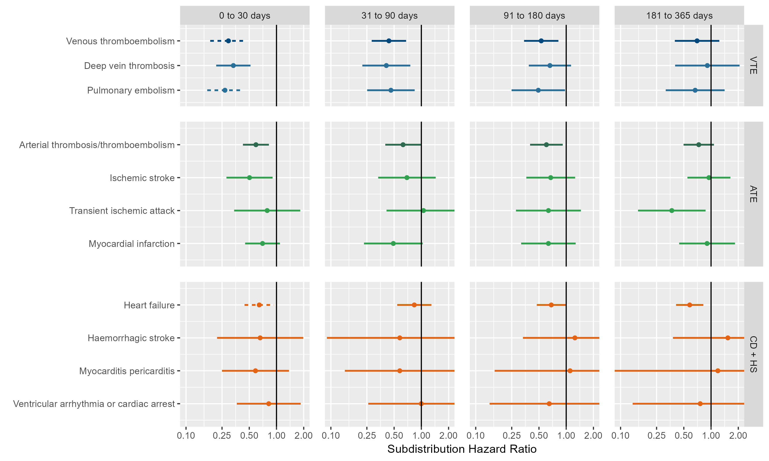 VTE = Venous thromboembolism, ATE = Arterial thrombosis/thromboembolism, CD + HS = Cardiac diseases and Hemorrhagic stroke

## **Figure S7: Forest plots for vaccine effect (any COVID-19 vaccine),** meta-analysis across cohorts and databases. Only first outcome after COVID-19 captured. Dashed line represents a level of hetereogeneity I2 > 0.4.

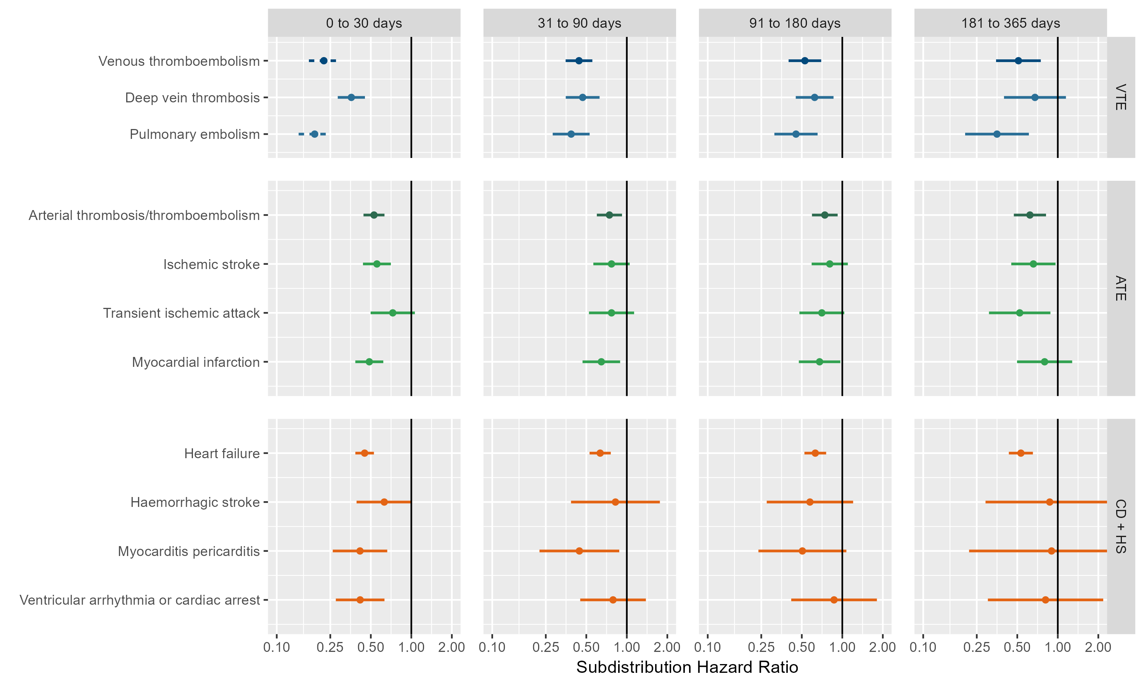 VTE = Venous thromboembolism, ATE = Arterial thrombosis/thromboembolism, CD + HS = Cardiac diseases and Hemorrhagic stroke

## **Figure S8: Forest plots for vaccine effect (ChAdOx1 vaccine),** meta-analysis across cohorts and databases. Dashed line represents a level of hetereogeneity I2 > 0.4.

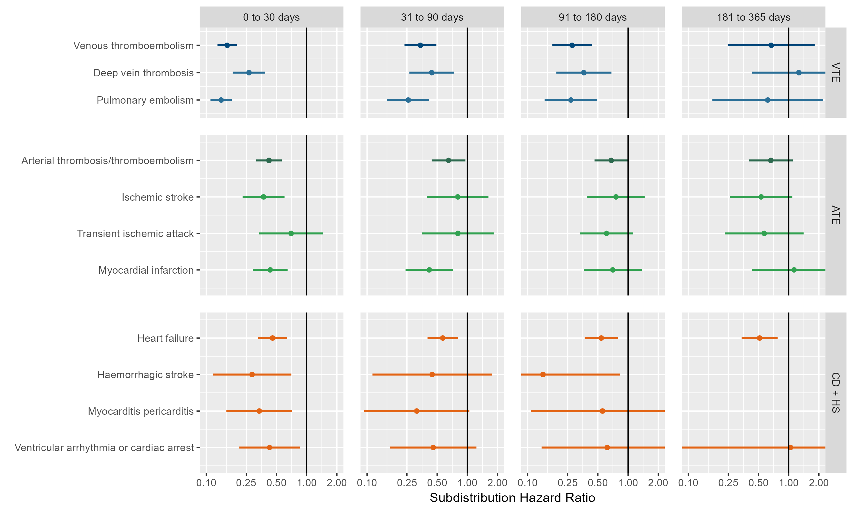 VTE = Venous thromboembolism, ATE = Arterial thrombosis/thromboembolism, CD + HS = Cardiac diseases and Hemorrhagic stroke

## **Figure S9: Forest plots for vaccine effect (ChAdOx1 vaccine),** meta-analysis across cohorts and databases. Follow-up ends at first vaccine dose after index date. Dashed line represents a level of hetereogeneity I2 > 0.4.

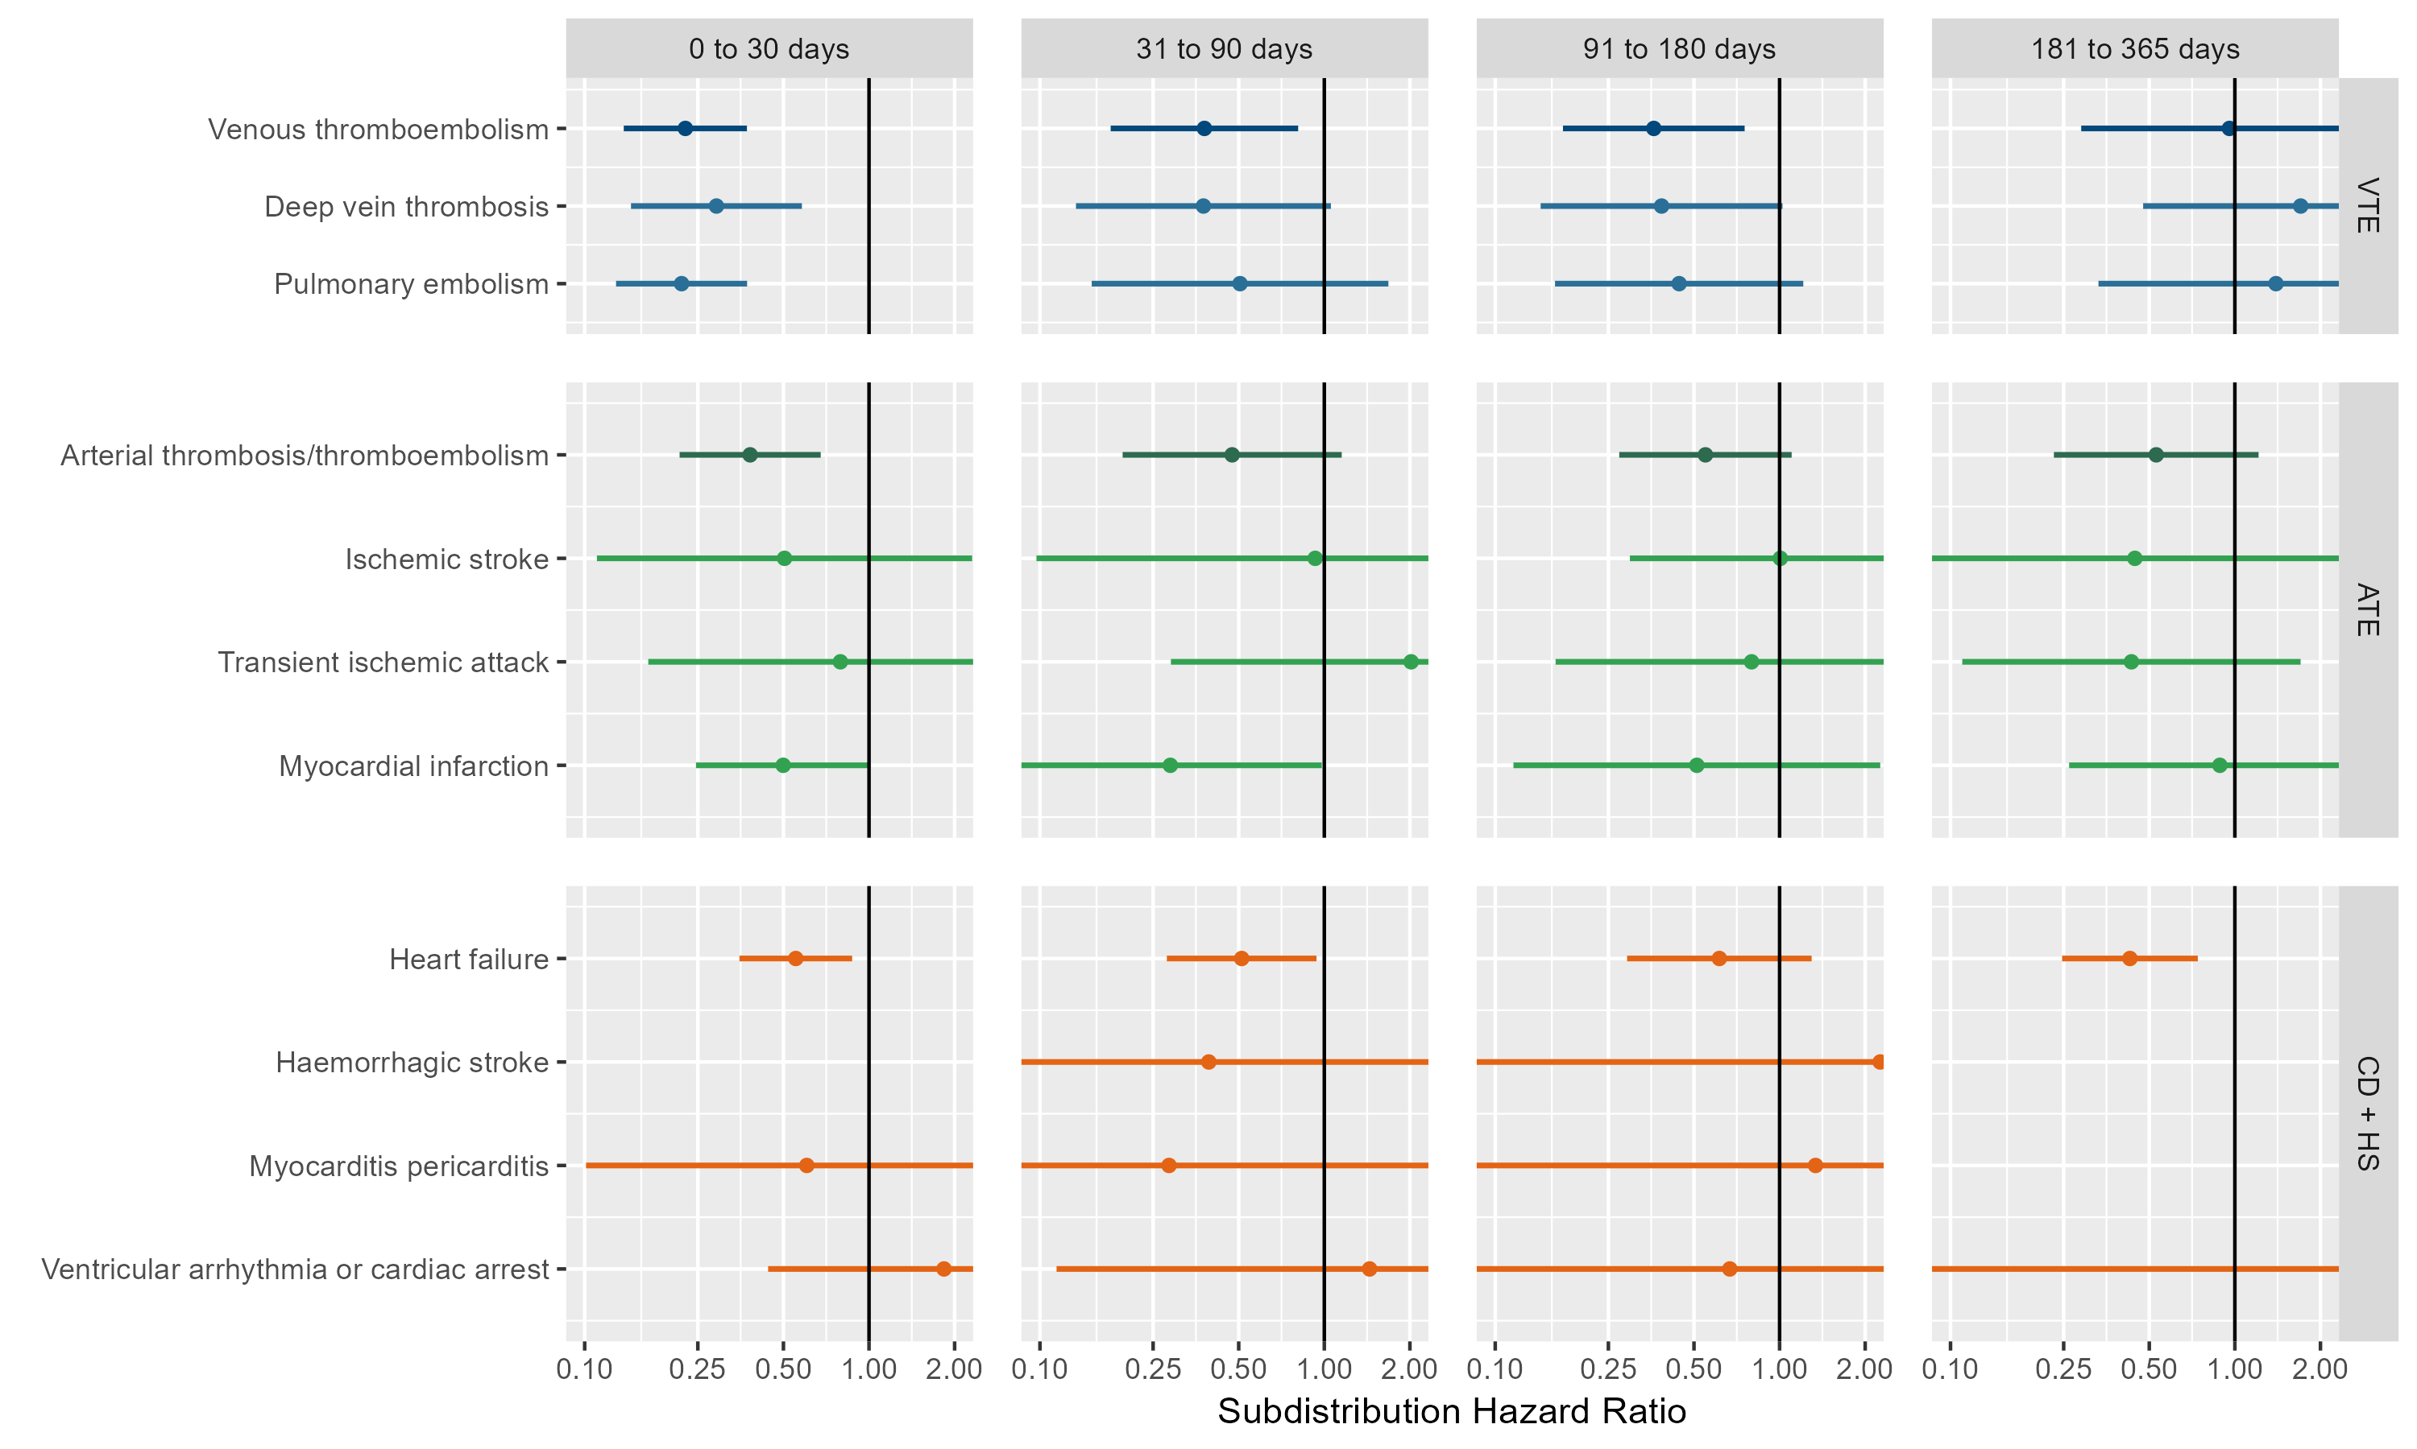 VTE = Venous thromboembolism, ATE = Arterial thrombosis/thromboembolism, CD + HS = Cardiac diseases and Hemorrhagic stroke

## **Figure S10: Forest plots for vaccine effect (ChAdOx1 vaccine),** meta-analysis across cohorts and databases. Only first outcome after COVID-19 captured. Dashed line represents a level of hetereogeneity I2 > 0.4.

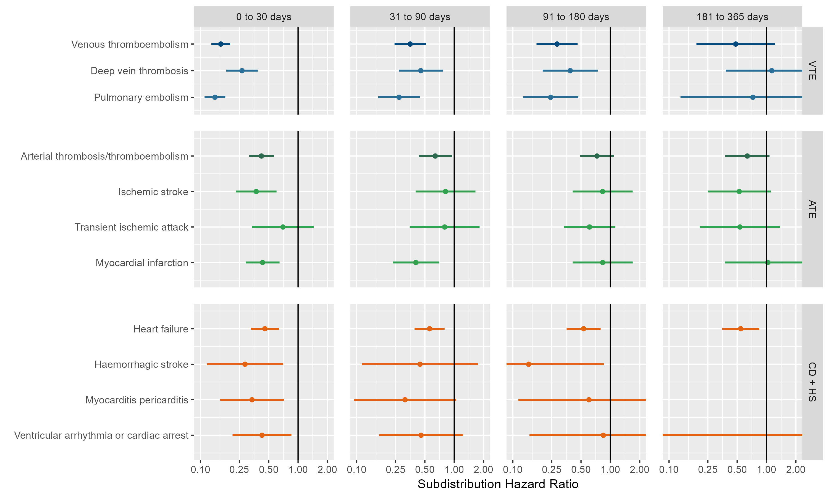 VTE = Venous thromboembolism, ATE = Arterial thrombosis/thromboembolism, CD + HS = Cardiac diseases and Hemorrhagic stroke

## **Figure S11: Forest plots for vaccine effect (BNT162b2 vaccine),** meta-analysis across cohorts and databases. Dashed line represents a level of hetereogeneity I2 > 0.4.

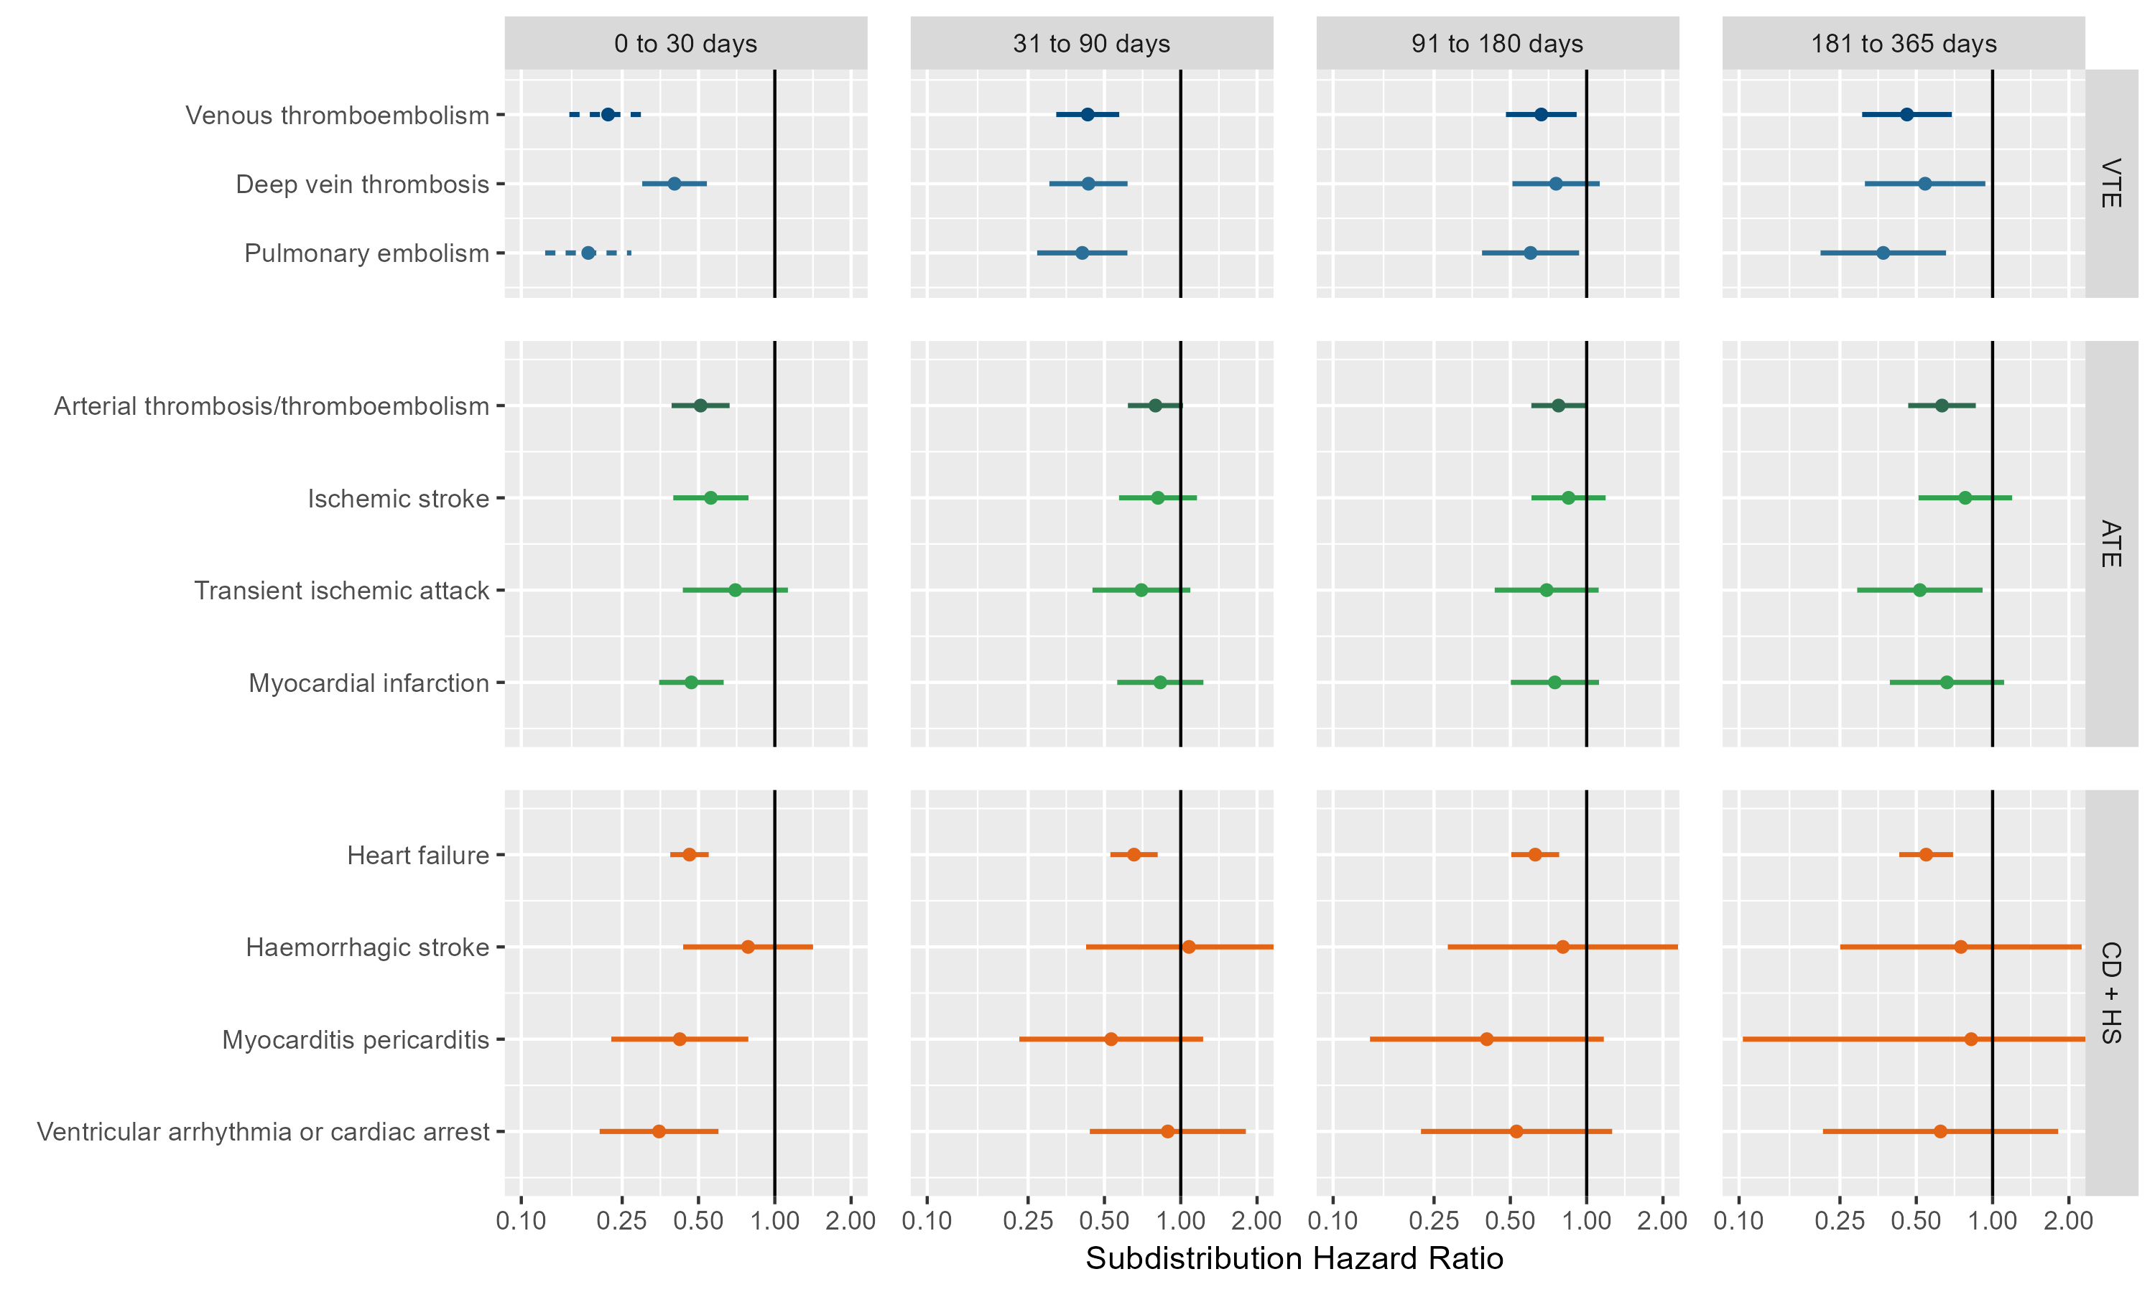 VTE = Venous thromboembolism, ATE = Arterial thrombosis/thromboembolism, CD + HS = Cardiac diseases and Hemorrhagic stroke

## **Figure S12: Forest plots for vaccine effect (BNT162b2 vaccine),** meta-analysis across cohorts and databases. Follow-up ends at first vaccine dose after index date. Dashed line represents a level of hetereogeneity I2 > 0.4.

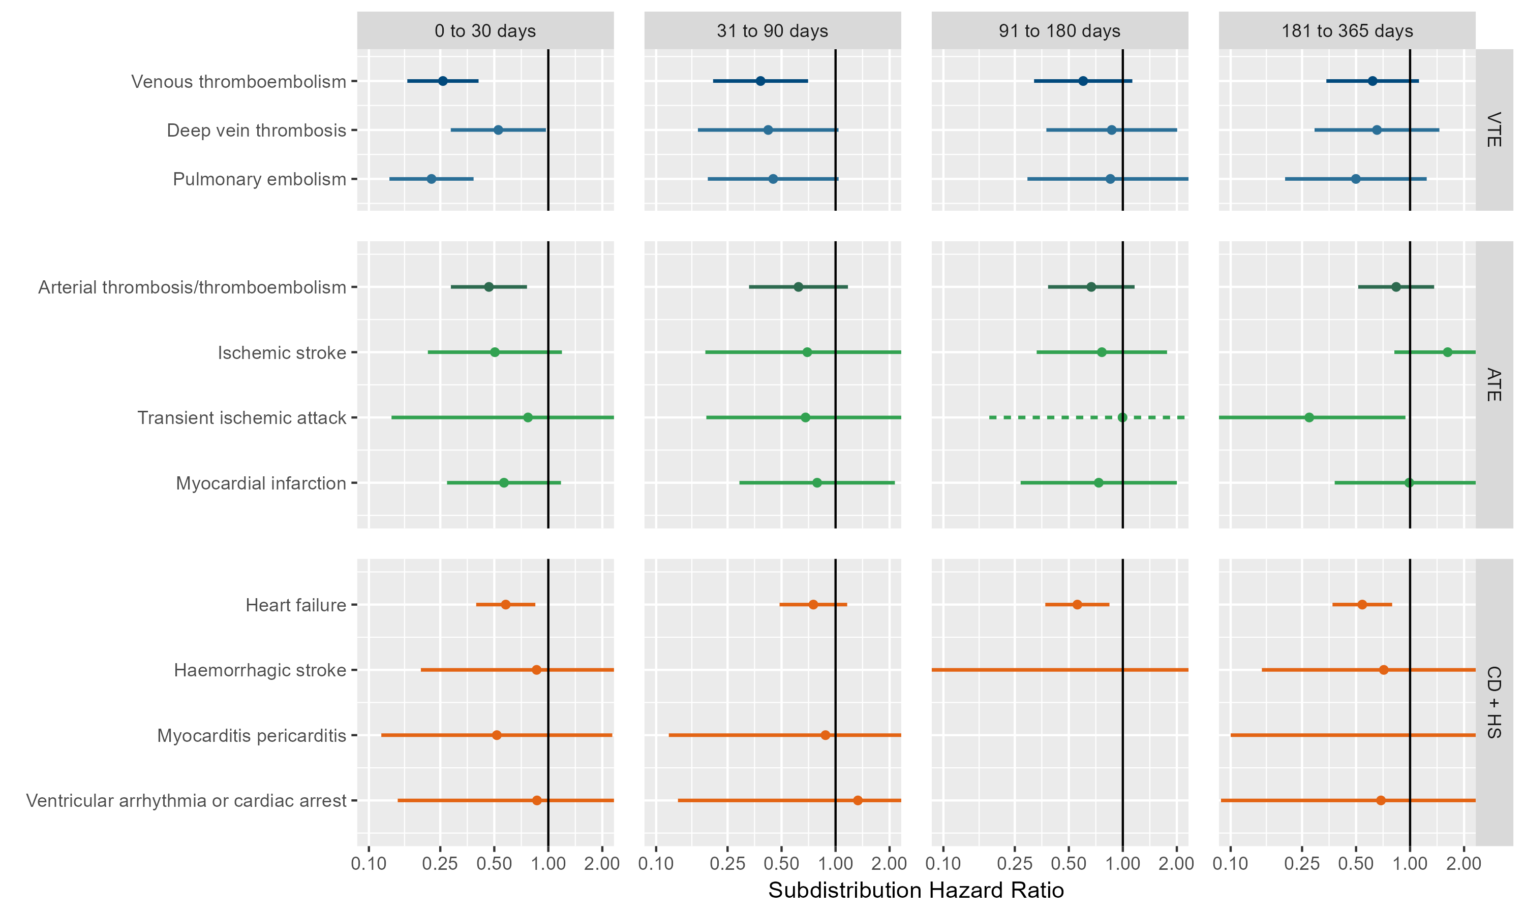 VTE = Venous thromboembolism, ATE = Arterial thrombosis/thromboembolism, CD + HS = Cardiac diseases and Hemorrhagic stroke

## **Figure S13: Forest plots for vaccine effect (BNT162b2 vaccine),** meta-analysis across cohorts and databases. Only first outcome after COVID-19 captured. Dashed line represents a level of hetereogeneity I2 > 0.4.

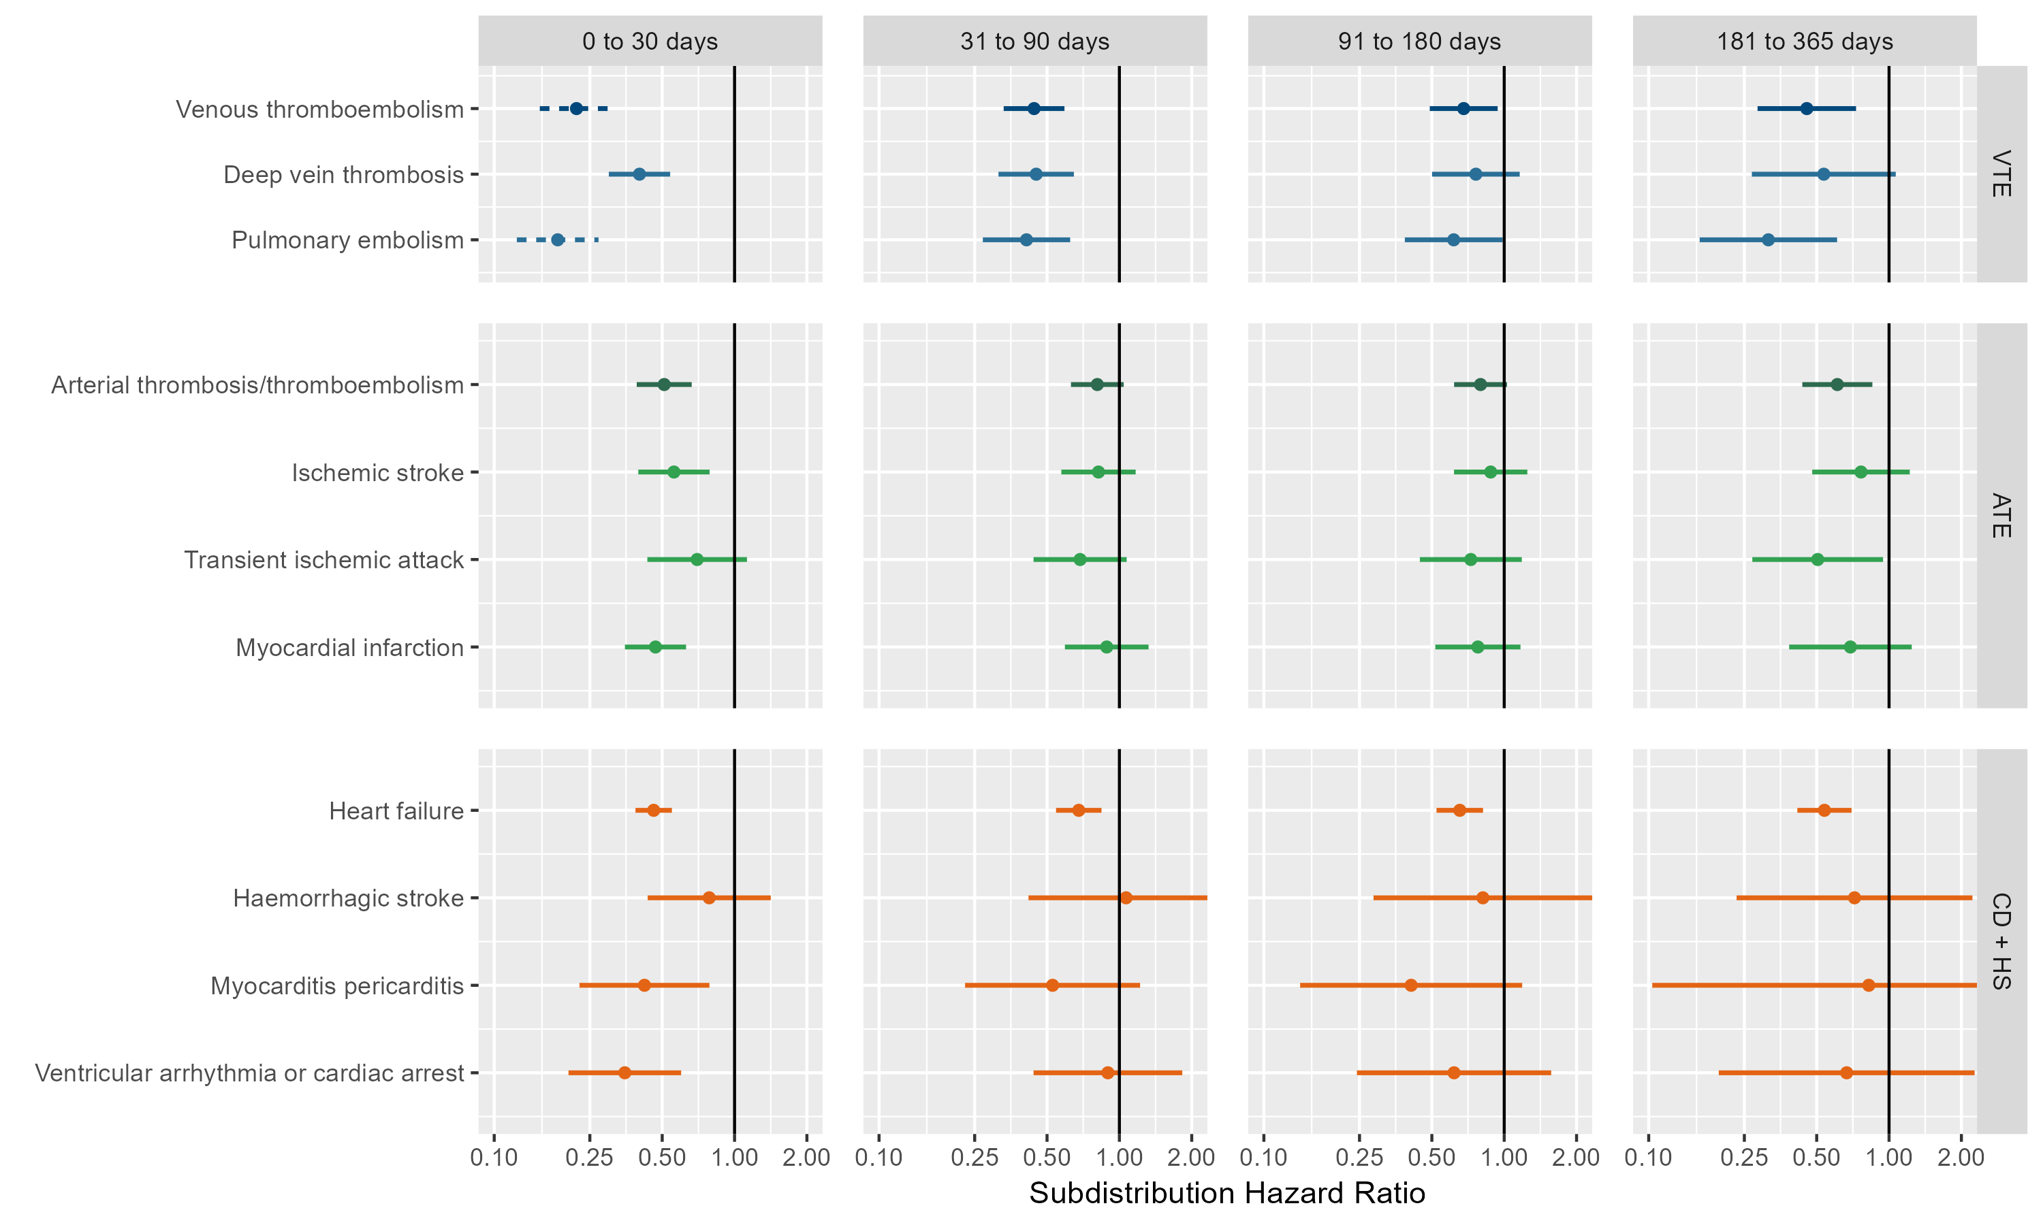 VTE = Venous thromboembolism, ATE = Arterial thrombosis/thromboembolism, CD + HS = Cardiac diseases and Hemorrhagic stroke

## **Figure S14: Forest plots for vaccine effect (any COVID-19 vaccine) on preventing venous thromboembolism complications,** for each cohort and database (meta-analysis estimates across cohorts in the last panel). Dashed line represents a level of hetereogeneity I2 > 0.4.

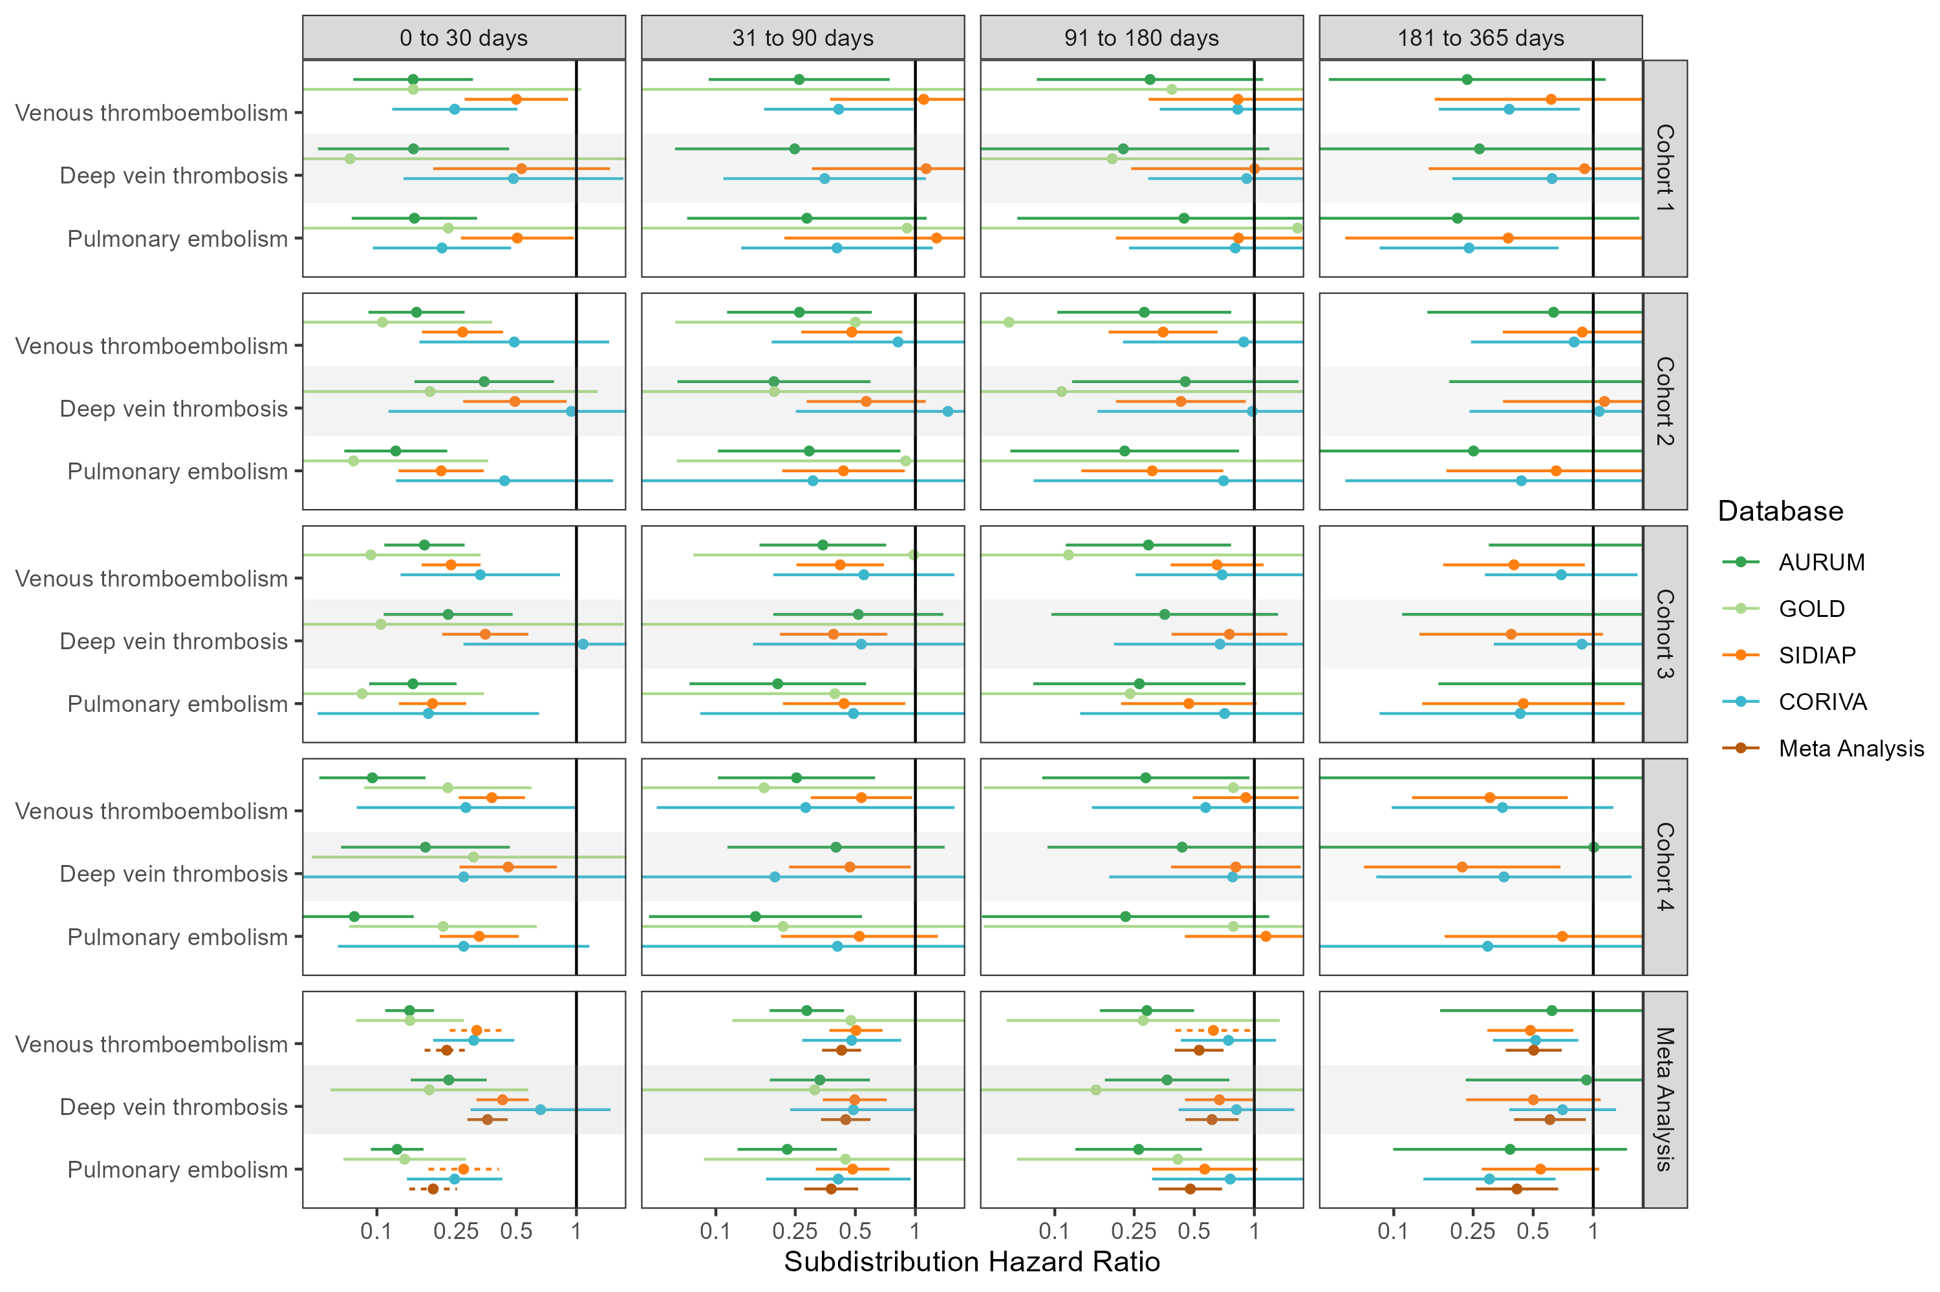

## **Figure S15: Forest plots for vaccine effect (any COVID-19 vaccine) on preventing venous thromboembolism complications,** for each cohort and database (meta-analysis estimates across cohorts in the last panel).Follow-up ends at first vaccine dose after index date. Dashed line represents a level of hetereogeneity I2 > 0.4.

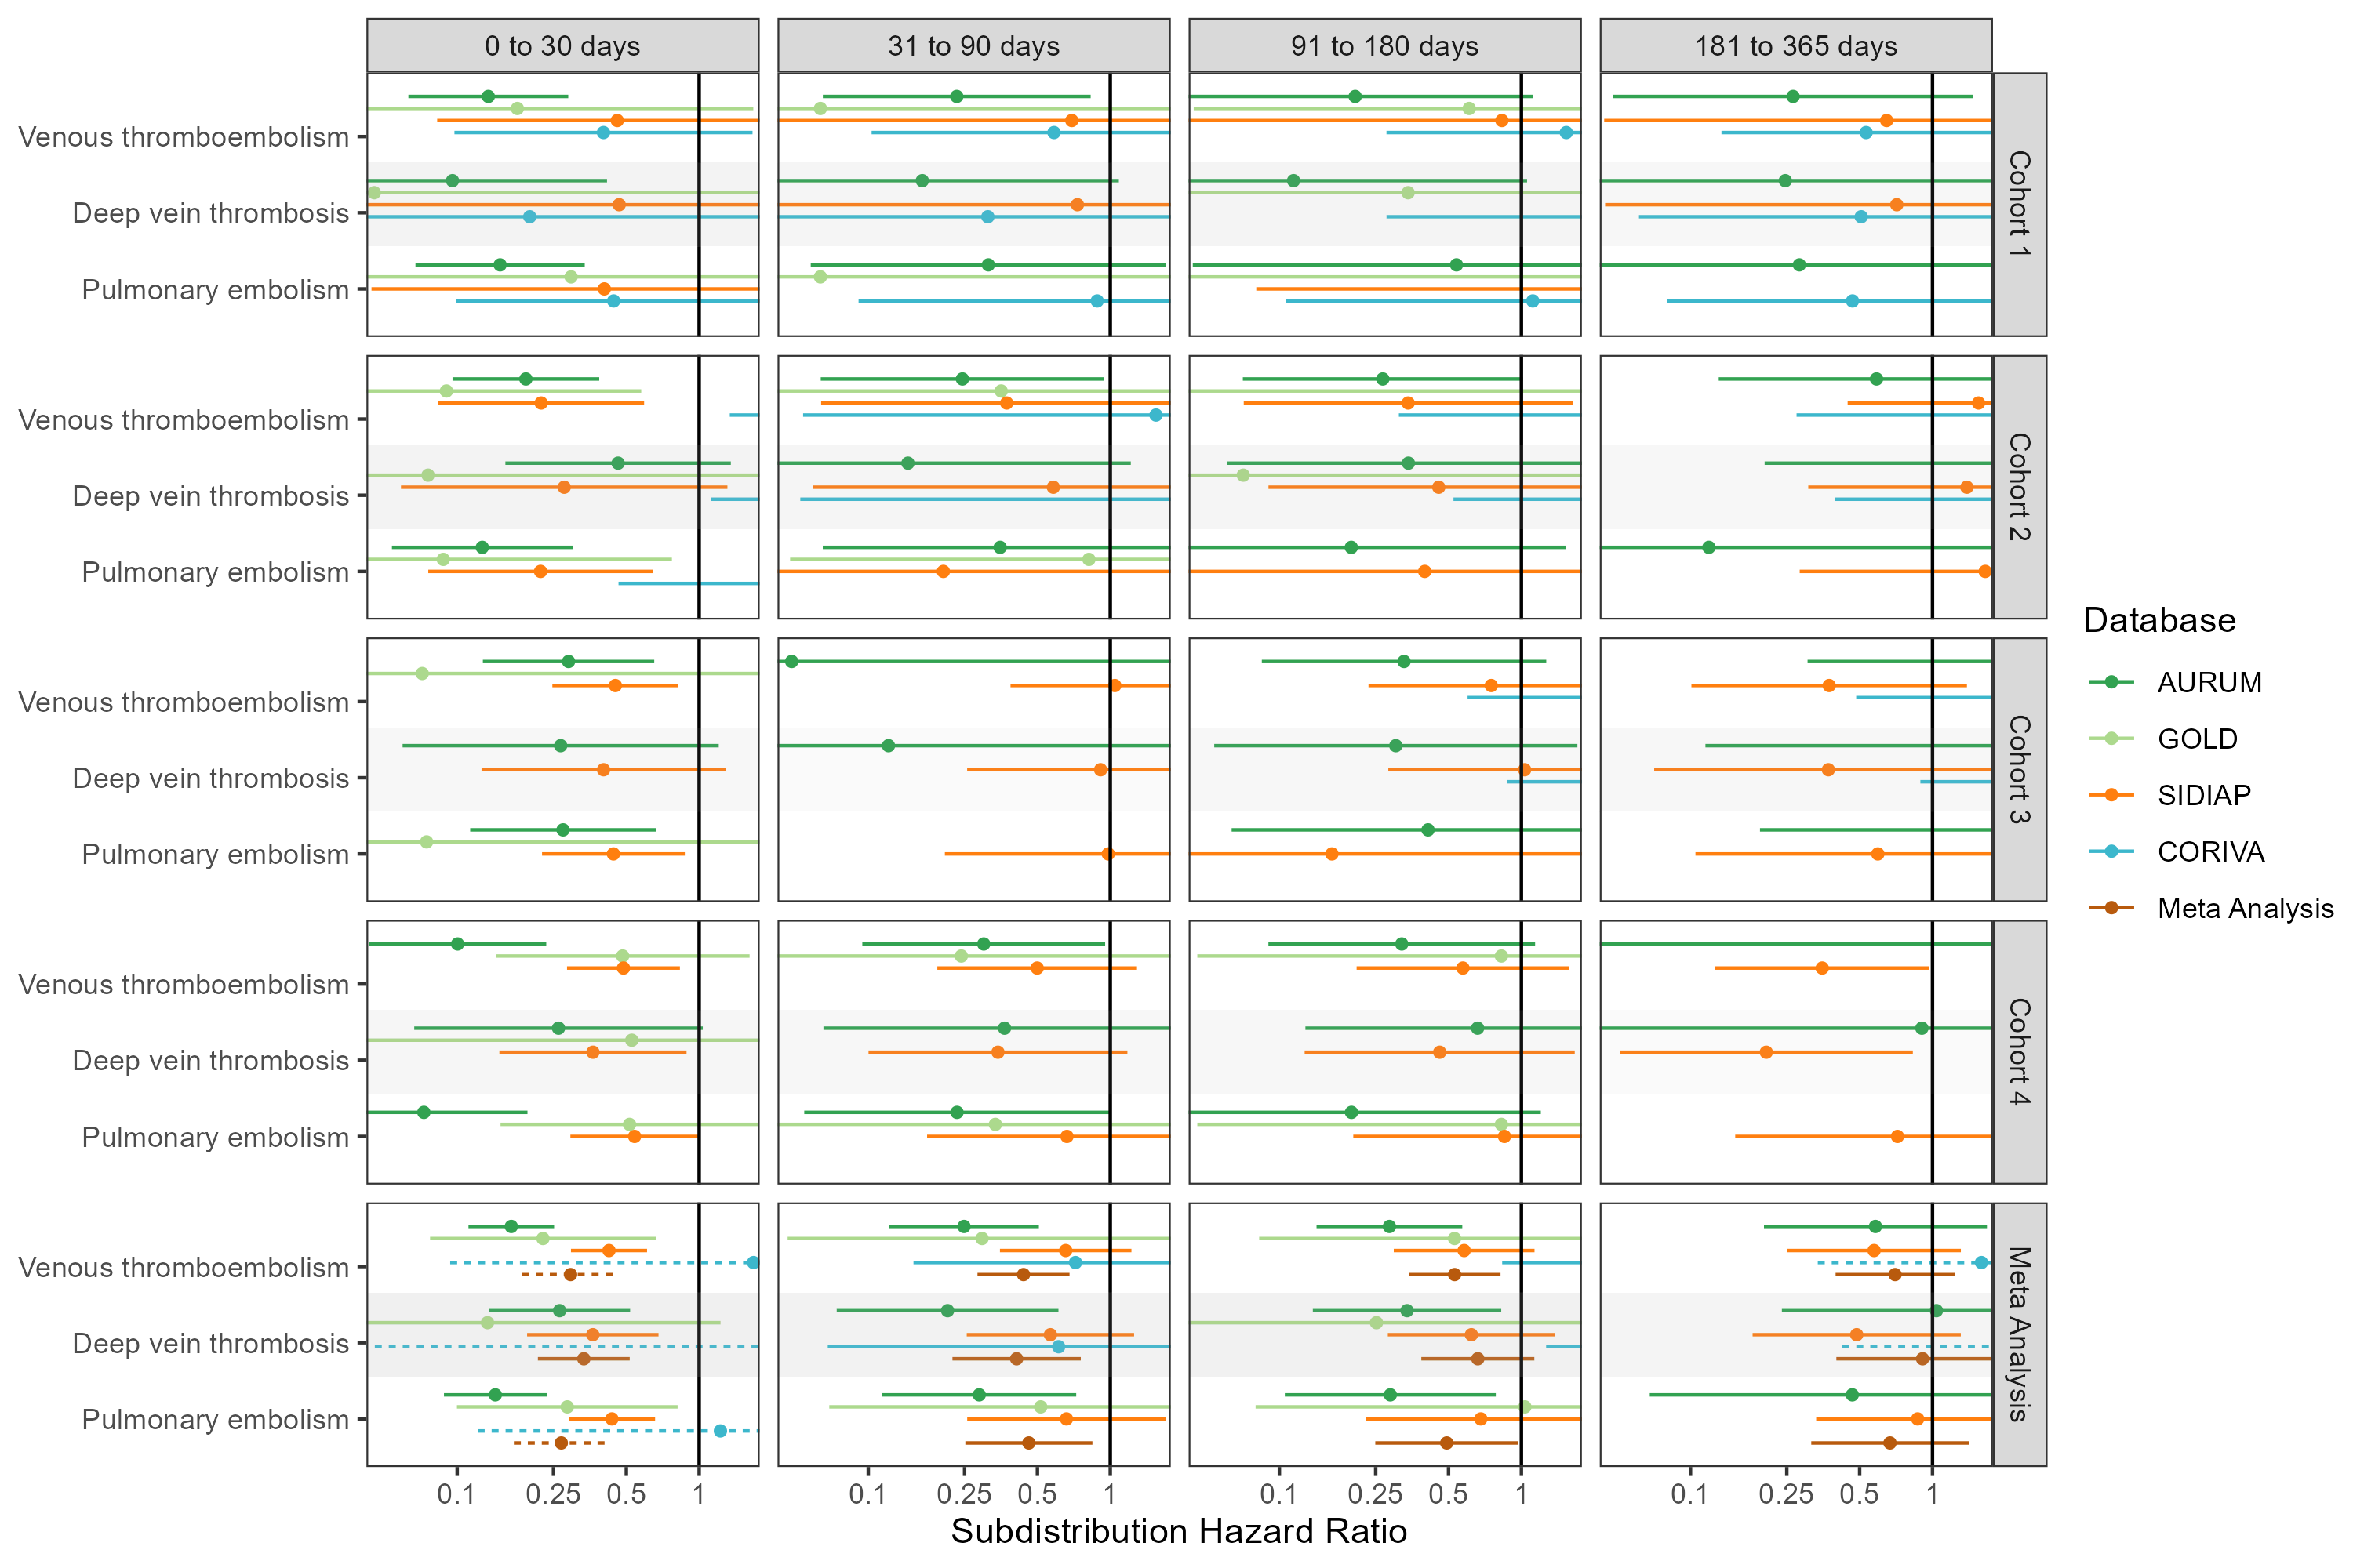

## **Figure S16: Forest plots for vaccine effect (any COVID-19 vaccine) on preventing venous thromboembolism complications,** for each cohort and database (meta-analysis estimates across cohorts in the last panel).Only first outcome after COVID-19 captured. Dashed line represents a level of hetereogeneity I2 > 0.4.

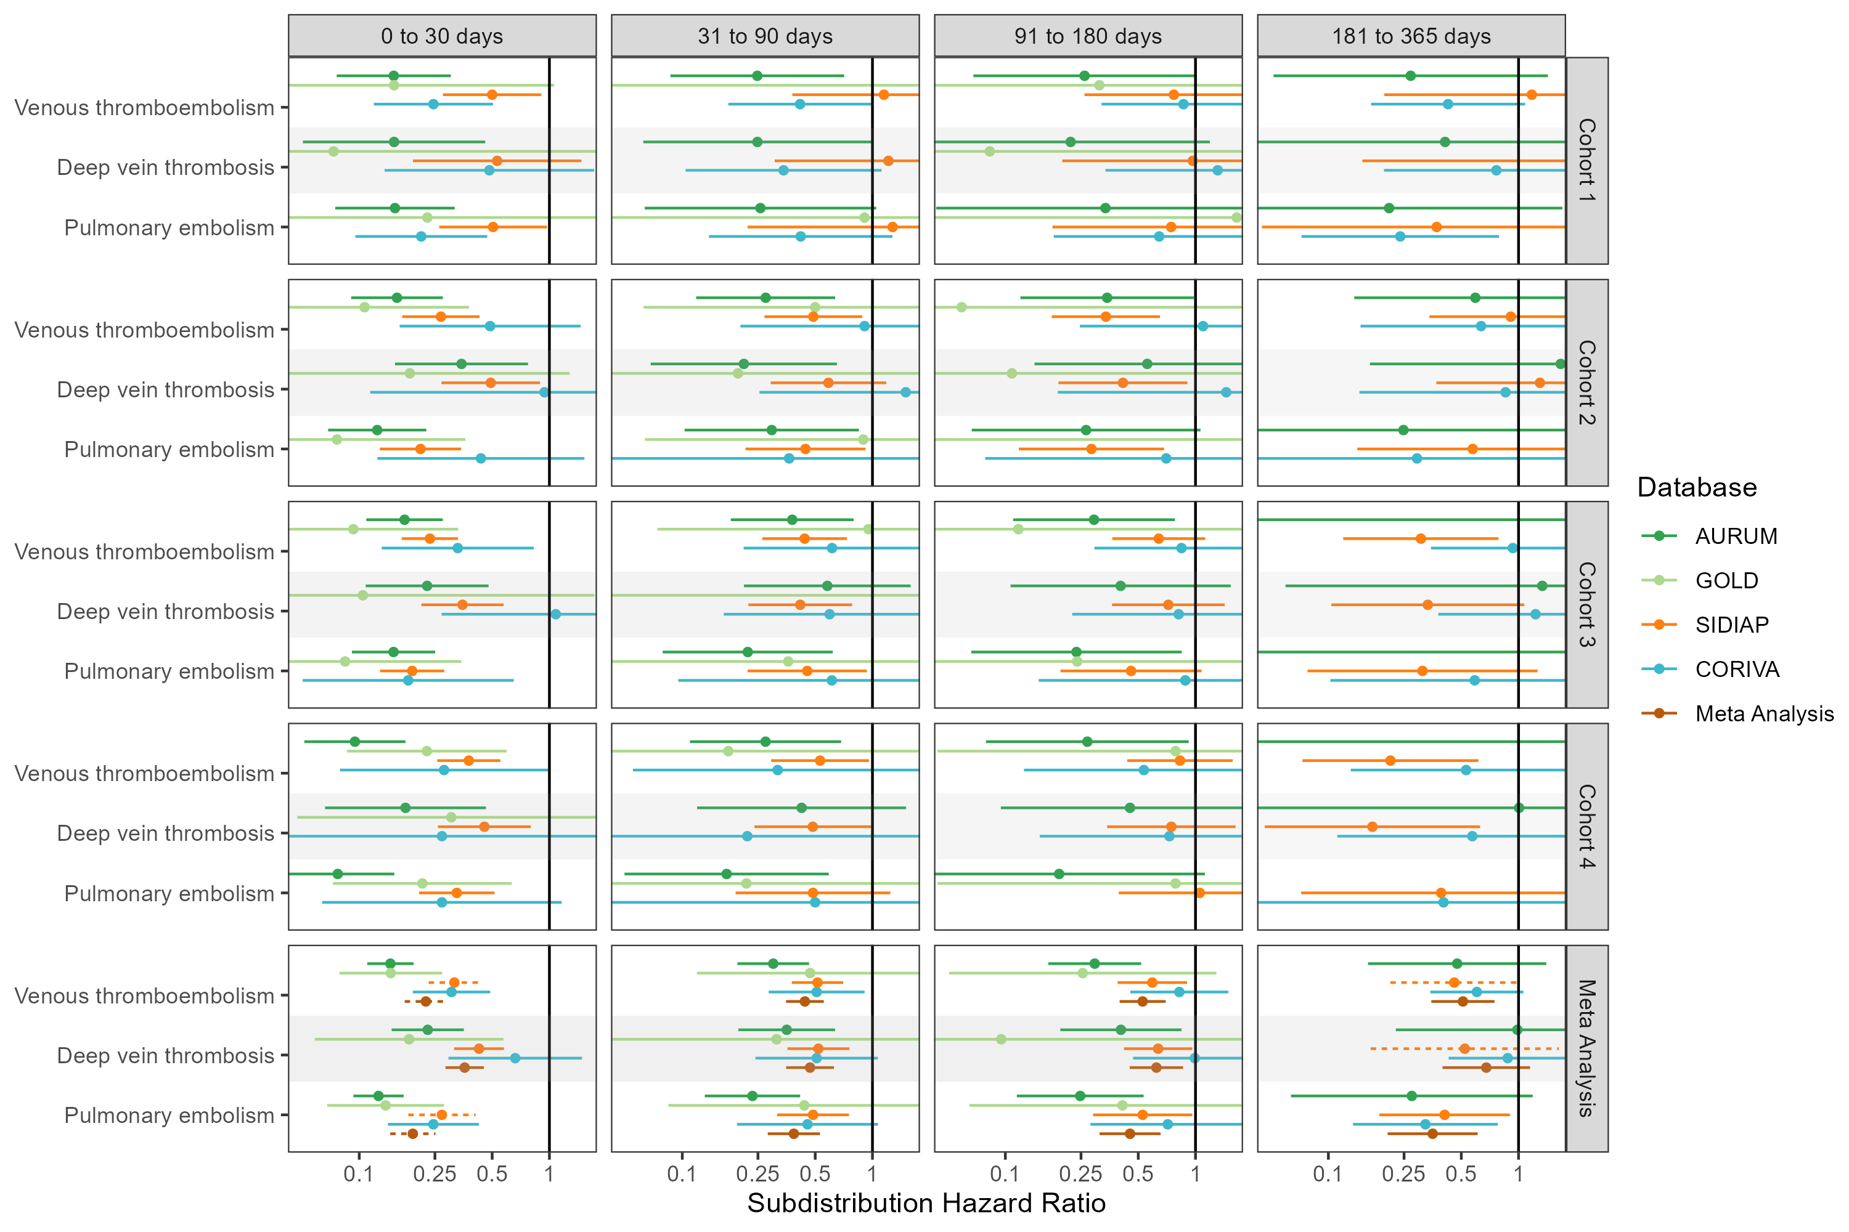

## **Figure S17: Forest plots for vaccine effect (ChAdOx1 vaccine) on preventing venous thromboembolism complications,** for each cohort and database (meta-analysis estimates across cohorts in the last panel). Dashed line represents a level of hetereogeneity I2 > 0.4.

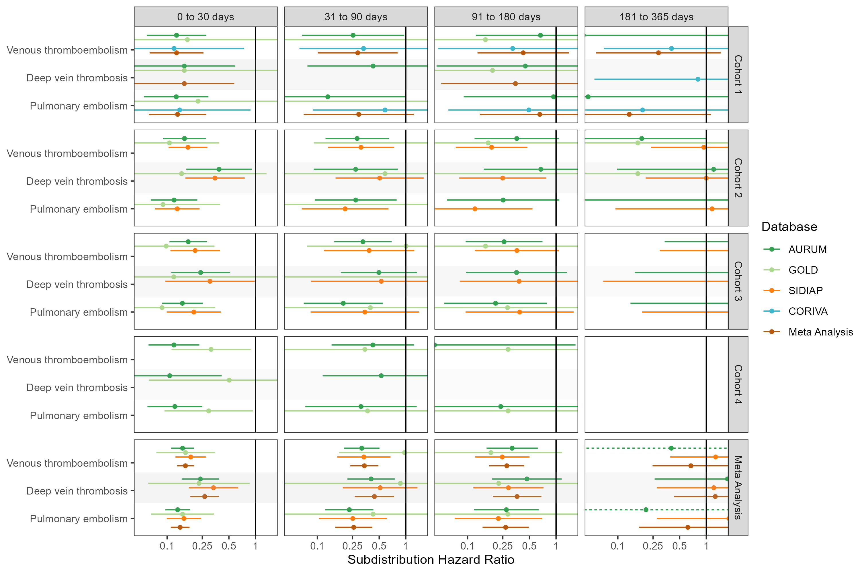

## **Figure S18: Forest plots for vaccine effect (ChAdOx1 vaccine) on preventing venous thromboembolism complications,** for each cohort and database (meta-analysis estimates across cohorts in the last panel).Follow-up ends at first vaccine dose after index date. Dashed line represents a level of hetereogeneity I2 > 0.4.

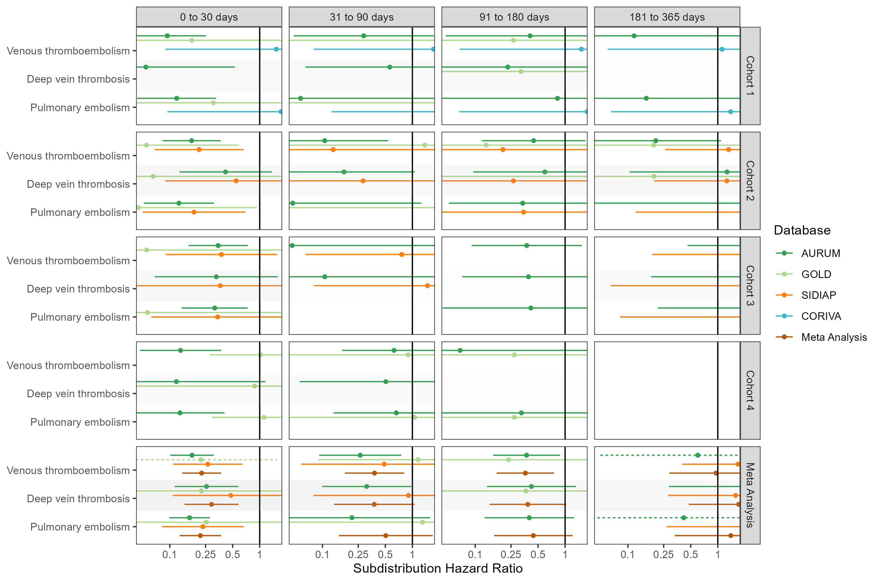

## **Figure S19: Forest plots for vaccine effect (ChAdOx1 vaccine) on preventing venous thromboembolism complications,** for each cohort and database (meta-analysis estimates across cohorts in the last panel).Only first outcome after COVID-19 captured. Dashed line represents a level of hetereogeneity I2 > 0.4.

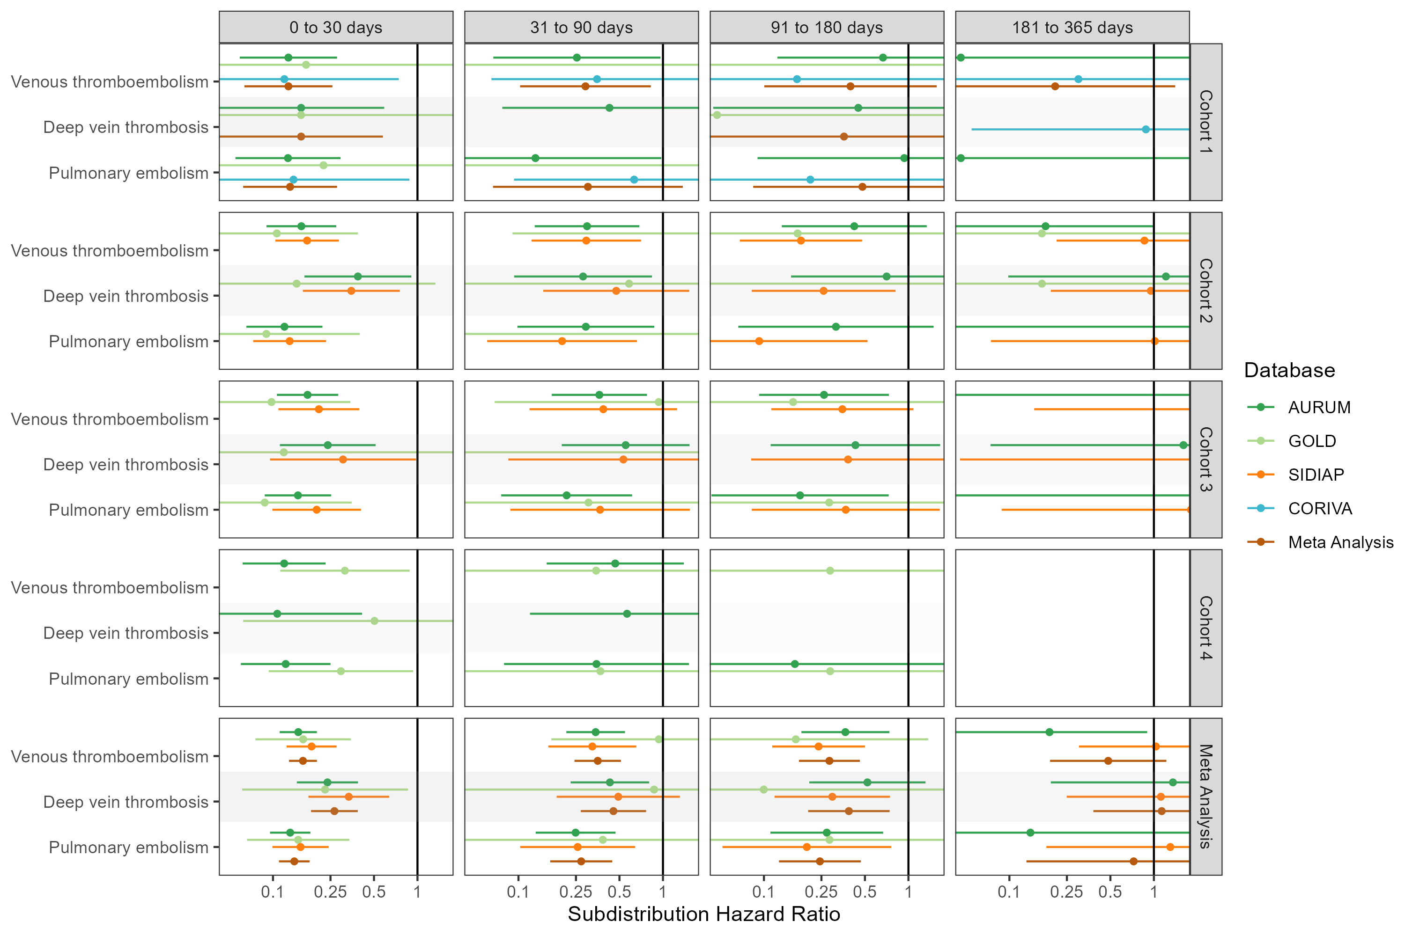

## **Figure S20: Forest plots for vaccine effect (BNT162b2 vaccine) on preventing venous thromboembolism complications,** for each cohort and database (meta-analysis estimates across cohorts in the last panel). Dashed line represents a level of hetereogeneity I2 > 0.4.

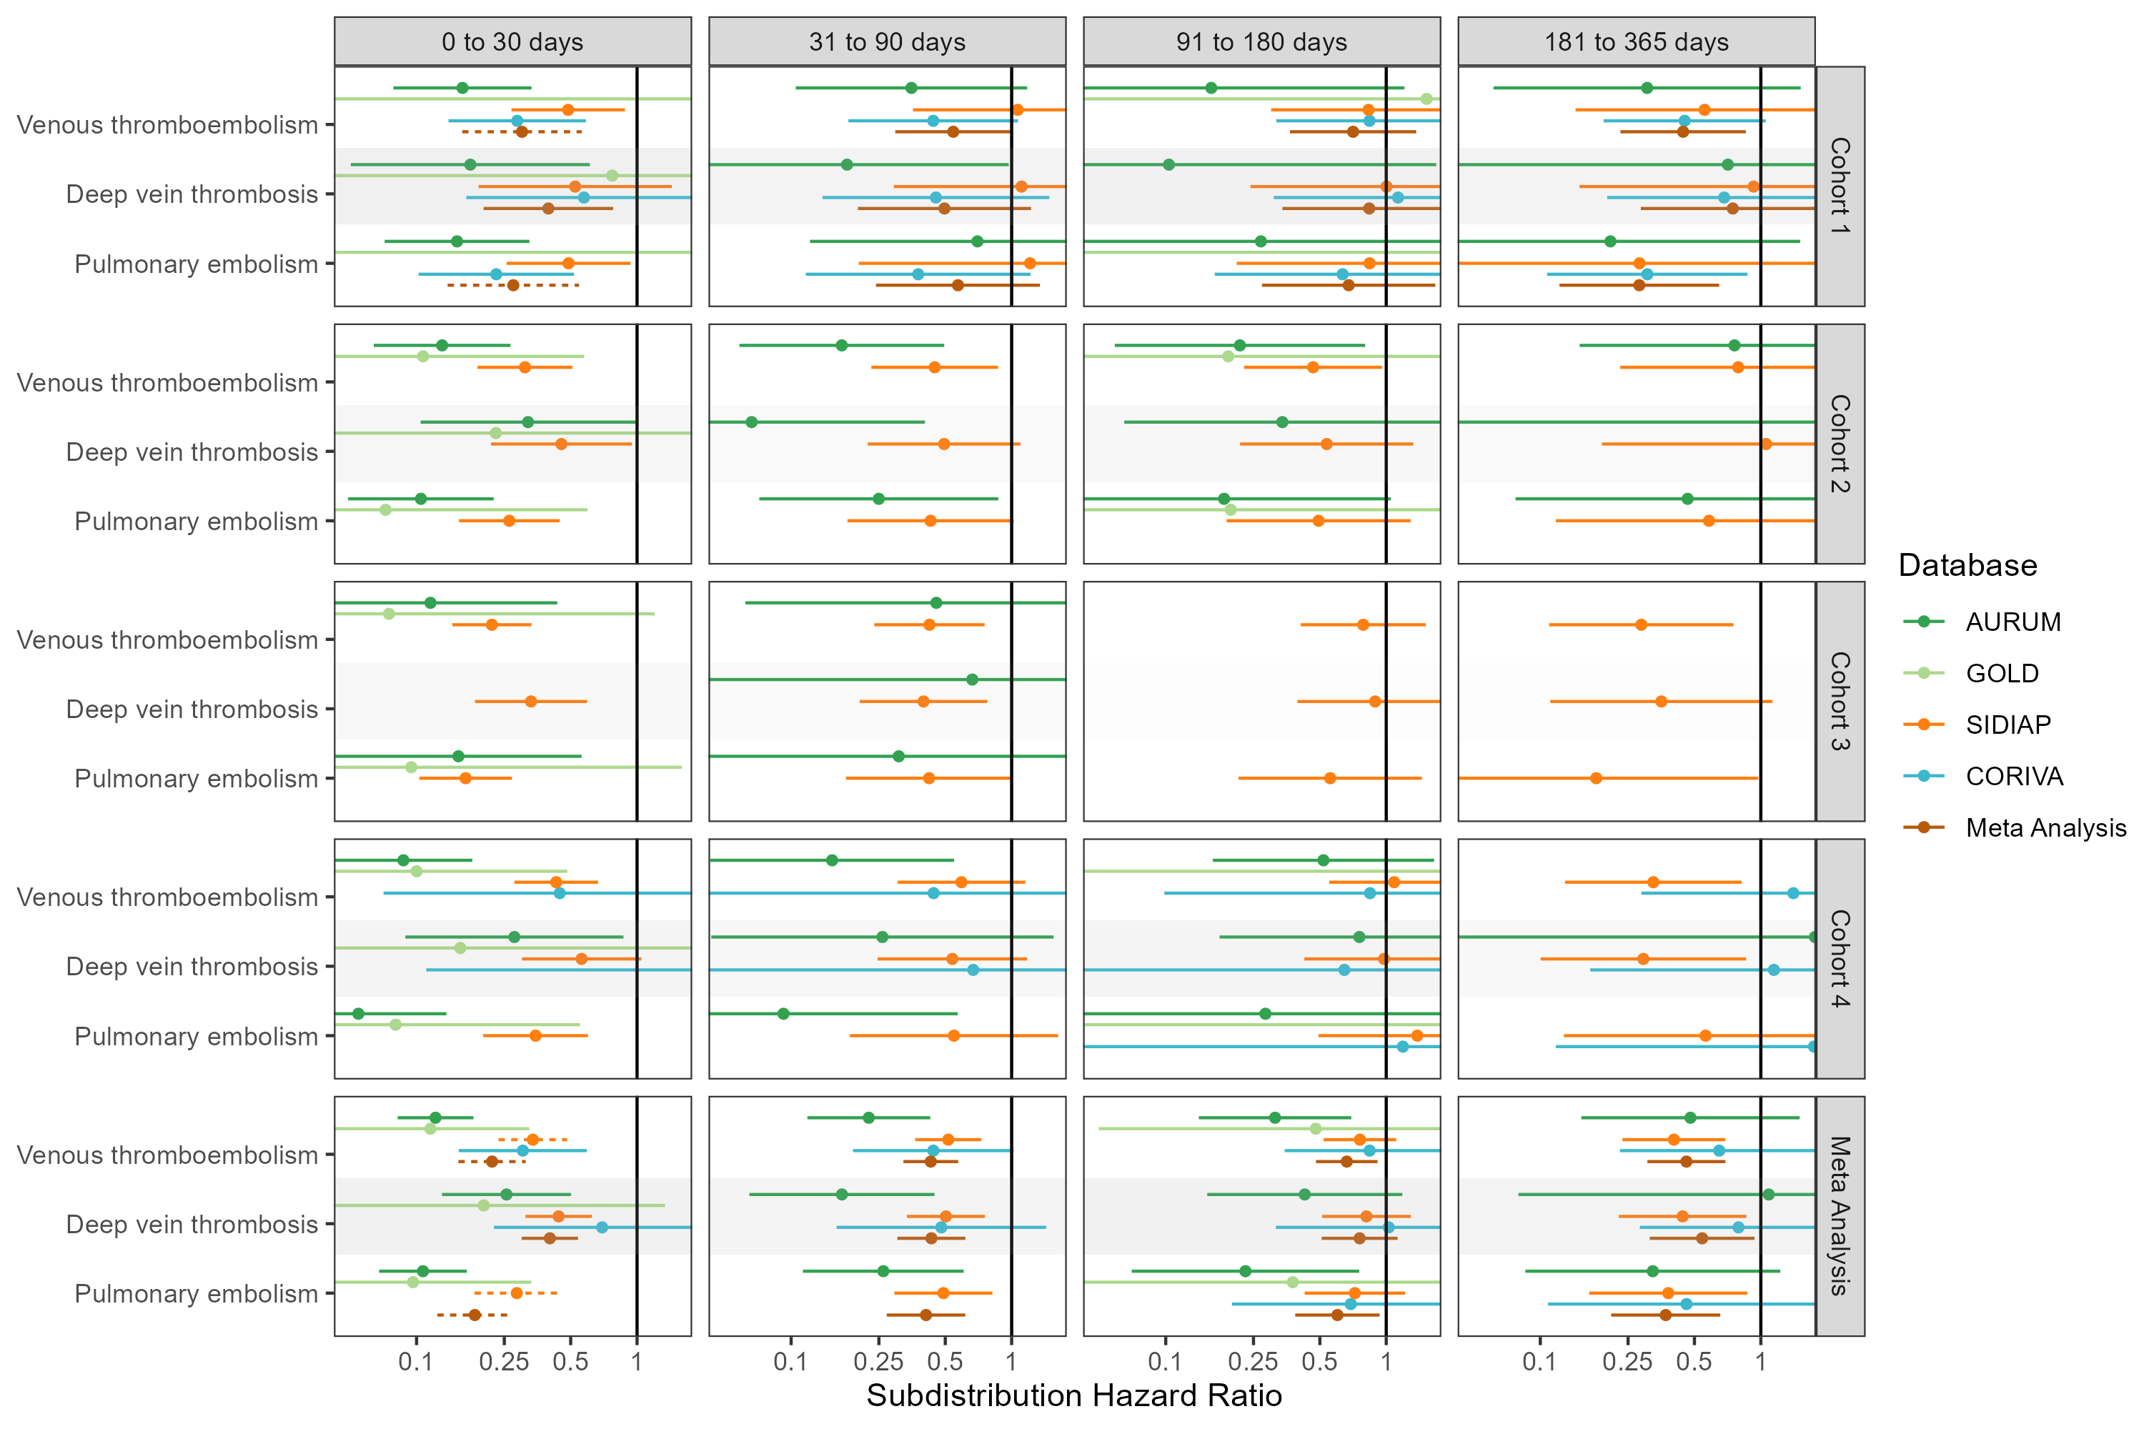

## **Figure S21: Forest plots for vaccine effect (BNT162b2 vaccine) on preventing venous thromboembolism complications,** for each cohort and database (meta-analysis estimates across cohorts in the last panel).Follow-up ends at first vaccine dose after index date. Dashed line represents a level of hetereogeneity I2 > 0.4.

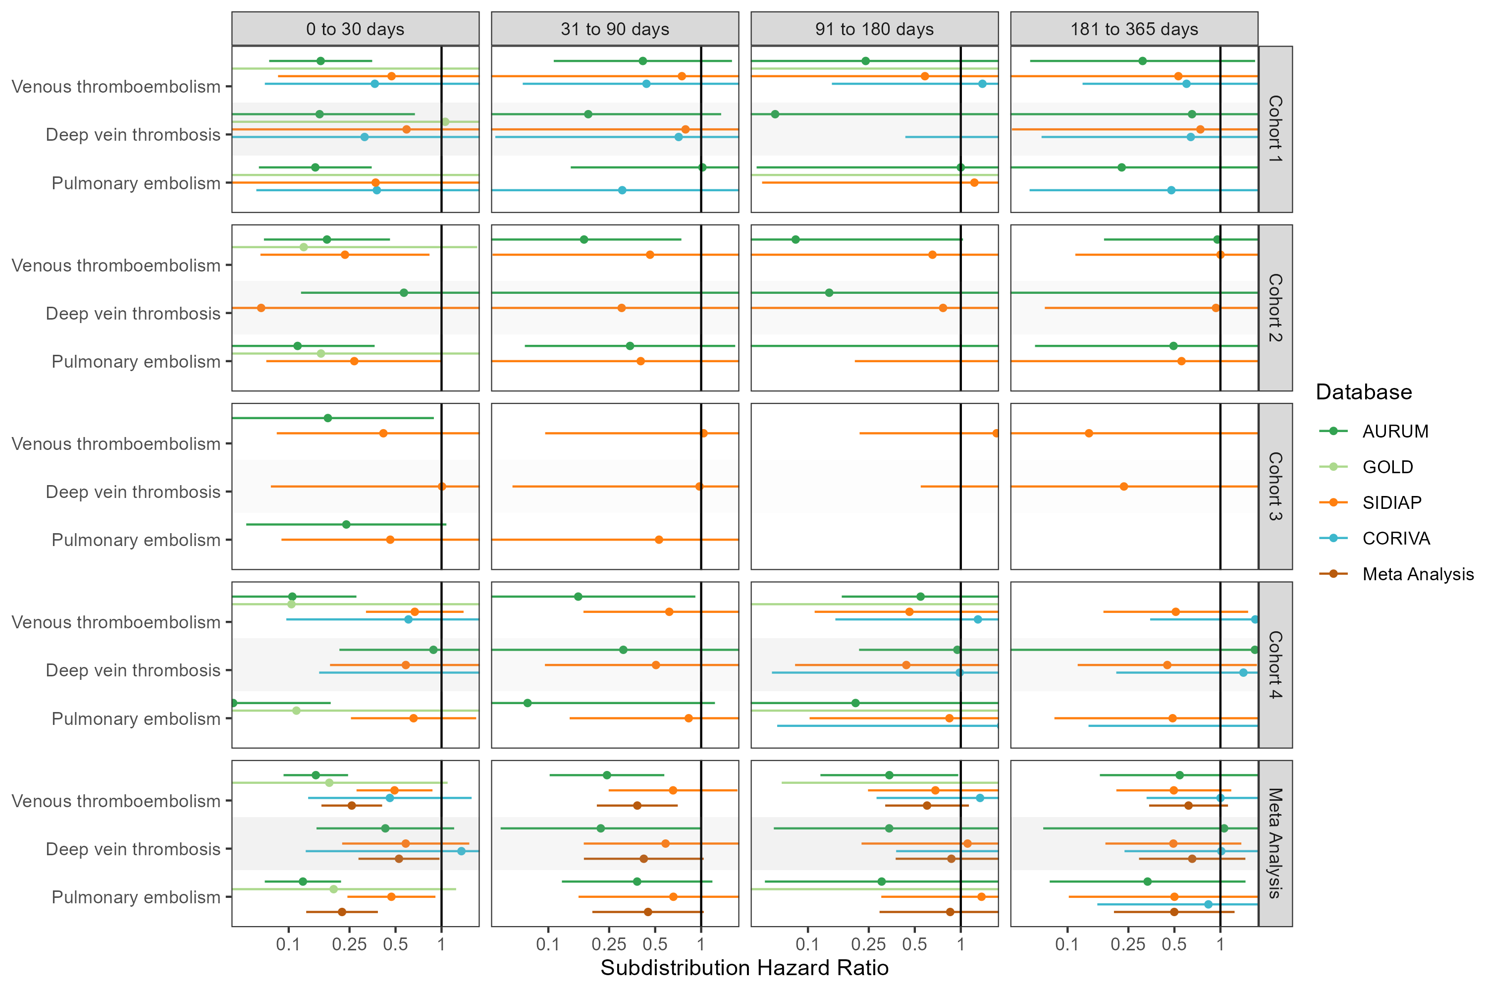

## **Figure S22: Forest plots for vaccine effect (BNT162b2 vaccine) on preventing venous thromboembolism complications,** for each cohort and database (meta-analysis estimates across cohorts in the last panel).Only first outcome after COVID-19 captured. Dashed line represents a level of hetereogeneity I2 > 0.4.

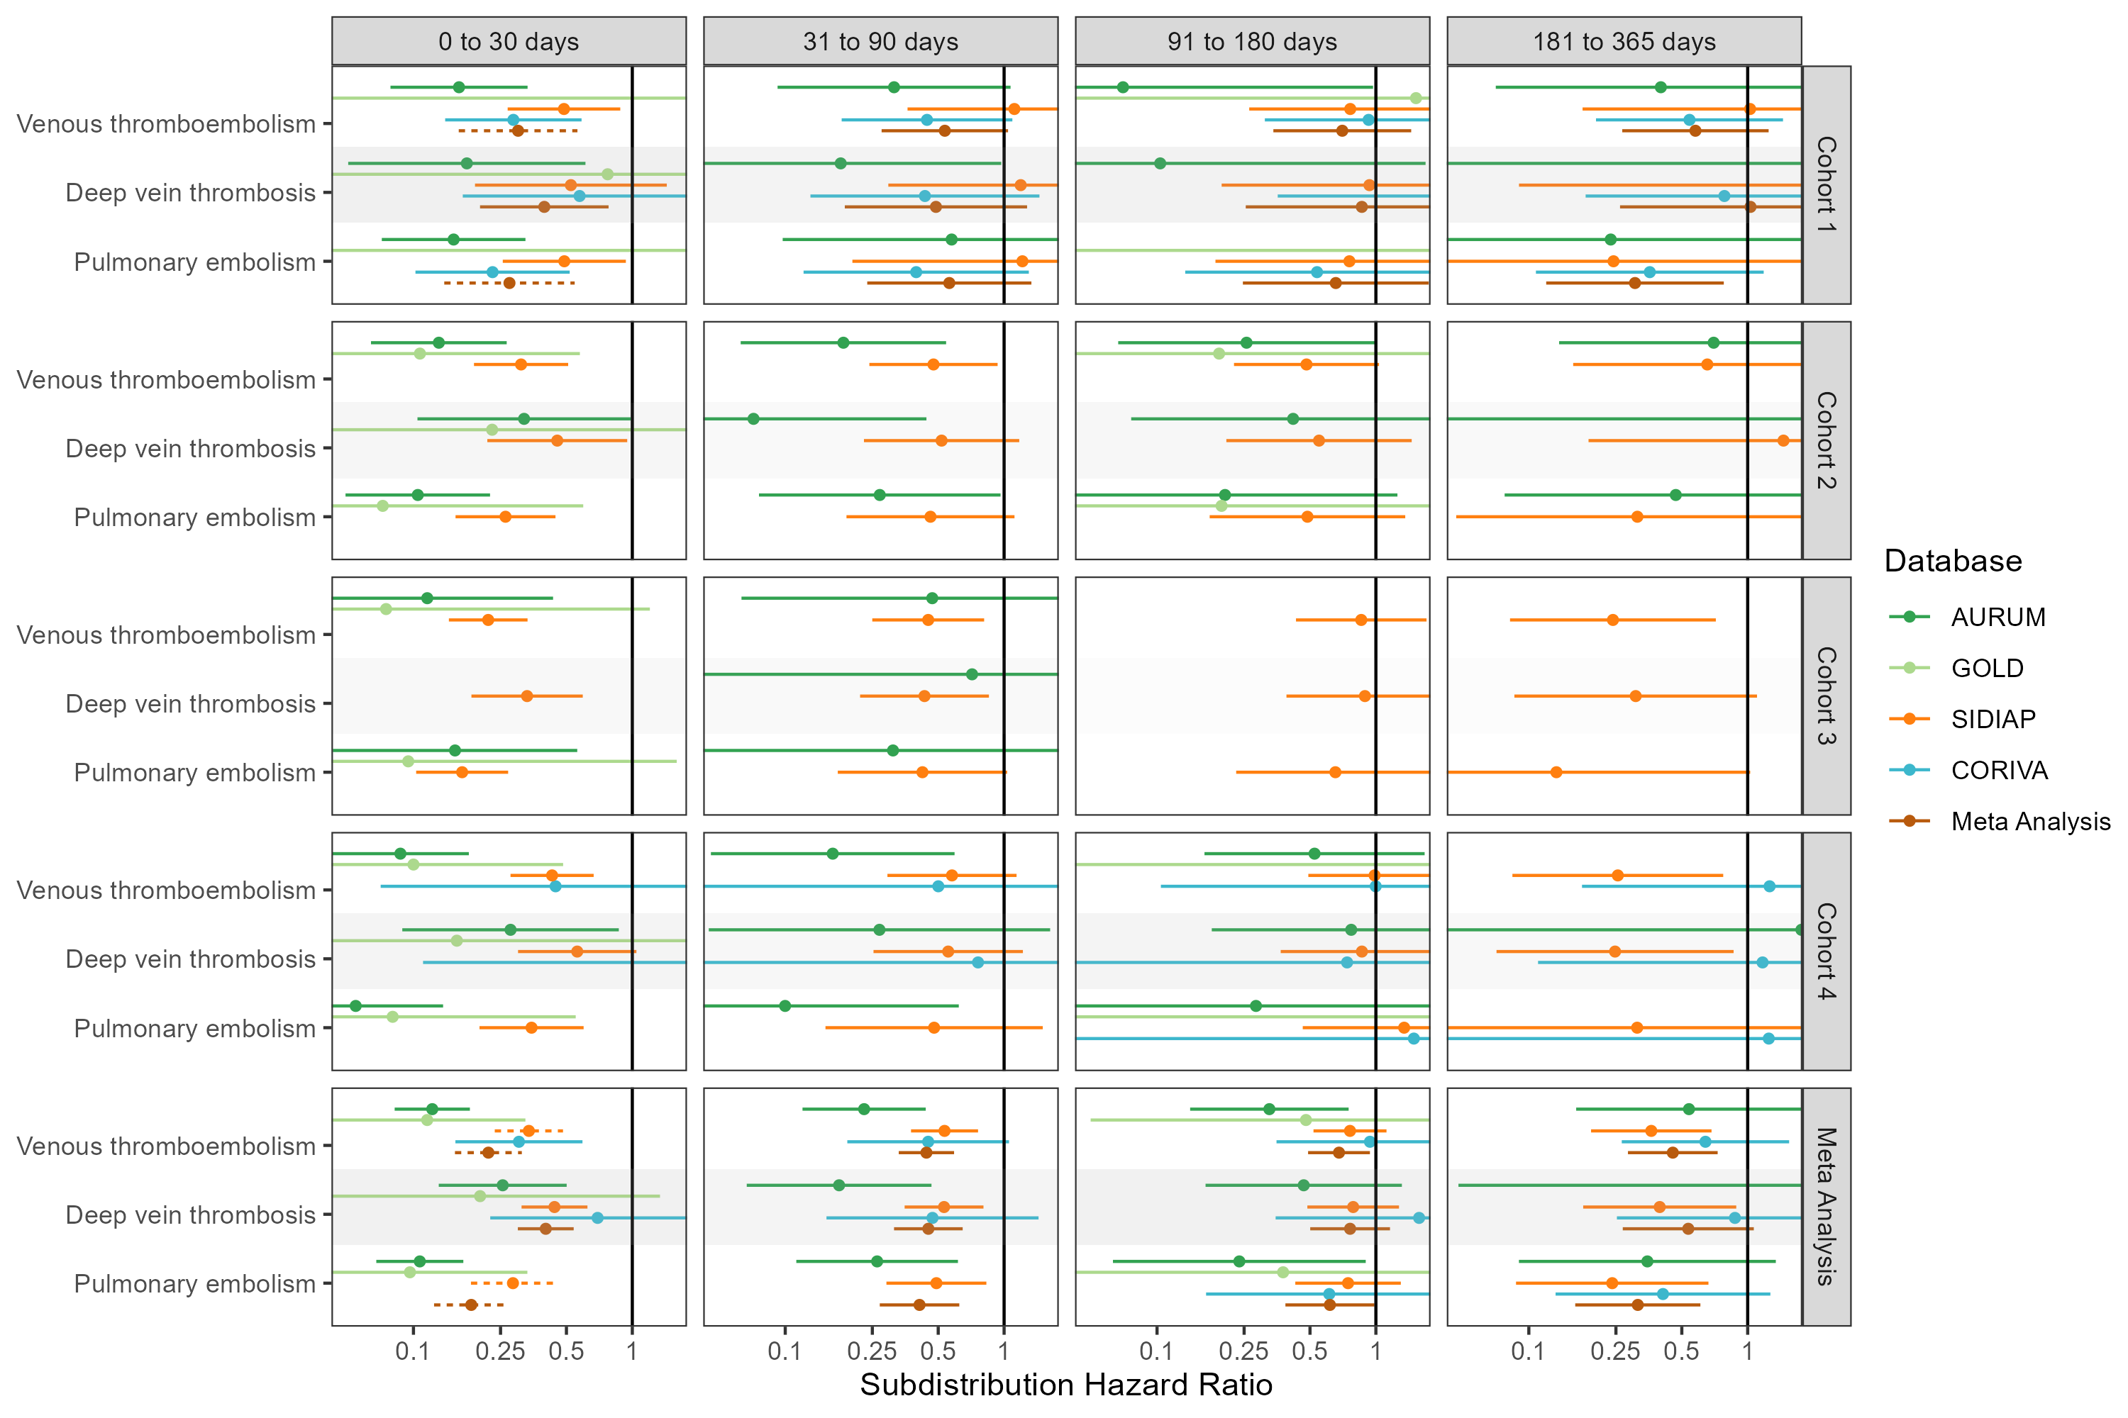

## **Figure S23: Forest plots for vaccine effect (any COVID-19 vaccine) on preventing arterial thrombosis/thromboembolism complications,** for each cohort and database (meta-analysis estimates across cohorts in the last panel). Dashed line represents a level of hetereogeneity I2 > 0.4.

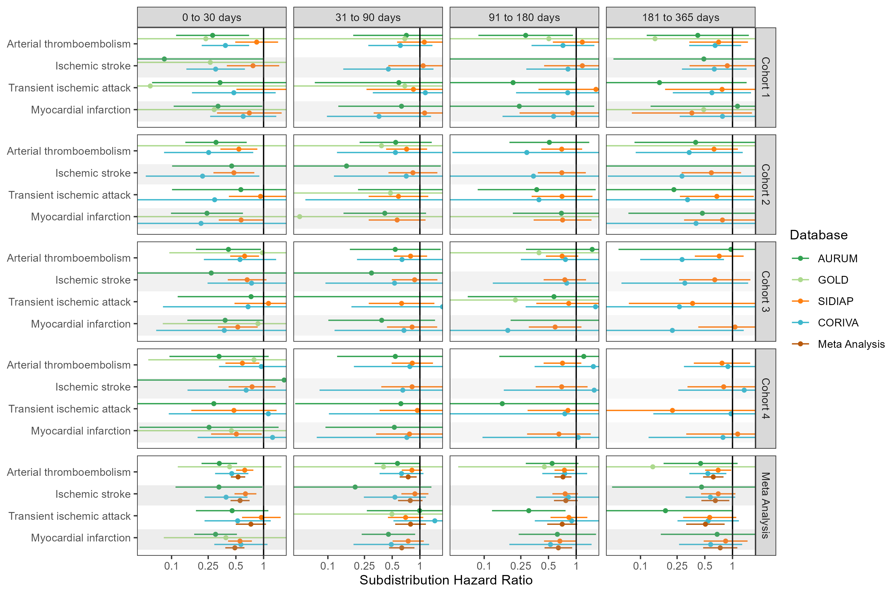

## **Figure S24: Forest plots for vaccine effect (any COVID-19 vaccine) on preventing arterial thrombosis/thromboembolism complications,** for each cohort and database (meta-analysis estimates across cohorts in the last panel).Follow-up ends at first vaccine dose after index date. Dashed line represents a level of hetereogeneity I2 > 0.4.

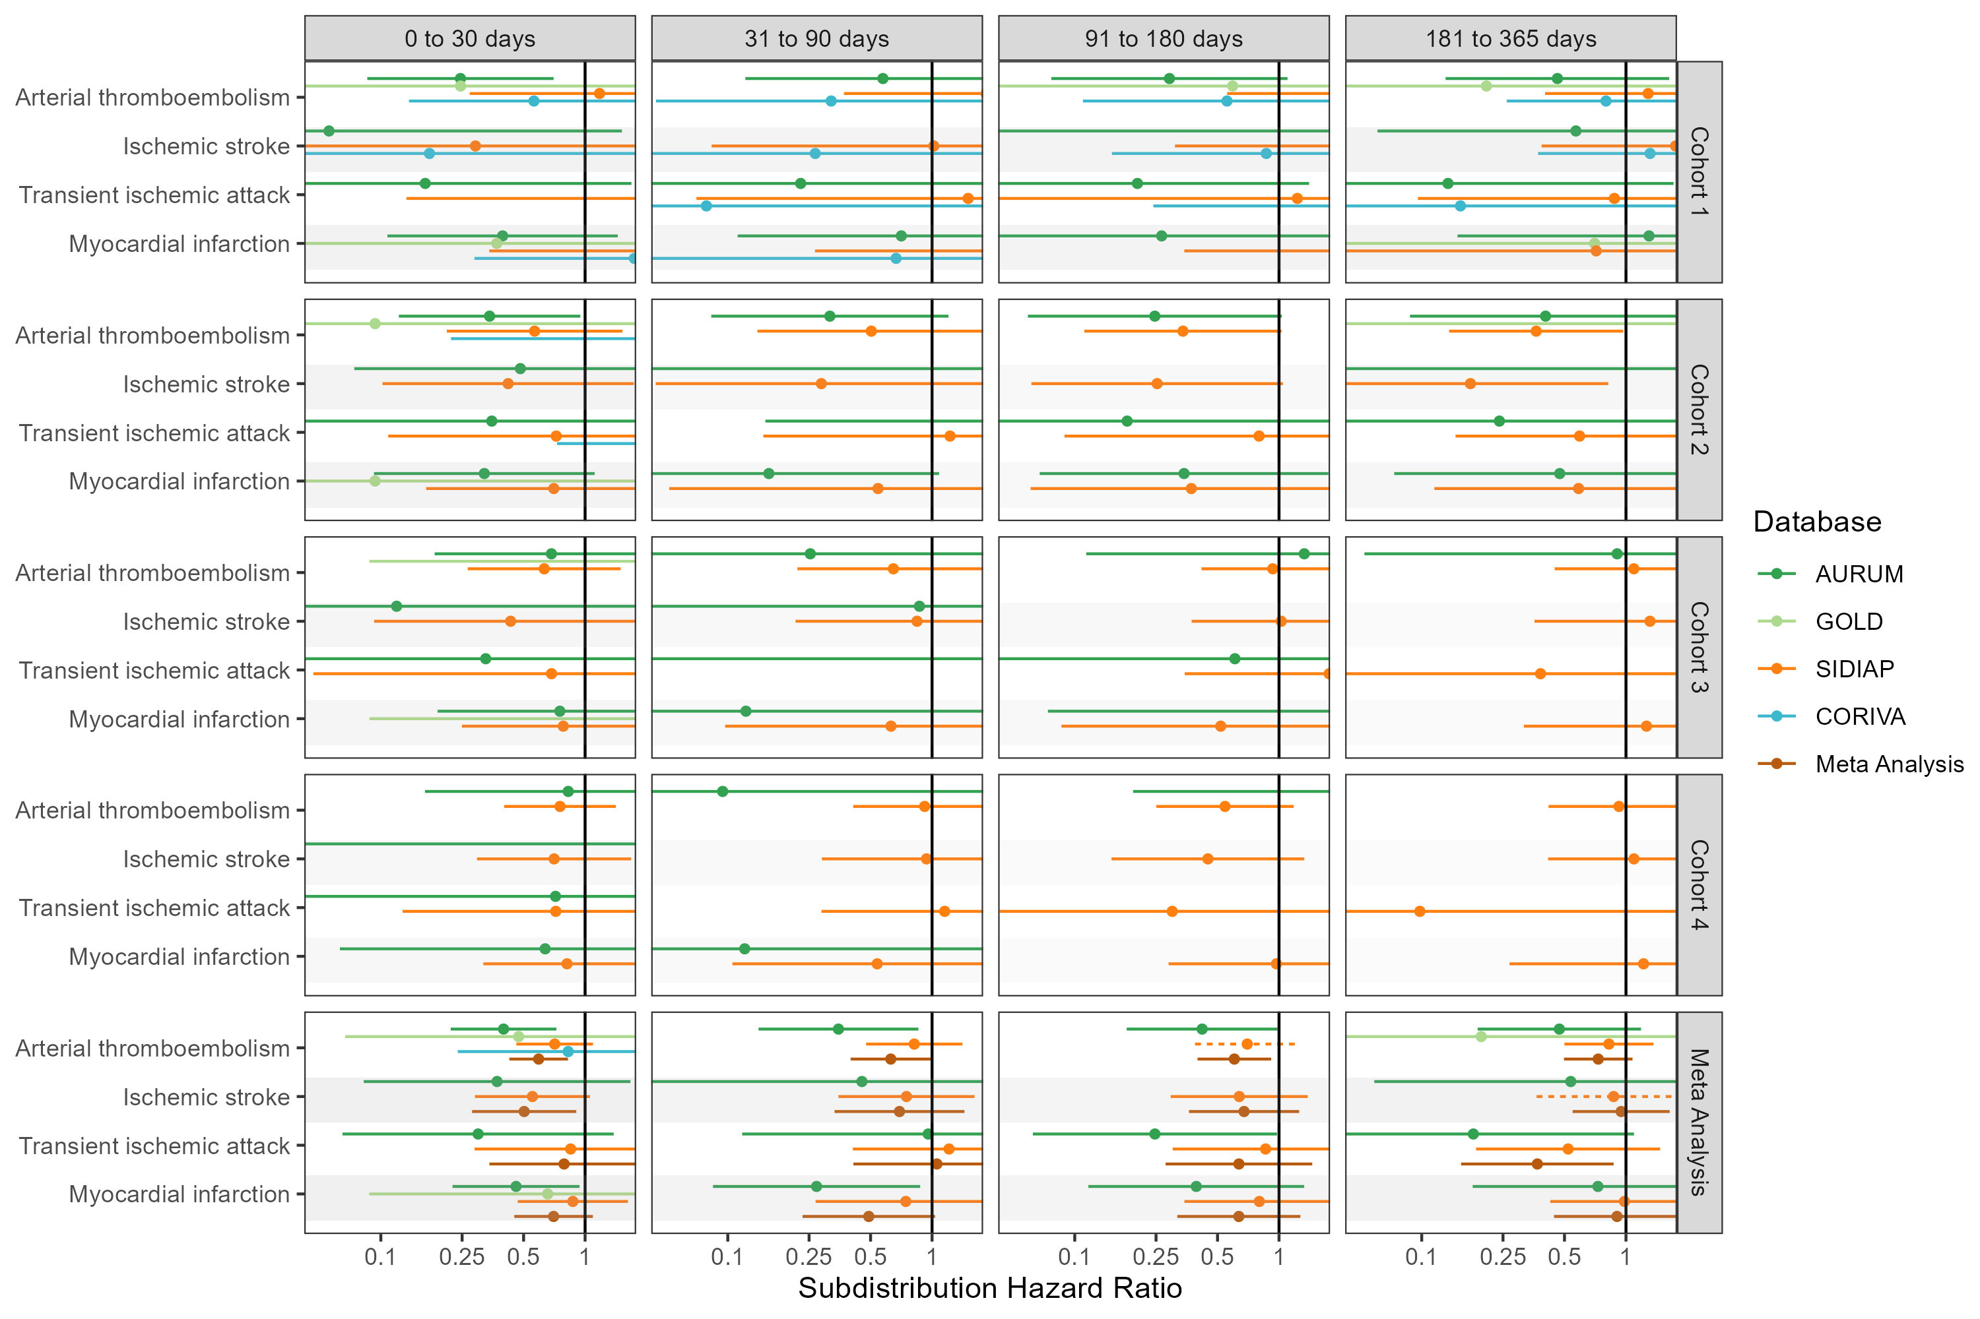

## **Figure S25: Forest plots for vaccine effect (any COVID-19 vaccine) on preventing arterial thrombosis/thromboembolism complications,** for each cohort and database (meta-analysis estimates across cohorts in the last panel).Only first outcome after COVID-19 captured. Dashed line represents a level of hetereogeneity I2 > 0.4.

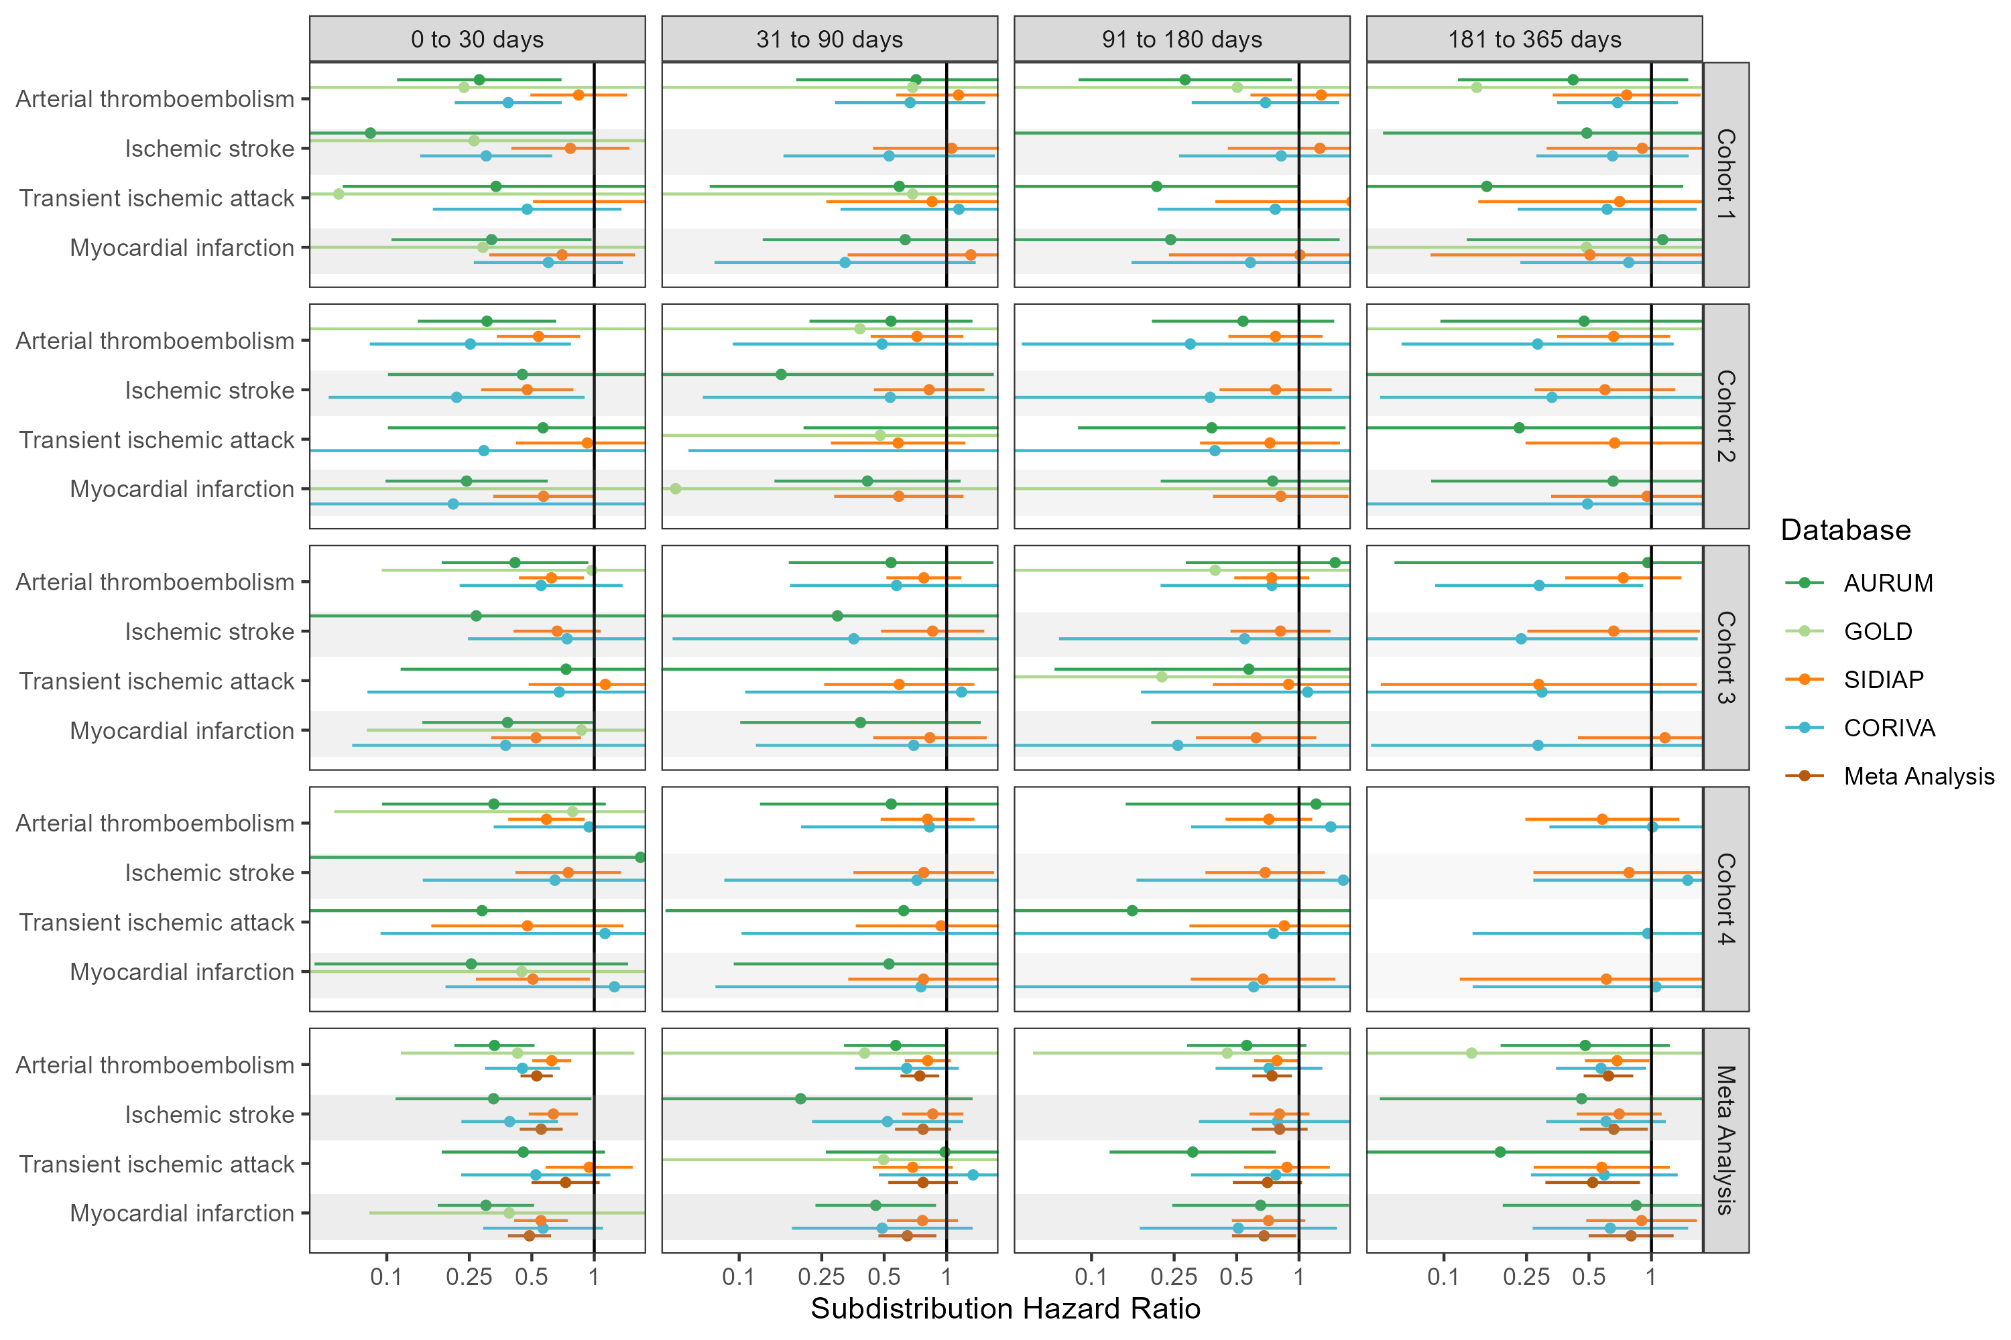

## **Figure S26: Forest plots for vaccine effect (ChAdOx1 vaccine) on preventing arterial thrombosis/thromboembolism complications,** for each cohort and database (meta-analysis estimates across cohorts in the last panel). Dashed line represents a level of hetereogeneity I2 > 0.4.

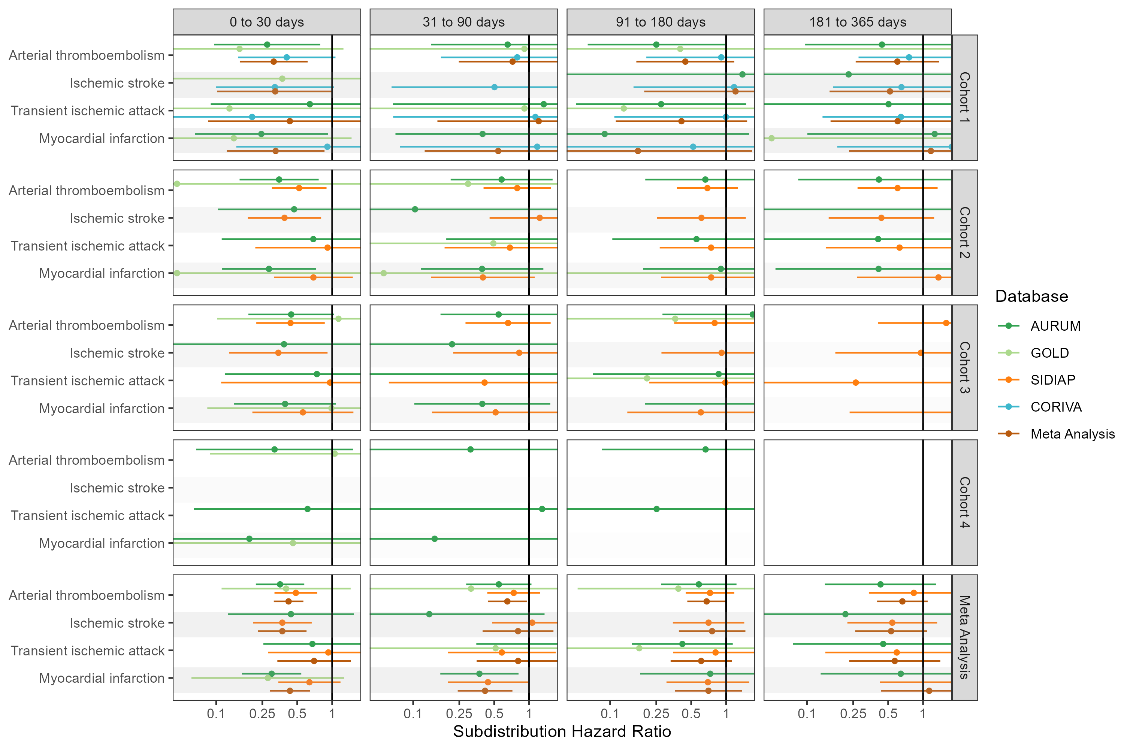

## **Figure S27: Forest plots for vaccine effect (ChAdOx1 vaccine) on preventing arterial thrombosis/thromboembolism complications,** for each cohort and database (meta-analysis estimates across cohorts in the last panel).Follow-up ends at first vaccine dose after index date. Dashed line represents a level of hetereogeneity I2 > 0.4.

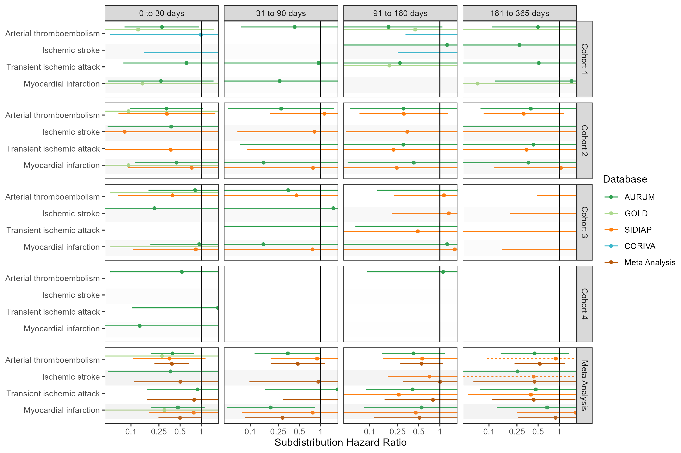

## **Figure S28: Forest plots for vaccine effect (ChAdOx1 vaccine) on preventing arterial thrombosis/thromboembolism complications,** for each cohort and database (meta-analysis estimates across cohorts in the last panel).Only first outcome after COVID-19 captured. Dashed line represents a level of hetereogeneity I2 > 0.4.

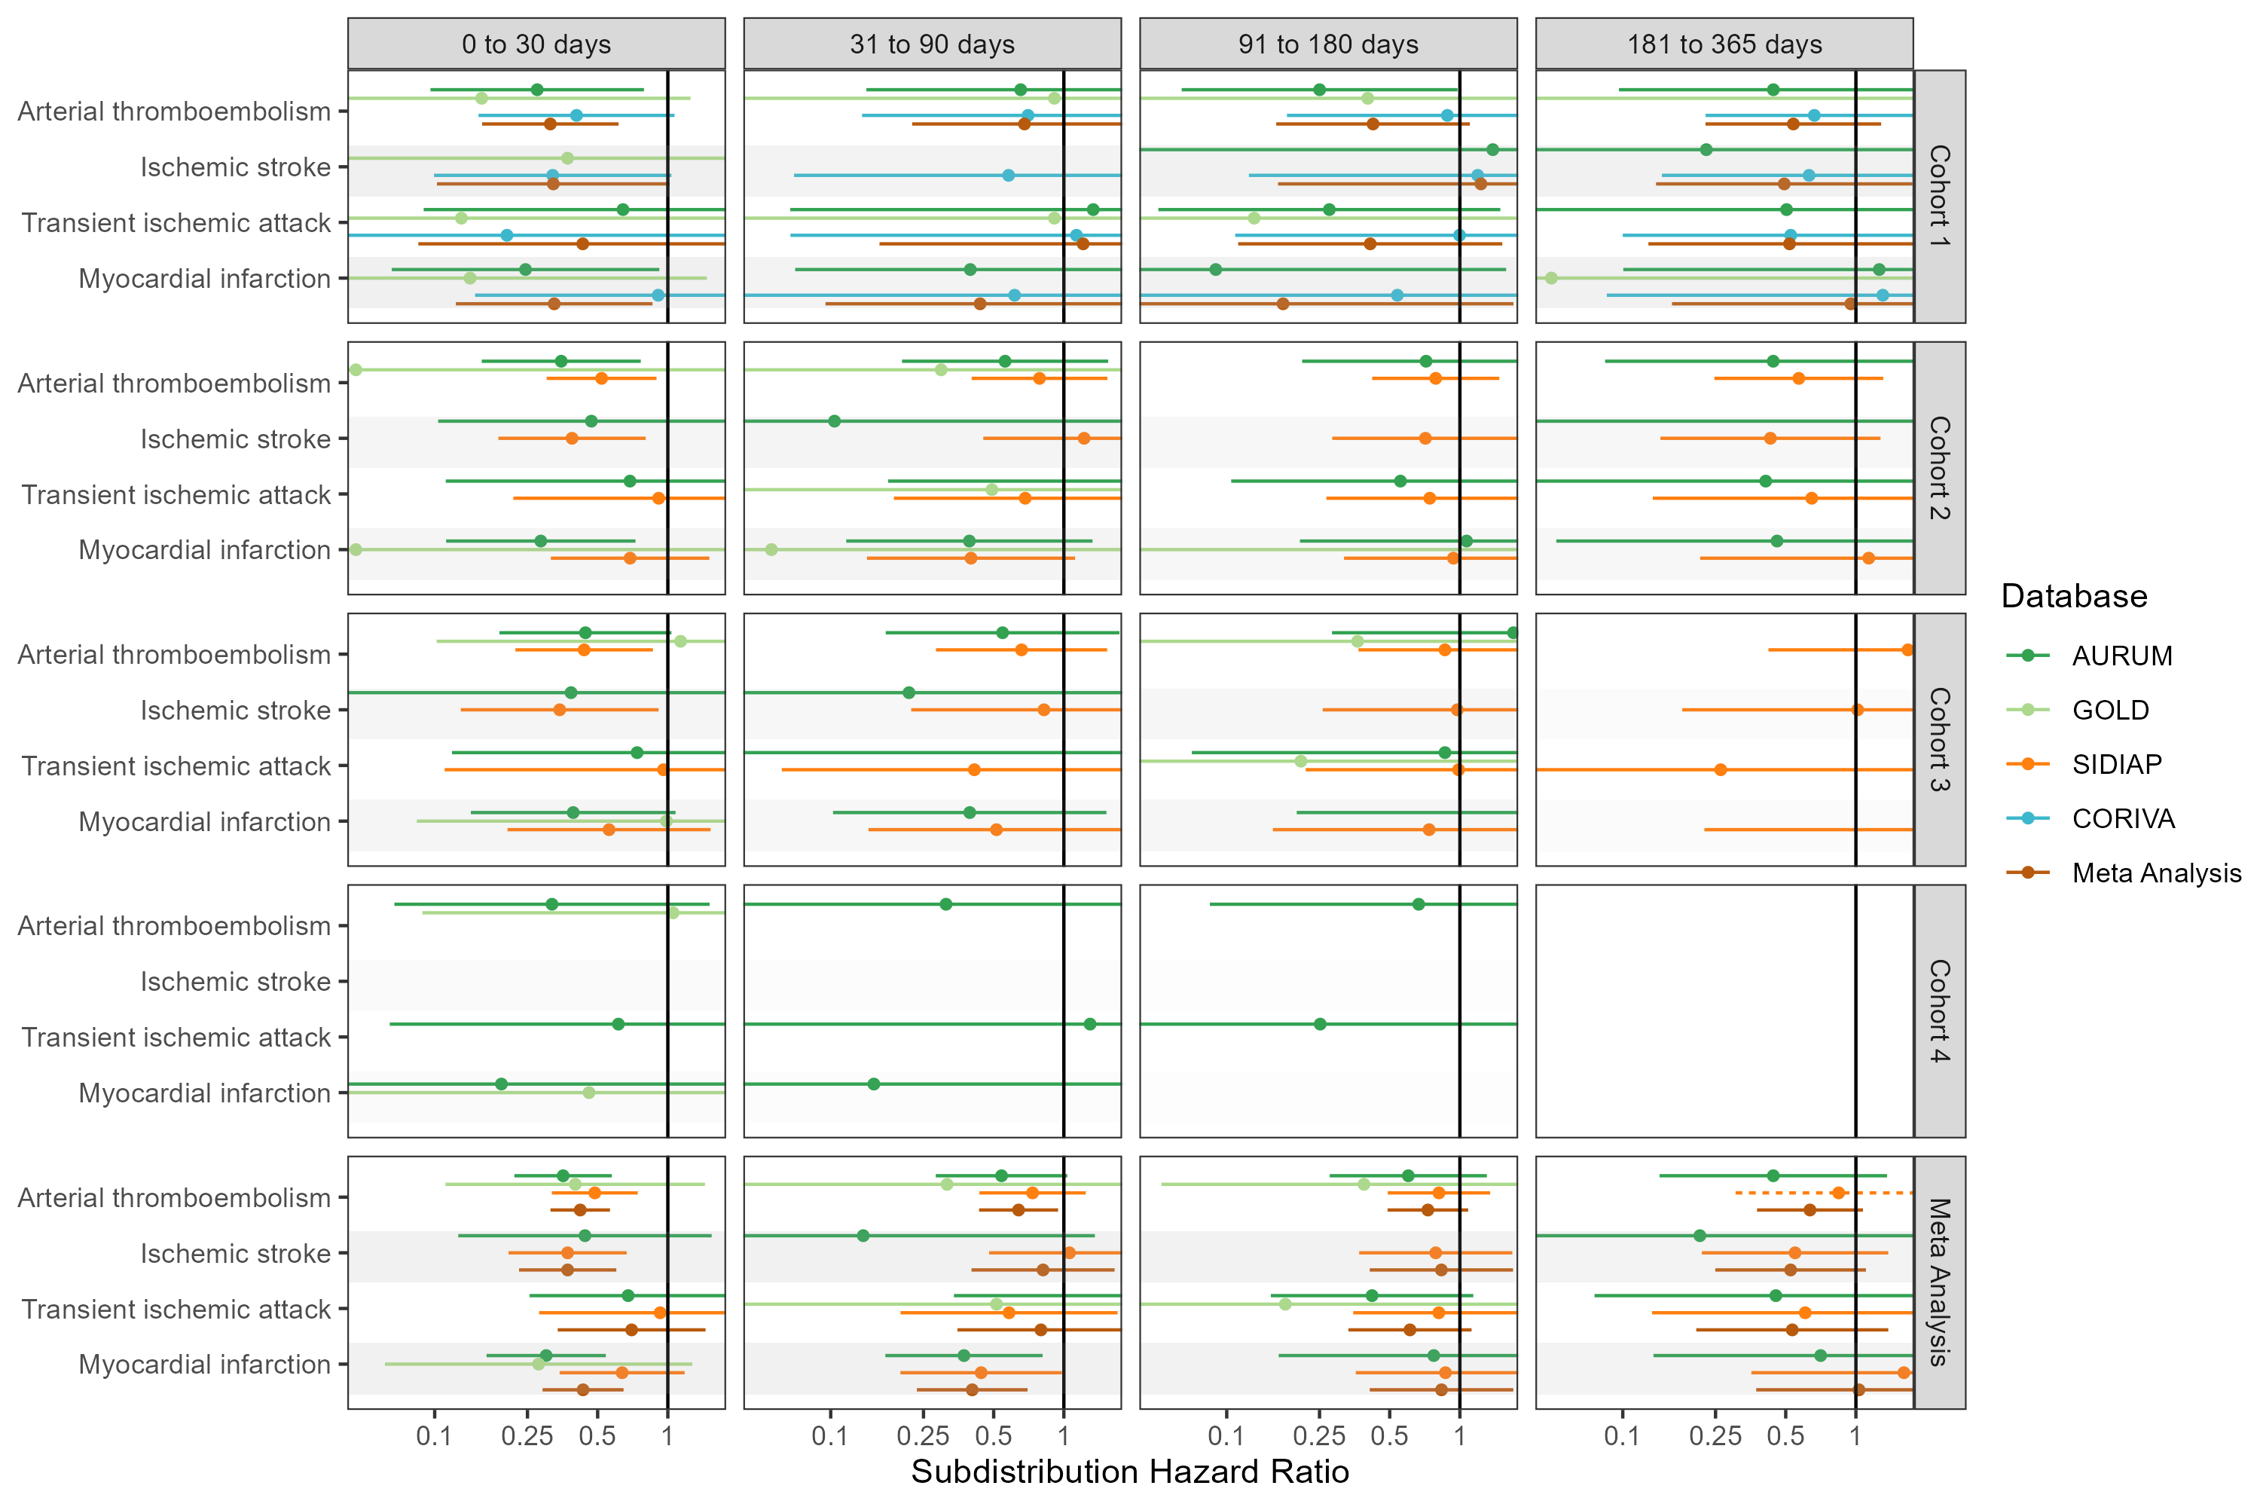

## **Figure S29: Forest plots for vaccine effect (BNT162b2 vaccine) on preventing arterial thrombosis/thromboembolism complications,** for each cohort and database (meta-analysis estimates across cohorts in the last panel). Dashed line represents a level of hetereogeneity I2 > 0.4.

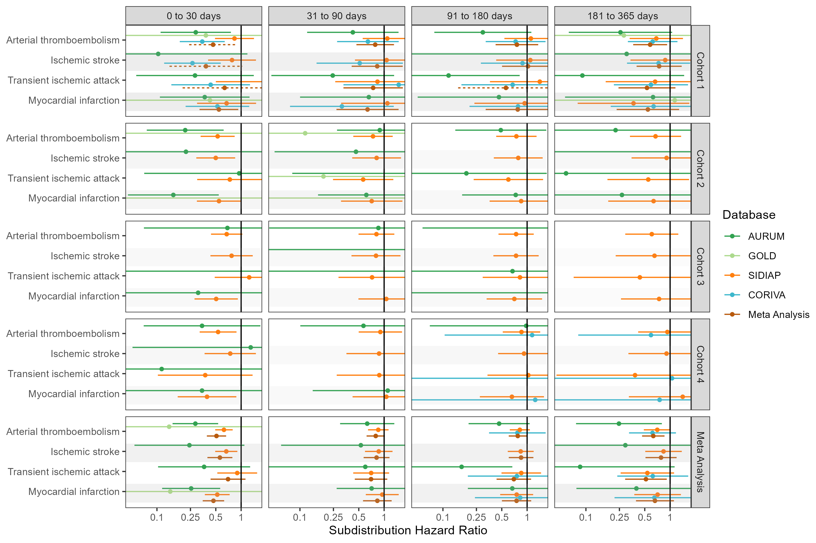

## **Figure S30: Forest plots for vaccine effect (BNT162b2 vaccine) on preventing arterial thrombosis/thromboembolism complications,** for each cohort and database (meta-analysis estimates across cohorts in the last panel).Follow-up ends at first vaccine dose after index date. Dashed line represents a level of hetereogeneity I2 > 0.4.

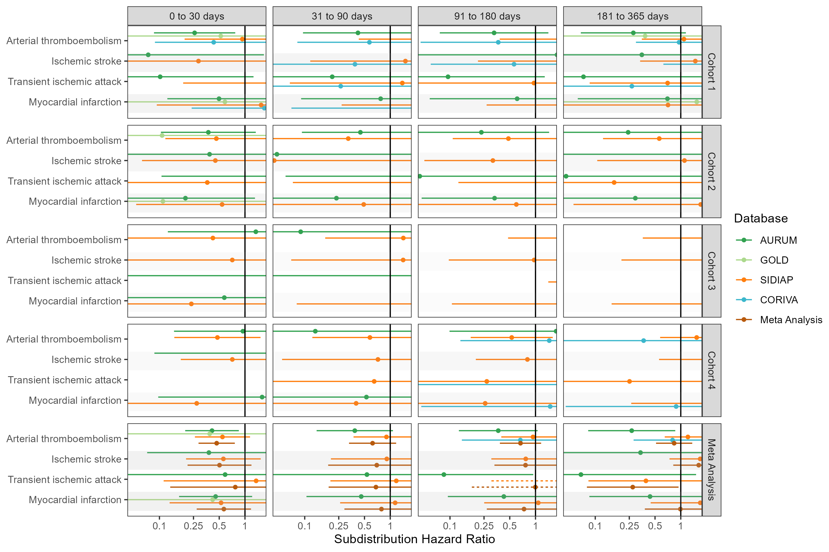

## **Figure S31: Forest plots for vaccine effect (BNT162b2 vaccine) on preventing arterial thrombosis/thromboembolism complications,** for each cohort and database (meta-analysis estimates across cohorts in the last panel).Only first outcome after COVID-19 captured. Dashed line represents a level of hetereogeneity I2 > 0.4.

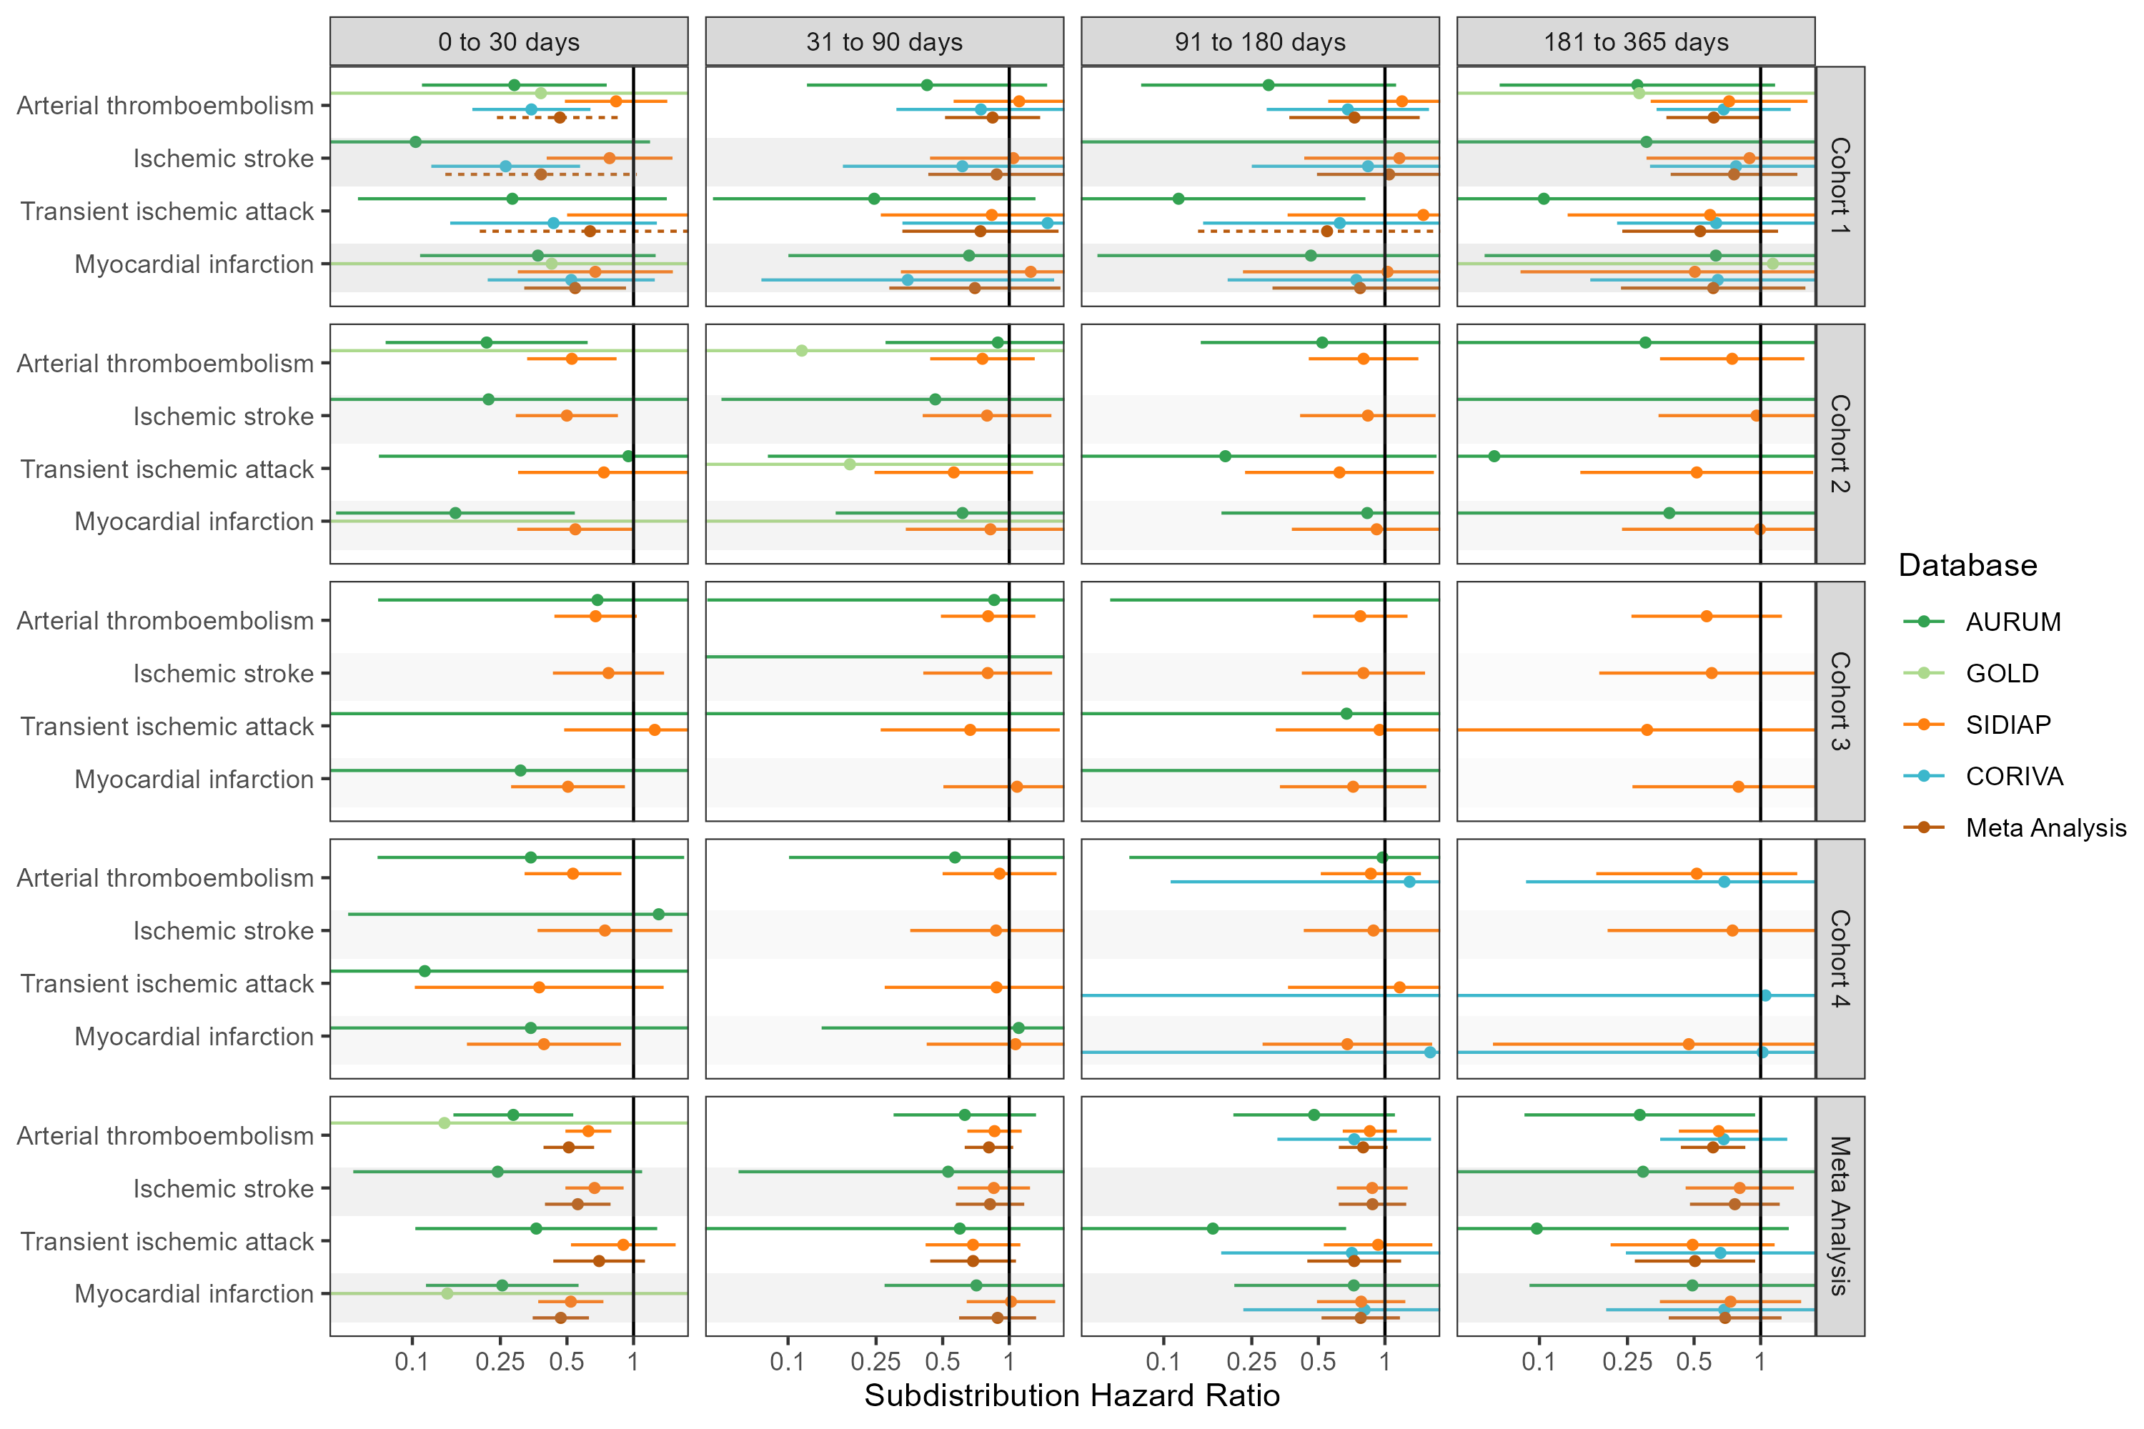

## **Figure S32: Forest plots for vaccine effect (any COVID-19 vaccine) on preventing cardiac diseases and hemorrhagic stroke,** for each cohort and database (meta-analysis estimates across cohorts in the last panel). Dashed line represents a level of hetereogeneity I2 > 0.4.

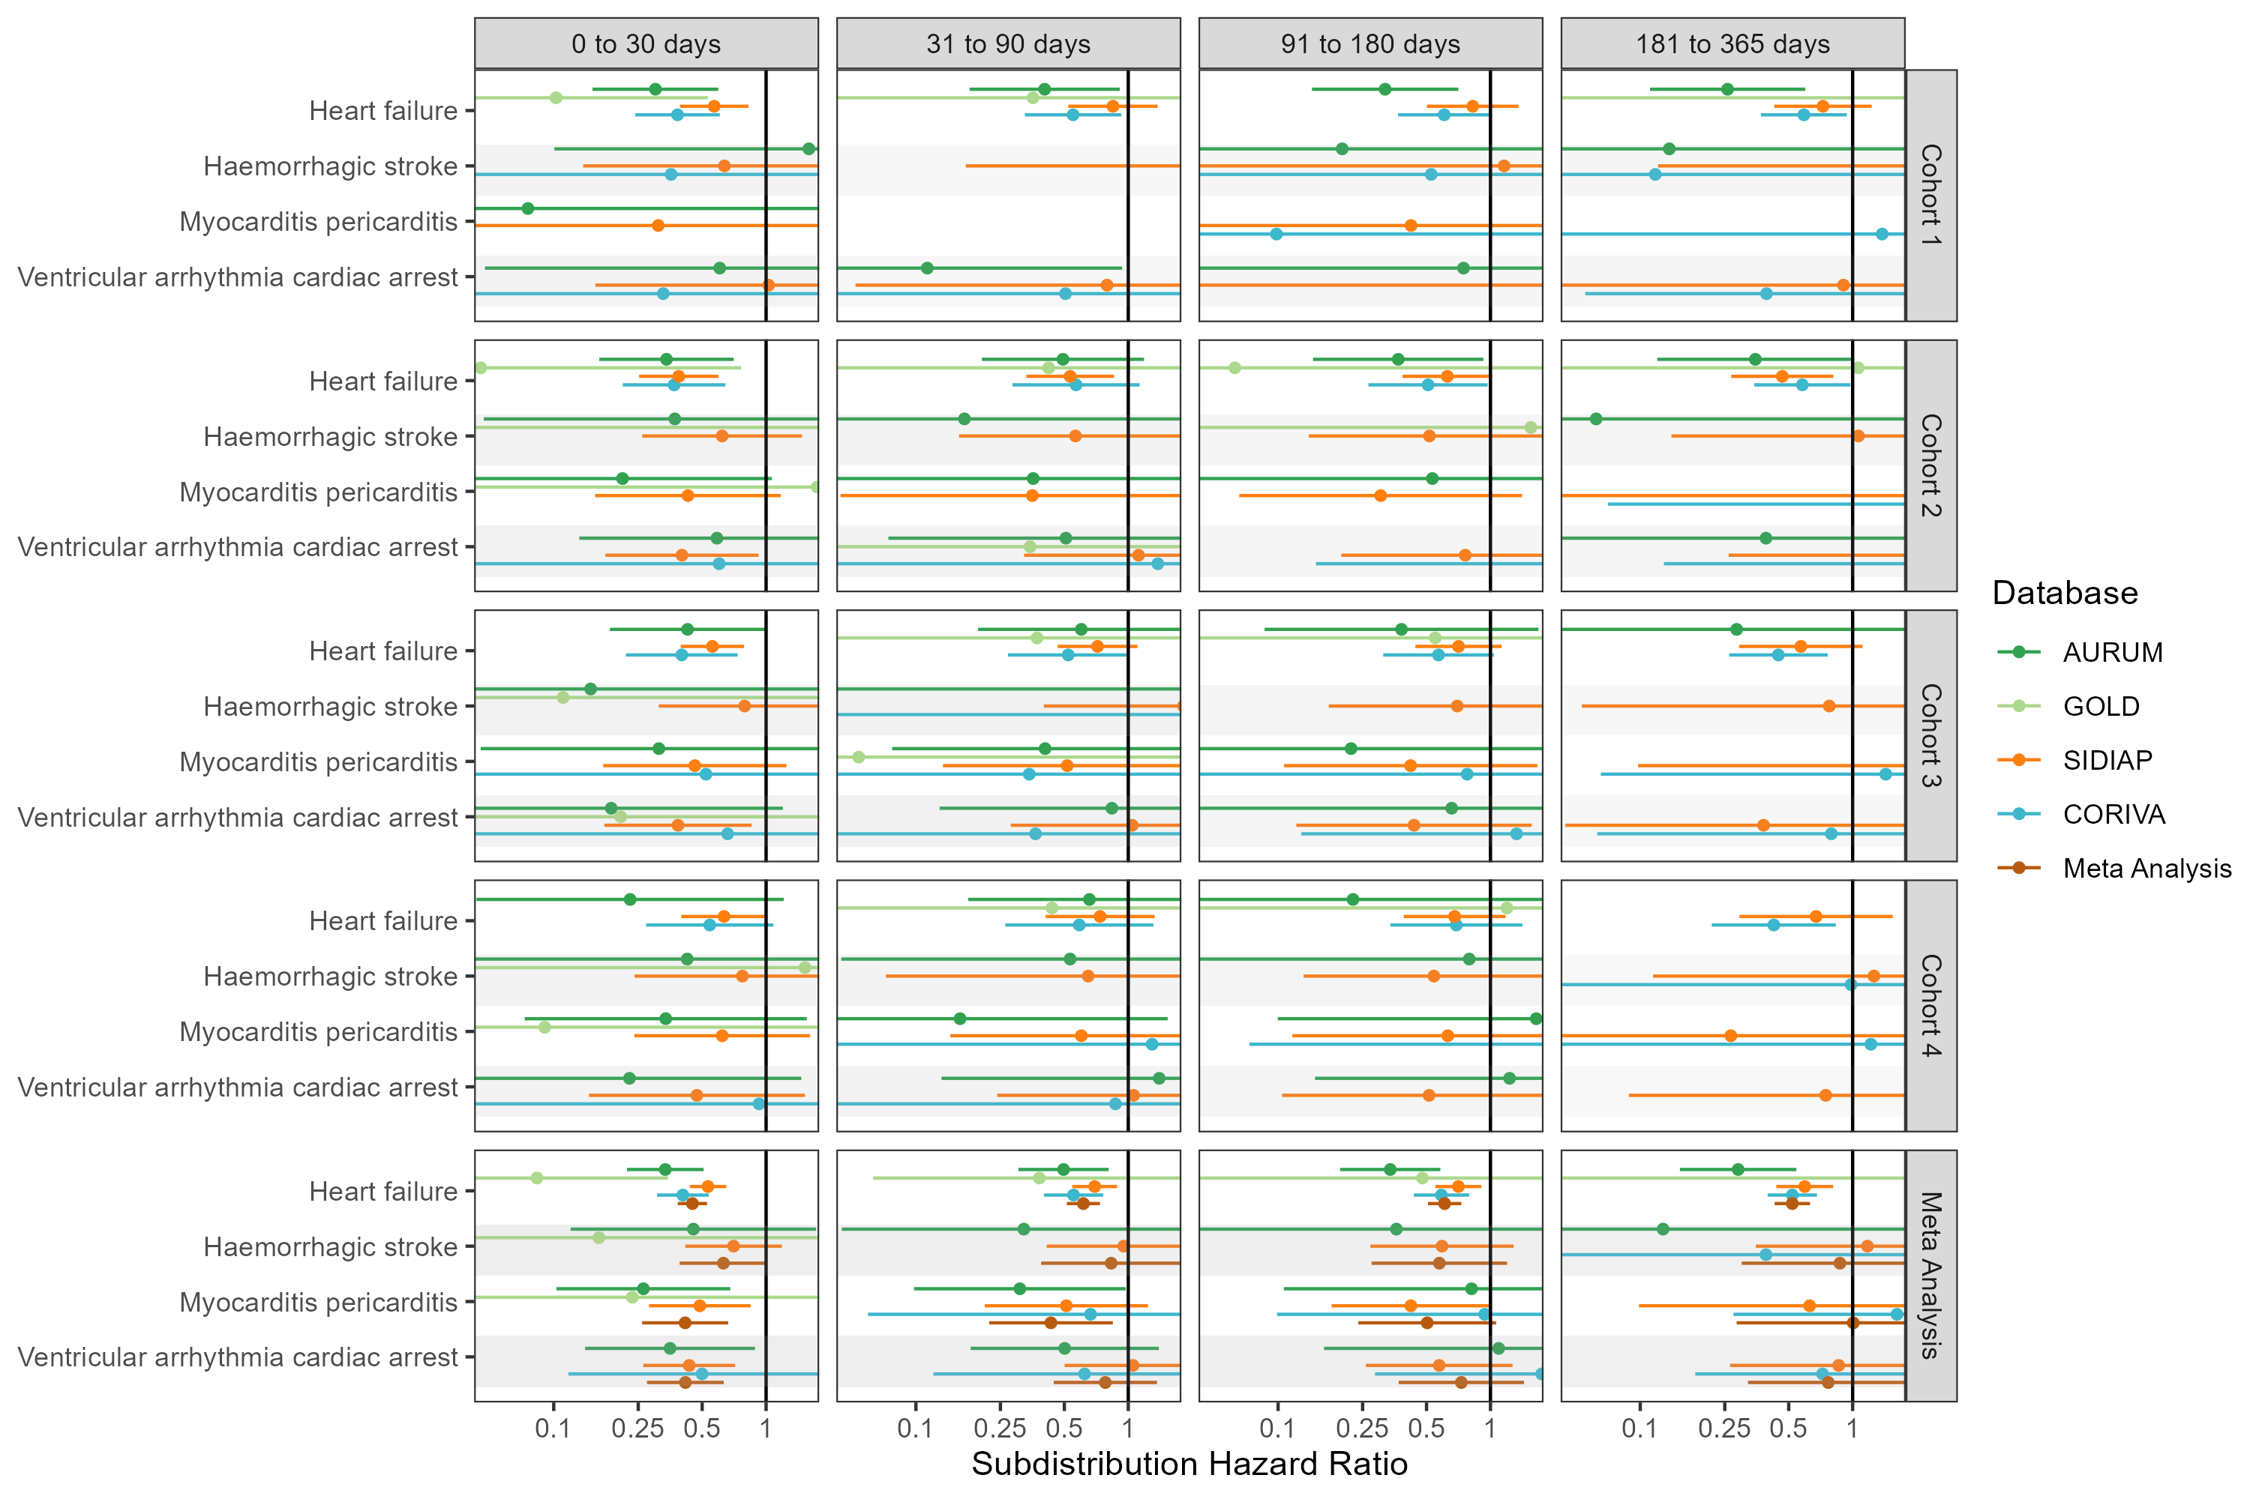

## **Figure S33: Forest plots for vaccine effect (any COVID-19 vaccine) on preventing cardiac diseases and hemorrhagic stroke,** for each cohort and database (meta-analysis estimates across cohorts in the last panel).Follow-up ends at first vaccine dose after index date. Dashed line represents a level of hetereogeneity I2 > 0.4.

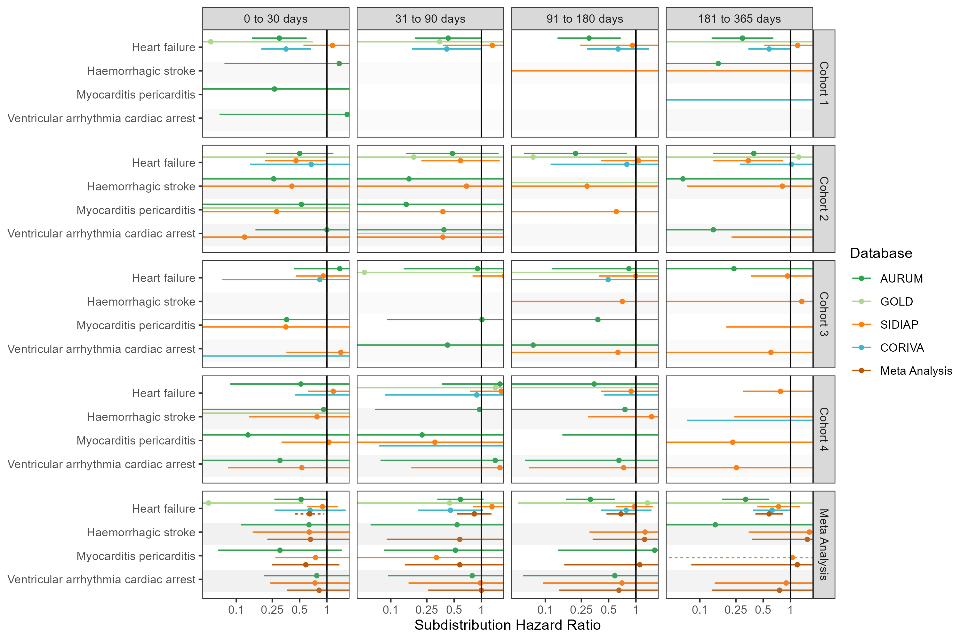

## **Figure S34: Forest plots for vaccine effect (any COVID-19 vaccine) on preventing cardiac diseases and hemorrhagic stroke,** for each cohort and database (meta-analysis estimates across cohorts in the last panel).Only first outcome after COVID-19 captured. Dashed line represents a level of hetereogeneity I2 > 0.4.

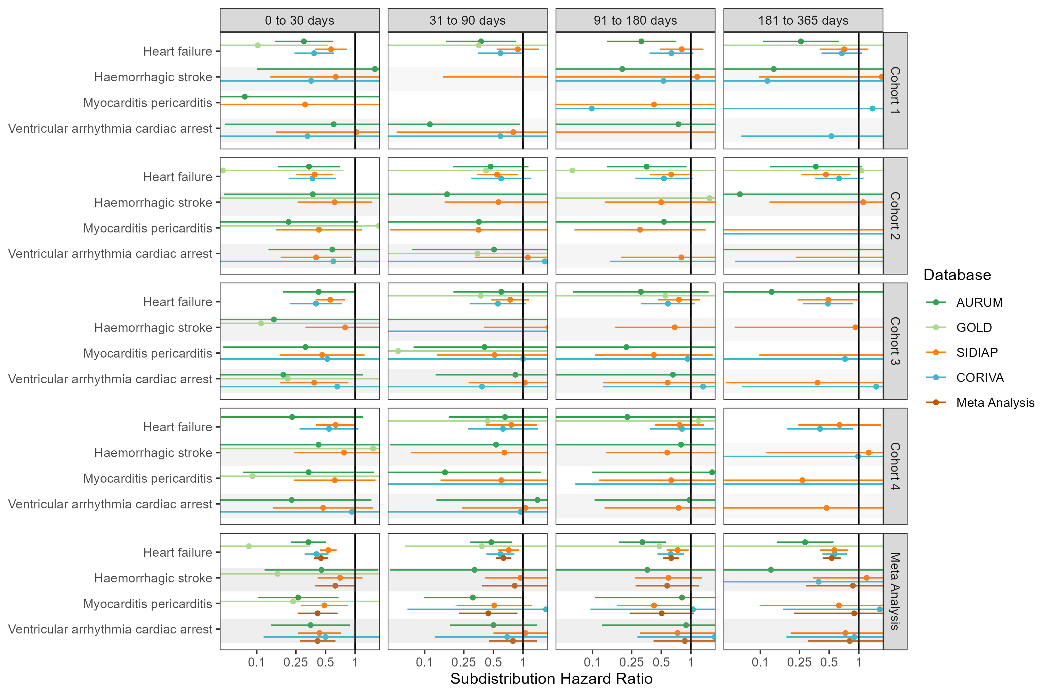

## **Figure S35: Forest plots for vaccine effect (ChAdOx1 vaccine) on preventing cardiac diseases and hemorrhagic stroke,** for each cohort and database (meta-analysis estimates across cohorts in the last panel). Dashed line represents a level of hetereogeneity I2 > 0.4.

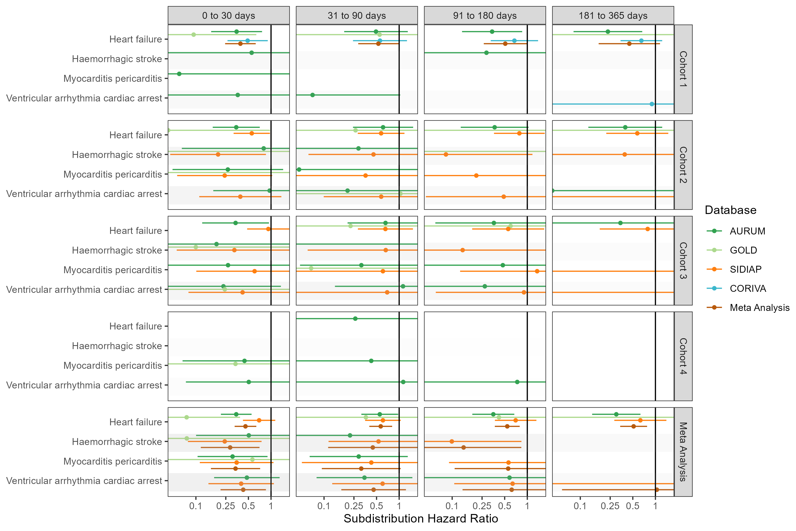

## **Figure S36: Forest plots for vaccine effect (ChAdOx1 vaccine) on preventing cardiac diseases and hemorrhagic stroke,** for each cohort and database (meta-analysis estimates across cohorts in the last panel).Follow-up ends at first vaccine dose after index date. Dashed line represents a level of hetereogeneity I2 > 0.4.

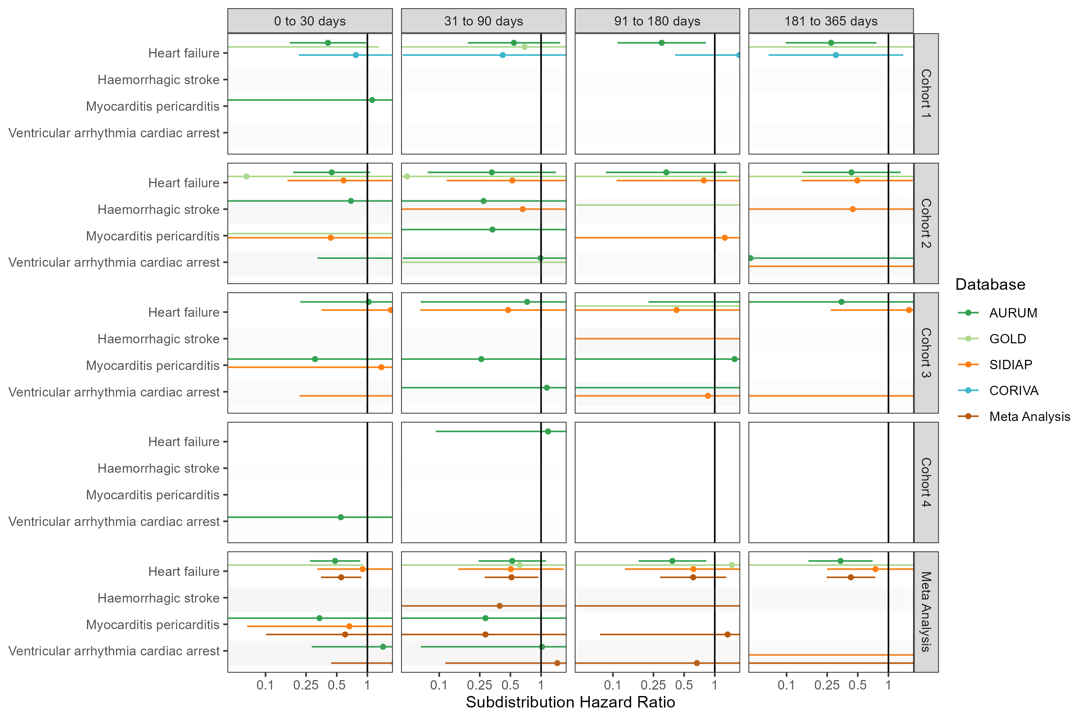

## **Figure S37: Forest plots for vaccine effect (ChAdOx1 vaccine) on preventing cardiac diseases and hemorrhagic stroke,** for each cohort and database (meta-analysis estimates across cohorts in the last panel).Only first outcome after COVID-19 captured. Dashed line represents a level of hetereogeneity I2 > 0.4.

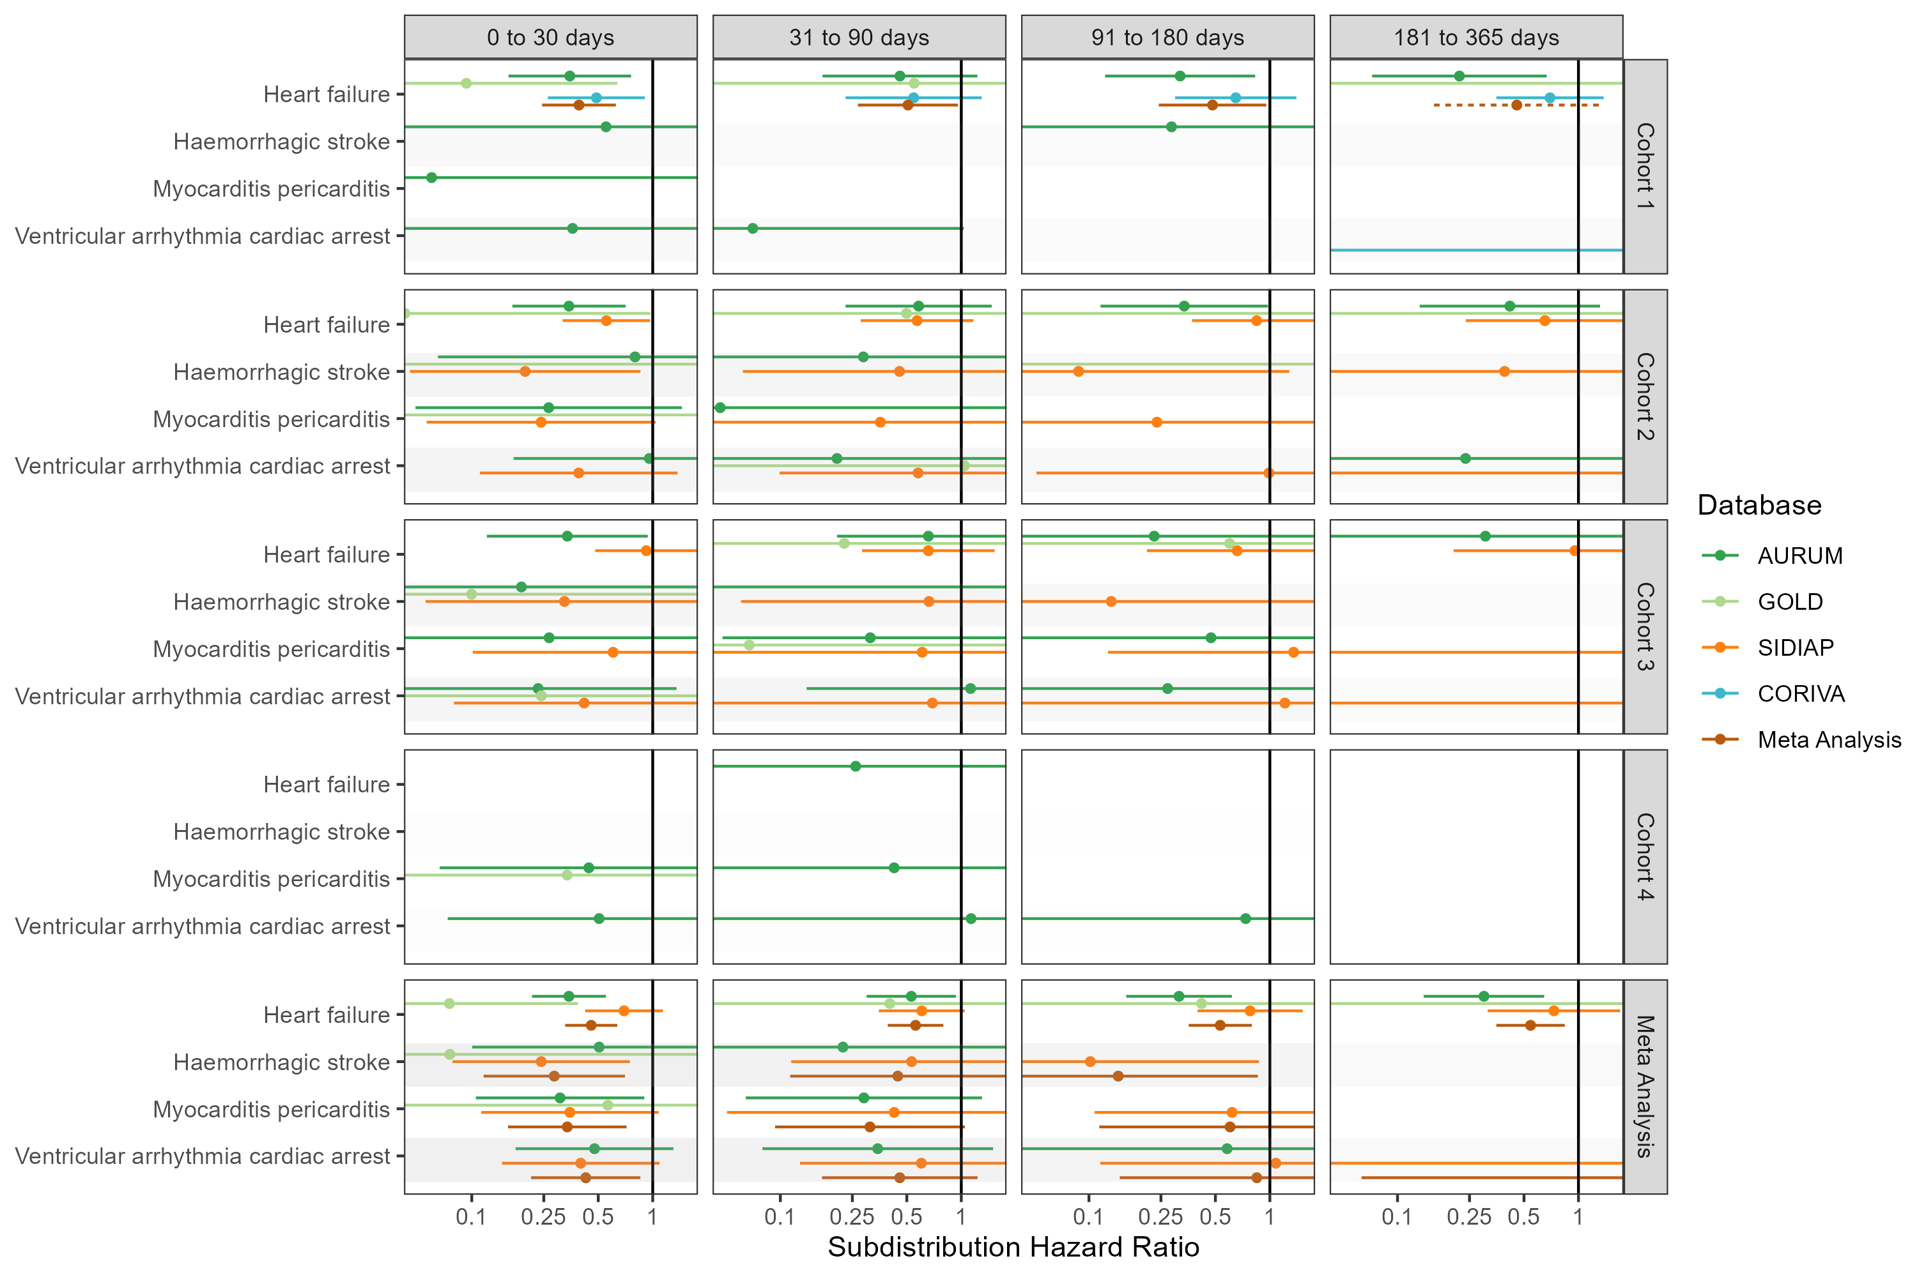

## **Figure S38: Forest plots for vaccine effect (BNT162b2 vaccine) on preventing cardiac diseases and hemorrhagic stroke,** for each cohort and database (meta-analysis estimates across cohorts in the last panel). Dashed line represents a level of hetereogeneity I2 > 0.4.

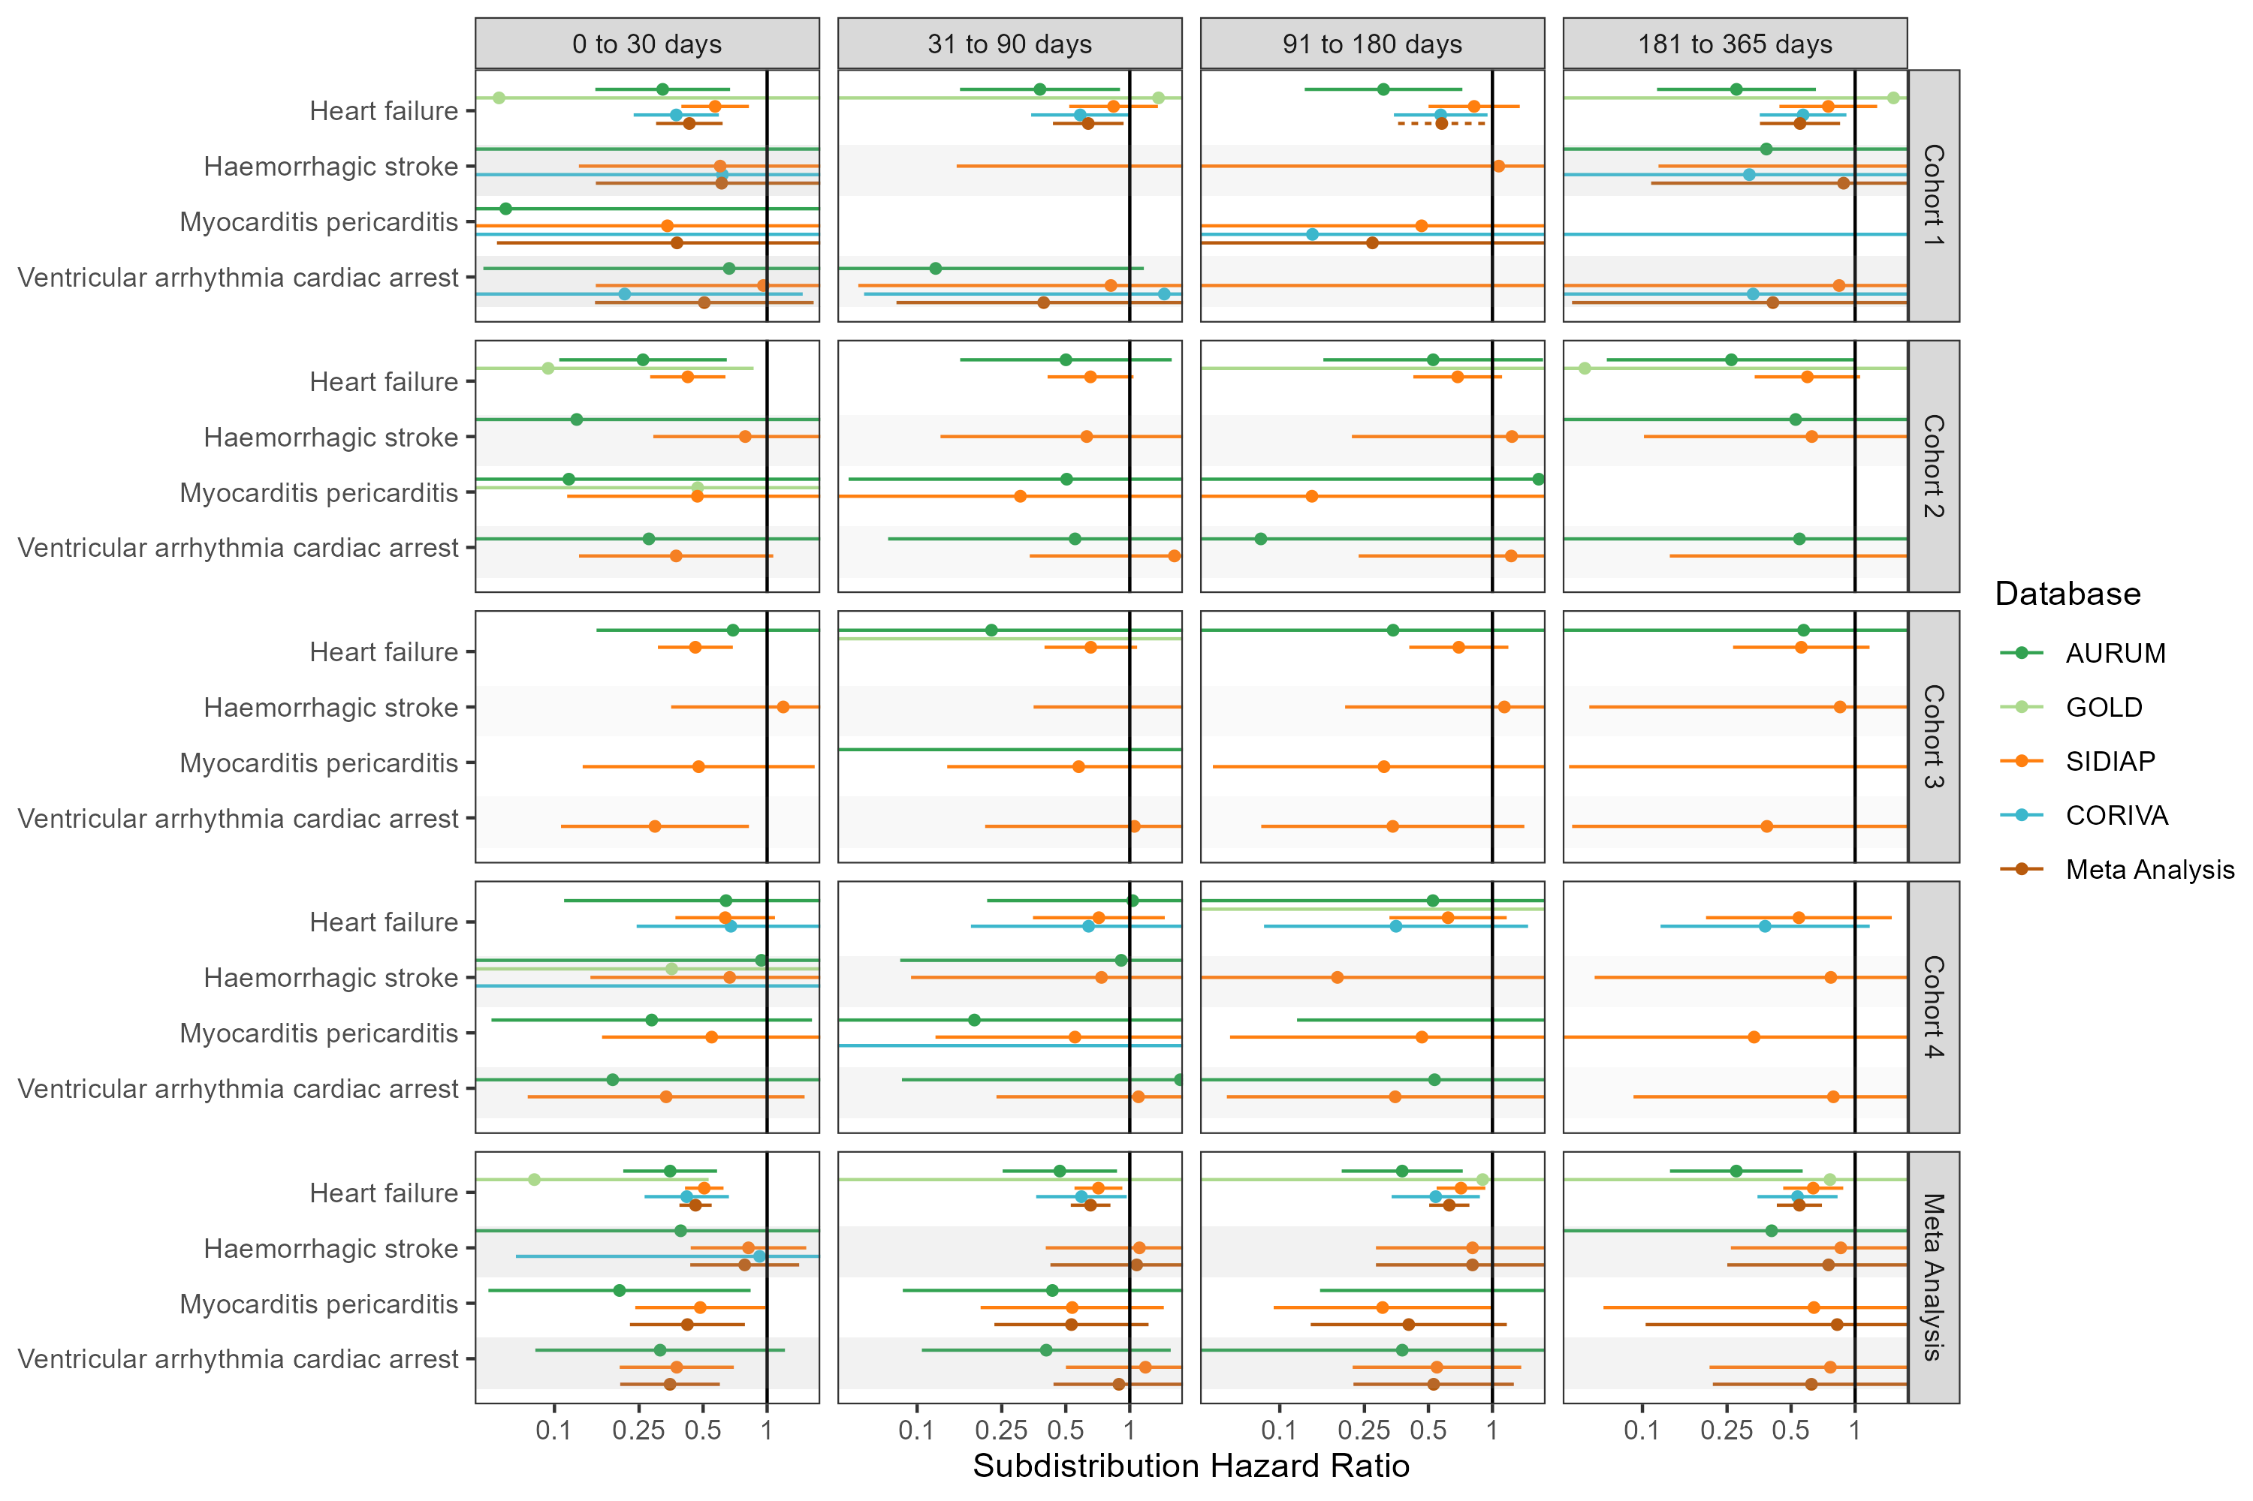

## **Figure S39: Forest plots for vaccine effect (BNT162b2 vaccine) on preventing cardiac diseases and hemorrhagic stroke,** for each cohort and database (meta-analysis estimates across cohorts in the last panel).Follow-up ends at first vaccine dose after index date. Dashed line represents a level of hetereogeneity I2 > 0.4.

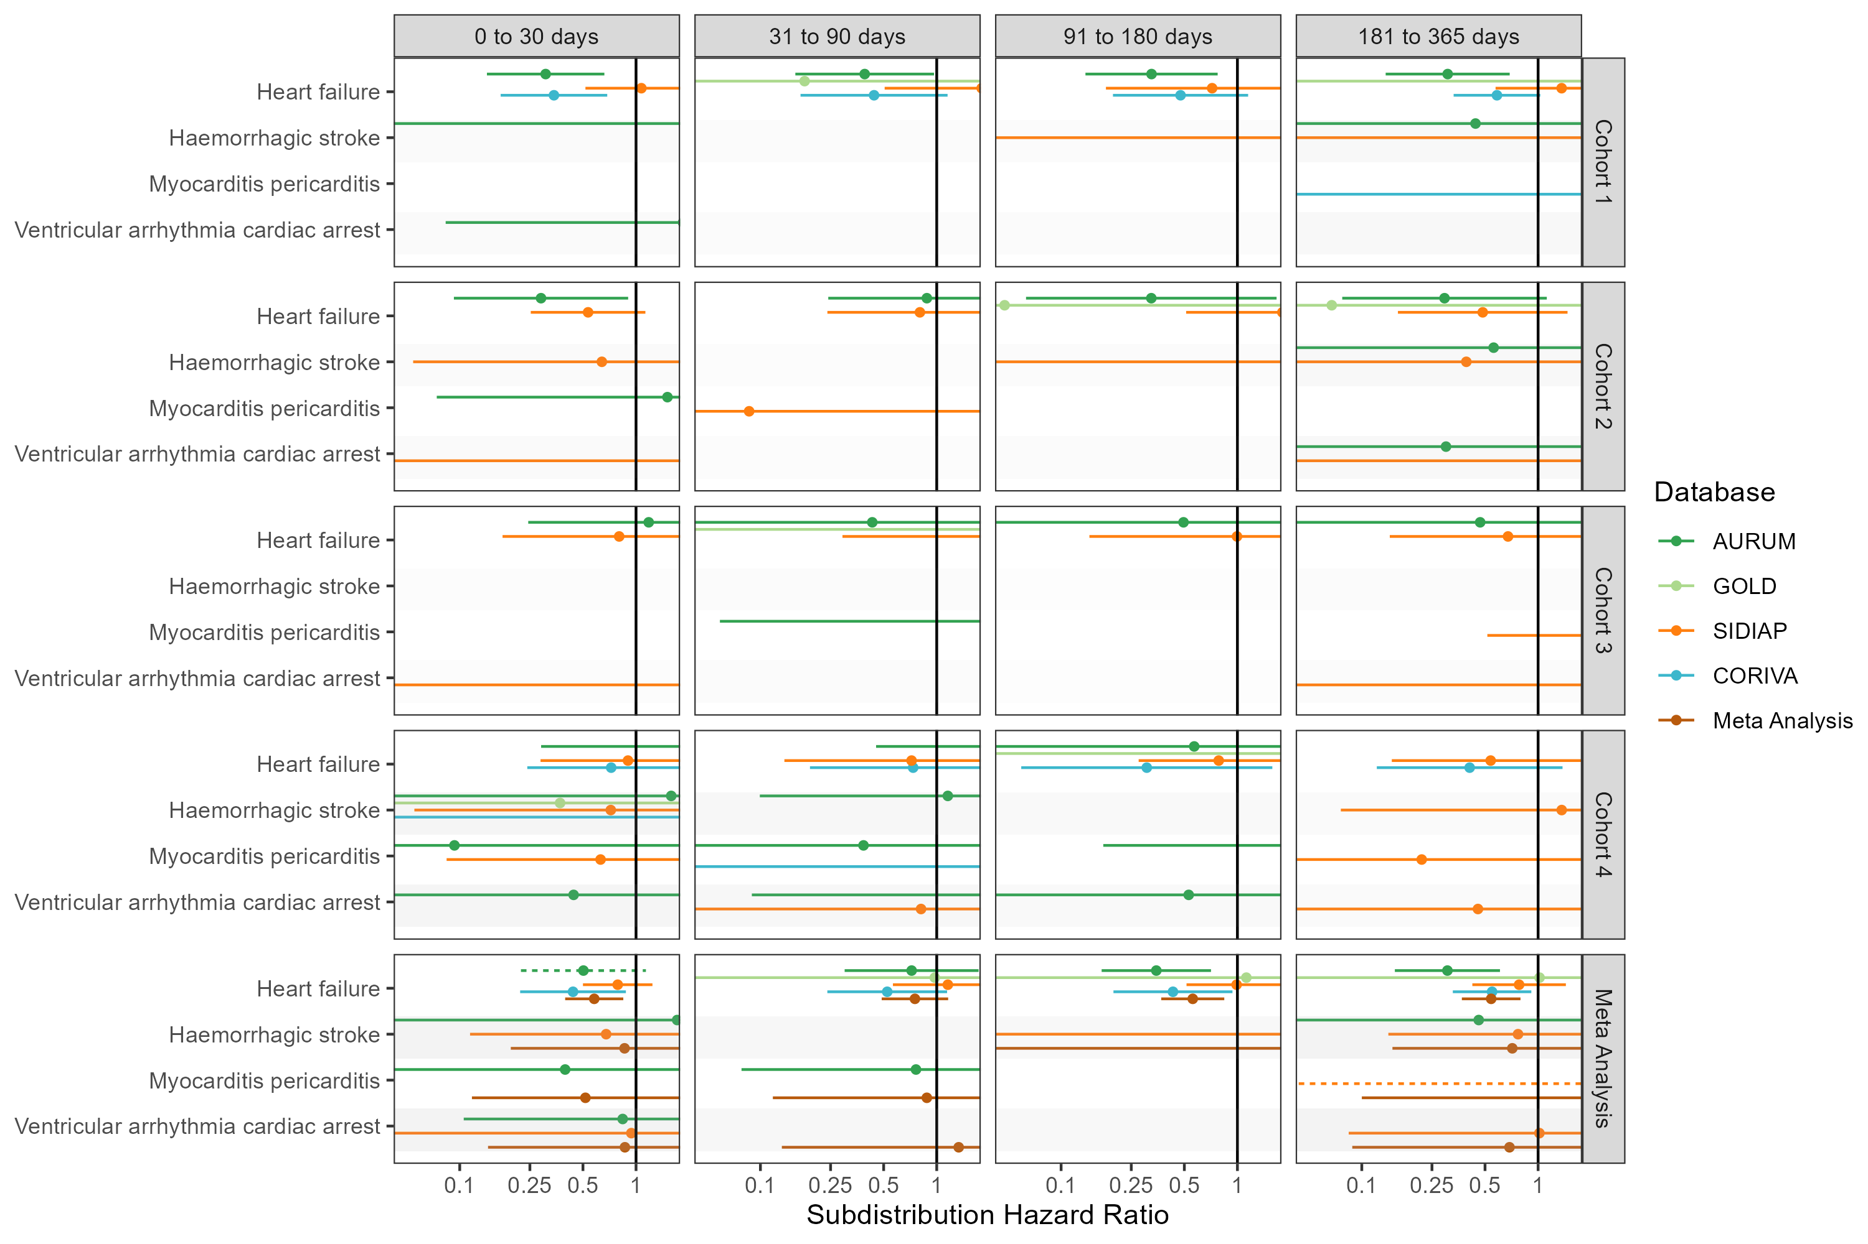

## **Figure S40: Forest plots for vaccine effect (BNT162b2 vaccine) on preventing cardiac diseases and hemorrhagic stroke,** for each cohort and database (meta-analysis estimates across cohorts in the last panel).Only first outcome after COVID-19 captured. Dashed line represents a level of hetereogeneity I2 > 0.4.

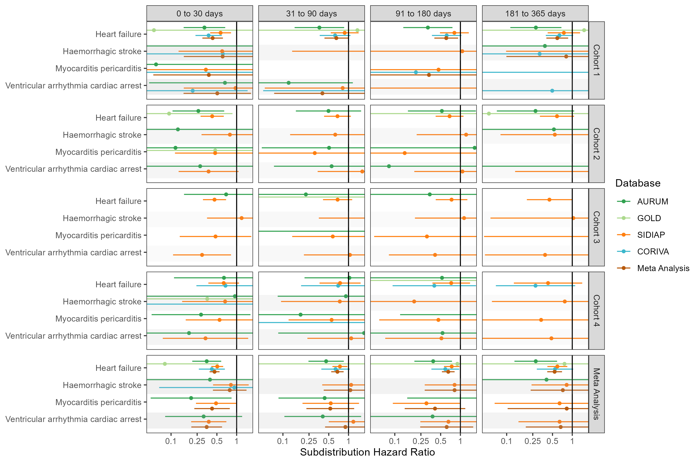

## **Figure S41: Forest plots for comparative effect,** meta-analysis across cohorts and databases. Follow-up ends at first vaccine dose after index date. Dashed line represents a level of hetereogeneity I2 > 0.4.

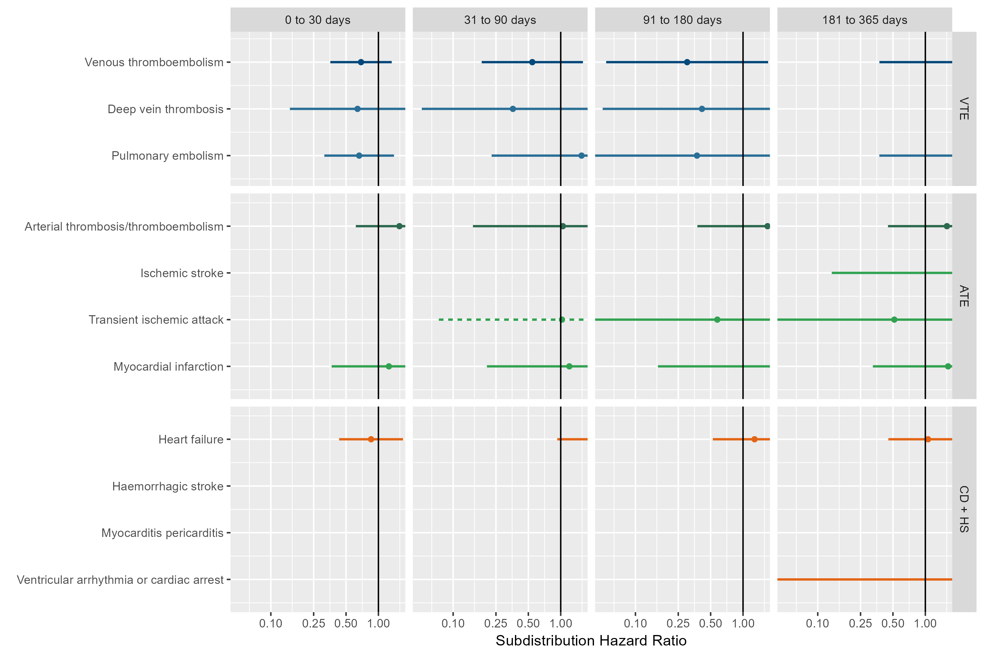 VTE = Venous thromboembolism, ATE = Arterial thrombosis/thromboembolism, CD + HS = Cardiac diseases and Hemorrhagic stroke

## **Figure S42: Forest plots for comparative effect,** meta-analysis across cohorts and databases. Only first outcome after COVID-19 captured. Dashed line represents a level of hetereogeneity I2 > 0.4.

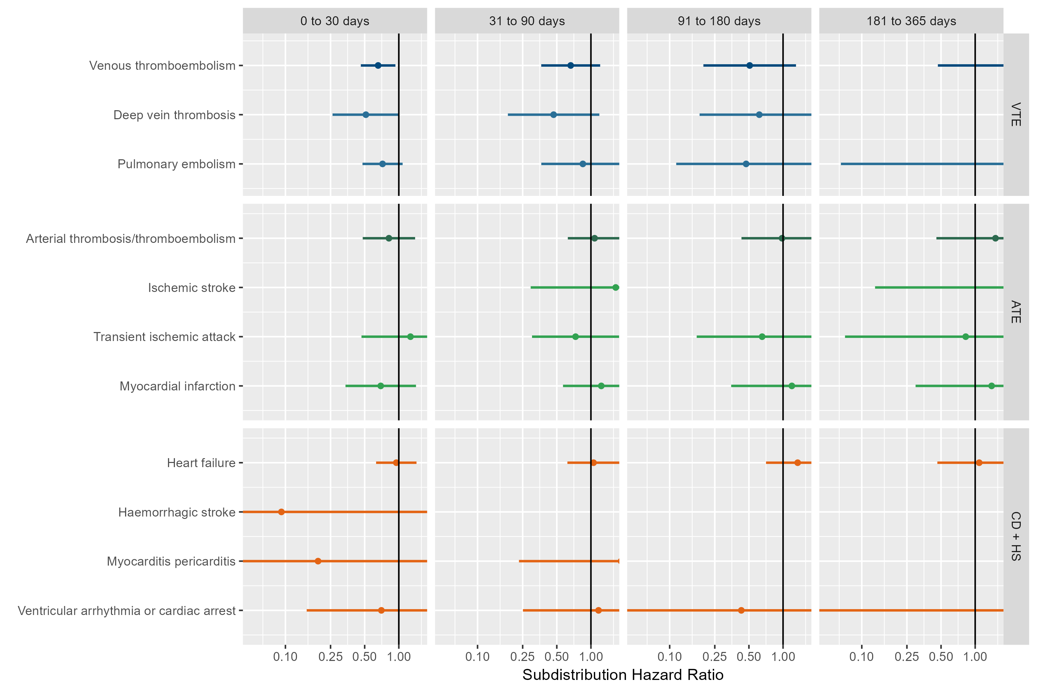 VTE = Venous thromboembolism, ATE = Arterial thrombosis/thromboembolism, CD + HS = Cardiac diseases and Hemorrhagic stroke

## **Figure S43: Forest plots for comparative effect on preventing venous thromboembolism complications,** for each cohort and database (meta-analysis estimates across cohorts in the last panel). Dashed line represents a level of hetereogeneity I2 > 0.4.

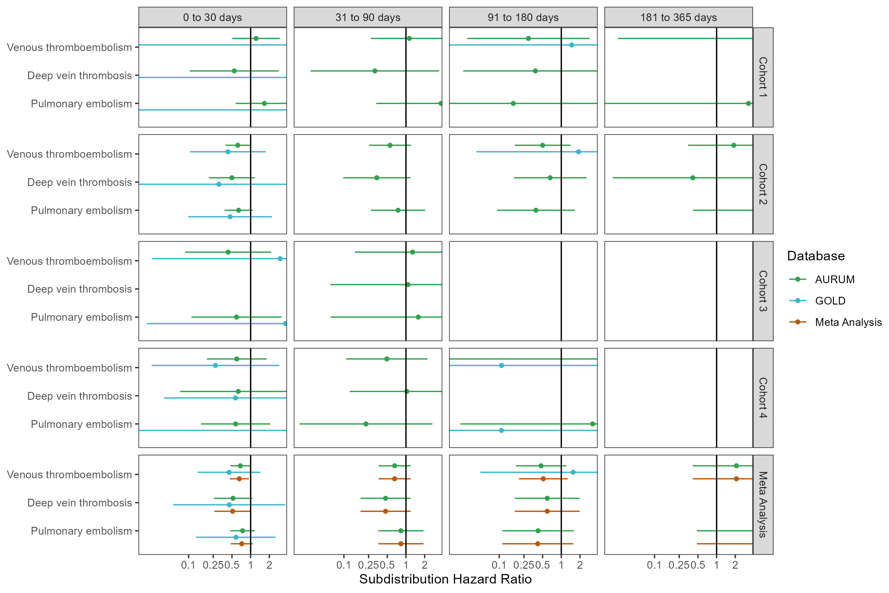

## **Figure S44: Forest plots for comparative effect on preventing venous thromboembolism complications,** for each cohort and database (meta-analysis estimates across cohorts in the last panel).Follow-up ends at first vaccine dose after index date. Dashed line represents a level of hetereogeneity I2 > 0.4.

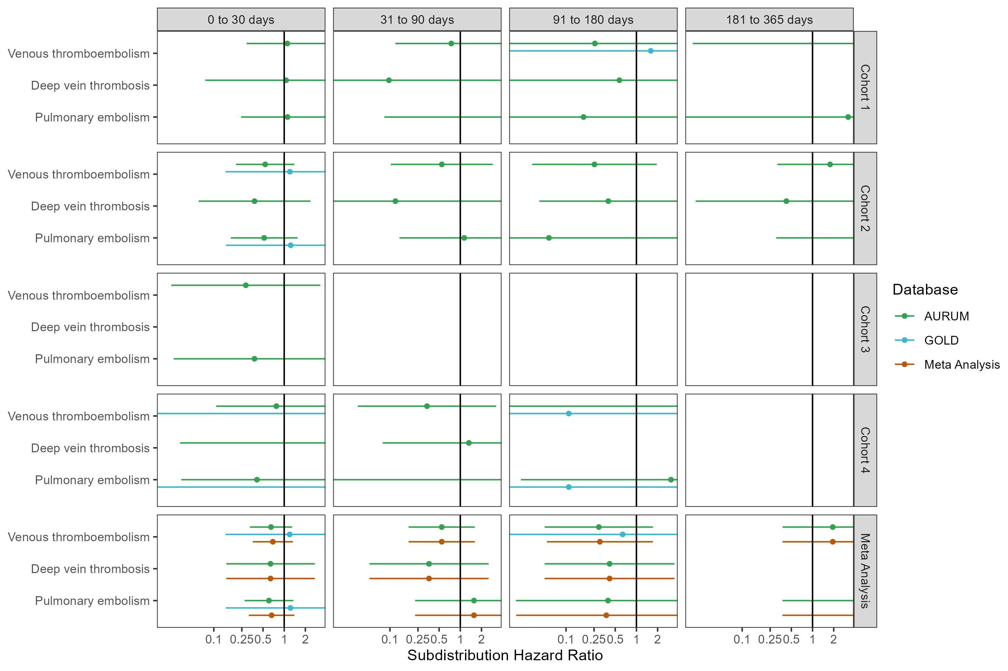

## **Figure S45: Forest plots for comparative effect on preventing venous thromboembolism complications,** for each cohort and database (meta-analysis estimates across cohorts in the last panel).Only first outcome after COVID-19 captured. Dashed line represents a level of hetereogeneity I2 > 0.4.

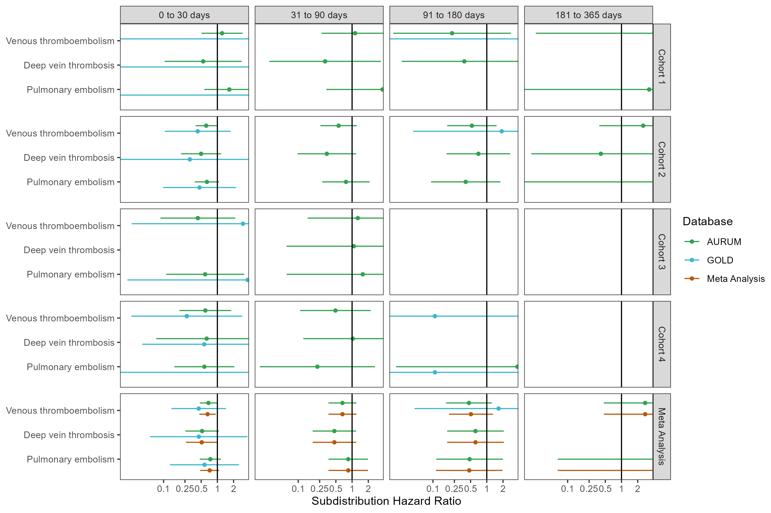

## **Figure S46: Forest plots for comparative effect on preventing arterial thrombosis/thromboembolism complications,** for each cohort and database (meta-analysis estimates across cohorts in the last panel). Dashed line represents a level of hetereogeneity I2 > 0.4.

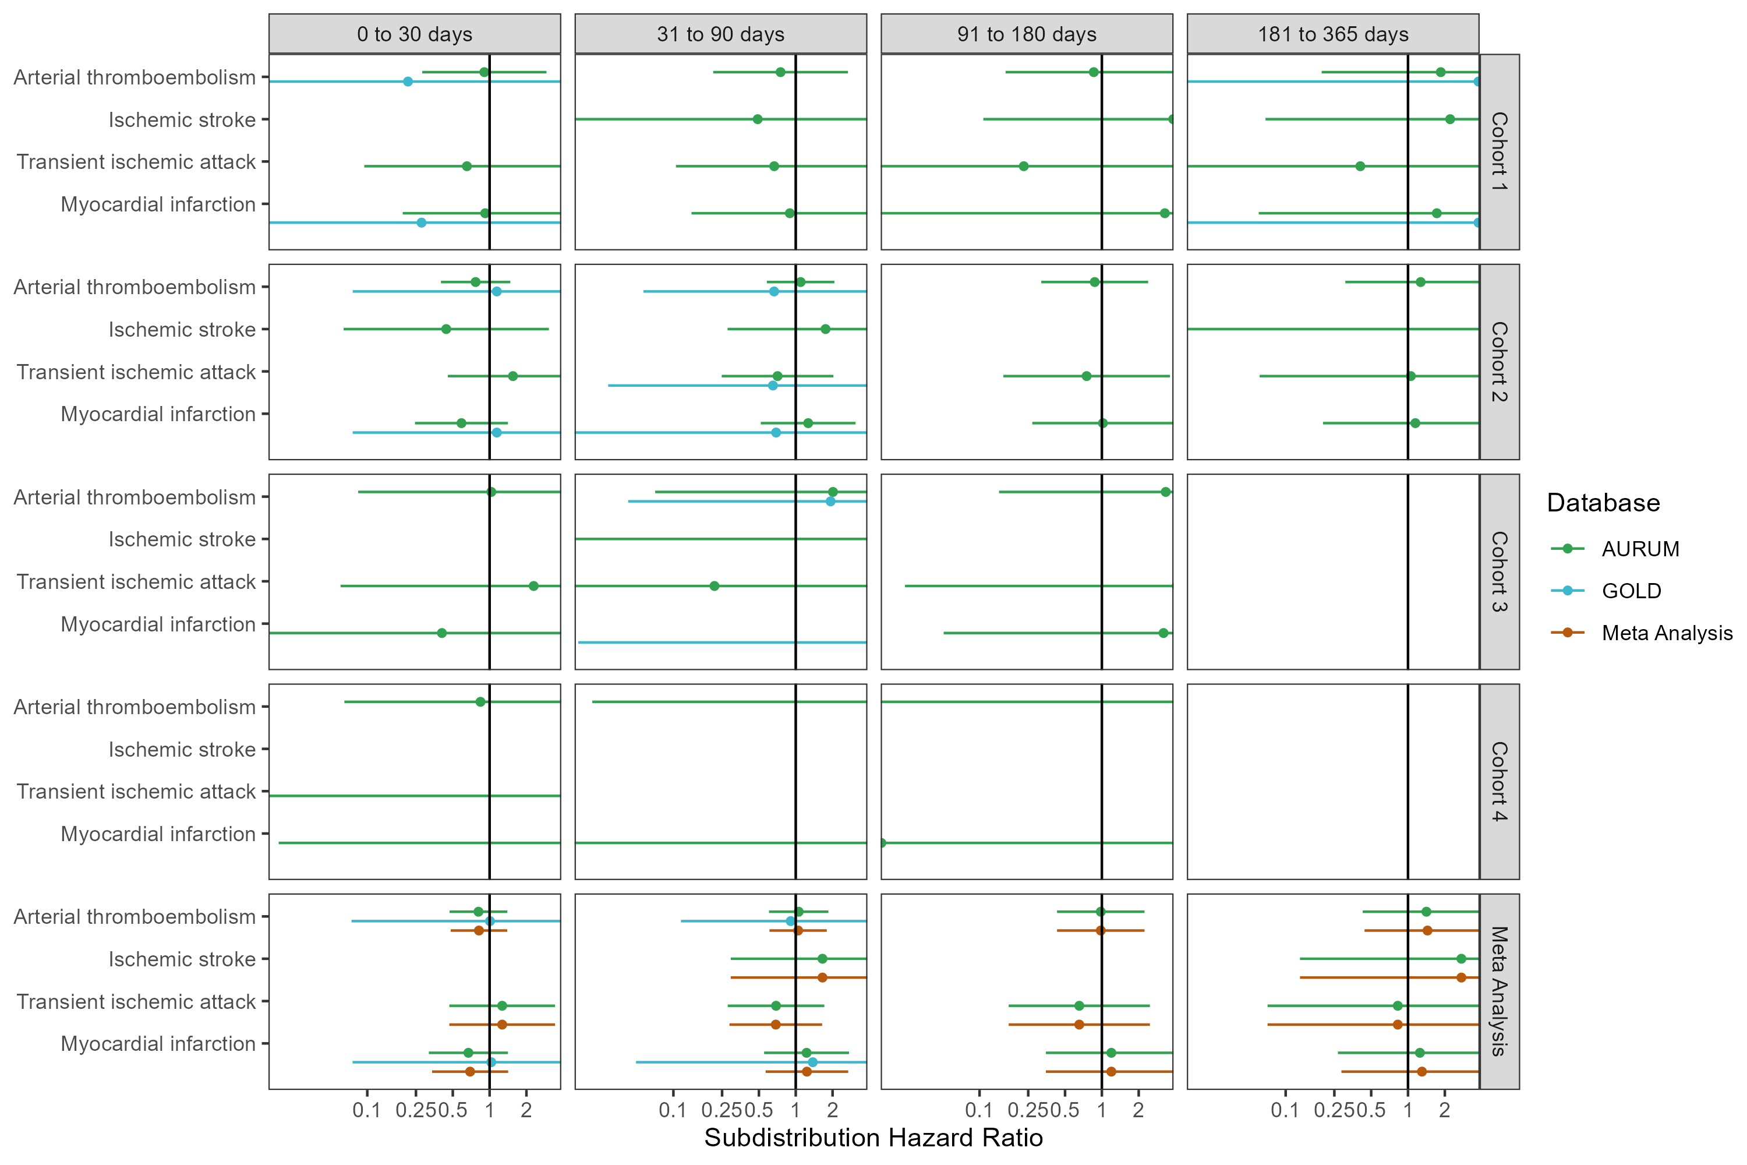

## **Figure S47: Forest plots for comparative effect on preventing arterial thrombosis/thromboembolism complications,** for each cohort and database (meta-analysis estimates across cohorts in the last panel).Follow-up ends at first vaccine dose after index date. Dashed line represents a level of hetereogeneity I2 > 0.4.

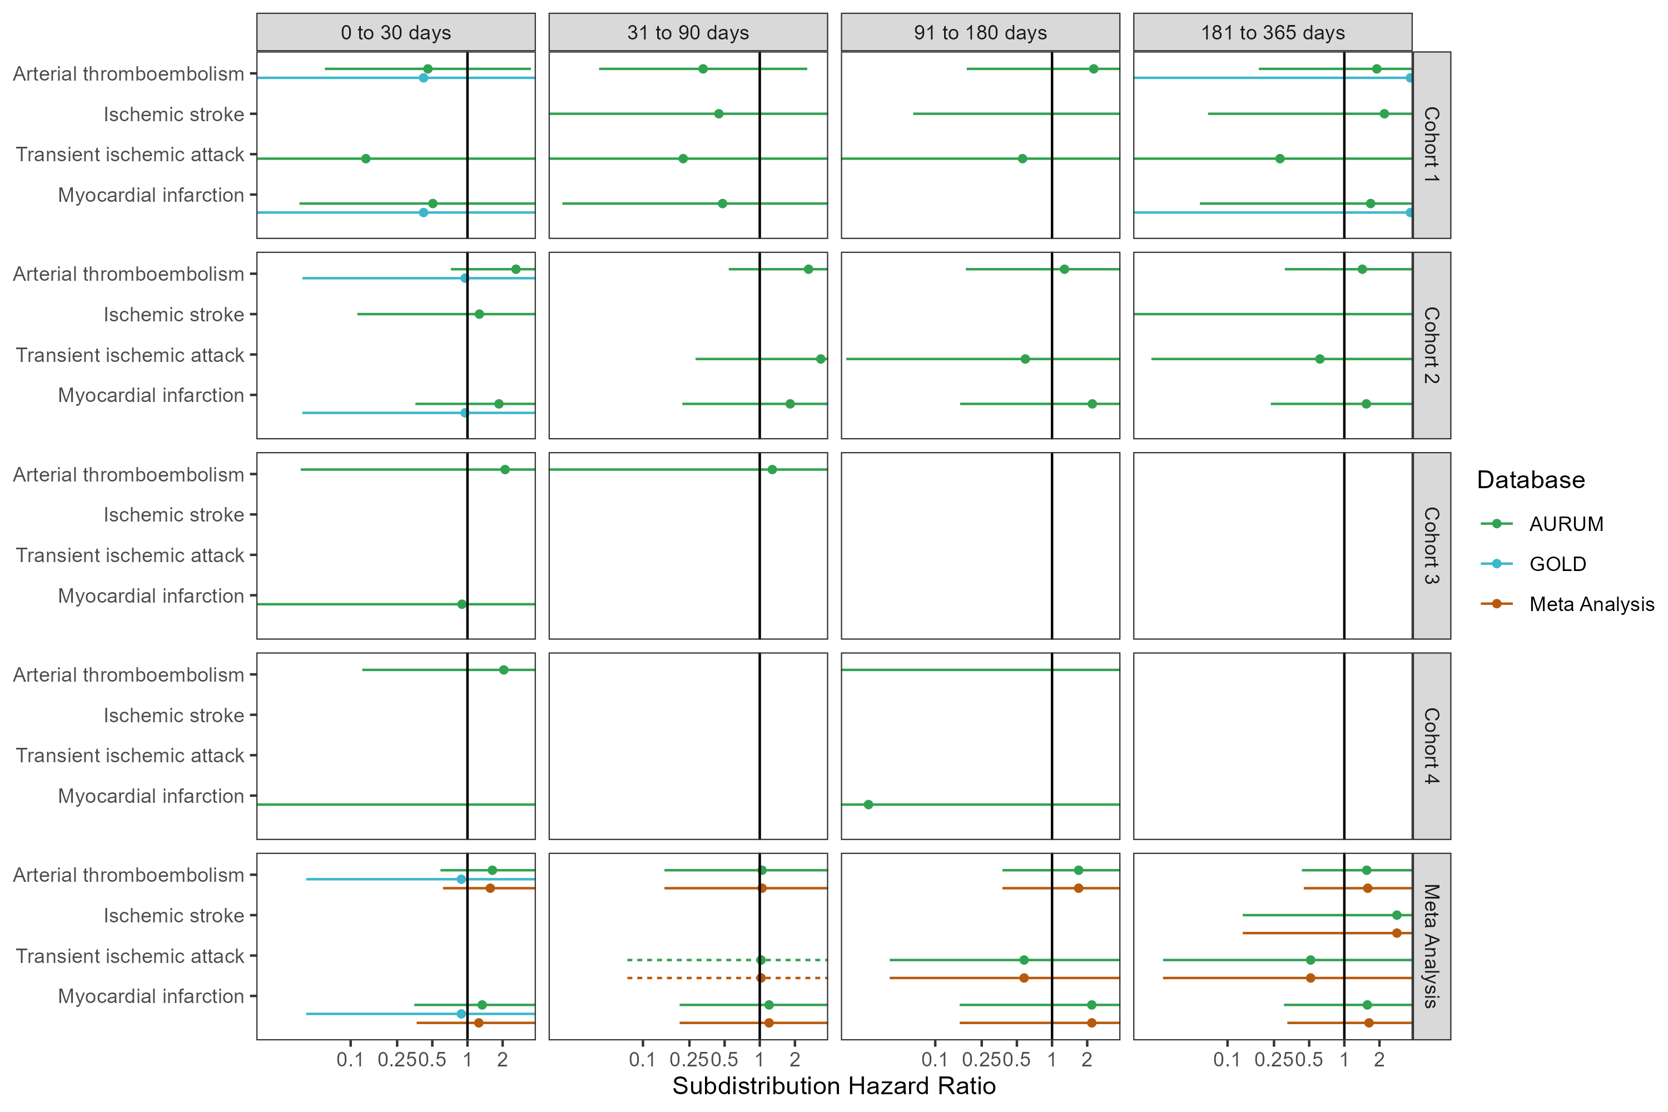

## **Figure S48: Forest plots for comparative effect on preventing arterial thrombosis/thromboembolism complications,** for each cohort and database (meta-analysis estimates across cohorts in the last panel).Only first outcome after COVID-19 captured. Dashed line represents a level of hetereogeneity I2 > 0.4.

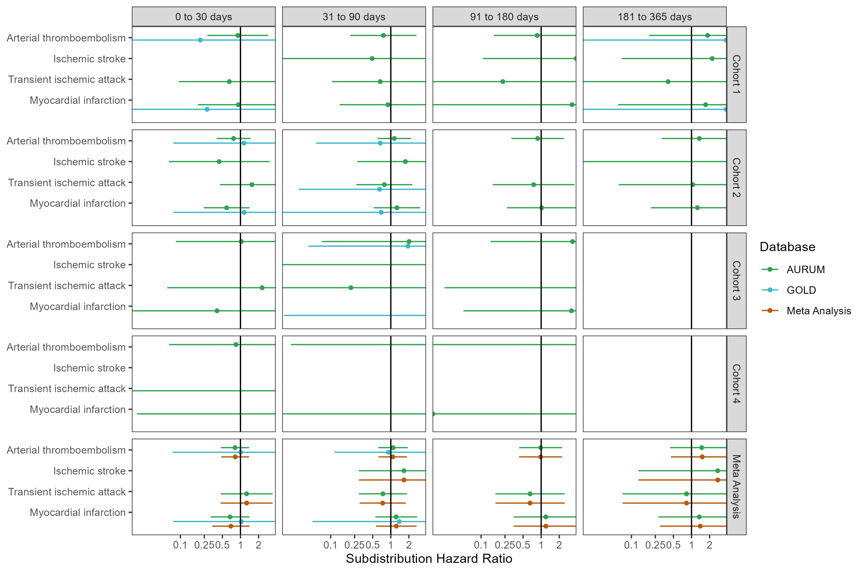

## **Figure S49: Forest plots for comparative effect on preventing cardiac diseases and hemorrhagic stroke,** for each cohort and database (meta-analysis estimates across cohorts in the last panel). Dashed line represents a level of hetereogeneity I2 > 0.4.

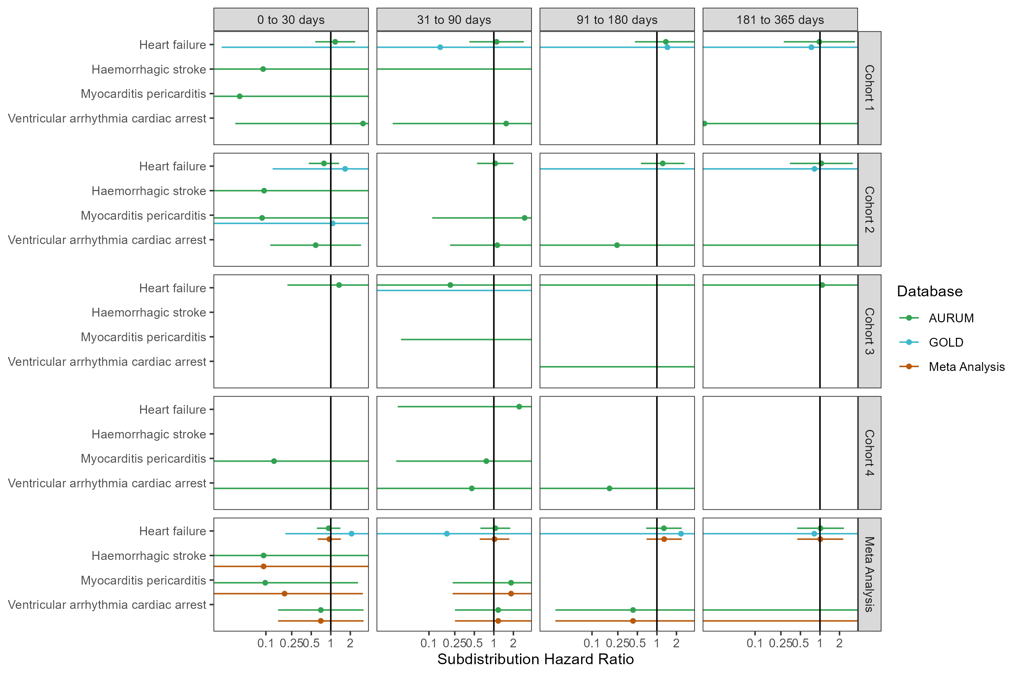

## **Figure S50: Forest plots for comparative effect on preventing cardiac diseases and hemorrhagic stroke,** for each cohort and database (meta-analysis estimates across cohorts in the last panel).Follow-up ends at first vaccine dose after index date. Dashed line represents a level of hetereogeneity I2 > 0.4.

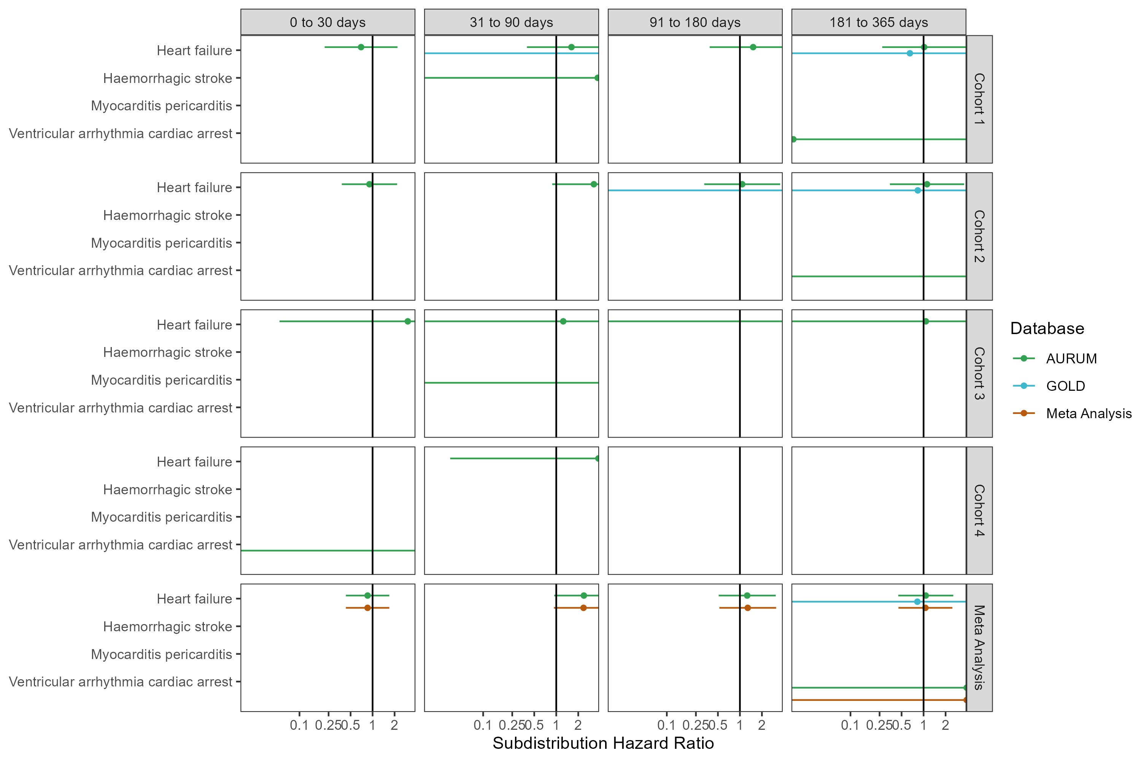

## **Figure S51: Forest plots for comparative effect on preventing cardiac diseases and hemorrhagic stroke,** for each cohort and database (meta-analysis estimates across cohorts in the last panel).Only first outcome after COVID-19 captured. Dashed line represents a level of hetereogeneity I2 > 0.4.

